Tiếng Anh 6 – i-Learn Smart World

UNIT 4 TEST

Note: Each correct answer earns 0.2 points.

I. PRONUNCIATION (0.8 points)
A. Choose the word whose underlined part is pronounced differently.
1. A. talent B. lantern C. fashion D. always
2. A. opens B. closes C. leaves D. ends
B. Choose the word that has a different stressed syllable from the rest.
3. A. parade B. special C. sometimes D. candy
4. A. decorate B. festival C. performance D. celebrate
II. VOCABULARY AND GRAMMAR (2.4 points)
Choose the best option (A, B, C or D) to complete each of the following sentences.
5. I __________ go to the movies. Maybe just once or twice a year.
A. always B. rarely C. sometimes D. often
6. Daniel __________ martial arts in the evenings.
A. is often having B. often do C. often does D. often have
7. Student A: How often do you go to the cinema?
Student B: __________
A. Yes, I love it. B. Not really.
C. Next Wednesday. D. Once or twice a month.
8. I __________ chat with people I don’t know because it’s dangerous.
A. never B. sometimes C. always D. usually
9. Before Tết, Vietnamese people decorate their houses __________ peach trees or apricot trees.
A. for B. by C. with D. on
10. My dad __________ breakfast for my family every day.
A. is cooking B. cooks C. cook D. will cook
11. On Christmas Day, children __________ Christmas presents from Santa Claus.
A. buy B. celebrate C. watch D. receive
12. I want to check out the __________. All the dishes look delicious.
A. food stands B. talent show C. puppet show D. tug of war
13. Brian is brilliant at dancing. He is going to sign up for the __________.
A. fashion show B. festival C. talent show D. puppet show
14. During Tết, people often _________ their relatives and friends.
A. have B. visit C. invite D. go to
15. What does the sign mean?
A. The café opens in the evening.  B. The café opens at 8 a.m. and closes at 4 p.m.  C. The café opens after 16:00.  D. The café doesn’t close in the evening. | 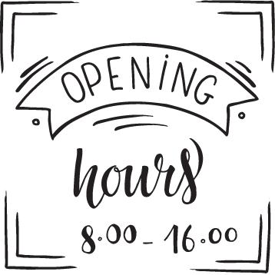

16. What does the sign mean?
A. This store opens at 7 o’clock.  B. This store closes at 7 o’clock.  C. This store opens on 24th July.  D. This store is always open. | 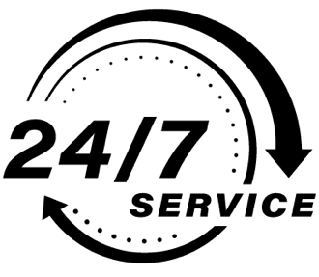
III. WORD FORMATION (1.2 points)
Write the correct forms of the words in brackets.
17. Hurry up! The train _______________ in ten minutes. (LEAVE)
18. I am really _______________ about the talent show tomorrow. (EXCITE)
19. Turkey and mashed potatoes are _______________ food on Thanksgiving Day. (TRADITION)
20. I think fashion shows are _______________. I don’t like them at all. (BORE)
21. During Tết, children wear new clothes and receive _______________ money. (LUCK)
22. There are many great _______________ at the music festival. (PERFORM)

IV. LISTENING (2 points)
A. Listen to the conversation between Amy and Dan and answer the following questions.
23. What does Dan sometimes do on Saturdays?
→
24. When does Amy go swimming?
→
25. What does Lois do at the sports center?
→
26. Does Amy often go out on Thursdays?
→
27. Who always does homework on Thursdays?
→

B. Bill and Pat are talking about a festival. Listen and match the activities with the time. There is ONE piece of information that you don’t need.

28. The food stands open at | _____ | A. 12 p.m.
29. The food stands close at | _____ | B. 4 p.m.
30. Music performances end at | _____ | C. 6 p.m.
31. The fashion show starts at | _____ | D. 7 p.m.
32. The fashion show ends at | _____ | E. 8 p.m.
 |  | F. 8:30 p.m.
V. READING (2 points)
A. Read Jian’s email and choose the best option (A, B, C or D) for each of the following questions.
Hi Sammy!
Thanks for your email. We’re celebrating Chinese New Year at the moment. We celebrate it in the first month of spring. It’s a very important festival for Chinese people. Before the celebrations, we clean our house. This is a tradition – we wipe away all the bad things. On New Year’s Eve, we have a special meal with our family. We eat traditional food and watch fireworks at midnight. We also wear red clothes. Red means fire, so we believe that our red clothes help chase away bad spirits. When we wake up on New Year’s Day, we always find red envelopes in our beds. There is money in them – they’re presents from our parents and grandparents. We watch dragon dances, too. They’re my favorite part of the festival. I love Chinese New Year, because I like all the traditions and I like being with my family.
Write to me about one of your festivals.
Take care.
Jian
33. When do Chinese people celebrate Chinese New Year?
A. At the moment B. In the first month of spring
C. In the first spring D. On New Year’s Eve
34. What do people often do before the celebrations?
A. wear red clothes B. eat traditional food
C. have special meals D. clean their houses
35. What is the meaning of the color ‘red’?
A. fire B. bad spirits C. New Year D. fireworks
36. On New Year’s Day, Jian usually ________.
A. gets presents from friends B. wipes away bad things
C. gets red envelopes with money inside D. gives presents to her parents
37. __________ is Jian’s favorite part of the festival.
A. Eating traditional food B. Getting money in red envelopes
C. Watching fireworks D. Watching dragon dances

B. Read the following passage and fill in each blank with a suitable word from the box. There are TWO words that you don’t need.
decorate decorations traditional parade celebrate costumes fireworks
GOLOWAN FESTIVAL
Golowan festival is one of the biggest (38) __________ festivals in Europe. Golowan means ‘midsummer’ in Cornish, the old language of Cornwall. ‘Midsummer’ is the longest day of the year and people celebrate ‘midsummer’ in many countries. The festival lasts for ten days. The celebrations begin with a big (39) __________ show and lots of different music events. People (40) __________ the streets with flags in different colors. School students make amazing animals out of paper. There aren’t any cars or buses on the streets in the town center. Hundreds of people dress up in beautiful (41) __________ and walk along the streets in a big (42) __________. Musicians play guitars and drums while people dance. Visitors can also try Cornish food at the food stands.
VI. WRITING (1.6 points)
A. Put the words in the correct order to make correct sentences.
43. We/ usually/ on/ home/ are/ at/ Sundays/.
→
44. sometimes/ My/ me/ with/ mother/ helps/ homework/ my/.
→
45. there/ in/ a/ is/ festival/ city/ When/ your/?
→
B. Rewrite the following sentences without changing their meanings.
46. Let’s play tug of war after school.
→ Why don’t .
47. I always get to school on time.
→ I am never .
48. My sister can paint pictures really well.
→ My sister is good .
C. Use the given words/phrases to make complete sentences.
49. What time/ you/ usually/ get up/ morning/?
→
50. There/ great food stand/ the market/ weekend/.
→

***End – Of – Test***

