

Tiết thứ ....
UNIT 12: ENGLISH-SPEAKING COUNTRIES
Lesson 6: Skills 2

Class | Date of teaching | Attendence
7A | ..../09/2022
7B | ..../09/2022
7C | ..../09/2022
I. OBJECTIVES: By the end of this unit, students will be able to gain the following things:
1. Knowledge:
- Listen for specific information about a tour of a city;
- Write a diary entry about a tour of a city.
a. Vocabulary: vocabulary on the topic “English-speaking countries”.
b. Grammar:
2. Competence:
a) General competencies:
- Students will be able to know more words and phrases about English speaking countries.
- Be collaborative and supportive in pair work and teamwork
- Actively join in class activities
b) Specific competencies:
- Group work and independent working, pair work, linguistic competence, cooperative learning and communicative competence.
- Sts can introduce themselves or one another fluently.
3. Qualities: The love of country; The awareness about importance of speaking English; Be ready to talk about English speaking countries.
- Develop self-study skills.
II. PREPARATIONS
Teacher: Grade 7 text book, laptop, TV, pictures and realia, Computer connected to the Internet, Sach mem.vn
Students: Text books, pencils, pics, blank papers, realia,….
III. PROCEDURE:
In each activity, each step will be represented as following:
* Task delivering
** Task performance
*** Report and discussion
 Judgement
Activity 1. WARM UP (5’-IW, GW)
* Aim:
To introduce the topic of the lesson.
* Content: Guessing game: What city is it?
* Product: Having a chance to speak English and focus on the topic of the lesson.
* Implementation: Teacher’s instructions…
Teacher’s & Student’s activities | Content
Guessing game: What city is it?
* Teacher divides the class into 2 teams. Each team will guess the the name of the city based on pictures given gradually by the teacher.
** Students play the guessing game.
*** The team with correct answer will be the winner.
 Teacher introduces the topic of the listening task: A tour around London.

Activity 2. KNOWLEDGE FORMATION (15'- PW, IW)
* Aim:
To prepare students for the listening by introducing two key phrases visually.
* Content:
* Product: Ss learn how to use them.
* Implementation: Teacher’s instructions…
Teacher’s & Student’s activities | Content
Task 1: Work in groups. Match the phrases to the pictures (p. 131)  * Teacher asks students work in groups to read the phrases and match them to the pictures.  ** Students discuss with partners.  *** Teacher elicits as many learnt vocabularies as possible and asks one or two students to re-describe the pictures to the class.   Teacher gives feedback and introduces the topic of the listening task: A tour around London. | Task 1: Work in groups. Match the phrases to the pictures (p. 131)  Answer key:  1. Changing of the Guard  2. Buckingham Palace
Activity 3. PRACTICE (15’-IW, PW, GW)
* Aim:
To help students develop their skill of listening for specific information, in this case: times.
To help students further develop their listening skill for specific information.
To help students summarise the content of the listening in notes.
To teach students how to write a diary entry about a tour they have taken.
* Product: Students’ answers.
* Implementation:
Teacher’s Student’s activities | Content
Task 2: A tour guide is talking about the schedule for a day trip in London. Listen and fill in the times. (p. 131)  * Teacher helps students revise the use of time in the listening and note taking skills by saying 3 - 4 different times for students to write down.  ** Teacher has students read the questions quickly. This helps students get some ideas of what they are going to listen to as well as determine the information they need for answering the questions.  *** Teacher has students exchange answers in pairs, invites some pairs to read their answers and confirm the correct ones   Teacher confirms the answers and gives feedback.  Task 3: Listen again and complete each sentence with ONE word. (p. 131)  * Teacher has students read the questions and determine what information they need for answering the questions, reminds them that the questions ask for one-word answers.  ** Teacher plays the recording again twice for students to listen and complete the sentences.  *** Teacher has students exchange answers in pairs, invites some pairs to say their answers and confirm the correct ones.   Teacher plays the recording again if needed, stopping at each place where the answers appear. | Task 2: A tour guide is talking about the schedule for a day trip in London. Listen and fill in the times. (p. 131)  Answer key:  1. 11:30 a.m.  2. 1:00 p.m.  3. 3:15 p.m.  4. 5:00 p.m.  Task 3: Listen again and complete each sentence with ONE word. (p. 131)  Answer key:  1. Queen  2. garden  3. Clock  4. photos  5. attractions
Task 4: Work in pairs. Fill in the table with information about the London tour. (p. 131)  * Teacher asks students to work in pairs, lets them read the table and decide what information they need to complete the table.  ** Students do the task within 4-5 minutes.  *** Teacher invites some pairs to share their answers with the class   Teacher gives feedback and provides suggested answers. | Task 4: Work in pairs. Fill in the table with information about the London tour. (p. 131)    Suggested answers:  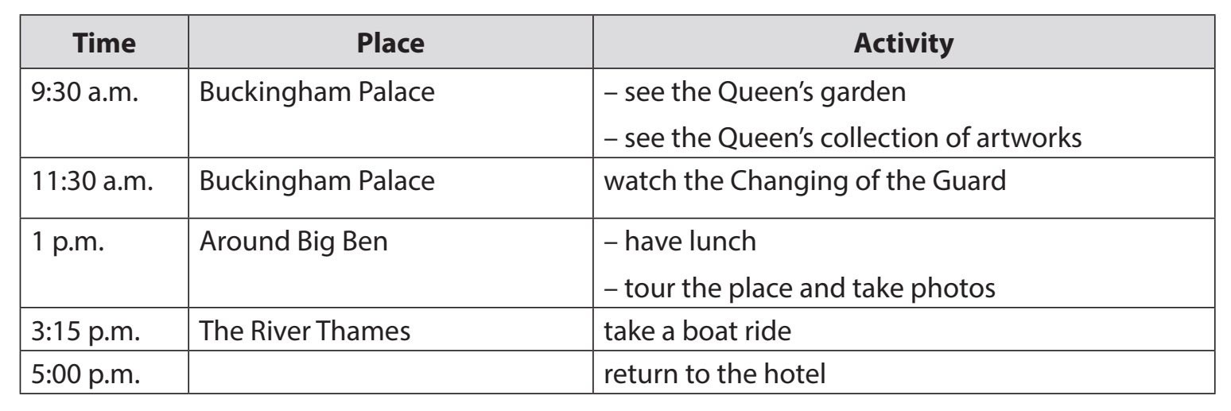
Task 5: Imagine that you took the tour of London. Write a diary entry of about 70 words about your tour, based on the table in 4 or use your imagination. (p. 131)  * Teacher explains to students what a diary entry is: It is a description of what you do during a tour and how you feel about it.  ** Students refer to the table in 4 for information. They can write about everything or just choose the activities they like most.  *** Teacher allows students to peer check first.   Teacher goes around to help (if necessary). | Task 5: Imagine that you took the tour of London. Write a diary entry of about 70 words about your tour, based on the table in 4 or use your imagination. (p. 131)  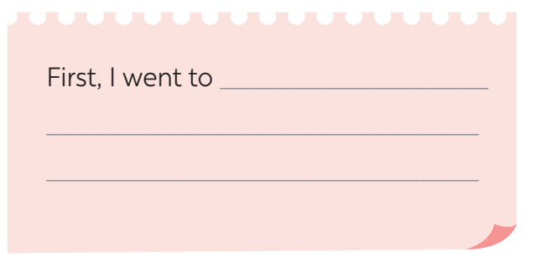  Suggested answers:  The tour of London began at 9:30 a.m. First, we went to Buckingham Palace. We visited the Queen’s Garden and saw her collection of artworks. At 11:30 a.m. we watched the Changing of the Guard. We then went to Big Ben. We took a lot of photos there. At 3:15 p.m., we took a boat ride on the River Thames. We saw many historic attractions along the river. I enjoyed the tour very much.
Activity 4. APPLICATION (7’-IW, PW, GW)
* Aim:
To peer check, cross check and final check students’ writing.
* Content:
* Product: Students’ answer.
* Implementation: Teacher’s instructions
Giving peer-reflection & evaluation
* Teacher asks students to work in groups of four and swap the entries to their group members.
** Students can give comment to others’ work.
*** Students then give comments to each other.
 Teacher then gives feedback as a class discussion.
* Wrap up  - Teacher asks students to talk about what they have learnt in the lesson.  * Homework:  - To allow students finalize their paragraph after being checked by friends and the teacher. | * Wrap up  - Teacher asks students to summarise what they have learnt in the lesson.  - Teacher has them say out loud the articles.  * Homework:  - Rewrite the diary on your notebook.  - Prepare for the next lesson (Unit 3-Lesson 7: Looking back and Project)
V. FEEDBACK:
With 7A ……………………………………………………………………………..…
With 7B …………………………...……………………………………..……………
With 7C ………………………………………………………………………….……

