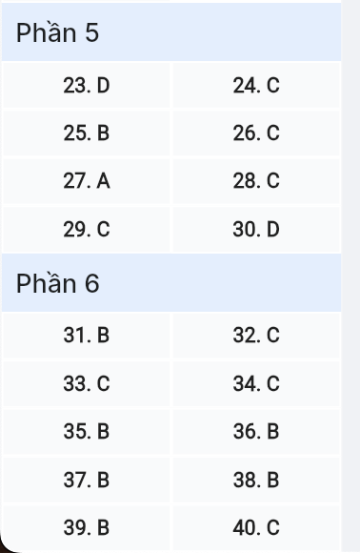
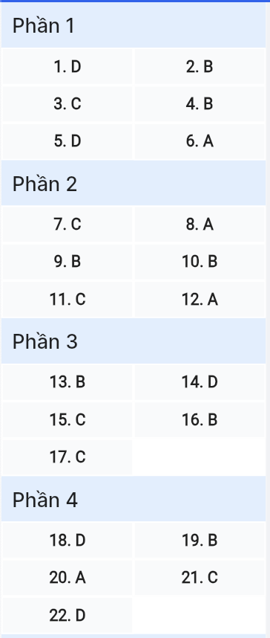
ĐỀ MINH HỌA SỐ 18
KỲ THI TỐT NGHIỆP TRUNG HỌC PHỔ THÔNG NĂM 2025
(Đề thi có 08 trang)
Môn thi: TIẾNG ANH
Thời gian làm bài: 50 phút, không kể thời gian phát đề
Read the following advertisement and mark the letter A, B, C or D on your answer sheet to indicate the option that best fits each of the numbered blanks from 1 to 6.

EAT SMART, LIVE WELL
"Is my diet nutritious enough? Am I making the right choices?" If these questions sound (1) ______, you're not alone! Our new (2) ______ is here to assist you in (3) ________ nutritious decisions. With our personalized menu called "Healthy Choice," you can select meals (4) ______ your dietary needs and preferences. Our expert nutritionists will provide you with advice and recipes to ensure your meals are both delicious and healthy. Join a community that shares your passion (5) ______ healthy well-being and inspires you (6) ______ the best version of yourself!
Question 1 [697607]: A. familiarly B. familiarity C. familiarize D. familiar

Question 2 [697608]: A. service meal planning B. meal planning service
C. planning service meal D. service planning meal

Question 3 [697609]: A. putting B. doing C. making D. taking

Question 4 [697610]: A. are fitted B. that fit C. fit D. which fitting

Question 5 [697611]: A. over B. to C. in D. for

Question 6 [697612]: A. to become B. becoming C. become D. to becoming

Read the following leaflet and mark the letter A, B, C or D on your answer sheet to indicate the option that best fits each of the numbered blanks from 7 to 12.

UNITED AGAINST PLASTIC POLLUTION
As we step into World Environment Day, the call to action is louder than ever, urging everyone to come together and tackle one of the most pressing environmental issues of our time: plastic pollution.
The Magnitude of Plastic Pollution:
Plastic debris not only disrupts the balance of marine life but also poses a significant threat to terrestrial ecosystems. Marine mammals and (7) ______ sea creatures often mistake plastic fragments for food, leading to injury or death. Microplastics resulting from the breakdown of larger plastics, have infiltrated the food chain, potentially causing harm to humans through the consumption of contaminated seafood and water.
Actions to Beat Plastic Pollution:
- Reduce your reliance on single-use plastics by (8) ______ reusable alternatives. By making simple switches, we can significantly reduce the (9) ______ of plastic waste generated.
- (10) ______ plastic straws and cutlery by using eco-friendly ones like metal or bamboo straws and biodegradable cutlery.
- Join local initiatives or organize clean-up campaigns in your community. (11) ______, we can prevent plastic waste from reaching our waterways and protect our environment.
- Share informative content and (12) ______ stories of individuals and organizations that have made a positive impact in fighting plastic pollution.
(Adapted from Campaignfortheworld.com)
Question 7 [697613]: A. others B. another C. other D. the others

Question 8 [697614]: A. adopting B. adapting C. following D. obeying

Question 9 [697615]: A. number B. amount C. level D. quality

Question 10 [697616]: A. run out of B. get rid of C. cut down on D. put up with

Question 11 [697617]: A. However B. Additionally C. Therefore D. Instead

Question 12 [697618]: A. success B. enthusiasm C. motivation D. inspiration
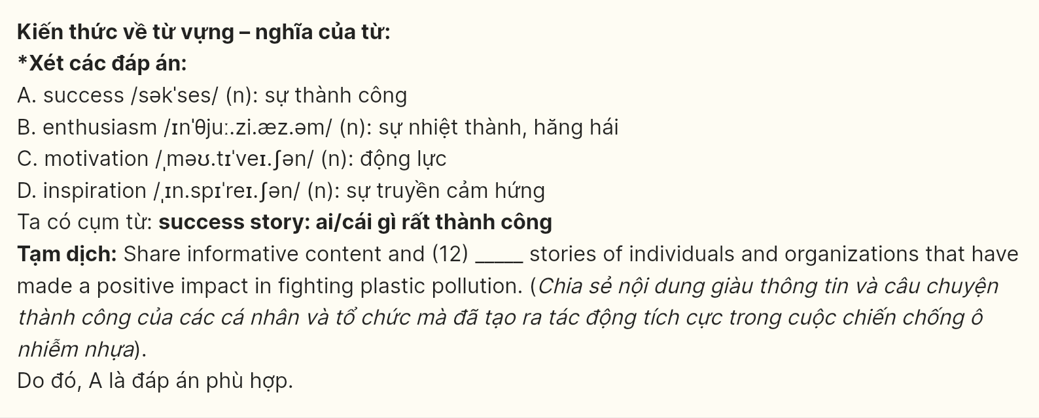
Mark the letter A, B, C, or D on your answer sheet to indicate the correct arrangement of the sentences to make a meaningful exchange or text in each of the following questions.
Question 13 [697619]:
a. Peter: Hi, John! Have you volunteered lately?
b. Peter: That sounds great! I've been thinking about getting involved too.
c. John: Yes, I have. I joined a local environmental project and it's been amazing.
A. b-a-c B. a-c-b C. c-b-a D. a-b-c

Question 14 [697620]:
a. Jack: Why fast food?
b. Mia: I usually order some fast food for lunch.
c. Jack: What do you usually eat for lunch?
d. Jack: As for me, I think fast food is unhealthy for our health. If I were you, I wouldn’t choose it.
e. Mia: It’s convenient, quick, and sometimes a wise option for those preoccupied with their work.
A. d-e-a-b-c B. c-e-d-b-a C. d-b-a-e-c D. c-b-a-e-d

(Adapted from Mirror)
Question 15 [697621]:
Hi Micky,
a. Your tips made a noticeable difference in my cooking.
b. Thanks again for recommending those useful tips, I really appreciate them.
c. Let’s catch up soon to exchange more tips and ideas for improving our cooking skills.
d. Since then, I’ve already started researching more about the topic and trying out some recipes.
e. I’ve been thinking a lot about what we discussed last time, especially about mastering new techniques in cooking.
Write back soon,
Rose
(Adapted from Express)
A. b-c-a-d-e B. b-d-e-a-c C. e-a-d-b-c D. e-b-c-a-d

Question 16 [697622]:
a. Upon arrival, a ride on the world-famous cable car, which offers panoramic views of the lush forests below, is a must.
b. In addition, a walk across the iconic Golden Bridge, held up by giant stone hands, provides a breathtaking view of the surrounding mountains and valleys.
c. Visiting Ba Na Hills is an exhilarating experience that should be thoughtfully planned to make the most of this unique mountain retreat.
d. To begin your journey, travelers often start in the city of Da Nang, taking a scenic fifty-minute drive up to Ba Na Hills.
e. Finally, travelers should spend a day exploring the hilltop French Village, enjoying the cool mountain air and European-inspired architecture.
(Adapted from Travel.com)
A. c-d-b-e-a B. c-d-a-b-e C. b-d-e-c-a D. b-a-c-d-e
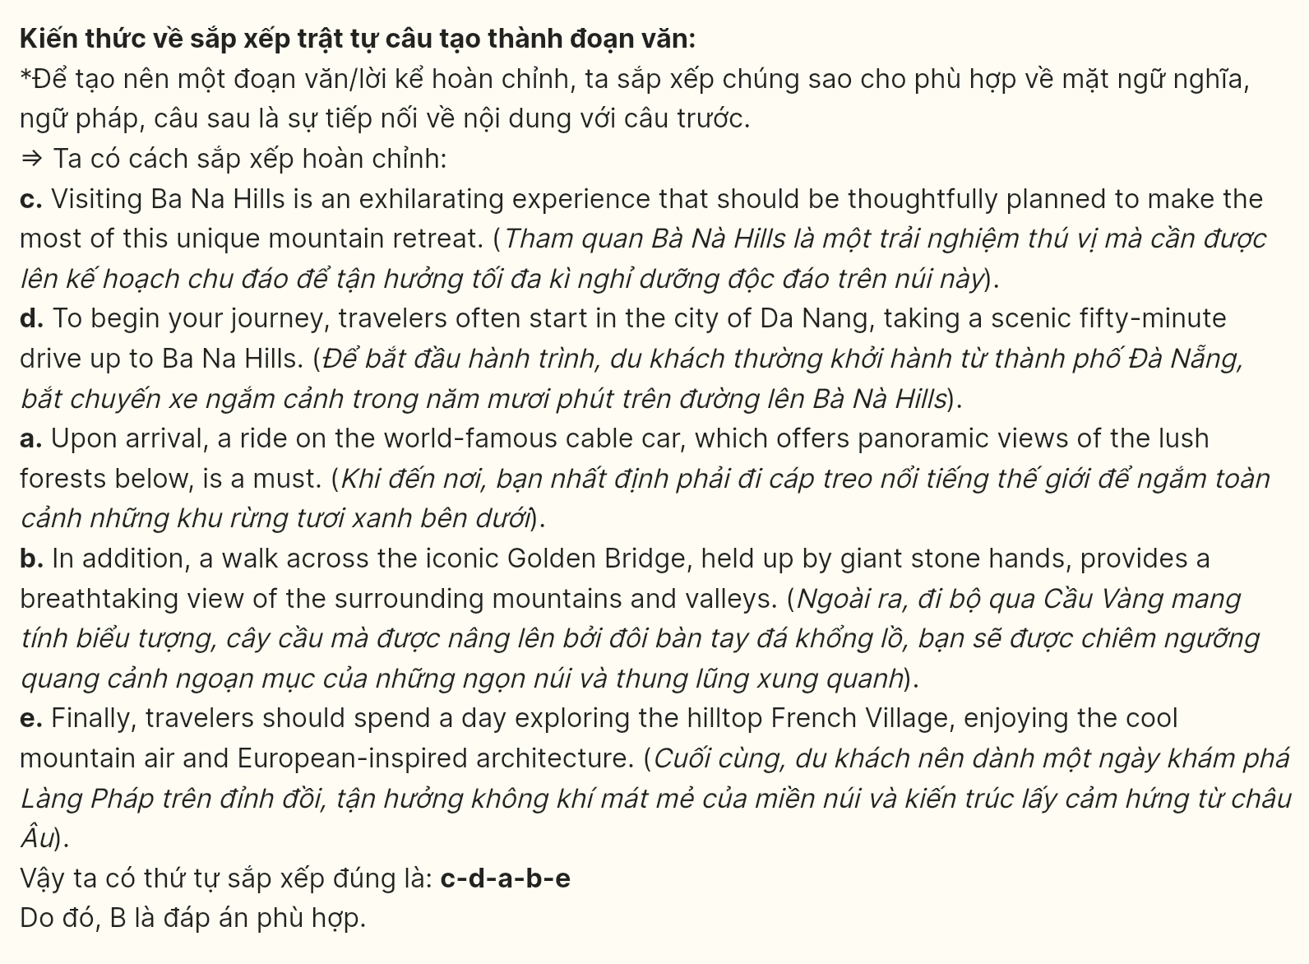
Question 17 [697623]:
a. Despite the rapid development, Masterise Homes still faces a shortage of affordable housing, with many residents commuting over 40 miles to find suitable accommodations.
b. Once characterized by open green spaces and family-owned businesses, the Masterise Homes area has seen a surge in high-rise condominiums and commercial complexes, reflecting a trend toward urbanization.
c. The urban shift has also spurred new investment opportunities, from luxury apartments to retail outlets, revitalizing the local economy and making Masterise Homes increasingly attractive to potential investors.
d. Over the last five years, Masterise Homes has undergone remarkable changes, transforming from a quiet town into a bustling real estate hotspot.
e. This has resulted in a 30% increase in property values, creating challenges for long-term residents who struggle to keep up with rising rents and property taxes.
(Adapted from Oxford Discover Future)
A. c-d-a-e-b B. d-e-a-e-b C. d-b-c-a-e D. d-b-c-e-a
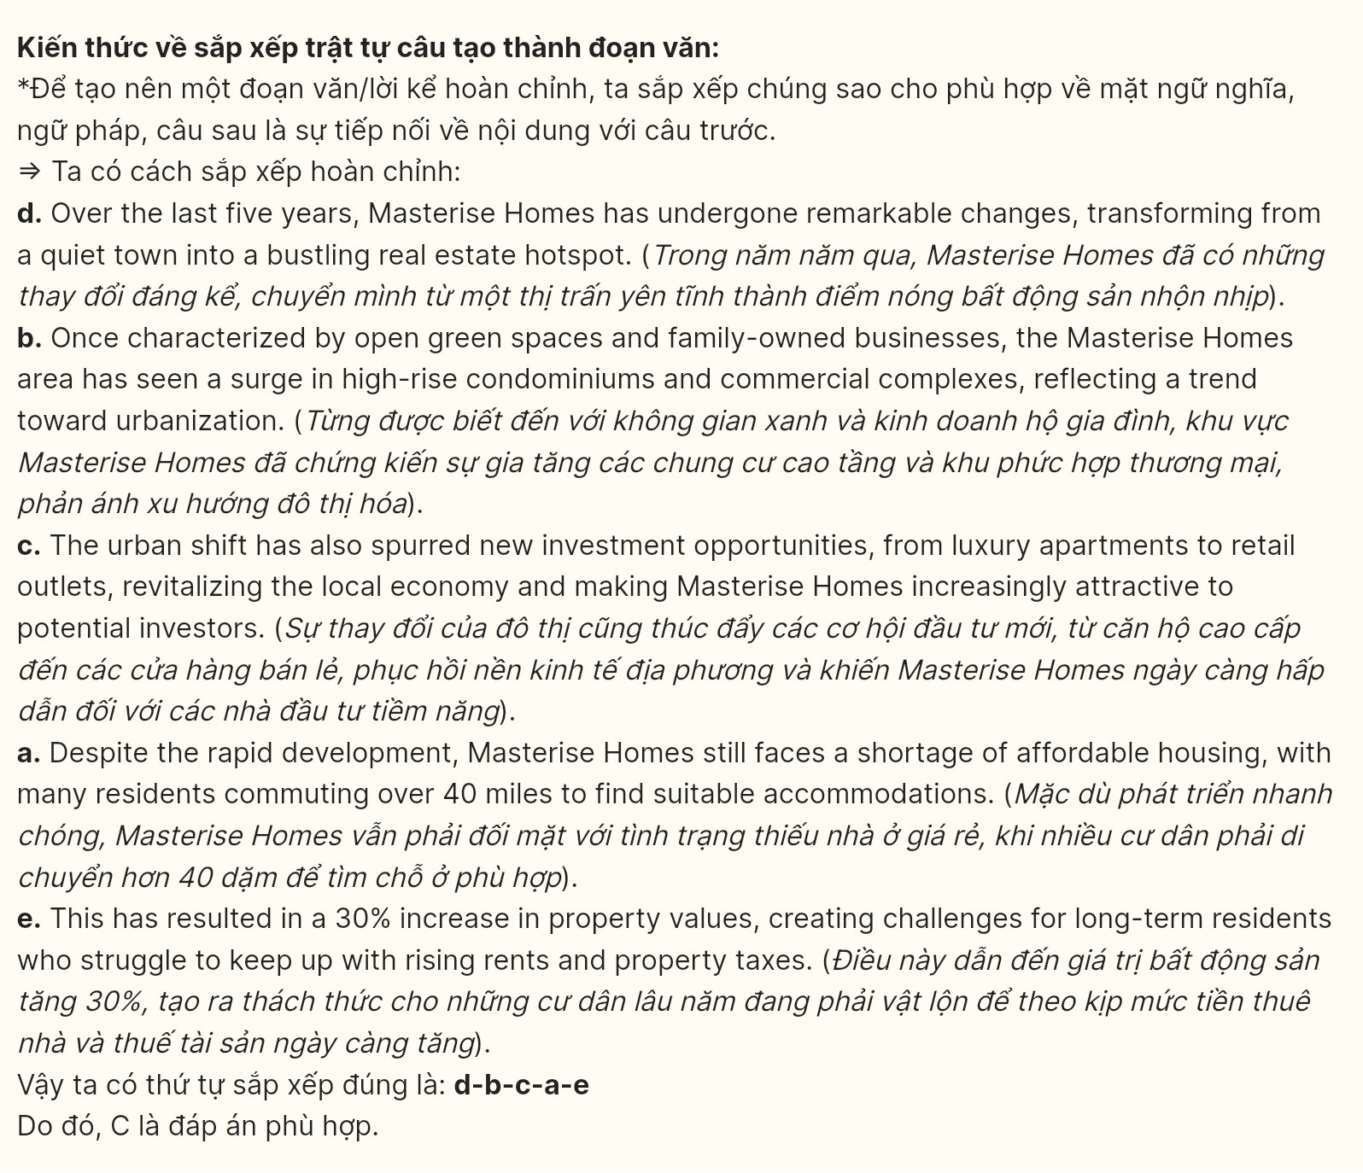
Read the following passage about corporate culture and mark the letter A, B, C or D on your answer sheet to indicate the option that best fits each of the numbered blanks from 18 to 22.

Contemporary organizational structures, amidst rapid workplace evolution, (18) ______. Companies worldwide embrace flexible policies and remote collaboration tools, fostering productivity across time zones. Recent workplace analytics indicate that organizations adopting hybrid models report increased employee satisfaction rates.
Business strategist David Reeves, (19) ______ achieved impressive results at the Future of Work Summit. His implementation of "Agile Leadership" principles empowers teams to make autonomous decisions. Through decentralized management approaches, organizations attain unprecedented levels of innovation and adaptability.
The Reeves Consulting Group promotes organizational transformation. (20) ______, their expertise spans from cultural restructuring to leadership development, enabling seamless organizational change.
Furthermore, (21) ______ the group’s pioneering "Adaptive Framework" responds dynamically to market shifts and employee needs.
The firm maintains rigorous implementation standards. Equipped with data-driven methodologies, (22) ______.
(Adapted from Advance.org)
Question 18 [697624]:
A. which demonstrates remarkable adaptability in market dynamics
B. having remarkable adaptability demonstrated in market dynamics
C. of which remarkable adaptability is demonstrated in market dynamics
D. demonstrates remarkable adaptability in market dynamics
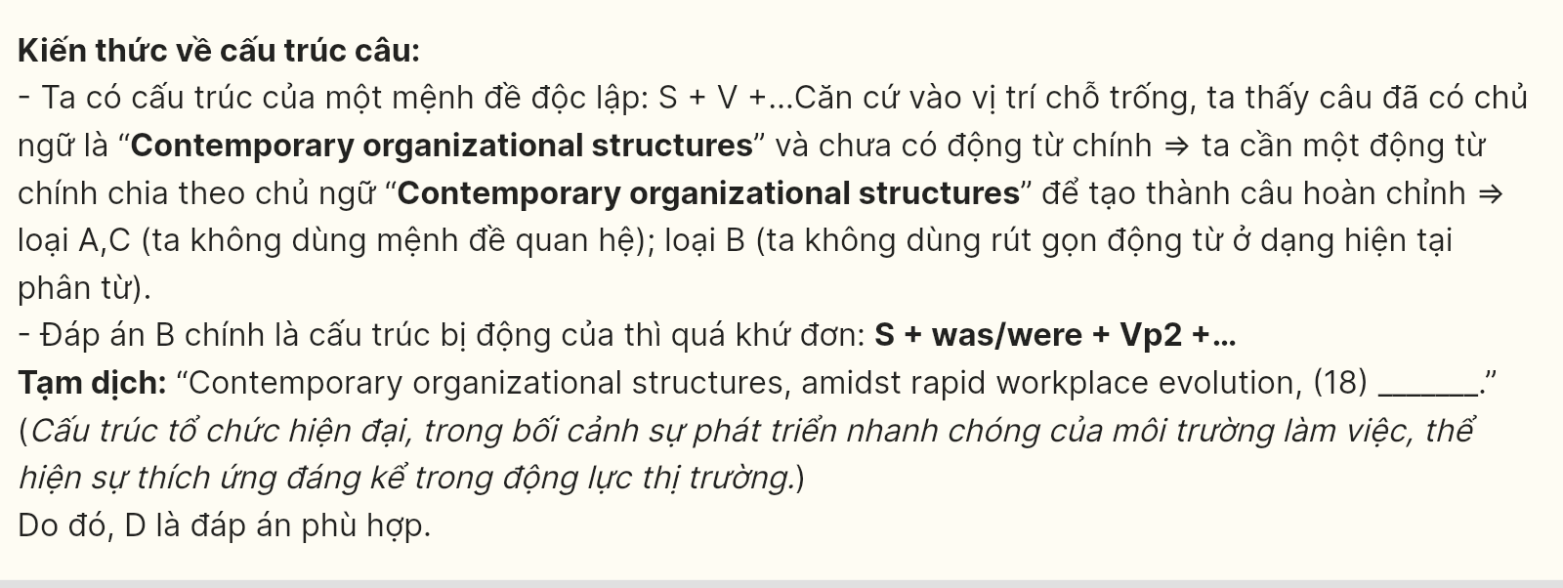
Question 19 [697625]:
A. with whom organizational advancement reached global excellence standards
B. who advanced organizational excellence with global standards
C. struggled to advance organizational excellence with global standards
D. reached organizational excellence through global advanced standards
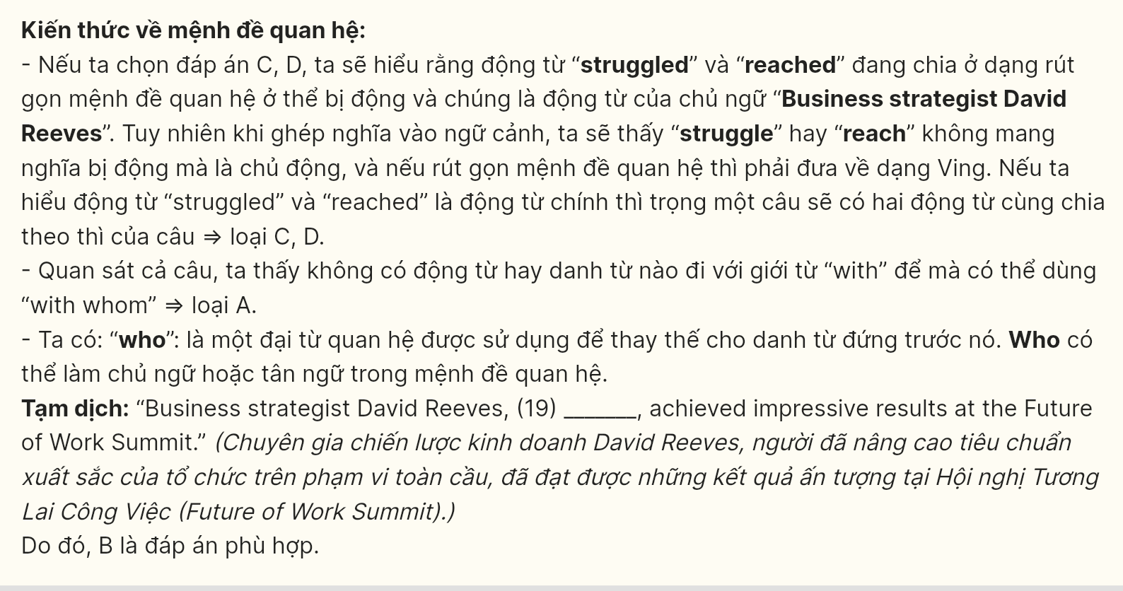
Question 20 [697626]:
A. The consultants implement strategic changes through systematic approaches
B. The strategies implement consultant changes through systematic approaches
C. The approaches implement systematic changes through strategic consulting
D. The changes consultants implement are strategic approaches through systematic
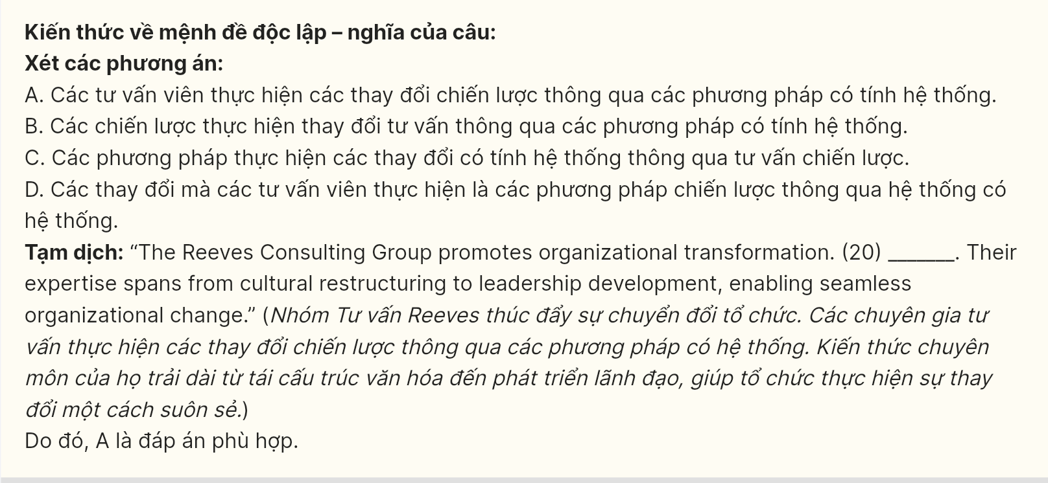
Question 21 [697627]:
A. innovative solutions adopted to workplace challenges, teams achieve sustainable growth
B. adopted innovative solutions to workplace challenges, sustainable growth is achieved
C. adopting innovative solutions to workplace challenges, teams achieve sustainable growth
D. workplace adopted innovative solutions to challenges, so sustainable growth achieved
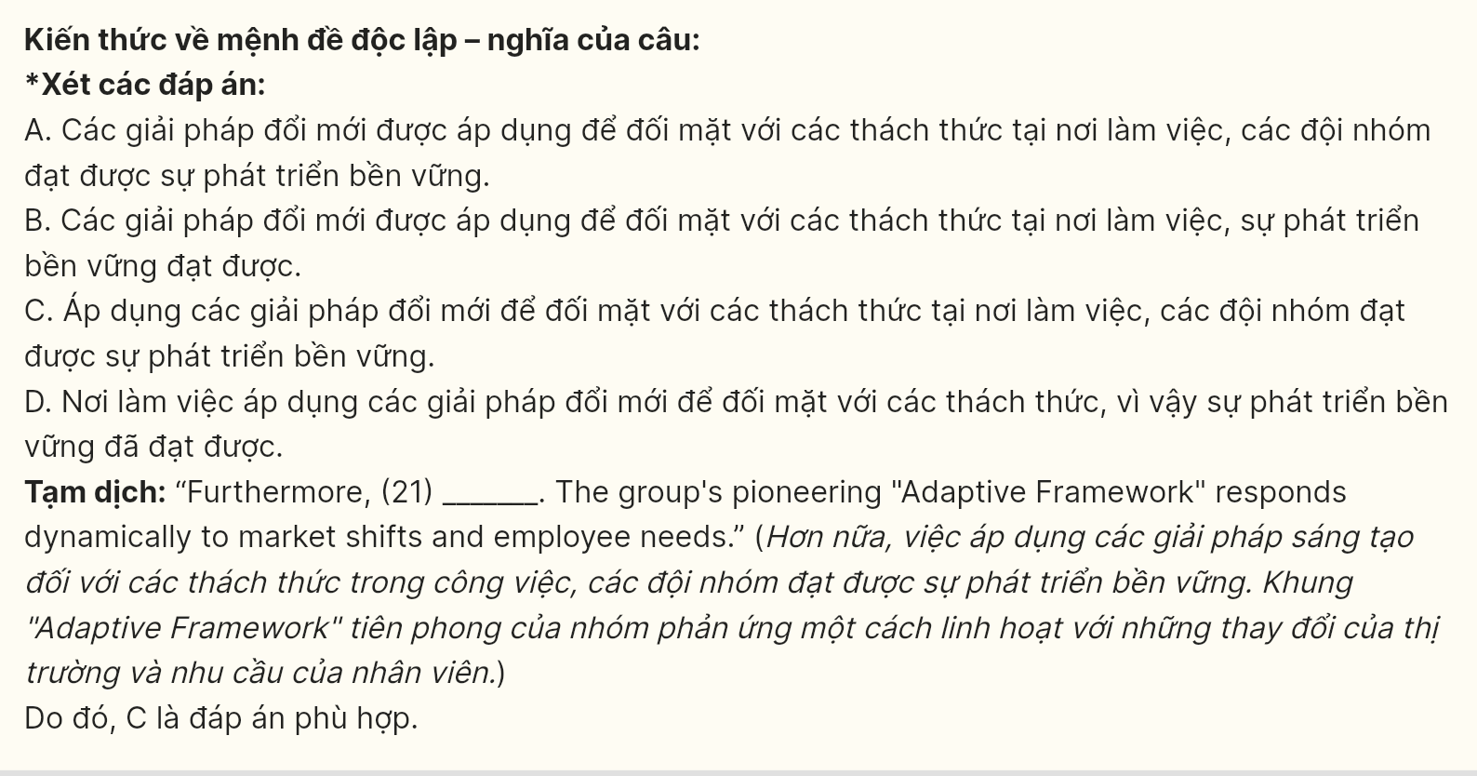
Question 22 [697628]:
A. organizational effectiveness improves through systematic implementation processes
B. the systematic processes will improve the organizational effectiveness through it
C. consultants deliver organizational improvements through systematic processes
D. the firm enhances organizational effectiveness through systematic processes

Read the following passage and mark the letter A, B, C or D on your answer sheet to indicate the best answer to each of the following questions from 23 to 30.

The Changing Landscape of Entertainment in the Digital Age
- Entertainment has always been a vital part of human culture, shaping societies and influencing creativity throughout history. However, it has undergone significant changes due to technological advancements and the rise of digital media. While traditional forms like cinema and theater still exist, streaming services and social media have transformed how audiences engage with content. This shift raises important questions about the future of entertainment and its impact on society.
- The rise of digital platforms has democratized access to a wide range of content. Services like Netflix and Hulu allow viewers to access countless movies and shows instantly. This accessibility empowers creators from diverse backgrounds to share their stories, giving rise to niche genres and independent films. However, the overwhelming number of choices can lead to decision fatigue, making it difficult for consumers to find what they want.
- Despite its benefits, digital entertainment also poses challenges. The binge-watching culture, encouraged by platforms that release entire seasons at once, can lead to isolation and negatively affect mental health. Viewers may prioritize screen time over real-life interactions, reducing meaningful connections. Additionally, algorithms that recommend content can create echo chambers, limiting exposure to diverse perspectives.
- Looking ahead, technology will continue to shape the entertainment landscape. Innovations like virtual reality (VR) promise immersive experiences that redefine how stories are told. Moreover, user-generated content on platforms such as TikTok allows audiences to participate actively in the entertainment process. While this shift fosters community, it also raises questions about originality and authorship in a rapidly changing environment.
Question 23 [697629]: Which of the following is NOT mentioned as a challenge posed by digital entertainment?
A. Isolation from real-life interactions
B. Reducing meaningful connections
C. Limiting exposure to diverse perspectives
D. Increasing cost of subscription services

Question 24 [697630]: The word fatigue in paragraph 2 is OPPOSITE in meaning to ______
A. solitude B. detachment C. vitality D. exhaustion

Question 25 [697631]: The word it in paragraph 1 refers to ______
A. history B. entertainment C. human culture D. creativity
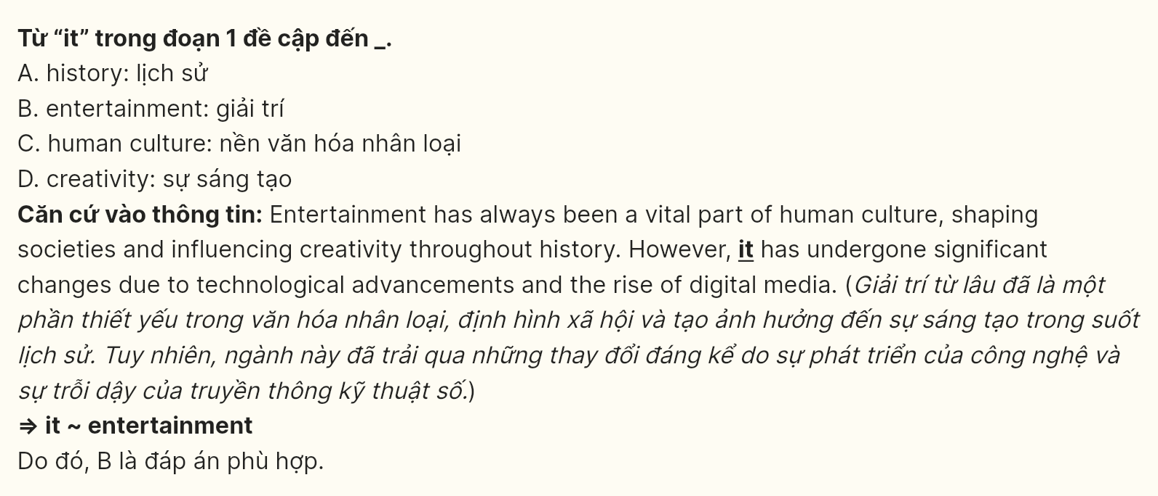
Question 26 [697632]: The word fosters in paragraph 4 could be best replaced by ______
A. diminishes B. suppresses C. encourages D. disrupts
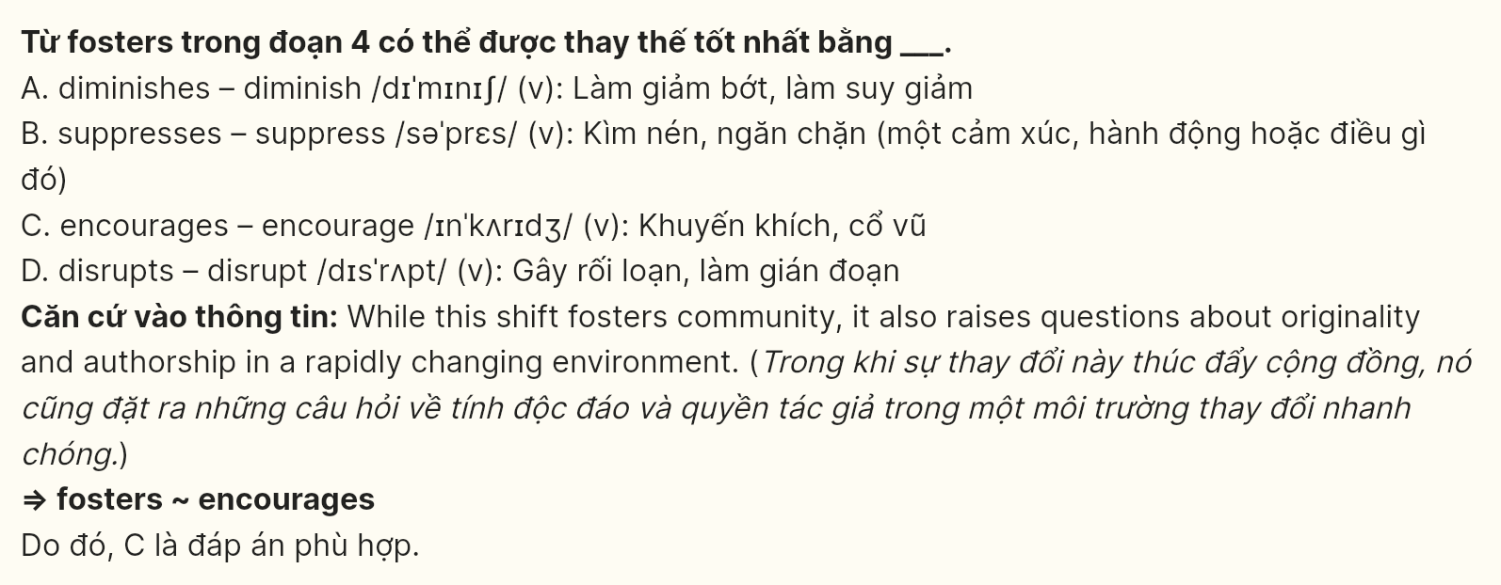
Question 27 [697633]: Which of the following best paraphrases the underlined sentence in paragraph 1?
A. The change in entertainment formats brings up significant concerns about its societal effects.
B. The future of entertainment is certain despite its impact on society.
C. The impact of entertainment on society is not influenced by technological changes.
D. Entertainment will continue to evolve without affecting society.
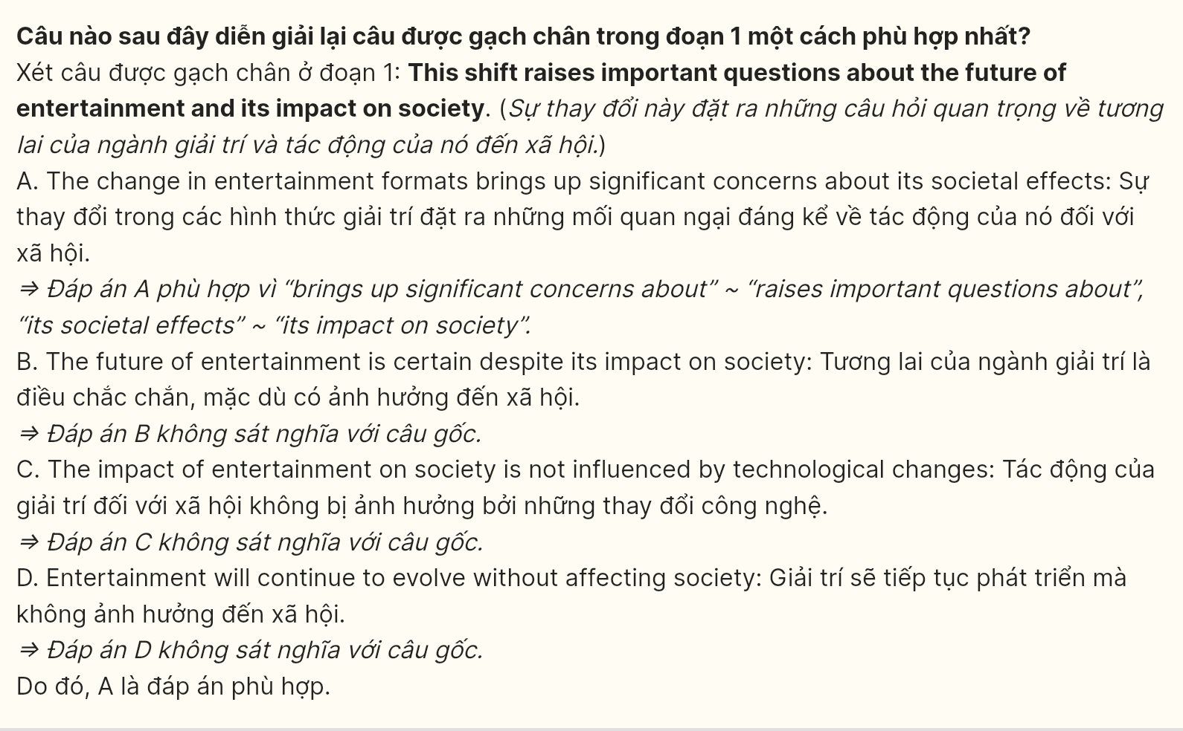
Question 28 [697634]: Which of the following is TRUE according to the passage?
A. Traditional forms of entertainment like cinema and theater no longer exist.
B. Streaming services have completely eliminated traditional entertainment forms.
C. Binge-watching can have detrimental effects on one's mental health.
D. Algorithms always expose viewers to a wide range of perspectives.
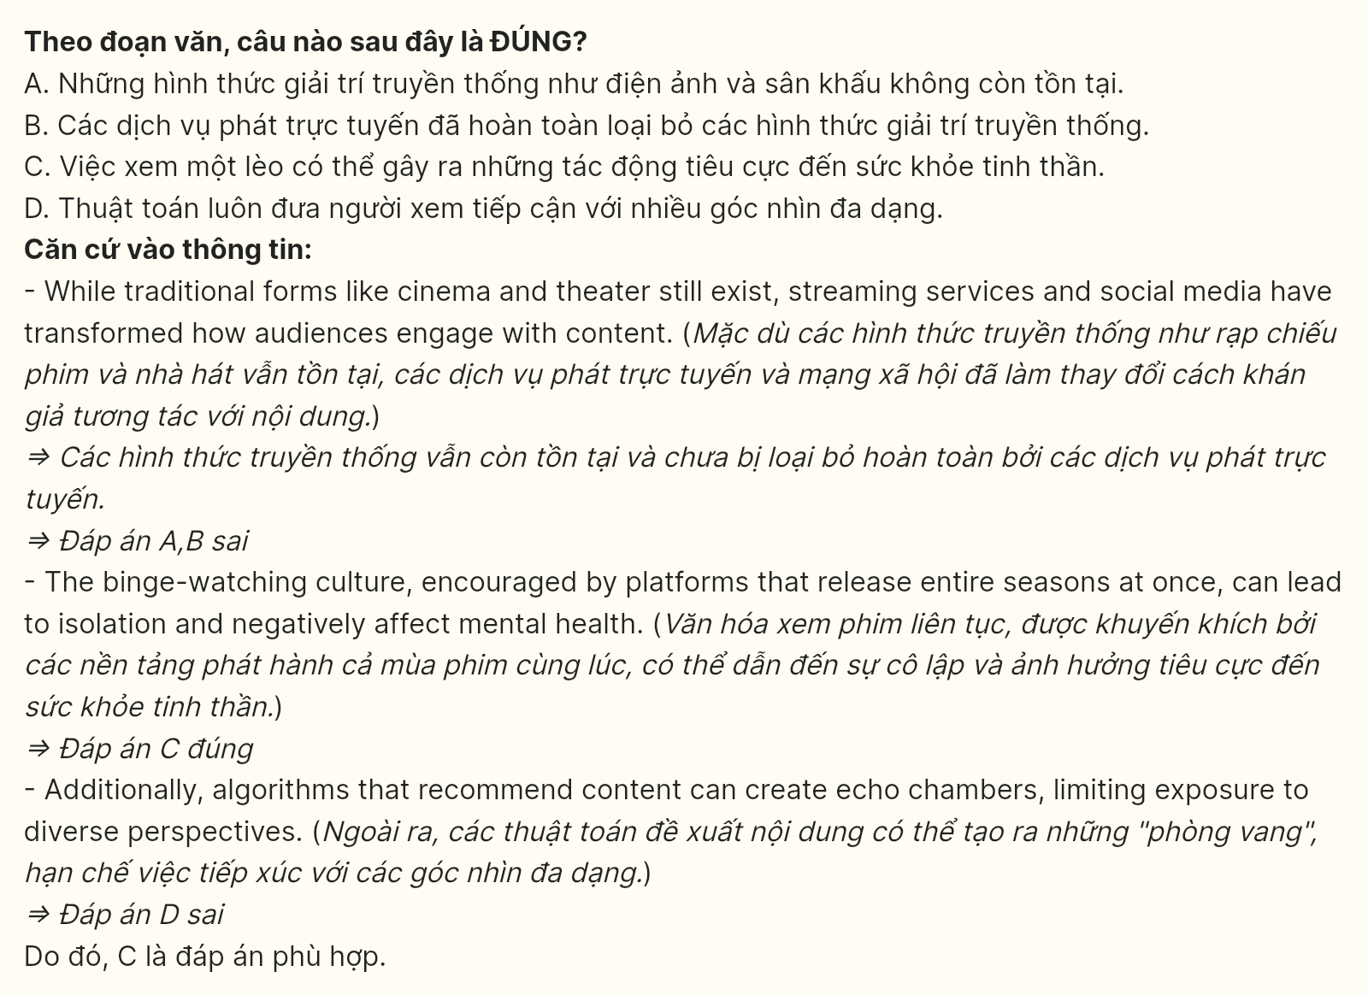
Question 29 [697635]: In which paragraph does the writer mention a contrastive relationship?
A. Paragraph 1 B. Paragraph 2 C. Paragraph 3 D. Paragraph 4
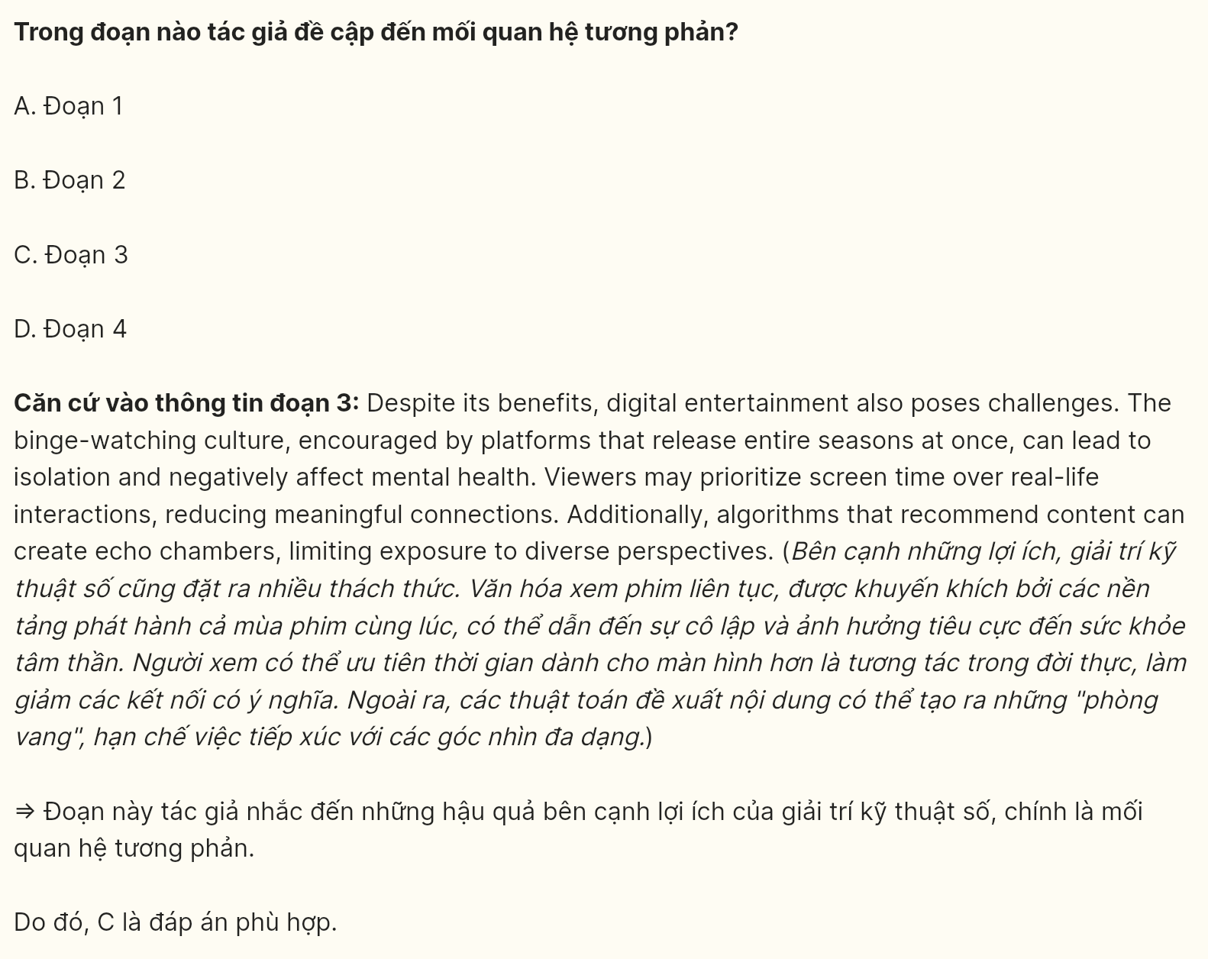
Question 30 [697636]: In which paragraph does the writer explore the future potential of technology in entertainment?
A. Paragraph 1 B. Paragraph 2 C. Paragraph 3 D. Paragraph 4

Read the following passage and mark the letter A, B, C or D on your answer sheet to indicate the correct answer to each question from 31 to 40.

Green living is a way of life that aims to balance the preservation and protection of the earth’s natural resources, habitats, and biodiversity with human civilization and community in as many ways as possible. In simple terms, living green and sustainably means developing a lifestyle that works with nature rather than against it and does no long-term or irreparable harm to any element of the ecological system.
With the growing threat of global warming, individuals and businesses, particularly in the hotel and hospitality industry, are shifting to a more eco-conscious way of conducting business. Many hotels and co-living complexes have chosen to give visitors more sustainable and greener rooms as demand for eco-friendly living has increased.
London is one such city that has made a name for itself in decreasing carbon emissions and fostering a greener way of life. It has several boutique hotels and staycations that combine luxury accommodations with more ecologically sustainable living options.
Many green hotels implement water-saving tactics like low-flow faucets and toilets alongside water recycling systems that align with their sustainability goals. They also bank on renewable energy sources to reduce their carbon footprint while catering to guests without compromising comfort. When planning a local sightseeing, it’s common for guests to contact the hotel and ask for renting vehicles. However, eco-sustainable hotels encourage guests to walk, cycle, or take public transport to reduce carbon emissions.
[I] Travelling is a breather from our daily routine. [II] However, if you like keeping things safe, especially when travelling to unknown countries, planning your trip with an eco-tour operator is best. In line with the growing demand for sustainability, tour operators are offering environmentally friendly travel experiences. [III] At the same time, they are collaboratively active with green companies and offering reusable items to all travellers to eliminate the usage of single-use plastics. Most tour operators advocate rail travel compared to flights to limit CO2 emissions. [IV]
(Adapted from https://www.greenlivingblog.org.uk/what-is-green-living/)
Question 31 [697637]: The word "it" in paragraph 1 refers to ________.
A. the preservation and protection B. nature
C. lifestyle D. living green and sustainably
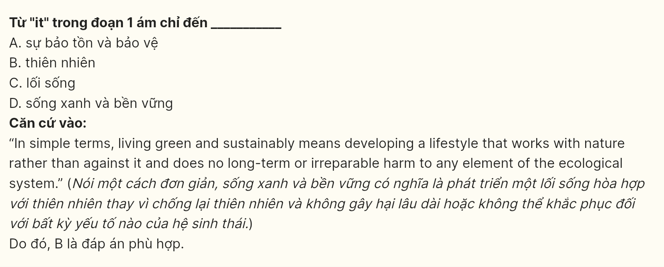
Question 32 [697638]: The word "irreparable" in paragraph 1 is OPPOSITE in meaning to ________.
A. impossible B. impractical C. restorable D. damaged
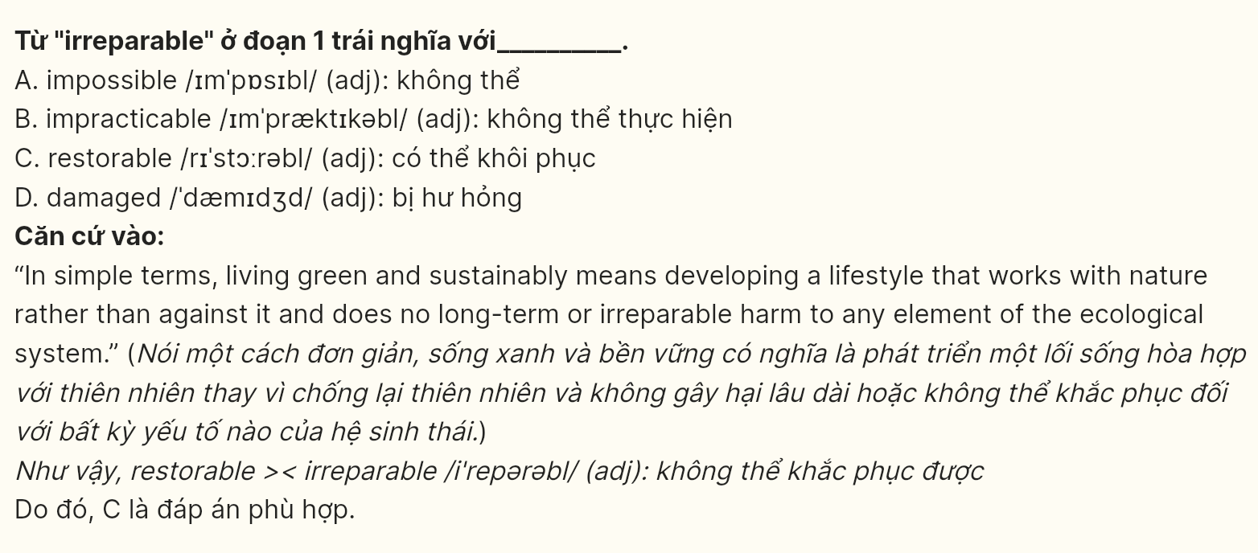
Question 33 [697639]: Which of the following best paraphrases the underlined sentence in paragraph 2?
A. Several hotels and co-living complexes provide visitors with traditional rooms instead of sustainable options because of low demand.
B. Hotels and co-living complexes have reduced the number of sustainable rooms available to visitors due to a decline in demand for eco-friendly living.
C. A growing interest in eco-friendly living has led numerous hotels and shared living spaces to offer their guests more environmentally sustainable accommodations.
D. As the interest in eco-friendly living has decreased, hotels and co-living complexes have opted to offer less sustainable rooms.
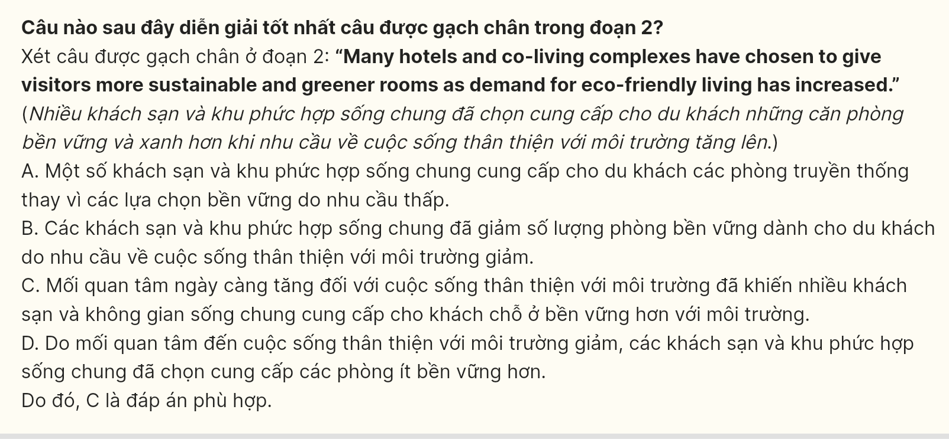
Question 34 [697640]: The phrase "bank on" in paragraph 4 could be best replaced by ________.
A. concentrate on B. involve in C. depend on D. benefit from
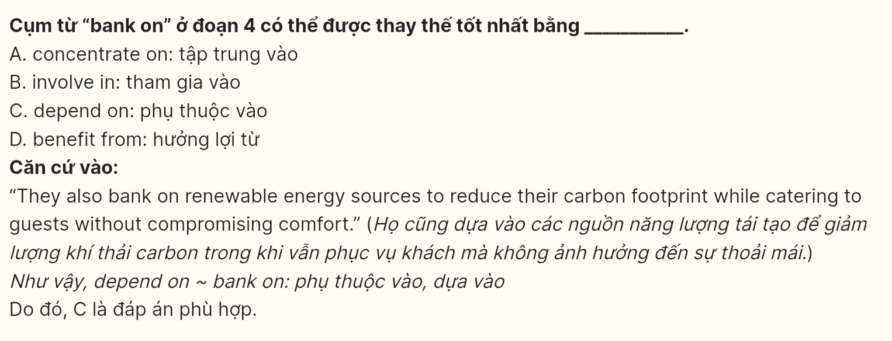
Question 35 [697641]: According to the passage, how do eco-sustainable hotels encourage guests to reduce carbon emissions when sightseeing?
A. By offering free taxi services
B. By encouraging walking, cycling or taking public transport
C. By providing rental cars
D. By recommending helicopter tours
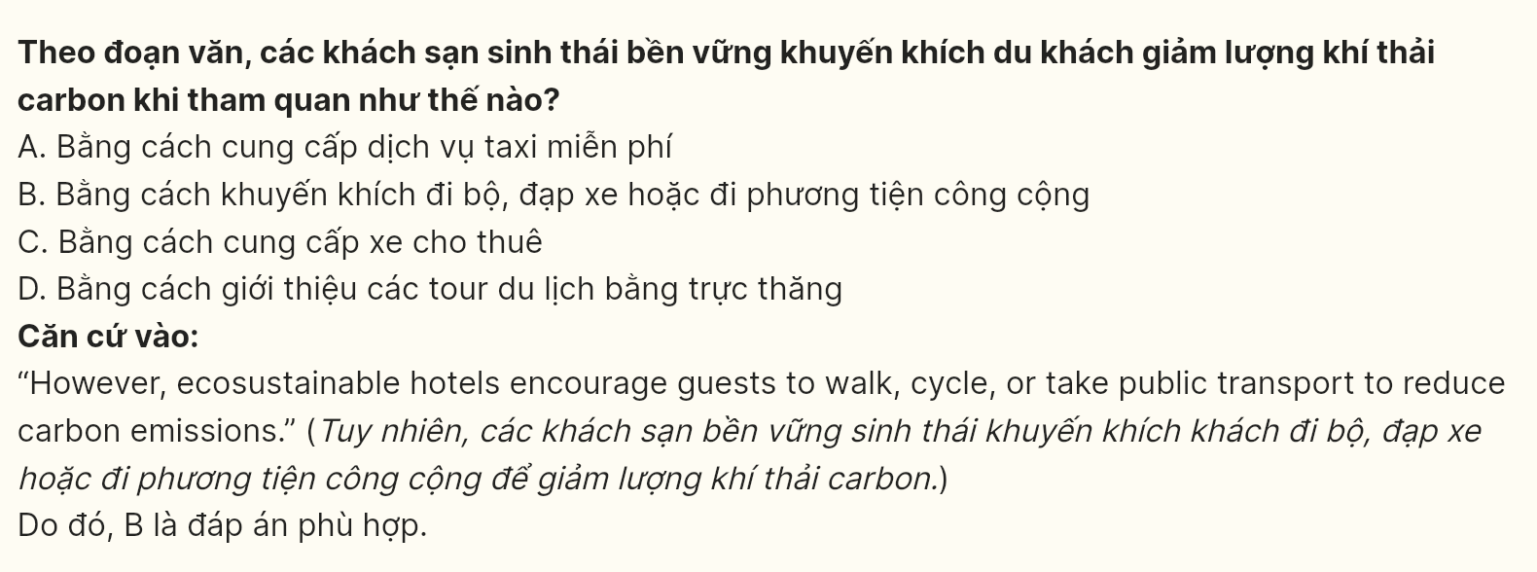
Question 36 [697642]: Which of the following best summarizes paragraph 4?
A. Green hotels only focus on providing luxurious accommodations and amenities to their guests.
B. Green hotels implement water-saving and renewable energy technologies while encouraging guests to use eco-friendly transportation options.
C. Green hotels require guests to participate in sustainability programs during their stay.
D. Green hotels ban the use of all forms of motorized vehicles for sightseeing.
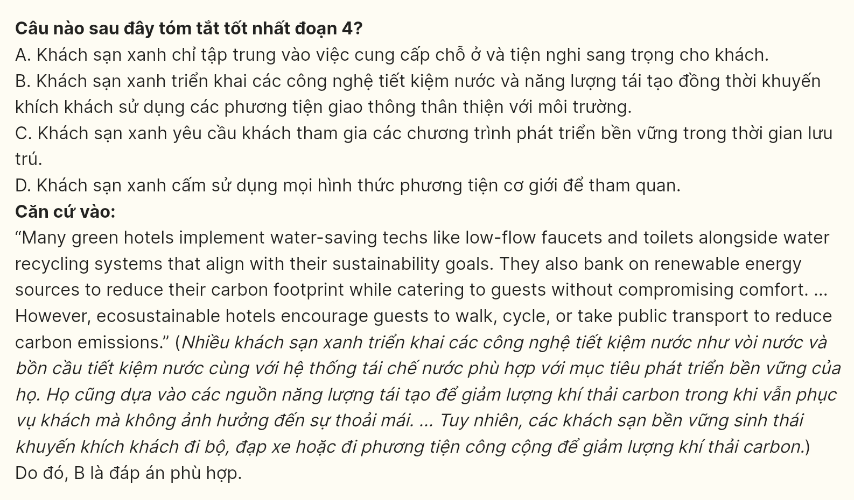
Question 37 [697643]: Where in paragraph 5 does the following sentence best fit?
It offers us a chance to experience the wonders of nature, learn about new cultures, and marvel at new experiences.
A. [I] B. [II] C. [III] D. [IV]

Question 38 [697644]: Which of the following is NOT TRUE, according to the passage?
A. London is recognized for its initiatives aimed at reducing carbon emissions and encouraging sustainable living practices.
B. Green living primarily focuses on promoting industrial growth over environmental conservation.
C. Most tour operators prefer rail travel over flights to reduce carbon dioxide emissions.
D. Many eco-friendly hotels use technologies that conserve water and implement systems for recycling water.
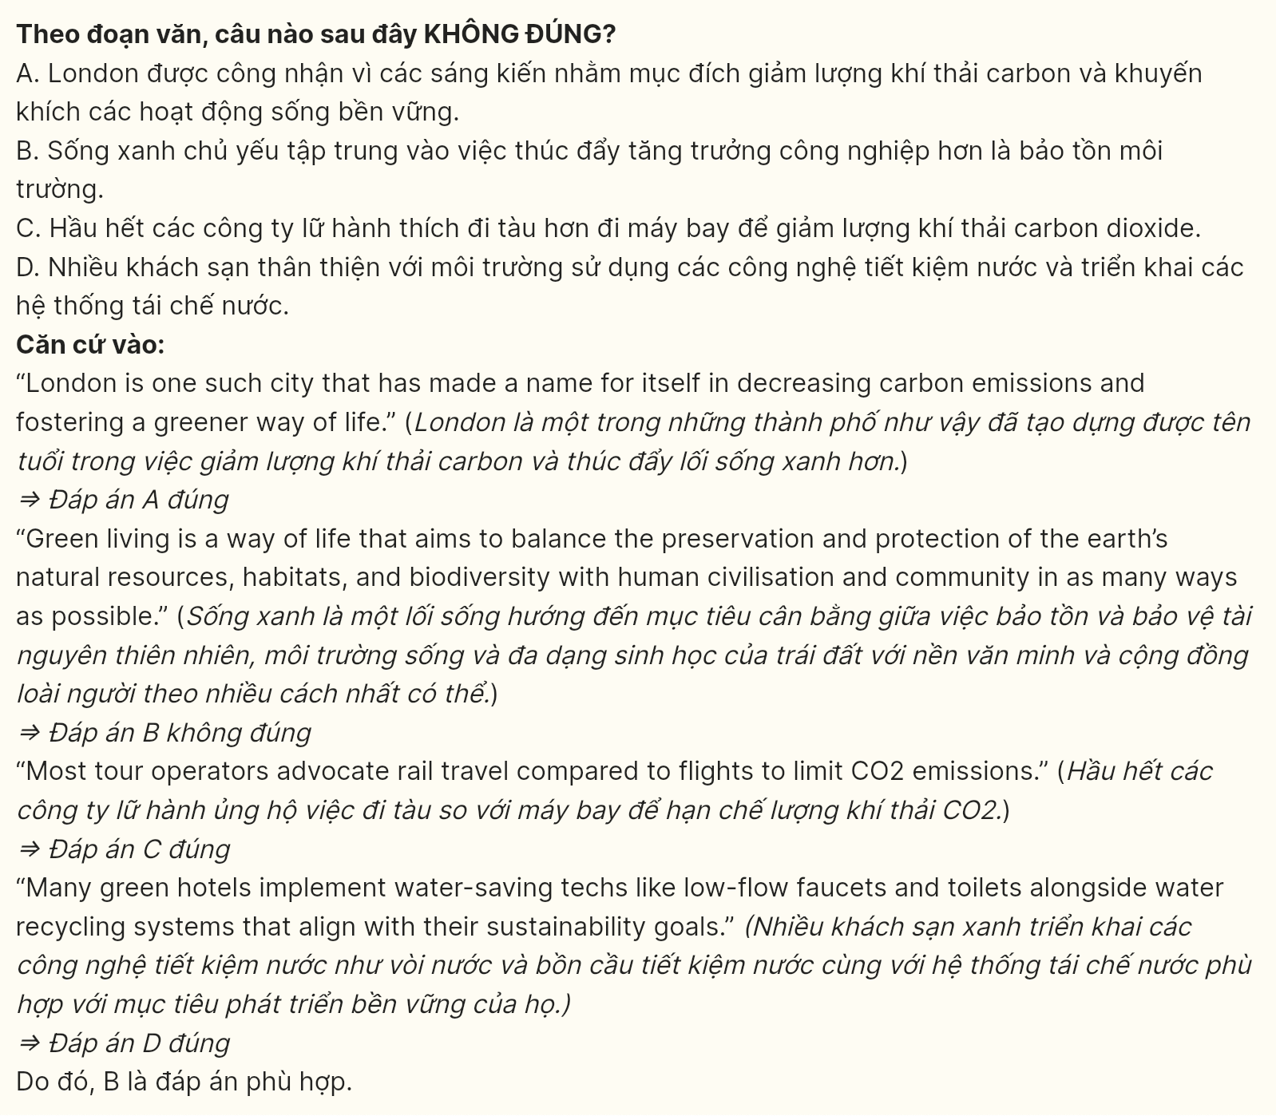
Question 39 [697645]: Which of the following can be inferred from the passage?
A. Eco-friendly hotels prioritize luxury over ecological responsibility.
B. There is an increasing focus on sustainable tourism from both travelers and tour companies.
C. Every hotel in London adopts environmentally sustainable practices.
D. Tour operators promote the use of single-use plastics.
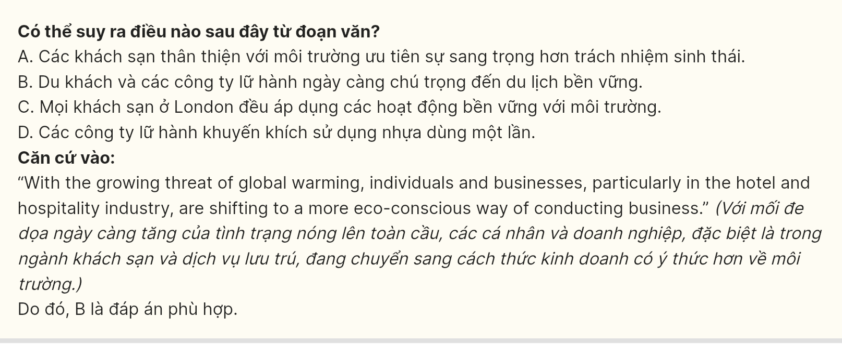
Question 40 [697646]: Which of the following best summarizes the passage?
A. Many hotels are now offering luxurious accommodations while ignoring environmental concerns, leading to increased carbon emissions and unsustainable travel practices.
B. Eco-tour operators are unnecessary for sustainable travel, as most travelers can plan their trips independently without considering their environmental impact.
C. Green living promotes sustainable lifestyles, with the hospitality industry increasingly adopting eco-friendly practices in response to global warming.
D. The shift toward green living in the hospitality sector has minimal impact, as most tourists continue to prioritize comfort over sustainability during their travels.
