|  |  |
| --- | --- |
| **Tiếng Anh 8 Friends Plus** | **FP 8 – UNIT 7 - TEST 1**  **Test for Unit**  *Thời gian làm bài: 40 phút (Không kể thời gian giao đề)*  *-------------------------* |

**I. Pronunciation**

**Question 1.** Which word has the underlined part pronounced differently from that of the others?

**A.** protest  **B.** chose  **C.** now  **D.** propose

**Question 2.** Which word has the underlined part pronounced differently from that of the others?

**A.** land  **B.** game  **C.** change  **D.** fate

**Question 3.** Which word has a different stress pattern from that of the others?

**A.** signature  **B.** volunteer  **C.** animal  **D.** benefit

**Question 4.** Which word has a different stress pattern from that of the others?

**A.** donate  **B.** campaign  **C.** protest  **D.** behave

**II. Choose the answer (A, B, C or D) that best fits the space in each question.**

**Question 5.** Many people have gathered **______** to force the company to stop releasing waste into the river.

**A.** signatures  **B.** accounts

**C.** names  **D.** nicknames

**Question 6.** They have urged people to **_________** products which do harm to the wildlife.

**A.** assist  **B.** help  **C.** support  **D.** boycott

**Question 7.** He said, “I’m very busy today.”

He said that ______________.

**A.** he was very busy that day  **B.** he is very busy today

**C.** he had been very busy that day  **D.** I’m very busy today

**Question 8.** How do your organization help the community? – “………”

**A.** Our friends really enjoy these activities.

**B.** We give food and clothes to the poor every week.

**C.** I think helping others is our responsibility.

**D.** People trust our work for the community.

**Question 9.** This campaign **______** to protect the environment.

**A.** want  **B.** avoids  **C.** aims  **D.** misses

**Question 10.** Someone invented a machine providing free rice for the poor during the COVID 19 **_____**.

**A.** shelter  **B.** lockdown  **C.** stay  **D.** ending

**Question 11.** We joined a charity to **_________** the poor people in our neighborhood last week.

**A.** support  **B.** miss  **C.** ignore  **D.** neglect

**Question 12.** Personally, I think mobile phones should be banned in classroom. – “……”

**A.** That's exactly how I feel.

**B.** I don’t think mobile phones are expensive.

**C.** Maybe another time.

**D.** What is it about?

**Question 13.** Despite **__________** from the locals, the construction will proceed.

**A.** requires  **B.** usages  **C.** protests  **D.** needs

**Question 14.** “You’ll have to make up your mind soon.”, she said to me.

She told me I _____ make up my mind soon.

**A.** would have to  **B.** had to

**C.** could have to  **D.** will have had to

**III. Look at the signs. Choose the best answer (A, B, C or D).**

**Question 15.**

What does this sign mean?

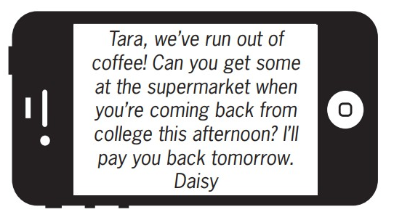

**A.** Daisy wants Tara to buy some coffee this afternoon.

**B.** Tara will go to the supermarket tomorrow.

**C.** Daisy will buy coffee tomorrow when she returns home.

**D.** Tara should give Daisy some money to buy coffee.

**Question 16.**

What does this sign mean?

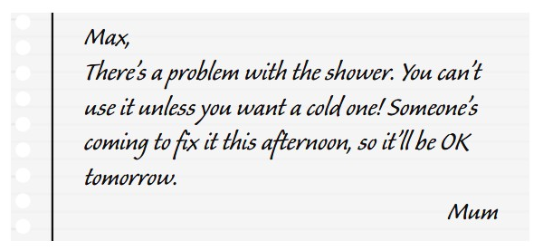

**A.** Max can take a hot shower now.  **B.** Max can only have hot shower tomorrow.

**C.** Someone helped Max fix the shower.  **D.** Mum needs Max to fix the shower.

**IV. Read the following passage. Decide if the statements from 17 to 20 are True or False, and choose the correct answers (A, B, C or D) for questions 21 and 22.**

Forests and trees are the lungs of our planet. They take in carbon dioxide, clean the water, and give millions of animals a place to live.

Cutting down trees is very bad for our forests. Climate change is caused by cutting down trees, which in turn causes more trees to be cut down. Biodiversity, which is the variety of life forms in an ecosystem, is also lost when trees are cut down. Biodiversity helps ecosystems work well and gives people and other animals food and plants that clean the air we breathe.

People who live near such areas or work in the forest which is cut down can get breathing problems. Deforestation can also send a lot of soil into rivers, which can contaminate them with pesticides and other chemicals used to grow crops on top of fields. When trees are cut down, they release carbon dioxide into the air, which contributes to global warming. In fact, deforestation is responsible for about 8% of all greenhouse gas emissions around the world every year, which is more than all forms of transportation put together.

**Question 17.** Our planet’s lungs are forests and trees.

**A.** False  **B.** True

**Question 18.** Cutting down trees does no harm to the environment.

**A.** True  **B.** False

**Question 19.** Forests and trees are home to a few animals.

**A.** True  **B.** False

**Question 20.** The $CO_{2}$ emitted when cutting down trees is much more than all forms of transportation put together.

**A.** True  **B.** False

**Question 21.** What is the main idea of the passage?

**A.** Save the animals from extinction.  **B.** Save the forests and trees.

**C.** Greenhouse effect.  **D.** Global warming

**Question 22.** Which is not mentioned as a bad result of cutting trees in the passage?

**A.** Sea pollution.  **B.** Emission of $CO_{2}$.

**C.** The loss biodiversity.  **D.** Breathing problems.

**V. Choose the word (A, B, C or D) that best fits the blank space in the following passage.**

Students can help protect the environment in many ____23___**.** Recycling is one of them. ____24___ keeps natural resources from being overused to make things that can be made over and over again without using up any more of the materials. People who don't have jobs or can't afford to buy new things all the time can save money by buying ____25___ items. When someone doesn't want to buy something brand new, they will sell their old stuff on Facebook Marketplace or Craigslist for money. They will then buy something brand new with the money they made from selling their old stuff instead of the original price they paid.

Students can also cut down waste by reusing items ____26___ buying brand-new ones they will only use once. For example, they don't have to buy a new pencil case every year; they can use the one they already have. Students can just keep using an old one until it gets ____27___ out, then they can buy a new one. Students can also help reduce waste by bringing their own bags to the grocery store. This will cut down on the number of plastic bags that companies have to make every day. Plastic is extremely difficult to ____28___ and will pollute the environment. Thus, protecting the environment is not difficult if we work together.

**Question 23.**

**A.** practices  **B.** examples

**C.** ways  **D.** directions

**Question 24.**

**A.** Littering  **B.** Wasting  **C.** Recycling  **D.** Polluting

**Question 25.**

**A.** latest  **B.** damaged  **C.** used  **D.** new

**Question 26.**

**A.** instead of  **B.** despite

**C.** in spite of  **D.** as

**Question 27.**

**A.** to wear  **B.** wearing  **C.** worn  **D.** wear

**Question 28.**

**A.** show up  **B.** appear  **C.** dim  **D.** dissolve

**VI. Supply the correct form of the word given in each sentence.**

**Question 29.** The majority of people ________ the internet via their phones. (accessible)

**Question 30.** He is such a kind and ________ man. (generosity)

**Question 31.** There is some evidence that honey can prevent the ________ of bacteria. (grow)

**Question 32.** Gentle exercise can be ________ for older people. (benefit)

**Question 33.** Now I'm heading to his office to ________ the paperwork. (signature)

**Question 34.** The dentist said that his tooth ________ filling. (necessary)

**VII. Rearrange the groups of words in a correct order to make complete sentences.**

**Question 35.** poor students. /money for her / was raising some/ She told/ me that she

She told ___________________________________________________________

**Question 36.** a volunteer?/have to work/in the evening/if I became/Would I

Would I ___________________________________________________________

**VIII. Rewrite each of the following sentences in another way so that it means almost the same as the sentence printed before it.**

**Question 37.** Liz is a generous person. Everyone loves her so much.

Lis is such ____________________________________________________

**Question 38.** My teacher told me, “You have to study harder for this semester.”

My teacher told ____________________________________________________

**Question 39.** Tim is the best programmer is this company.

No one ____________________________________________________

**Question 40.** I advise you to buy that book because it is the best seller.

If I ____________________________________________________

**IX. Listen and fill in the blanks with one word/ number. Then listen again and choose the best answer.**

**Question 41.** The author wouldn’t ____________ to have an office job.

**Question 42.** His dream is to become a _________ player.

**Question 43.** The first thing he must do is to get a _________.

**Question 44.** He is playing for his _____________ team.

**Question 45.** He might play for a professional team if he does ________.

**Question 46.** He wants to start his own business.

**A.** True  **B.** False

**Question 47.** He thinks becoming a professional player is easy.

**A.** True  **B.** False

**Question 48.** His coach thinks he is good enough to play in regional team.

**A.** False  **B.** True

**Question 49.** He will miss his family when travelling around the country.

**A.** False  **B.** True

**Question 50.** He doesn’t think he will play for his country.

**A.** True  **B.** False

**----HẾT---**