Mã đề 7.1.2 | Đ ÁP ÁN KIỂM TRA GIỮA KÌ I.  Môn : ANH VĂN 7  Thời gian làm bài: 60 phút.  (Đề này gồm 04 phần 04 trang)

SECTION 1. LISTENING
I. There are 5 questions in this part, for each question there are 3 pictures and a short recording.Choose the correct picture. Type in CAPITAL LETTERS A, B or C in the answer box. (1 points )
1 | Where will the friends meet? | 2 | What has the girl forgotten to bring?
 | 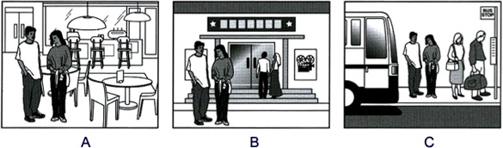 |  | 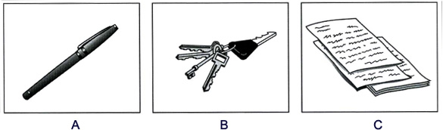
3 | Which TV programme is on at 9 o'clock tonight? | 4 | Which calendar will the boy buy?
 | 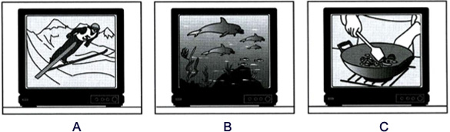 |  | 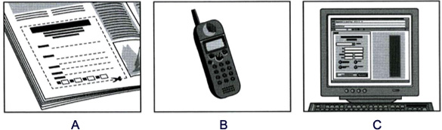
5 | What will the man do this winter?
 | 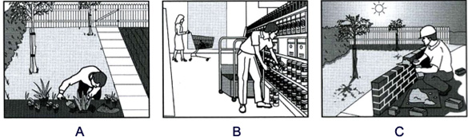
II-Listen to the conversation and do this exercise while you listen. Complete the form. (1 point )
AT THE LIBRARY-GIVING PERSONAL INFORMATION.
6. Lucy’s surname is:…………..
7. She’s in class:……………..
8. Lucy is:……………
9. The librarian asks for Lucy’s:………………
10. The school librarian gives Lucy a school :………..

SECTION 2. LANGUAGE (2 points)
I. Odd one out
11.A. supported B. approached C. noticed D. finished
12.A. arrange B. arise C. area D. arrive
II. Choose the correct option.
13. We help families in ________ by providing food, clothing, housing and much more.
A. control B. case C. need D. shape
14. Nam is interested in___________ experiments in his free time.
A. do B. does C. to do D. doing
15. _________ people usually live on the streets, under bridges, or in camps.
A. Sick B. Homeless C. Elderly D. Disabled
16.What time_____your classes start ? – At seven o’clock.
A. does B. did C. do D. was
17.My family enjoys __________ because we can sell vegetables and flowers _________ money.
A. garden – toB. gardening – for C. garden – of D. gardening – by
18. “-----------------” - “ He’s Ok now.”
A. What does he look like? B. How is he? C.How tall is he?
19.We _______ David in town a few days ago.
A. did see B. was saw C. did saw D. saw
20. “ May I borrow your pen for a minute, please?” – “-------------”
A. Yes, certainly. B. Yes, thank you. C. No, thanks D.Yes, you may
SECTION 3: READING (3 points )
I. Choose the best answer A, B, C to fill blank in the following pasage (1.5 points)
Hobbies are activites for entertainment. Hobby can cost you almost nothing. Music is the most popular. For example, many people play the guitar for……(1)in their free time . Sports provide other(2)….. hobbies. Cycling , running, tennis, table tennis are the sports that millions of people play dring their free time.
Some people’s coin collections are wonderful. There are still hundreds of (3)…. collections,such as bottle collections , seashell collections, butterfly collectionsand so on.
For some people , a hobby is favorite (4)…….. , like chess. In chess, we need two or more people(5)……….
1. A.fun B. funny C. funnier
2. A. strange B. normal C. favorite
3. A. another B. other C. others
4. A.game B. exercise C. Sports
5. A.play B. to play C. to playing
II. Read the passage and choose the correct answer for each question (1,5 points)
Everyone suffers from the common cold at some time or other. It isn’t a serious illness, but people spend a lot of money on medicine. The medicine can only relieve the symptoms. That is, it can make you cough less, make you feel better, and stop your nose running for a while. So far, there is no cure for the common cold and no medicine to prevent it. People also drink a lot of hot water with sugar, lemon juice. It helps provide with a lot of vitamin C.
1.Is the common cold very popular?
A. Yes, it is B. Yes, it does C. No, it isn’t D. both A & B
2. Is the common cold a serious illness?
A. Yes, it is B. Yes, it does C. No, it isn’t D. both A & B

3. What does the medicine help people with the common cold?
A. coughing less B. feeling better C. stopping your nose running D. All A, B& C

4. Beside medicine, what do people do to make them feel better?
A. drink a lot of warter B. drink a lot of sugar C. drink a lot of lemon juice D. All A, B,C
5. Why is it useful?
A. provide vitamin C B. provide vitamin D C. provide vitamin E D. All A,B,C

SECTION D: WRITING (3 points )
I. Find out the mistake in each following sentence. (0.6 points)
1. I find carve eggshells boring because it takes a lot of time to complete one shell.
A B C D
2. My brother not goes to class to learn how to paint.
A B C D
II. Rewrite the following sentences as directed ( using the suggested words) so that the meanings stay the same. (0.9 points )
1. They started to swim five years ago.
They have…………………………………………five years.
2. My form teacher began teaching math in 2001.
My form teacher……………………………………. .2001.
3. I find arranging flowers wonderful.
My hobby ………………………………………………
III. Write a short paragraph ( about 50- 60 words) about your favorite
hobbies . (1.5 points )
Focus on
1. What is the name of hobby?
2. When did you start/ take up?
3. what do you need to start your hobby?
4. who did you share hobby with?
5. Do you continue the hobby in the future or stop?
………………………The end…………………………

Mã đề 7.1.2 | Đ ÁP ÁN KIỂM TRA GIỮA KÌ I.  Môn : ANH VĂN 7  Thời gian làm bài: 60 phút.  (Đề này gồm 04 phần 04 trang)

Parts | Keys | Marks
- LISTENING  (2 points ) | - (1point)  1.A 2.A 3.C 4.B 5 .A | 0,2 point for each
 | - (1 point)  6.M-O-Ỏ-R-E 7.1B 8. 13  9. PHOTO 10.CARD | 0,2 point for each
- VOCABULARY – GRAMMAR – LANGUAGE FUNCTION  (2 points) | - (2 points)  11. C 12.C 13.B 14.D 15.B  16.C 17.B 18.B 9.D 20.A | 0,2 point for each
- READING  (3,0 points) | - (1,5 points)  21.B 2 2.C 23.B 2 4.A 2 5.B | 0,3 point for each
 | - (1,5 points)  26.A 27.C 28.D 29.D 30.A | 0,3 point for each
- WRITING  ( 3,0 points) | - (0,6 points)  1 A  2 A  II. (0,9 points)  1.They have swum for five years.  2. My form teacher has teached math since 2001.  3. My hobby is arranging flowers. | 0,3 point for each
 | - (1,5 points)  1. Organization: 0,5 points  + correct form of a passage  + well-organized, easy to follow  2. Content: 0,5 points  + cover the task successfully  + include relevant supporting ideas  3. Language: 0,5 points  + appropriate vocabulary  + correct grammar  + punctuation / spelling  Suggestion  My favorite hobby is reading books. I started my hobby four years ago, when my mother gave me a book on my birthday. Its title iss “ The friendship”. The boook is very interesting and meaningfull. Since then, I have been keen on reading so much. I usually share my hobby with my sister because she loves it , too . For me, reading books needs time and patience . I find reading books usefull because it can help me widen my knowledge and learn many things. In the future i will continue hobby because it helps me a lot of real life. | 0,5 points

