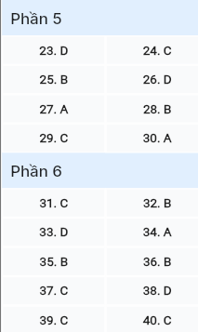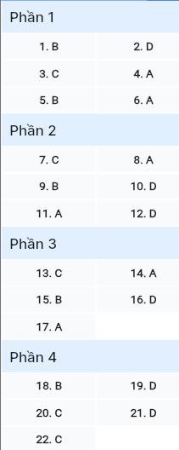**ĐỀ MINH HỌA SỐ 02**  
**KỲ THI TỐT NGHIỆP TRUNG HỌC PHỔ THÔNG NĂM 2025**  
(Đề thi có 08 trang)  
**Môn thi: TIẾNG ANH**  
**Thời gian làm bài: 50 phút, không kể thời gian phát đề**

**Read the following advertisement and mark the letter A, B, C or D on your answer sheet to indicate the option that best fits each of the numbered blanks from 1 to 6.**



**JOB ADVERTISEMENT: OFFICE ASSISTANT!**

We are searching for a dedicated and (1) ______ office assistant to join our team. You will have the opportunity to grow and learn in a(n) (2) ______ where your ideas and contributions will be valued. The candidate (3) ______ in a fast-paced setting will assist with scheduling, answering calls, and client support. You will also have some downtime, so you can even (4) ______ a nap during longer breaks! To apply, simply fill in an application form and send it (5) ______ our HR department. We offer a great work-life balance and a chance to grow with our team. Don’t hesitate (6) ______ and join our dynamic company culture!

**📧 Contact Us:** Email your application to hr@company.com or call us at (415) 987-6543 for more information.

**Question 1 (696614):** A. energy B. energetic C. energetically D. energize

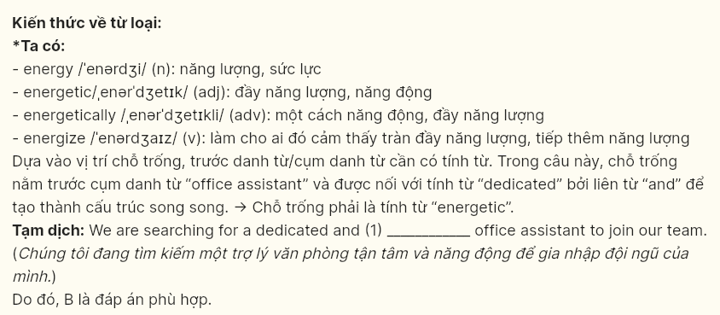

**Question 2 (696615):** A. environment office vibrant B. office vibrant environment

C. vibrant environment office D. vibrant office environment

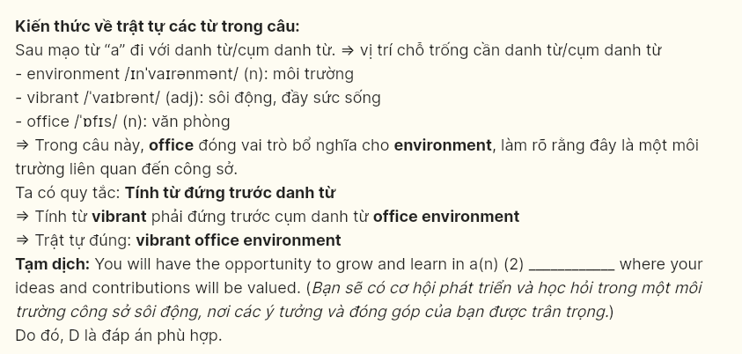

**Question 3 (696616):** A. who thrive B. is thriving C. thriving D. thrive



**Question 4 (696617):** A. take B. do C. keep D. make



**Question 5 (696618):** A. for B. to C. from D. on



**Question 6 (696619):** A. to apply B. apply C. to applying D. applying



**Read the following leaflet and mark the letter A, B, C or D on your answer sheet to indicate the option that best fits each of the numbered blanks from 7 to 12.**

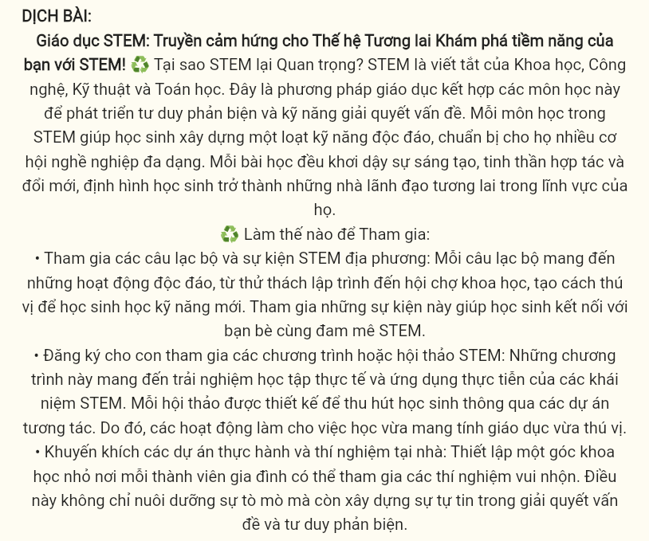

**STEM Education: Inspiring the Next Generation**  
**Unlock your potential with STEM!**

**💡 Why is STEM Important?**

STEM (7) ______ Science, Technology, Engineering and Mathematics. It’s an educational approach that combines these subjects to foster critical thinking and problem-solving skills. Each subject in STEM helps students build up a unique set of abilities, preparing them for a wide (8) ______ of careers.

Every lesson inspires creativity, collaboration, and innovation, shaping students into future leaders in their fields.

**How to Get Involved:**

* **Join local STEM clubs and events:** Each club offers unique activities, from coding challenges to science fairs, providing a fun way for students to learn new skills. Participating in these events helps students connect with peers who share similar (9) ______ in STEM.
* **Enroll your child in STEM programs or workshops:** These programs offer hands-on learning experiences and real-world (10) ______ of STEM concepts. Each workshop is designed to engage students with interactive projects. (11) ______, the activities make learning both educational and enjoyable.
* **Encourage hands-on projects and experiments at home:** Set up a small science corner where each family member can participate in fun experiments. This not only (12) ______ curiosity but also builds confidence in problem-solving and critical thinking.

**Question 7 (696620):** A. stands up B. asks for C. stands for D. writes down



**Question 8 (696621):** A. range B. amount C. deal D. number



**Question 9 (696622):** A. passions B. interests C. desires D. attractions

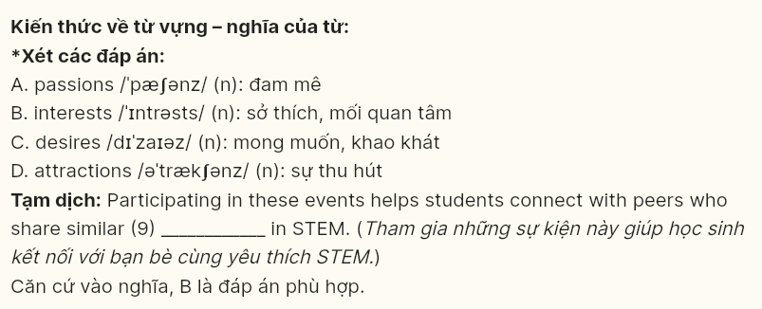

**Question 10 (696623):** A. contributions B. competitions C. attentions D. applications

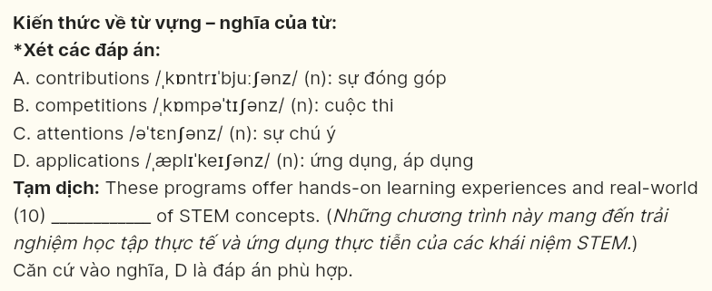

**Question 11 (696624):** A. Accordingly B. Eventually C. Alternatively D. Similarly



**Question 12 (696625):** A. hinders B. cherishes C. sustains D. nurtures

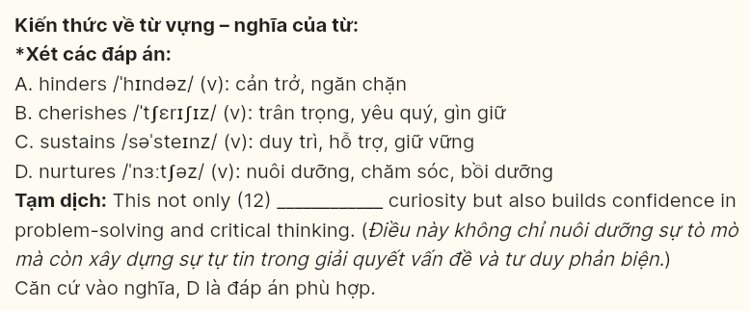

***Mark the letter A, B, C or D on your answer sheet to indicate the best arrangement of utterances or sentences to make a meaningful exchange or text in each of the following questions from 13 to 17.***

**Question 13 (696626):**  
a. Sarah: I’m planning to start my own business one day. I’ve always wanted to be an entrepreneur.  
b. Sarah: I’m interested in opening a coffee shop with a unique concept. I’ve already started researching it.  
c. Alex: That’s a great idea! What kind of business are you thinking about?

A. c-a-b B. b-c-a C. a-c-b D. a-b-c



**Question 14 (696627):**  
a. Tom: I’m glad you brought it up. I’ve been feeling that way too, but I wasn’t sure how to say it.  
b. Linda: I agree. Let’s plan something special this weekend, just the two of us.  
c. Linda: Do you think we’ve been spending enough time together? I know we’ve both been really busy.  
d. Linda: I’ve been feeling like something’s off between us lately. Is it just me?  
e. Tom: Not really. I think we need to make more time for each other. Maybe we’re both taking each other for granted.

A. d-a-c-e-b B. d-e-b-a-c C. c-a-b-e-d D. c-e-d-a-b



**Question 15 [696628]:**

**Dear Mr. Smith,**

a. Could you please review the updated report and let me know if anything else needs to be addressed?  
b. I didn’t realize the error until it was sent, and I understand that it may have caused confusion during the meeting.  
c. Please rest assured that I will double-check my work more carefully moving forward to prevent such mistakes.  
d. I am writing to apologize for the mistake I made in the report I submitted last week.  
e. I take full responsibility for the oversight, and I have already revised the document to ensure that all the data is correct.

Sincerely,  
David

A. a-c-e-d-b B. d-b-e-c-a C. c-e-a-b-d D. e-c-b-a-d

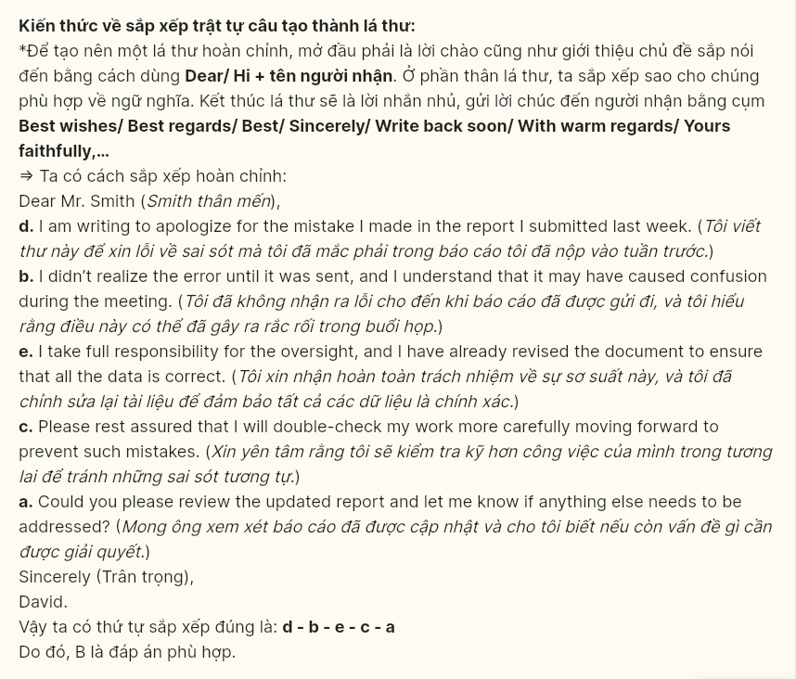

**Question 16 [696629]:**

a. It was eye-opening to see firsthand how small actions can contribute to preserving natural habitats.  
b. One of the most impactful moments was witnessing the release of rehabilitated animals back into the wild, knowing that our efforts played a role in their recovery.  
c. My experience with conservation started when I volunteered for a local wildlife protection project.  
d. To sum up, it was a rewarding experience that deepened my appreciation for nature.  
e. I was able to participate in various activities, from planting trees to helping monitor endangered species.

A. a-e-b-c-d B. b-c-e-a-d C. e-b-c-a-d D. c-e-a-b-d

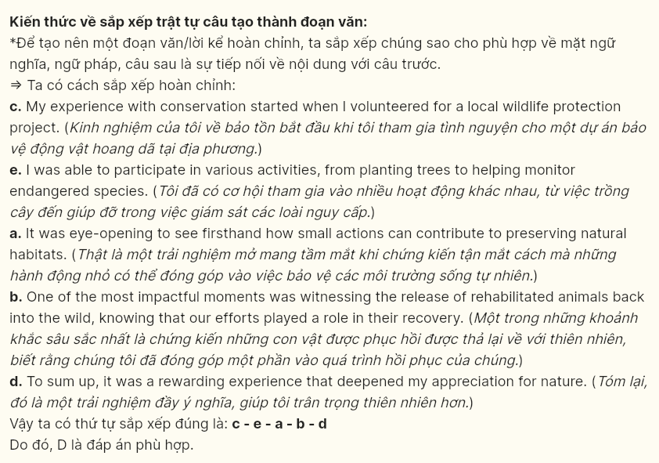

**Question 17 [696630]:**

a. With the development of new treatments and technologies, diseases that were once incurable can now be managed or even eradicated.  
b. Furthermore, innovations like telemedicine have made healthcare more accessible, allowing patients to consult with doctors remotely, especially in rural areas.  
c. For instance, the discovery of antibiotics revolutionized the treatment of infections, saving millions of lives.  
d. These changes have not only increased life expectancy but also enhanced the quality of life for many individuals.  
e. The advancements in medicine have dramatically improved healthcare over the years.

A. e-a-c-b-d B. e-b-a-d-c C. e-d-a-c-b D. e-c-d-b-a

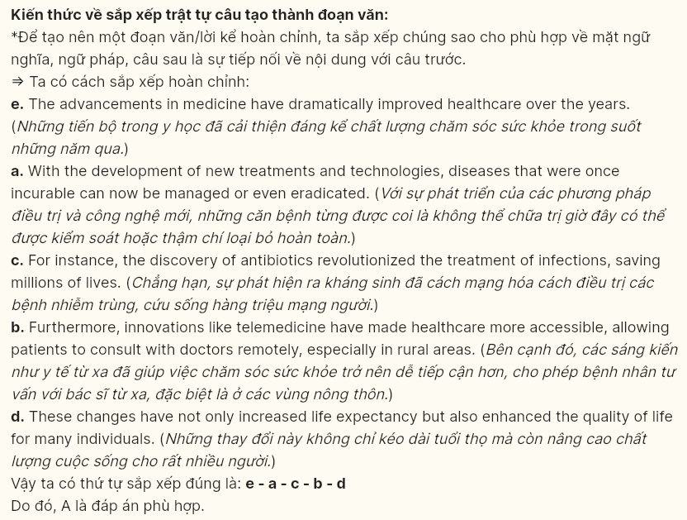

***Read the following passage about humanoid robots and mark the letter A, B, C, or D on your answer sheet to indicate the option that best fits each of the numbered blanks from 18 to 22.***

**

**Pokemon Go**, a popular augmented reality game, (18) ______. It allows players to catch virtual creatures, called Pokemon, in real-world locations using their smartphones. With its unique concept and interactive features, Pokemon Go has transformed mobile gaming. Even years after its release, it remains a widely played game around the world.

The game uses a map-based system where players can find and catch different Pokemon. These creatures are part of the well-known Pokemon franchise (19) ______. Players must walk around to encounter Pokemon, promoting physical activity. Pokemon Go has had a significant impact on both the gaming and fitness communities.

One of the main features of the game is its social aspect. (20) ______. This sense of community has helped maintain the game’s popularity, as players can interact with each other. (21) ______. By working together, they can achieve goals that would be difficult to accomplish alone.

(22) ______, the game brought several improvements. One of the key updates was the addition of remote raids, which allowed players to join group events from their homes. These changes kept the game engaging for both new and experienced players. As a result, Pokemon Go has maintained its popularity and continues to make an impact on the gaming world.

**Question 18 [696631]:**

A. which was officially launched to the public in July 2016  
B. was officially launched to the public in July 2016  
C. of which the app was officially launched to the public in July 2016  
D. having been officially launched to the public in July 2016



**Question 19 [696632]:**

A. from which the attention of millions of fans worldwide  
B. has captured the attention of millions of fans worldwide  
C. succeeding in capturing the attention of millions of fans worldwide  
D. which has captured the attention of millions of fans worldwide



**Question 20 [696633]:**

1. Joining teams and battling at gyms, special events can be participated in  
   B. Participation in teams and gyms encourages battle in special events  
   C. Players can join teams, battle at gyms, and participate in special events  
   D. It has allowed players to join teams and battle at gyms in special events



**Question 21 [696634]:**  
A. Even though catching rare Pokemon is challenging, collaboration between players has also been encouraged.  
B. It has not only encouraged collaboration between players but also assisted them in catching rare Pokemon.  
C. Completing challenges and catching rare Pokemon, it has also encouraged collaboration between players.  
D. It has also encouraged collaboration between players so that they can complete challenges and catch rare Pokemon.



**Question 22 [696635]:**  
A. Having equipped with new features in 2020  
B. To introduce new features in 2020  
C. Having been introduced with new features in 2020  
D. Software developers added new features to it in 2020

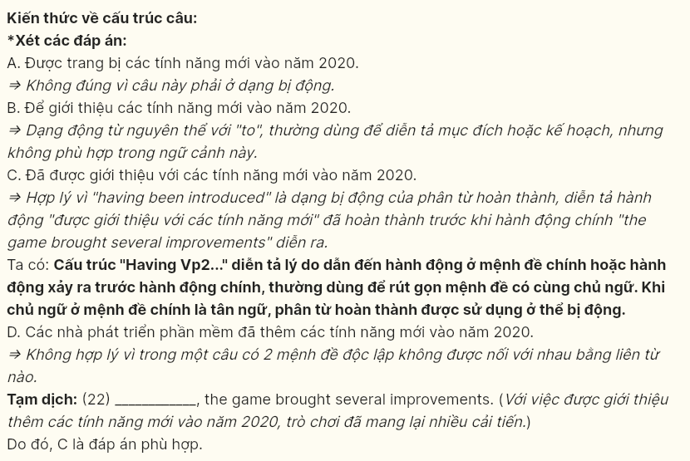

**Read the following passage and mark the letter A, B, C, or D on your answer sheet to indicate the best answer to each of the following questions from 23 to 30.**



Mass tourism refers to the phenomenon of large numbers of people visiting popular destinations. This form of tourism has become widespread in recent decades, fueled by affordable travel options and increasing disposable incomes. Cities and natural attractions that were once reserved for the privileged are now **accessible** to the general public, allowing millions to experience different cultures and landscapes.

One of the most noticeable effects of mass tourism is environmental degradation. Popular destinations, particularly those with fragile ecosystems, suffer from overcrowding, pollution, and the depletion of local resources. Coastal areas, for example, face damage from excessive waste, and heritage sites can suffer from wear and tear due to large crowds. Local communities also feel the **strain** as infrastructure struggles to keep up with the demands of thousands of visitors.

Economically, mass tourism can bring substantial revenue to destinations, creating jobs and supporting local businesses. **Hotels, restaurants, and transport services benefit directly from the influx of visitors.** Although the benefits are not always evenly distributed, mass tourism can provide valuable income to some local businesses. In many cases, however, the profits generated from mass tourism are concentrated in the hands of large corporations, leaving local residents with few long-term advantages. Additionally, the seasonal nature of mass tourism means that jobs can be unstable, often disappearing in the off-season.

Mass tourism can be a powerful economic driver, but **it** presents challenges that need to be carefully managed. Governments, businesses, and travelers must work together to minimize its negative impacts. Sustainable tourism practices, such as limiting visitor numbers and supporting eco-friendly initiatives, are crucial to ensuring that future generations can continue to enjoy the beauty of popular travel destinations.

**Question 23 [696636]:** The word **accessible** in paragraph 1 is **OPPOSITE** in meaning to ________:  
A. illegal B. inevitable C. unprecedented D. unavailable



**Question 24 [696637]:** Which of the following is **NOT** mentioned as an effect of mass tourism?  
A. overcrowding B. pollution C. loss of local culture D. depletion of local resources

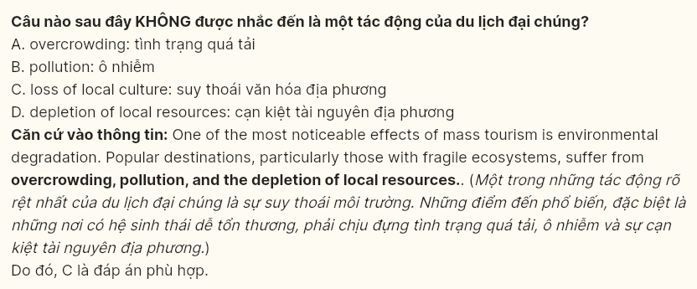

**Question 25 [696638]:** The word **strain** in paragraph 2 could best be replaced by ________:  
A. measure B. pressure C. arrival D. pleasure

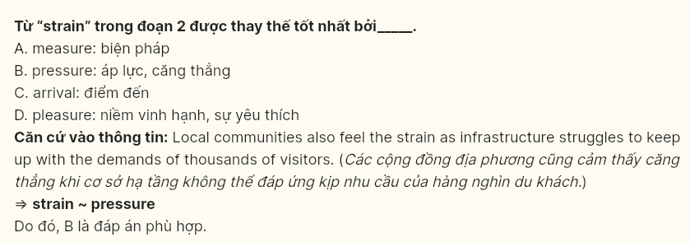

**Question 26 [696639]:** Which of the following best paraphrases the underlined sentence in paragraph 3?  
A. The influx of visitors strongly supports hotels, restaurants, and transport services.  
B. The arrival of visitors brings direct consequences to hotels, restaurants, and transport services.  
C. Hotels, restaurants, and transport services are adversely impacted by the arrival of visitors.  
D. Hotels, restaurants, and transport services gain direct benefits from the arrival of visitors.

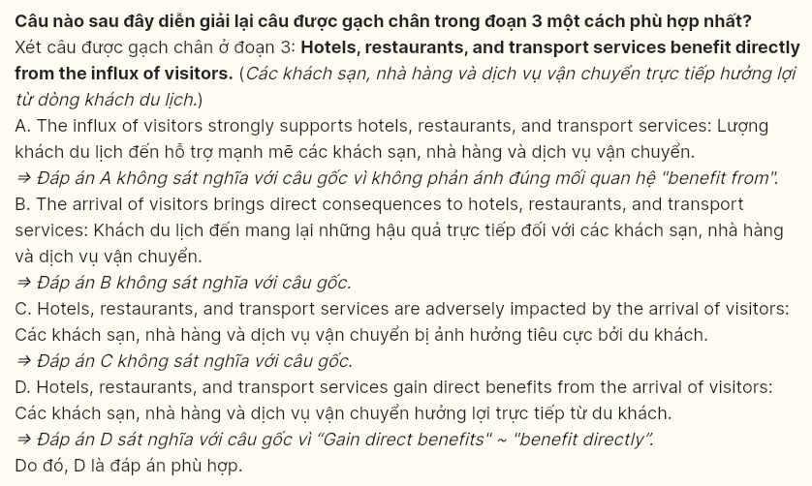

**Question 27 [696640]:** The word **it** in paragraph 4 refers to ______:  
A. mass tourism B. economic driver C. seasonal nature D. the off-season

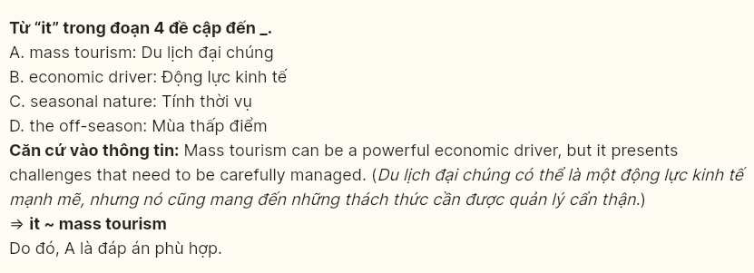

**Question 28 [696641]:** Which of the following is TRUE according to the passage?  
A. Mass tourism provides stable and long-term job opportunities in all popular destinations.  
B. Sustainable tourism practices are key to ensuring the future of travel destinations.  
C. The main economic benefits of mass tourism go to large international corporations.  
D. Local businesses are always unaffected by the seasonal fluctuations of mass tourism.

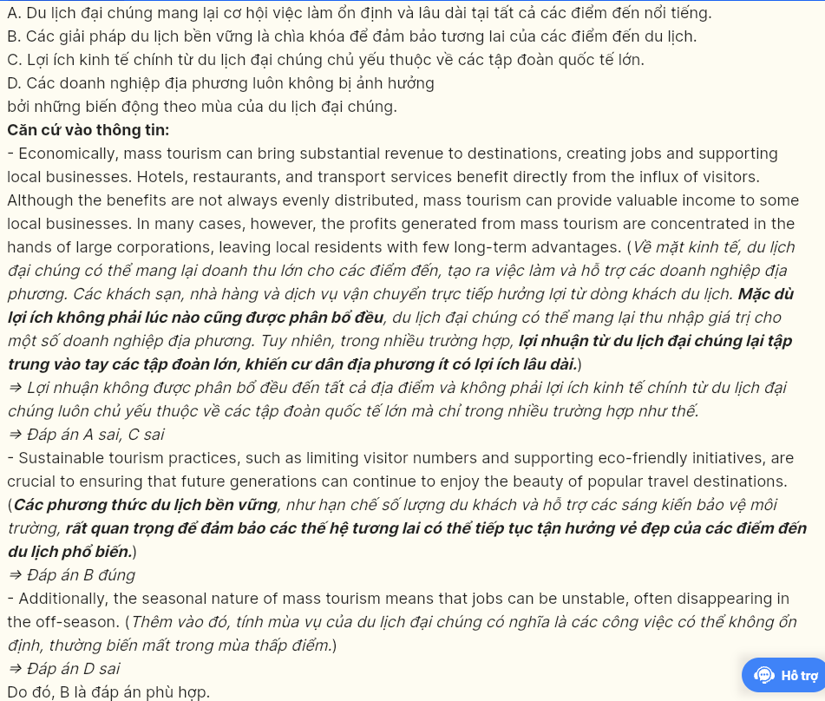

**Question 29 [696642]:** In which paragraph does the writer mention a **concession relationship?**  
A. Paragraph 1 B. Paragraph 2 C. Paragraph 3 D. Paragraph 4

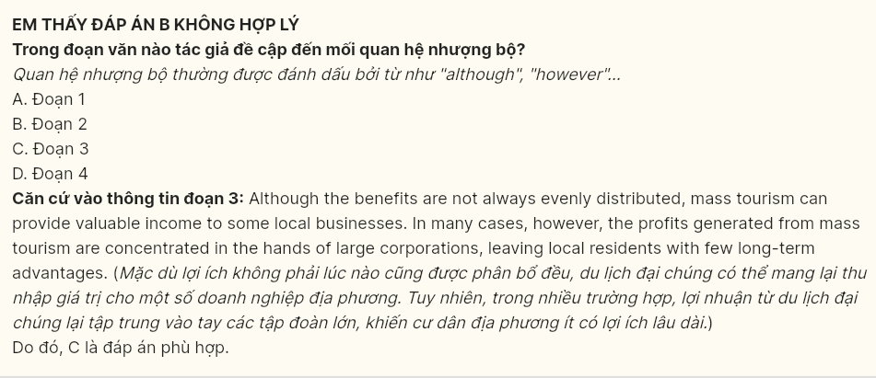

**Question 30 [696643]:** In which paragraph does the writer describe the factors that have contributed to the widespread growth of tourism?  
A. Paragraph 1 B. Paragraph 2 C. Paragraph 3 D. Paragraph 4

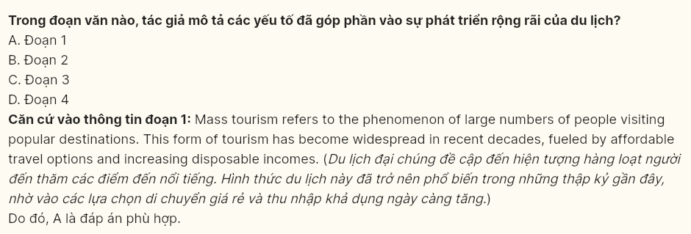

**Read the following passage and mark the letter A, B, C or D on your answer sheet to indicate the best answer to each of the following questions from 31 to 40.**



A significant number of young people have chosen career paths that have little to do with their degrees. This trend is particularly **prominent** in the age of digital disruption, where industries are rapidly changing, and new job opportunities emerge almost daily. The traditional belief that a university degree should directly lead to a career in the same field is slowly fading as more young professionals step into roles that align less with **their** studies but offer them greater personal and financial fulfillment.

**[I]** One of the primary reasons for this shift is the changing nature of the job market. **[II]** With the rise of technology, online platforms, and a booming gig economy, young people now have access to career opportunities that were once unavailable or difficult to reach. **[III]** Many young people are motivated by the flexibility and creative freedom these roles offer, as well as the potential for higher pay and work-life balance, especially with the growing demand for remote work.

**[IV]** Another significant factor is the desire for personal fulfillment and a sense of purpose. Many young people are no longer **content with** simply earning a paycheck; they seek jobs that resonate with their passions and values. Careers in the arts, sustainable industries, and startups often offer more meaningful experiences, prompting individuals to take risks and step away from the traditional career paths. Furthermore, online learning platforms have made it easier for young professionals to upskill and transition into new fields, giving them the confidence to pursue non-traditional jobs.

Despite these opportunities, working outside one’s major can come with challenges. **The lack of formal training or experience in a new field can be a barrier, and many employers still favor candidates with degrees directly related to the job.** However, these challenges are not insurmountable. Networking, internships, and continuous learning can help bridge the gap. For those willing to take risks and invest in their growth, the rewards can be substantial: increased job satisfaction, better income, and the chance to build a career that aligns with their personal interests and values.

**Question 31 (696464):** Where in paragraph 2 does the following sentence best fit?  
***“For instance, social media management, content creation, and digital marketing are fields that attract graduates from various disciplines like economics, medicine, or engineering.”***

A. [I] B. [II] C. [III] D. [IV]

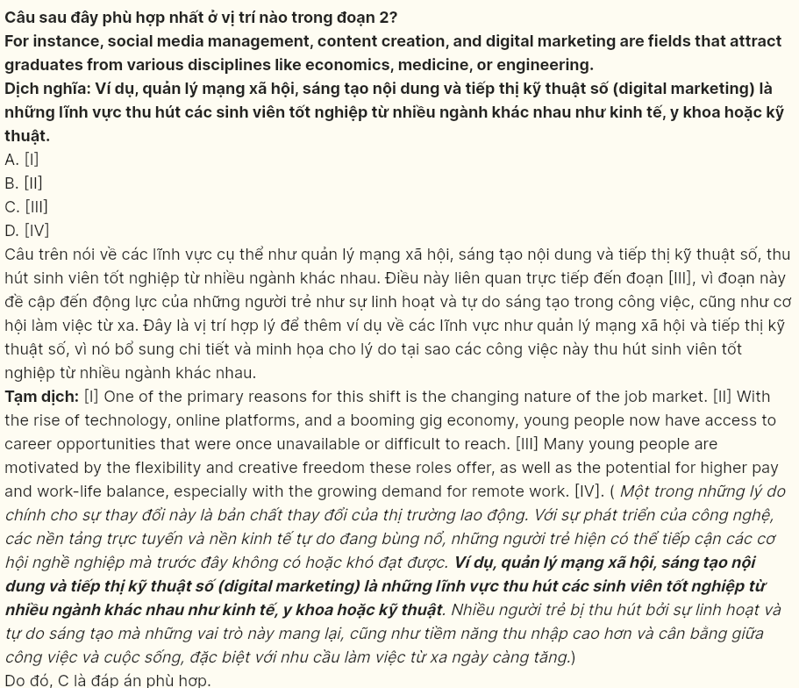

**Question 32 (696465):** The word ***prominent*** in paragraph 1 could be best replaced by ______:  
A. brilliant B. noticeable C. successful D. obscure

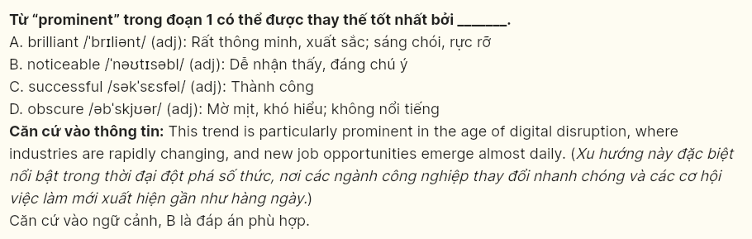

**Question 33 (696646):** The word ***their*** in paragraph 1 refers to ______.  
A. roles B. career paths C. job opportunities D. young professionals

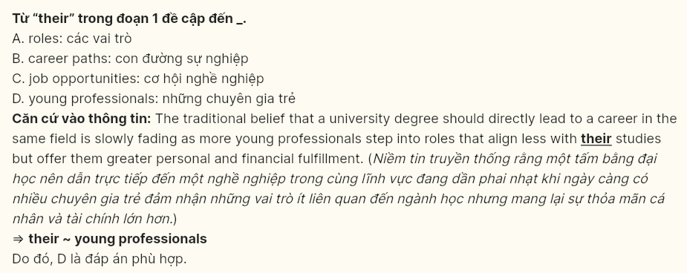

**Question 34 (696647):** The phrase ***content with*** in paragraph 3 is **OPPOSITE** in meaning to _____:  
A. upset about B. satisfied with C. keen on D. delighted with

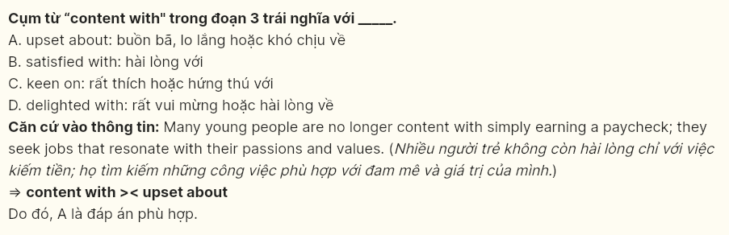

**Question 35 (696648):** According to paragraph 3, which of the following is **NOT** mentioned as a reason why young people seek careers outside their field of study?  
A. the desire for more job satisfaction  
B. the desire for financial independence  
C. the pursuit of work that aligns with personal passions  
D. the chance to take risks and explore unconventional career paths

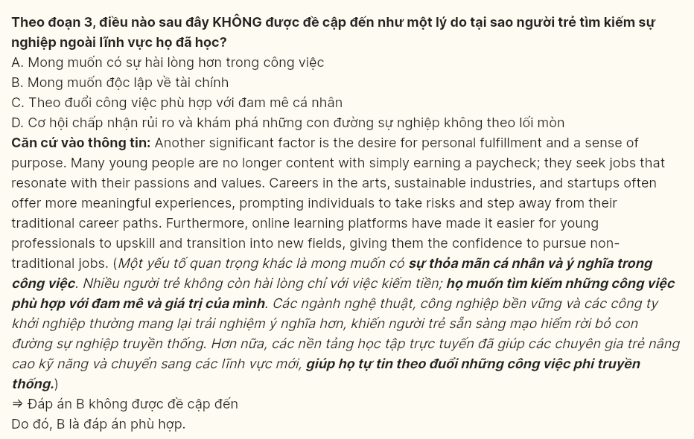

**Question 36 (696649):** Which of the following best summarizes paragraph 2?  
A. The job market has shifted due to technology and remote work opportunities, making jobs in fields like digital marketing more accessible and appealing to young people.  
B. The changing job market, driven by technology, online platforms, and the gig economy, offers young people new career opportunities that prioritize flexibility, freedom, pay, and work-life balance.  
C. Many young professionals now seek flexibility and creative freedom in their careers, with many transitioning into jobs like content creation, driven by the rise of the digital economy.  
D. The rise of remote work and online platforms provides young people with new career opportunities offering flexibility, pay, and work-life balance.

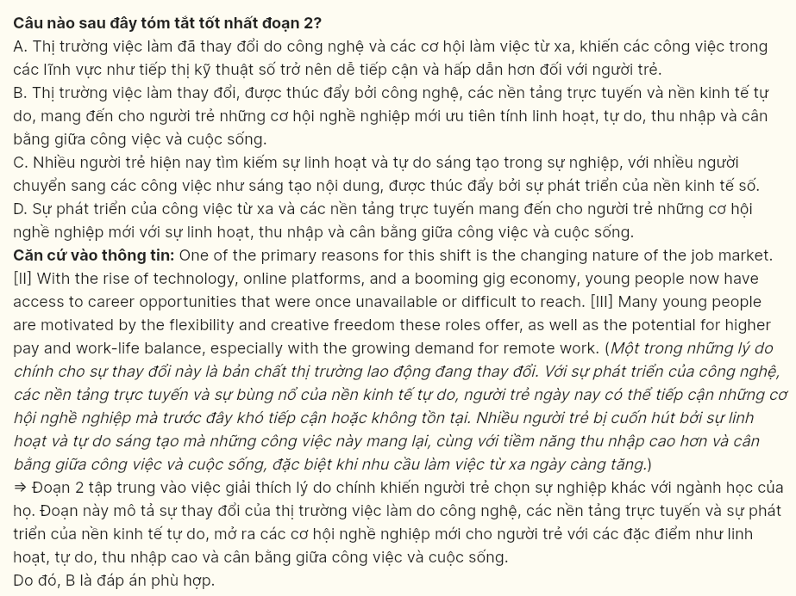

**Question 37 (696650):** Which of the following is **TRUE** according to the passage?  
A. The trend of choosing non-traditional career paths is primarily due to the lack of job opportunities in students’ fields of study.  
B. Employers always prefer candidates with degrees directly related to the job, regardless of their skills or experience.  
C. Online learning platforms have made it easier for young people to switch to new careers and gain skills outside their degrees.  
D. Young people are no longer interested in jobs that offer higher pay and work-life balance as they are more focused on personal fulfillment and meaningful work.



**Question 38 (696651):** Which of the following best paraphrases the underlined part in paragraph 4?  
A. A lack of formal training or experience in a new field can serve as a drawback, and many employers still recruit candidates with degrees that are equal to the position.  
B. A lack of formal training or experience in a new field has negative consequences, and many employers still advocate for candidates with degrees that are connected to the position.  
C. A lack of formal training or experience in a new field can be an advantage, and many employers still hire candidates with degrees that are suitable for the position.  
D. A lack of formal training or experience in a new field can present a challenge, and many employers still prefer candidates with degrees that are directly relevant to the position.

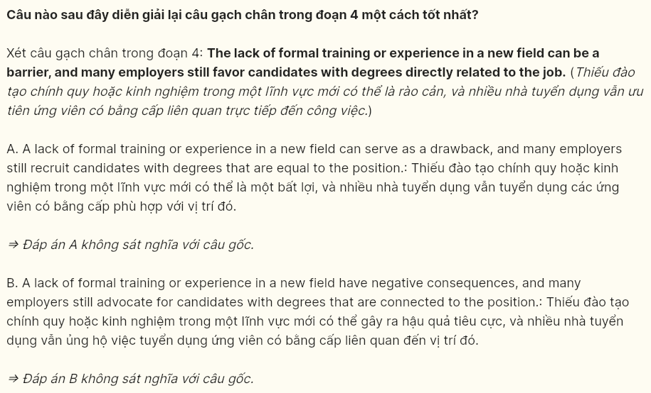

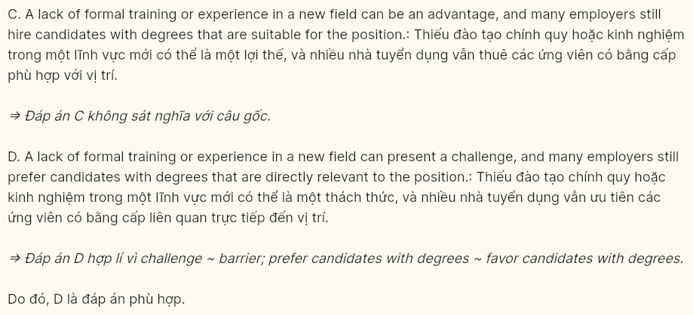

**Question 39 (696652):** Which of the following can be inferred from the passage?  
A. Young professionals are willing to compromise on financial stability in order to follow their passions and work-life balance goals.  
B. The challenges faced by young people in transitioning to new careers are easily overcome with minimal effort.  
C. The lack of formal training or experience in a new field can be resolved and those willing to take risks can reap significant rewards.  
D. Young people are increasingly prioritizing traditional career paths over non-traditional ones due to the risks involved.



**Question 40 (696653):** Which of the following best summarises the passage?  
A. The rise of technology and the gig economy has led young people to seek non-traditional careers for better pay and work-life balance.  
B. Young people are shifting from traditional careers to passion-driven jobs, aided by online learning, with some serious challenges.  
C. Many young people pursue careers outside their degrees due to various factors, which can lead them to face some challenges, but these can be overcome.  
D. Technology and online platforms are enabling young people to pursue careers outside their degrees, prioritizing work-life balance and personal fulfillment.



**----- THE END -----**