Unit 5 Test
I. Listening
Listen to the travel guide and fill in each blank with ONE word or a number.
Place | Activity / Item | Information
Ha Long Bay | Boat tour | It has many limestone (1) ……………….
Phong Nha Cave | Bring a (2) ………______ | The cave is dark and wet.
Mui Ne | Sand dunes | Tourists should use (3) ………………..
Phu Quoc Island | Visit forests and beaches | Tourists must not (4) …………….. rubbish.
Fansipan | Mountain trip | Visitors should travel with a (5)……………….
II. Pronunciation
A. Choose the word whose bold part is pronounced differently.
6. A. mountain B. waterfall C. desert D. guide
7. A. tent B. torch C. tourist D. dark
B. Choose the word that has a different stress pattern from the others.
8. A. mountain B. attraction C. island D. compass
9. A. beautiful B. dangerous C. wonderful D. expensive
III. Language use
Choose the best answer A, B, C or D.
10. Ha Long Bay is famous for its beautiful limestone __________.
A. islands B. scissors C. plasters D. backpacks
11. You need a __________ to find the right direction in the forest.
A. sunscreen B. compass C. seafood D. waterfall
12. How __________ water do we need for the trip?
A. many B. much C. a few D. any
13. There are __________ beautiful beaches in Phu Quoc.
A. much B. a little C. some D. an
14. Visitors __________ swim near the boats because it is dangerous.
A. must B. mustn't C. can D. should
15. We should bring a __________ because it may rain in the mountains.
A. waterproof coat B. scissors C. desert D. plaster
IV. Signs & Notices
Look at the signs and choose the best explanation.

16. What does this sign mean?
A. You must not throw rubbish here.
B. You can put rubbish on the trail.
C. You should bring more food.
D. You can camp anywhere.
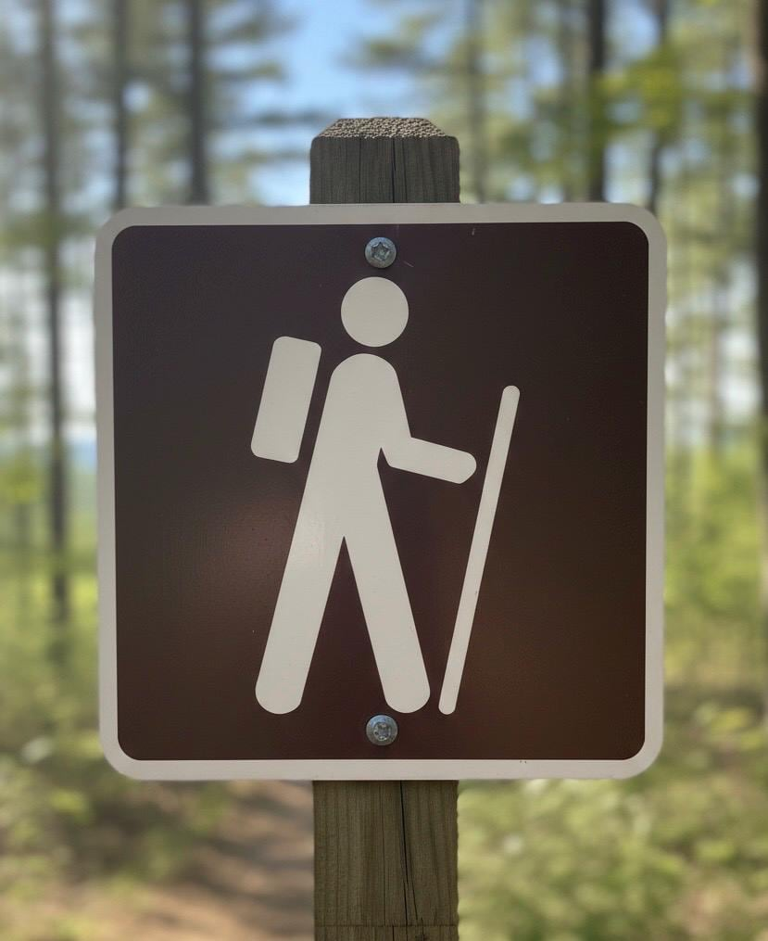 | 17. What does this sign mean?  A. You can buy backpacks and walking sticks near here.  B. This is a special path for people who want to go hiking.  C. Drivers can park their cars along this forest road.  D. You must not walk into the woods without a tour guide.
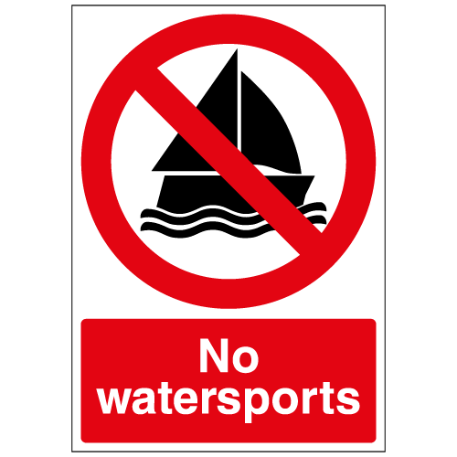 | 18. What does this sign mean?  A. You can rent a boat to travel around the lake here.  B. You need to buy a ticket to watch the boat race.  C. You should learn how to swim before going into the water.  D. You must not play any sports or sail boats in the water here.
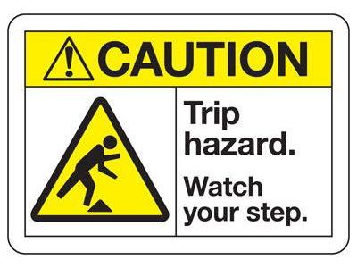 | 19. Read the notice. What is TRUE?  A. You should run quickly to get through this area.  B. You can leave your school bags on the ground here.  C. You need to wash the floor because it is dirty.  D. You must look carefully where you walk so you do not fall.
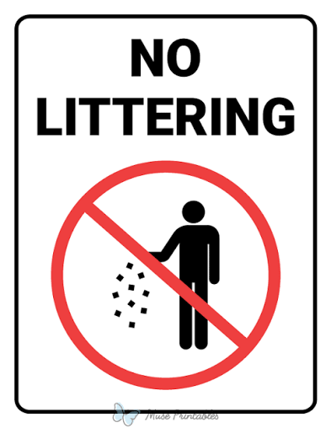
V: LOGIC
Rearrange the sentences (a-d) to make a complete conversation.
20.
a. Because it has many beautiful islands and caves.
b. What is your favourite natural wonder?
c. Why do you like it?
d. I like Ha Long Bay the best.
A. b - d - c - a B. b - c - d - a C. d - b - c - a D. d - c - a - b
21.
a. You must bring a torch and a waterproof coat.
b. What must I bring to Phong Nha Cave?
c. Thanks. Can I touch the rocks?
d. No, you mustn't.
A. b - c - a – d B. a - b - d - c C. b - a - c - d D. c - d - b - a
22.
a. A little is enough.
b. Is there any food on the boat?
c. Great! How much water do we need?
d. Yes, there is some seafood for lunch.
A. b - a - c - d B. b - d - c - a C. a - b - d - c D. c - d - b - a
23.
a. Sure. What time can we meet?
b. That's fine. I'll bring some sunscreen.
c. How about seven o'clock?
d. Let's visit the sand dunes this weekend.
A. b - a - c - d B. a - b - c - d C. b - c - a - d D. d - a - c - b
VI: READING
A. Read and choose the correct word for each blank.
Mui Ne is a famous place in Binh Thuan. It has beautiful sand dunes and a long beach. There is a lot of (24) _________ and very little rain. Tourists should bring (25) _________ because the sun is strong. They must not leave (26) _________ rubbish on the sand. Mui Ne is an amazing place, and many tourists want to (27) _________ it every summer.
24. A. sand B. forests C. caves D. waterfalls
25. A. scissors B. sunscreen C. a plaster D. a compass
26. A. many B. a few C. any D. a
27. A. visit B. wear C. break D. turn
B. Read the text and choose the best answer A, B, C or D.
My name is Minh. Last summer, I went to Phu Quoc Island with my family. Phu Quoc is a beautiful island in Viet Nam. It has clean beaches, green forests and many interesting places. We stayed near the beach, so we could swim in the morning and watch the sunset in the evening.
On the second day, we visited a national park. The guide told us that we must stay on the trail and must not pick flowers or disturb animals. My mother brought some water and sunscreen. My brother brought a camera to take photos. In the evening, we went to the night market and enjoyed fresh seafood. I think Phu Quoc is a wonderful place for a holiday.
28. What is the text mainly about?
A. Minh's school B. Minh's trip to Phu Quoc C. Minh's brother D. A cave tour
29. Where is Phu Quoc?
A. In Viet Nam B. In Japan C. In Thailand D. In England
30. What does Phu Quoc have?
A. A lot of snow B. Only mountains
C. Many deserts D. Clean beaches and green forests
31. What did Minh's family do in the morning?
A. They swam. B. They went shopping.
C. They visited a museum. D. They watched fireworks.
32. What must visitors do in the national park?
A. Disturb animals B. Pick flowers C. Stay on the trail D. Go alone
33. What did Minh's mother bring?
A. Some water and sunscreen B. A compass and a torch
C. A sleeping bag D. Some scissors
34. Where did they enjoy fresh seafood?
A. In a cave B. In the forest C. At a local market D. At the night market
35. How does Minh feel about Phu Quoc?
A. It is boring. B. It is wonderful.
C. It is dangerous and ugly. D. It is too expensive.
VII: WRITING
A. Rearrange the words to make complete sentences.
36. must / You / bring / a bottle of water /.
______________________________________________________________________.
37. is / Ha Long Bay / famous / its beautiful islands / for /.
______________________________________________________________________.
B. Rewrite the sentences without changing their meanings.
38. It is necessary to bring a compass.
You ________________________________________________________________.
39. There is not much water left.
There is only _______________________________________________________.
40. Do not throw rubbish in the bay.
You ________________________________________________________________.

AUDIO SCRIPT (PHẦN I: LISTENING)
Welcome to our travel guide for this summer! Here are five wonderful places for your holiday.
- First, Ha Long Bay is famous for its beautiful limestone islands. You can take a boat tour and enjoy fresh seafood there.
- Next, Phong Nha Cave is dark and wet, so remember to bring a torch. You must follow the guide when you are inside the cave.
- If you like the sun and sand, visit Mui Ne. It has amazing sand dunes. You should use sunscreen because the sun is very strong.
- Phu Quoc Island is a great place with green forests and clean beaches. Visitors must not throw rubbish on the beach or in the forest.
- Finally, Fansipan is the highest mountain in Viet Nam. It is a difficult trip, so visitors should travel with a group.
*************************************
Đáp án tham khảo
Listening: 1. islands | 2. torch | 3. sunscreen | 4. throw | 5. group
II. Pronunciation: 6. D | 7. D | 8. B | 9. D
III. Language use: 10. A | 11. B | 12. B | 13. C | 14. B | 15. A
IV. Signs & Notices: 16. A | 17. B | 18. D | 19. D
V. Logic: 20. A | 21. C | 22. B | 23. D
VI. Cloze Test: 24. A | 25. B | 26. C | 27. A
Reading Comprehension: 28. B | 29. A | 30. A | 31. A | 32. A | 33. A | 34. A | 35. B
VII. Writing:
36. You must bring a bottle of water.
37. Ha Long Bay is famous for its beautiful islands.
38. You must bring a compass.
39. There is only a little water left.
40. You mustn't throw rubbish in the bay.

