**TIẾNG ANH 8 – FRIENDS PLUS**

**UNIT 3 – TEST 2**

**I. PRONUNCIATION**

**Câu 1.** Which word has the underlined part pronounced differently from that of the others?

**A.** ocean **B.** Pacific **C.** cycle **D.** surface

**Đáp án đúng:** A

A. ocean /ˈəʊʃn/

B. Pacific /pəˈsɪfɪk/

C. cycle /ˈsaɪkl/

D. surface /ˈsɜːfɪs/

**Câu 2.** Which word has the underlined part pronounced differently from that of the others?

**A.** dive **B.** climb **C.** idea **D.** distance

**Đáp án đúng:** D

A. dive /daɪv/

B. climb /klaɪm/

C. idea /aɪˈdɪə/

D. distance /ˈdɪstəns/

**Câu 3.** Which word has a different stress pattern from that of the others?

**A.** volcano **B.** quantity **C.** continue **D.** adventure

**Đáp án đúng:** B

A. volcano /vɒlˈkeɪnəʊ/

B. quantity /ˈkwɒntəti /

C. continue /kənˈtɪnjuː /

D. adventure /ədˈventʃə(r) /

**Câu 4.** Which word has a different stress pattern from that of the others?

**A.** technique **B.** mountain **C.** teenage **D.** desert

**Đáp án đúng:** A

A. technique /tekˈniːk/

B. mountain /ˈmaʊntən/

C. teenage /ˈtiːneɪdʒ/

D. desert /ˈdezət/

**II. Choose the answer (A, B, C or D) that best fits the space in each question.**

**Câu 5.** Sơn Đoòng Cave holds the world’s largest natural cave ______ a volume of 38.5 million m3.

**A.** in **B.** for **C.** with **D.** into

**Đáp án đúng:** C

**Câu 6.** Although Nam had an interesting solo trip around Viet Nam, he found it hard to ______ his friends and family.

**A.** stay with **B.** leave behind **C.** stop off **D.** carry on

**Đáp án đúng:** B

**Câu 7.** A desert is a large area covered with sand or rocks, and with very little ______.

**A.** evaporation **B.** solidification **C.** precipitation **D.** liquefication

**Đáp án đúng:** C

**Câu 8.** “Can you think of an ______ destination to visit next summer vacation?” – “The Maldives?”

**A.** extreme **B.** exotic **C.** excited **D.** exhausting

**Đáp án đúng:** B

**Câu 9.** ______ on Bella’s blog have been paying for her trip to the Galapagos Islands.

**A.** Advances **B.** Additions **C.** Adjectives **D.** Adverts

**Đáp án đúng:** D

**Câu 10.** Running 250 kilometres through the dunes of the Gobi Desert is part of a ______ desert challenge in the Gobi March.

**A.** four-race **B.** four-races **C.** four-raced **D.** four-racing

**Đáp án đúng:** A

**Câu 11.** The team are celebrating their victory because they have ______ won the tournament.

**A.** yet **B.** just **C.** still **D.** not

**Đáp án đúng:** B

**Câu 12.** We ______ Argentina a couple of times.

**A.** visited **B.** was visiting **C.** have visited **D.** have been visiting

**Đáp án đúng:** C

**Câu 13.** Johnny ______ a lot over the last few weeks.

**A.** did **B.** does **C.** has done **D.** has been doing

**Đáp án đúng:** C

**Câu 14.** Daisy: “I have got exams all weeks.” - Dean: “______”

**A.** Wasn’t it good? **B.** What about you? **C.** That sounds great. **D.** Good luck with that.

**Đáp án đúng:** D

**III. Look at each sign or notice. Choose the best answer (A, B, C or D) that matches its meaning.**

**Câu 15.** What does the sign mean?

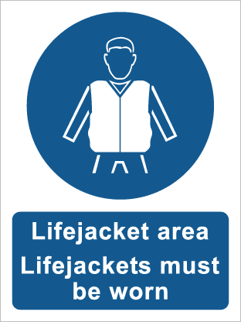

**A.** A life jacket must be worn in this area. **B.** Save your life first.

**C.** Do not use a life jacket in any circumstances. **D.** Press the button to use a life jacket.

**Đáp án đúng:** A

**Câu 16.** What does the sign say?

**A.** Your luggage can be left unattended. **B.** It is dangerous to dive here.

**C.** Personal information will be stolen here. **D.** This place is not for searching food.

**Đáp án đúng:** B

**IV. Read the following and do as directed.**

Potholing is an adventurous pastime for people who love exploring places where no one has been before. Although it really gets the adrenaline flowing, cave explorers must bear in mind that accidents might happen and their results can be fatal. The main dangers involved in potholing are falling, hypothermia, flooding, and physical exhaustion. It is important that explorers should make good preparations and be well-equipped for their journeys. Below are some necessary pieces of equipment for potholing.

**Helmets** are worn to protect the head from falling rocks and any bumps that might occur. A main light source is normally attached to the helmet so hands can be kept free.

**Boots** are usually worn in driver caves while rubber boots are worn in wetter caves.

**Ropes** are necessary for climbing.

**A first aid** kit with splints, bandages, plasters and other medical supplies should be carried. There should be a person who is qualified to use the medical equipment in your crew.

**True/False Questions:**

**Câu 17.** Potholing is a safe activity with no dangers.

**A.** True **B.** False

**Đáp án đúng:** B

**Câu 18.** There’s a chance that you will be injured when exploring caves.

**A.** True **B.** False

**Đáp án đúng:** B

**Câu 19.** There are only four necessary items for potholing.

**A.** True **B.** False

**Đáp án đúng:** B

**Câu 20.** An exploration team should have a qualified healthcare professional.

**A.** True **B.** False

**Đáp án đúng:** A

**Choose the correct answer to each question:**

**Câu 21.** Why does the author mention “falling, hypothermia, flooding, and physical exhaustion”?

**A.** To explain what potholing is. **B.** To give examples of potential risks in potholing.

**C.** To make a list of necessary equipment. **D.** To prove that potholing is adventurous.

**Đáp án đúng:** B

**Câu 22.** What can be inferred from the passage?

**A.** A light source plays a vital role in protecting the head.

**B.** Boots and ropes are only used for climbing stiff slopes.

**C.** A first aid kit must be available at all times during the journey.

**D.** Cavers should know the dangers and prepare well before they set out.

**Đáp án đúng:** D

**V. Choose the word (A, B, C or D) that best fits each blank space in the following passage.**

**Sơn Đoòng Adventure**

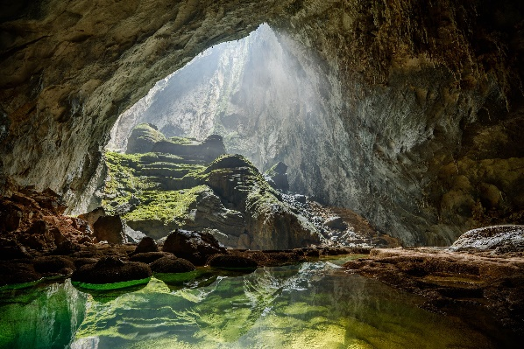As a sensation-seeker, I had (23) ______ of exploring the world’s largest cave, Sơn Đoòng Cave. It was not until last year that my dream came true. After the graduation ceremony, I decided to set (24) ______ on a six-day adventure tour to the cave.

Upon my arrival in Đồng Hới City, I was picked up by a travel agent and then taken to a bungalow in Phong Nha. Together with other guests (25) ______ joined the expedition, I attended a safety briefing session so that we could understand the nature of the adventure. The journey really started on the second day. After entering the cave, I was (26) ______ by its spectacular views with enormous cave formations slowly appearing in front of my eyes. The highlight of the journey was the visit to the Garden of Edam at Doline 2. I could have a bird’s-eye (27) ______ of the entire forest with a variety of flora and fauna found nowhere else on Earth.

It is not much to say that the journey to Sơn Đoòng Cave was the adventure of a (28) ______. I had a lot of fun admiring the breathtaking scenery and learned how to protect the environment by strictly observing the regulations.

**Câu 23.** Choose the correct answer.

**A.** drawn **B.** dropped **C.** driven **D.** dreamt

**Đáp án đúng:** D

**Câu 24.** Choose the correct answer.

**A.** in **B.** on **C.** up **D.** off

**Đáp án đúng:** D

**Câu 25.** Choose the correct answer.

**A.** which **B.** whom **C.** who **D.** when

**Đáp án đúng:** C

**Câu 26.** Choose the correct answer.

**A.** excited **B.** stunned **C.** frightened **D.** interested

**Đáp án đúng:** B

**Câu 27.** Choose the correct answer.

**A.** view **B.** sight **C.** glimpse **D.** gaze

**Đáp án đúng:** A

**Câu 28.** Choose the correct answer.

**A.** lifespan **B.** lifetime **C.** lifelong **D.** long life

**Đáp án đúng:** B

**VI. Supply the correct form of the word given in each sentence.**

**Câu 29.** Free printable family tree charts are available online to ______ your research. **(ORGANIZATION)**

**Đáp án đúng:** organize / organise

**Câu 30.** Katherine has written an ______ blog about travelling around the world. It has motivated other young people to go backpacking. **(INSPIRE)**

**Đáp án đúng:** inspirational

**Câu 31.** ______ climbers and overcrowding are being blamed for this season’s high death toll on Mt. Everest. **(EXPERIENCE)**

**Đáp án đúng:** inexperienced

**Câu 32.** I spent six months as a visiting ______ at Princeton University. **(PROFESSION)**

**Đáp án đúng:** professor

**Câu 33.** We enjoy ______, especially on the open sea. **(SAILOR)**

**Đáp án đúng:** sailing

**Câu 34.** Do you know how many edible plants grow ______ in our own front yards? **(NATURE)**

**Đáp án đúng:** naturally

**VII. Rearrange the groups of words in a correct order to make complete sentences.**

**Câu 35.** in Viet Nam. / gradually become popular / an individual sport / Running a marathon is / which has

**Đáp án đúng:** Running a marathon is an individual sport which has gradually become popular in Viet Nam.

**Câu 36.** waves in the Atlantic ocean / off the beaches / some of the world’s biggest / of Ireland and Portugal. / Surfers can ride

**Đáp án đúng:** Surfers can ride some of the world’s biggest waves in the Atlantic Ocean off the beaches of Ireland and Portugal.

**VIII. Rewrite each of the following sentences in another way so that it means almost the same as the sentence printed before it.**

**Câu 37.** We haven’t seen her for ages. **(LAST)**

🡪 It’s

**Đáp án đúng:** It’s ages since I last saw her.

**Câu 38.** They haven’t tried cave exploration before. **(ONLY)**

🡪 Exploring

**Đáp án đúng:** Exploring cave(s) is the only thing (that) they haven’t tried.

**Câu 39.** The experience is so great that I can’t forget it. **(SUCH)**

🡪 This is

**Đáp án đúng:** This is such a great experience that I can’t forget it.

**Câu 40.** It is hard to leave behind my children.

🡪 I find

**Đáp án đúng:** I find it hard to leave behind my children. / I find it hard to leave my children behind.

**------ HẾT ------**