## **Tiếng Anh 8 i-Learn Smart World - Luyện tập - Unit 8 Time allotted: 45**

**PART 1 PRONUNCIATION (4 questions)**

**Choose the word whose underlined part differs from the other three in pronunciation in the following question.**

1. A. show B. cloth C. local D. home

2. A. ethnic B. sell C. spend D. sewing

**Choose the word that differs from the other three in the position of the main stress in the following question.**

3. A. dessert B. pattern C. headscarf D. basket

4. A. utensils B. exciting C. pottery D. tradition

**PART 2 USE OF ENGLISH (13 questions)**

**Choose the option that best completes the following sentence.**

5. I love the ______________ on H'mong clothing. They look like flowers, animals, and stars.

A. patterns B. signs C. materials D. colors

6. My friend gave me a bamboo ______________ set on my birthday. The set included a spoon, a fork and chopsticks.

A. clothing B. utensil C. cooking D. pottery

7. You should wear a(n) ______________ to protect your clothes from getting dirty while you are cooking.

A. blouse B. cloth C. headscarf D. apron

8. Vietnam is home to 54 ______________ groups; each of them has its own unique traditions.

A. ethnic B. minor C. small D. tiny

9. After nearly a thousand years, the Chăm villagers still make pottery completely ______________ hand.

A. in B. with C. by D. for

10. I love the ______________ jewelry that Nùng women wear. They are so white and bright.

A. golden B. silver C. wooden D. clay

11. Tày women usually wear a blouse, pants and a(n) ______________ covering their long hair.

A. belt B. apron C. headscarf D. clothing

12. With ______________ population of 1.7 million people, ______________ Tày are the biggest ethnic minority group in Vietnam.

A. a / no article B. a / the C. no article / the D. no article / no article

13. The Thái people have ______________ unique dance which is called Xòe Dance.

A. a B. an C. the D. no article

14. Chăm pottery is ______________ popular souvenir for ______________ tourists visiting Vietnam.

A. the / the B. a / the C. a / no article D. no article / the

15. The tourists asked the farmer ______________ corn.

A. when do they plant B. when did they plant C. when they plant D. when they planted

16. Mai asked her teacher ______________ the Thái people lived in stilt houses.

A. where B. whether C. that D. what

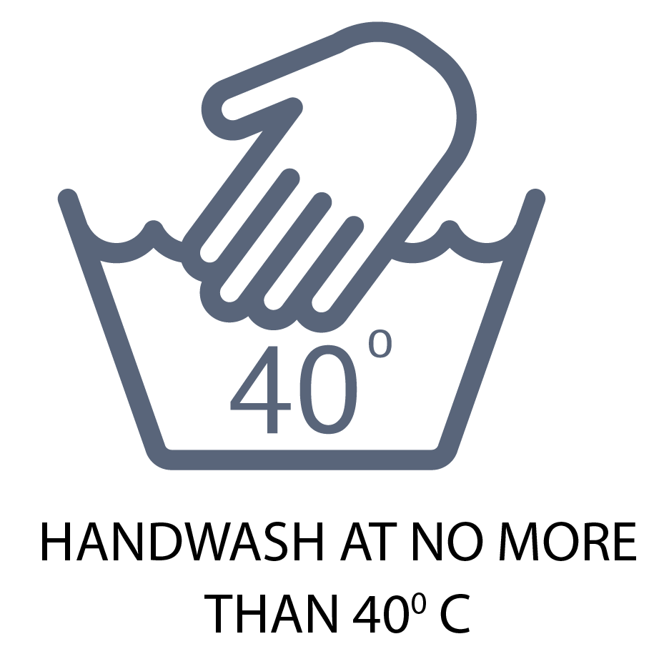

17. What does the notice mean?

A. You have to wash your hands at 40 degrees Celsius.

B. You can't put this kind of clothing in the washing machine.

C. This kind of clothing should be washed in water that is warmer than 40 degrees Celsius.

D. This kind of clothing can't be washed when it is 40 degrees Celsius.

**PART 3 WORD FORMATION (6 questions)**

**Write the correct form of the given word.**

18. The Khmer people do farm work, fish, and make handicraft ______________. ***(PRODUCE)***

19. Thắng cố, a ______________ dish of the H’Mong ethnic group in Sa Pa, is not easy to eat for most visitors. ***(TRADITION)***

20. Lô Lô women are ______________ at weaving, dyeing, sewing and embroidery. ***(TALENT)***

21. Thomas watched wonderful gong ______________ in the central highlands of Vietnam last year. ***(PERFORM)***

22. The Red Dao people are famous for their unique and ______________ costumes. ***(COLOR)***

23. The Ê-đê people have a large ______________ of folk tales. ***(COLLECT)***

**PART 4 ERROR RECOGNITION**

**Find the underlined part that needs correction in the following question.**

24. For Mông ethnic group in the northern province of Hà Giang, mèn mén (steamed minced corn) is a special part of their culture.

A. For Mông ethnic B. the northern C. steamed minced D. their culture

**PART 5 READING (5 questions)**

**Read the website article. Write ONE suitable word in each space. (5 questions)**

**What ethnic group are you from?**   
Do you find it easy to answer this question? (25) ___________ you come from a small group of people who all live in the same part of a country, perhaps the answer is yes. But it is a strange question for many people in the West, (26) ___________ they do not think that they are part of an ethnic group. For example, most white people in the UK think that they are British, but that is a nationality.   
However, scientists say that everyone belongs to an ethnic group of some sort, even if they do not recognize it. White British people, for example, share a language, English, and a history. Their grandparents, great grandparents, and so on have all lived in the (27) ___________ country for centuries. They enjoy many traditions together, such (28) ___________ Christmas and New Year.   
The British ethnic group also has similar ideas about government, and many social customs, like shaking hands. They believe that women are equal to men and that parents (29) ___________ let their children make decisions about their lives from quite an early age.

**PART 6 LISTENING (5 questions)**

**Listen to a conversation between two friends. Choose the best answer for each question. (5 questions)**

30. What does the girl mean by ‘your people’?

A. The boy’s family

B. The boy’s friends

C. The boy’s ethnic group

D. The boy’s schoolmates

31. The boy says ‘Same here’ because ______________.

A. he doesn’t know anything about the girl’s family

B. he is from the same ethnic group as the girl

C. he knows their ethnic groups are similar

D. he knows nothing about the girl’s ethnic group

32. How does a boy become an adult in the girl’s ethnic group?

A. The ceremony is very similar for boys and girls.

B. There’s a party when a boy becomes 16.

C. The ceremony happens when boys are younger.

D. The girl is not sure.

33. People in the boy’s family ______________.

A. believe in tree gods

B. believed in tree gods in the past

C. come from a village a long way from the city

D. have the same ideas about gods as village people

34. It is lucky in the girl’s culture if the first person to enter your house at new year is ______________.

A. a dark-haired man

B. a beautiful woman

C. a handsome man

D. a light-haired woman

**PART 7 WRITING (6 questions)**

**Rewrite the following sentences using reported speech.**

35. "Do you like to have steamed vegetables tonight?", asked Maria's mother.

→ Maria's mother asked her ___________

36. "How long does it take to make an embroidered blouse?" Nick asked the local woman.

→ ___________

**Rewrite the following sentence without changing its meaning. Use the given word(s) if any.**

37. "Dad, where does the Sán Dìu ethnic group live?", Khoa asked.

→ Khoa asked his dad___________

**Rewrite the following sentences using reported speech.**

38. "Does a Red Dao girl have to sew and embroider her own wedding costume?" Susan asked.

→ Susan asked the tour guide ___________

**Put the words in the correct order to make a correct sentence.**

39. /The Chăm people/their Chăm towers/a rich culture/and are/famous for/have

→ .......................................

40. are experienced/provinces of Vietnam,/who live/hunters/The Mạ people,/./farmers and/in the northern

→ .......................................

**---THE END---**