Date of planning: 3/5/2022  Date of teaching: 18/5/2022 | Peroid 101 : UNIT 12: ROBOTS  Lesson 5 : SKILLS_2/ Listening and Writing
THIS UNIT INCLUDES:
Vocabulary  - Daily activities  Pronunciation:  - Tones in statement.  Grammar  - Superlative adjectives: short adjectives (smallest, tallest, ect ) | Skills:  - Reading about an Internationa Robot Show.  - Talking about what robots can do.  - Listening about what robots can do.  - Writing a paragraph about a robot you would like to have.  Everyday English  Expressing agreement and disagreement.
I. OBJECTIVES: By the end of this lesson, students will be able to gain the following things :
1. Knowledge:
- To teach listening and writing. To develop their listening about what robots can do. Writing a paragraph about a robot you would like to have.
+ Vocabulary: - Use the words for daily activities;
- Say statements with correct tones;
- Expressing agreement and disagreement about something;
+ Grammar: - Superlative adjectives: short adjectives (smallest, tallest, ect )
- Compare people and things using superlative adjectives;
2. Competence: Students will be able to listen about what robots can do. Writing a paragraph about a robot you would like to have.
3. Quality/ behavior : The awareness of doing daily activities. Having good attitude to doing the housework. Imagining what robots will do in the future . Having serious attitude to working in groups, individual work, cooperative learning and working.
II. TEACHING AIDS:
- Teacher: Text book, laptop, louspeaker, projector…
- Students : Text books, studying equipments….
- Work Arrangements: T_Ss , group works; individual ……
III. PROCEDURE:
1. WARM UP & INTRODUCTION (3’-5’)

Aims:
- To develop student’s listening skills for specific information. It also provides input for the writing skills.
* Content: Review the previous lesson . To start this lesson, ask Ss about the content of the previous lesson. T may ask Ss to tell about what types of robots there are and what they can do.
* Output: Having a chance to speak English and focus on the topic of the lesson..
* Organisation : Teacher’s instructions

Teacher’s & Student’s activities | Content
+ Greeting  + Revision  - Teacher (T) asks Ss some questions about them and class.  - Ask Ss to open their book and introduce what they are going to study….  - T leads in the lesson. | + Greeting  + T- Ss  - Students (Ss) listen and answer the teacher’s or friend’s questions  - Listen and know what they are going to learn  - Open their book and write the tittle of the lesson
2. PRESENTATION/ NEW LESSON (12’)

ACTIVITY 1: Pre-listening
Aims:
- To help Ss understand the gist of the conversation;
- To help Ss develop the skill of listening for specific information.
* Content: Listen and tick the phrases.
* Output: To improve listening skills. Tick the phrases correctly.
* Organisation : Teacher’s instructions…

Teacher’s & Student’s activities | Content
1. Listen to the conversation between Khang and Dr. Adams and tick (✓) the phrases you hear.  *) Pre- teach vocabulary:  - Teacher quickly uses different techniques to teach vocabulary (situation, realia, translation .....) if have .  * First, ask Ss to underline the key words in each of the five given phrases and guess which phrases will appear in the conversation.  - Play the recording and askSs to tick the phrases they hear from the conversation.Then ask two or three Ss to write their answers on the board.  - Play the recording again for Ss to check the answers. If time Is limited, T may only play the recording once.  - T may pause at the sentences that include the information Ss need for their answers.  - Ask for Ss' answers. Confirm the correct answers and write them on the board next to their guesses. | 1. Listen to the conversation between Khang and Dr. Adams and tick (✓) the phrases you hear.  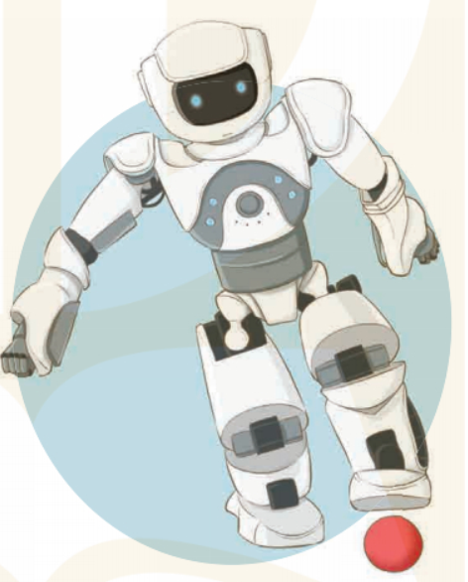  - T_ Ss; Do the tasks.  - Give the keys.  * Key :  - look after sick people ✓  - understand what we say ✓  - build the very high buildings ✓  - teach many subjects ✓  - move heavy things
3.While-listening (18’)

ACTIVITY 2 : While-listening
Aim: To help Ss develop the skill of listening for specific information.
* Content: Listen again the conversation and tick T/F .
* Output: Ss can understand more and get specific information, tick the correct answer .
* Organisation : Teacher’s instructions…

Teacher’s & Student’s activities | Content
2. Listen to the conversation between Khang and Dr. Adams and tick (✓) the phrases you hear.  - Have Ss look at the statements in this activity.  - Ask them how to do it.  - Give them some strategies to do the exercise (e.g. reading the questions, underlining the key words, listening to the text paying attention to the key words, deciding if each sentence is true or false).  - Play the recording twice for Ss to do exercise 2. For stronger classes, ask Ss to take notes of the information to explain why a sentence is false.  - Have Ss share their answers in pairs. Invite some pairs to give their answers and confirm the correct ones.  - Play the recording again if needed, stopping at the place where Ss find it difficult to hear. - For a better class, ask Ss to correct the false sentences.  - If there is time, invite one ortwo students to briefly tell about robots focusing on their abilities.  - Check and confirm the correct answers.  *Post-listening  * T may give some clues  - Call on some Ss to speak freely.  - Correct pronunciations, grammar, vocab, intonation. | 2. Listen to the conversation between Khang and Dr. Adams and tick (✓) the phrases you hear.  - T_ Ss  - Listen to the teacher’s instructions carefully and learn how to do it.  - Fulfil the tasks  - Give the answers  Key:  1. F (Robots can do quite a lot today)  2. T 3. T 4. T  5. F (No, not everything. They can’t understand our feelings or play football)  Audio script:  Khang: Dr Adams, please tell me something about robots.  Dr Adams: Sure. Robots can do quite a lot today. Home robots can do housework. Doctor robots can look after sick people. And ...  Khang: Can robots build houses?  Dr Adams: Yes. Worker robots can even build the very high buildings.  Khang: Can they teach?  Dr Adams: Yes. Teacher robots can teach many subjects in a classroom or online.  Khang: Can they understand what we say?  Dr Adams: Yes, they do. They can even speak to us.  Khang: Robots can do everything like humans?  Dr Adams: No, not everything. They can't understand our feelings or play football.
ACTIVITY 3 : Writing
Aim: To help Ss generate ideas for their writing.
* Content: Imagine a robot they would like to have. Make note.
* Output: Ss get more ideas for the writing.
* Organisation : Teacher’s instructions…

3. Writing a robot you would like to have. Make notes about it.  - Ask Ss to describe a robot they want to design (its name, type of robot, where it can work and what it can do).  - Remind them that they do not have to write full sentences and they can use abbreviations.  - Ask Ss to share their notes with their partners.  - T may read out the notes from some stronger Ss to the whole class.  - If time allows, have some Ss present their friend's ideas or write the ideas on the board. | 3. Writing a robot you would like to have. Make notes about it.  - T_ Ss  - Listen carefully to the instructions  - Work individually  * Ss learn how to do the tasks  - Ss’ answers  I agree with the idea that in the future robots will be very useful to us. Firstly, home robots will be able to do all of our housework. Secondly, teaching robots will be able to help children do their homework. Next, worker robots will be able to build houses in the air; doctor robots will be able to help sick people; space robots will be able to build space stations on many other planets. Finally, robots will be able to do dangerous work for us. For these reasons, I think that robots will be useful in our future.
4. APPLLICATION (8’- 10’)
ACTIVITY 4:
Aim: To help Ss practise writing a paragraph about a robot they want.
* Content: Write a paragraph about the robot Ss would like to have. Use the information in 3.
* Output: Ss can write a paragraph about the robot they would like to have.
* Organisation : Teacher’s instructions…

Teacher’s & Student’s activities | Content
4. Now write a paragraph of 50-60 words about the robot you would like to have. Use the information in 3 to help you  - Set up the writing activity:  - T reminds Ss that the first thing is always to consider what they are going to write. Ss can use the ideas they have prepared in 3.  - T asks Ss to brainstorm for the ideas and the language needed to write.  - T may ask Ss to refer back to the reading for useful language and ideas, and write some useful expressions and language on the board.  - Ask Ss to write the first draft individually.  - Ask Ss to work in pairs making peer corrections.  - Have them write their final version.  - T may display all or some of Ss' writings on the wall / notice board.  - T and other Ss give comments. Ss edit and revise their writings.  - If time is limited, T may ask Ss to write the final version at home.  * Post writing  - If time allows, have some Ss present their friend's ideas or write the ideas on the board.  - Ask one or two groups to stick their product on the board.  - Other Ss and T give comments. Ss copy their group's writing into their notebooks and revise as homework.  - T and other Ss listen and make comments. | 4. Now write a paragraph of 50-60 words about the robot you would like to have. Use the information in 3 to help you  - T_ Ss  - Listen carefully and learn how to write  - Write themselves  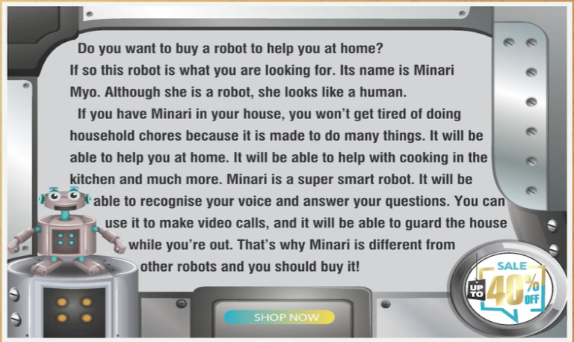  * Student’s answer.  I agree with the idea that in the future robots will be very useful to us. Firstly, home robots will be able to do all of our housework. Secondly, teaching robots will be able to help children do their homework. Next, worker robots will be able to build houses in the air; doctor robots will be able to help sick people; space robots will be able to build space stations on many other planets. Finally, robots will be able to do dangerous work for us. For these reasons, I think that robots will be useful in our future.  * My future robot' s name is Lucas. It is a housework robot. It can help me to do every housework such as: washing, cleaning, decorating....my house. In the future, it will be able to do more and more, it'll become a vehicle to get me to school or can help me to do my homework. It isn't dangerous for people, it's very friendly. I love my future robot so much .  * Robot is very useful . My robot is home robot. Its name is Linda, My robot is my best friend. It does a lot for me. It can clean the house, it can cook meal , do the washing up and iron my clothes……
5. WRAP-UP & HOME WORK (2’)

* Have Ss summarise what they have learnt with the two skills.
* HOME WORK.
- Finish writing a diary entry. Copy in the note books.
- Do more exercises in workbook.
- Prepare new lesson.

=========================

