Date of preparing: ………………………………….
Date of teaching: ………………………………….

Period …
UNIT 1: HOME
Lesson 3 - Part 1 (Page 12) - Vocabulary and Listening
Geography

I. OBJECTIVES
By the end of the lesson, Ss will be able to…
1. Knowledge
- know more vocabularies about directions.
- ask and answer about village, town and city.
2. Ability
- improve the use of English, speaking and listening skills.
3. Quality
- have positive attitude in English language learning so that they actively participate in all classroom activities.
- love hometown.

II. TEACHING AIDS AND LEARNING MATERIALS
Lesson plan, PPT slides, student’s book, workbook, notebook, personal computer (if any), projector/TV, speakers, DCR & DHA on EDUHOME, handouts…
III. PROCEDURES
A. Warm up: (5’)
a) Objective: Introduce the new lesson and set the scene for Ss to acquire new language; get students' attention at the beginning of the class by means of enjoyable and short activities as well as to engage them in the steps that follow.
b) Content: Introduction of some vocabularies about directions/ Burano Island – Italy.
c) Product: Ss get to know some new words they are going to study in the lesson.
d) Competence: Collaboration, communication, critical thinking.
e) Organization of the activity:
Teacher’s Activities | Students’ Activities
- Give greetings  - Check attendance  - Option 1: Vocabulary - a. Write the words in the boxes on the map  - Use part a. Vocabulary – Write the words in the boxes on the map for the Warmup activity  - Bring a compass to class, and help Ss use the compass and find directions  - Have Ss write answers  Lead to the new lesson  - Option 2: Introduce Burano Island – Italy  - Write questions on the board  1. Where is Burano Village?  2. How do people travel around the village?  3. How are the houses in the village? / What is special about the houses in the village?  - Have Ss work in pairs and guess the answer  - Show a video clip about Burano Island – Italy  Link: https://www.youtube.com/watch?v=ZO70JUFUPig  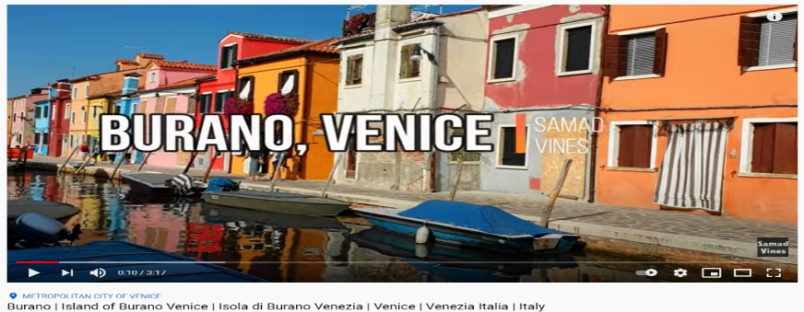  - Have Ss watch the clip and answer some questions:  - Introduce: Burano Island – Italy is the hometown of a boy in the listening section Ss are going to study today  Lead to the new lesson | - Greet T  - Learn how to use a compass, then write answers  Answer key  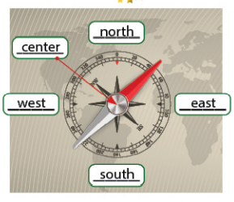  - Look at the questions  - Work in pairs, discuss the possible answers  - Watch the video clip, then give answers  Expected answers  1. Burano Village is in Venice, Italy  2. by boat / walk  3.The houses in the village are painted

B. New lesson (35’)
- Activities 1: Vocabulary (15’)
a) Objective: Ss know more vocabularies about directions and places.
b) Content:
- Writing words about direction.
- Writing words about places.
c) Products: Ss know how to pronounce the new words correctly and use them in appropriate situations.
d) Competence: Communication, collaboration, presentation, creativity.
e) Organization of the activity:
Teacher’s Activities | Students’ Activities
a. Write the words in the boxes on the map. Listen and repeat  - Demonstrate the activity using the example  - Have Ss look at the compass and write the words in the boxes on the map  - Ask Ss to work in pairs to check their answers with their partners  - Call Ss to give answers  - Check answers as a whole class  - Play audio (CD1 – Track 12). Have Ss listen and repeat  - Call some Ss to read the words again  - Correct Ss’ pronunciation if necessary  b. Read the description and write the underlined words under each picture. Listen and repeat  - Option 1:  - Have Ss read the description and write the underlined words under each picture  - Ask Ss to work in pairs to check their answers with their partners  - Call Ss to give answers  - Check answers as a whole class  - Play audio (CD1 – Track 13). Have Ss listen and repeat  - Call some Ss to read the words again  - Correct Ss’ pronunciation if necessary  - Option 2:  - Have Ss close all books  - Give / Show pictures, have Ss look and fill in the blanks  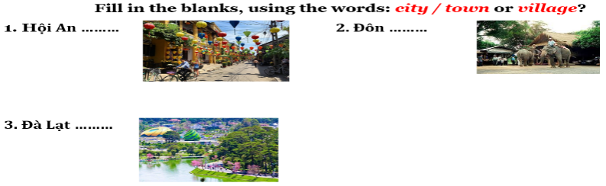  - Have Ss distinguish city / town and village through the pictures  - Have Ss open their books, read the description and write the underlined words under each picture  - Call Ss to give answers  - Check answers as a whole class  - Play audio (CD1 – Track 13). Have Ss listen and repeat  - Call some Ss to read the words again  - Correct Ss’ pronunciation if necessary | - Look and write  - Work in pairs  - Give answers  - Listen and repeat  - Read the words again  Answers keys  - Do the task  - Work in pairs  - Give answers  Answer keys  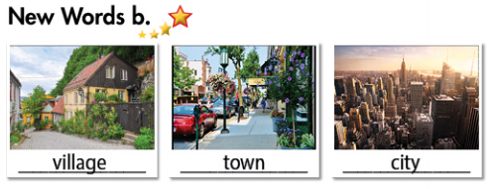  - Close all books  - Work in pairs  - Fill in the blanks  Answer keys  1. Hội An Town  2. Đôn Village  3. Đà Lạt City  - Comment  - Open books  - Give answers  - Listen and check  - Say the words again
- Activity 2: Listening (10’)
a) Objective: Ss can develop their listening comprehension skills.
b) Content: Listening to a boy talking about his hometown.
c) Products: Ss practice listening for main ideas and details.
d) Competence: Collaboration, communication, reasoning, analytical and synthesizing skills.
e) Organization of the activity:
Teacher’s Activities | Students’ Activities
a. Listen to a boy talking about his hometown. Does he like living there?  - Have Ss look at the request of the task. Analyze the instruction, emphasize the key words  - Guide Ss to listen for tone of voice  - Play audio (CD1 – Track 14)  - Have Ss listen and answer the question by circling Yes / No  - Check answers as a whole class  b. Listen and circle “True” or “False”  - Have Ss read the sentences, underline key words and make a guess whether the given sentences are True or False  - Demonstrate the activity.  - Play audio (CD1 – Track 14) again  - Have Ss listen and circle “True” or “False”  - Call Ss to read their answers  - Check answers as a whole class | - Read the instruction and underline the key words  - Listen and give answers  Answer keys  Yes.  - Check answers  - Read, underline key words and guess  - Listen and circle “True” or “False”  - Read answers  Answer keys  1T 2F 3F 4T  - Check answers
- Activity 3: Grammar – Useful language (10’)
a) Objective: Ss can use some useful languages in their speaking.
b) Content: structures to ask and answer about places.
c) Products: Ss apply the structure to producing the language successfully.
d) Competence: Collaboration, communication, presentation
e) Organization of the activity:
Teacher’s Activities | Students’ Activities
Listen then practice  - Option 1:  - Have Ss look at the Useful Language box  - Explain  - Explicit the structure:  Be famous for  - Play audio (CD1 – Track 15)  - Have Ss practice the useful language  - Have Ss practice the conversation, using other vocabularies from “New words” and Listening”, and their own ideas  - Call some pairs to present, give feedback and evaluation  - Option 2:  - Follow the same steps as option 1  - Call some Ss to ask and answer about a city / town / village they know (not in the book)  - Have Ss act out the conversation as naturally as they can (without using the textbook)  - Give feedback and evaluation | - Look  - Listen and take notes  - Listen  - Practice in pairs  - Present  Suggested conversation  A: Where is Burano?  B: It’s in the north of Italy  A: Is it a town?  B: No, it’s a small village  A: What’s it famous for?  B: It’s famous for painted houses.  - Work in pairs  - Present

C. Consolidation (3’)
* Vocabularies about directions and places: north, west, east, south, city, town, village, …
* Structures:
Be famous for …
To the north of ... / in the sound of …
D. Homework (2’)
- Practice asking and answering about places and directions.
- Do exercises in Workbook: Lesson 3 - New words – Listening (page 6).
- Prepare: Lesson 3 – Reading, Speaking and Writing (page 13 – SB).

