Thời gian làm bài: 40 phút (Không kể thời gian giao đề)
-------------------------

Câu 1. Look at the signs. Choose the best answer for the question.
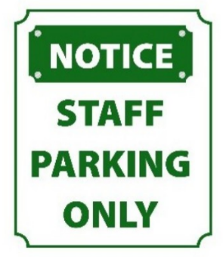
A. No one is allowed to park in this area.
B. This parking area is for everyone.
C. You have to contact the staff if you want to park in this area.
D. Only people who work here can park in this area.
Câu 2. Look at the signs. Choose the best answer for the question.
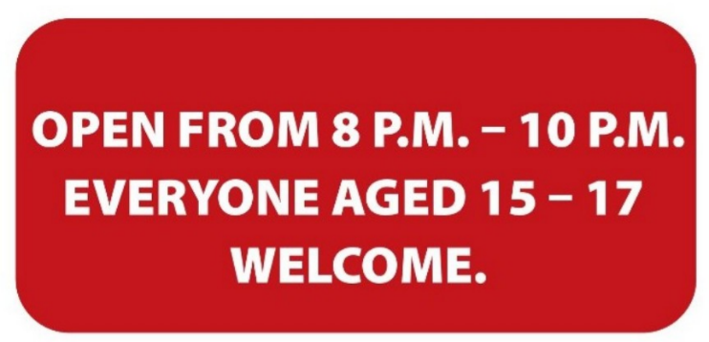
A. Only 15-17 people can enter the place from 8 p.m. to 10 p.m.
B. Only teenagers who are over 15 are allowed to enter this place.
C. The venue is open to all teenagers under the age of 17.
D. Teenagers aged 15-17 can visit the venue from 8 p.m. to 10 p.m.
Câu 3. What is the main reason James cannot attend the concert?
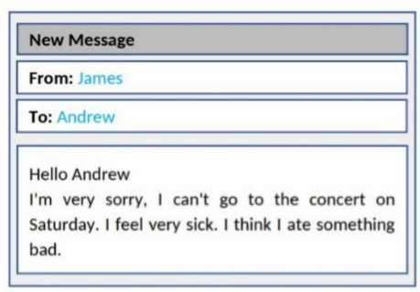
A. He lost his ticket B. He doesn't like the music
C. He has another commitment D. He is feeling unwell
Câu 4. Look at the signs. Choose the best answer for the question.

A. Today you can buy apples at a cheaper price before 6 p.m.
B. You can’t buy any apples before 6 p.m.
C. You can buy cheaper apples after 6 p.m.
D. You can only buy apples today.
Câu 5. What does this sign mean?
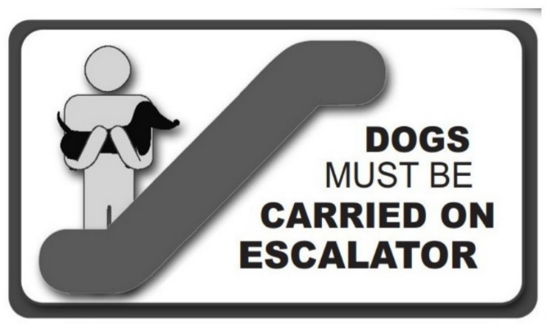
A. If you want, you can ride the escalator with your dog.
B. You don’t have to carry your dog on the escalator.
C. When using the escalator, you should carry your dog in your arms.
D. If you have a dog, you can't use the escalator.
Câu 6. What can you see at the circus?
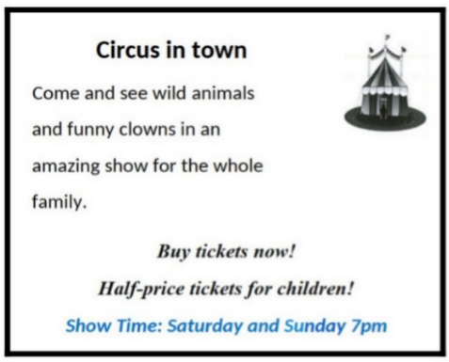
A. Only funny clowns B. Only acrobats
C. Only wild animals D. Wild animals and funny clowns
Câu 7. Look at the signs. Choose the best answer for the question.

A. You must look after your cameras in this area. B. Cameras can only be used for security purposes.
C. Cameras can be used in this area. D. This area is supervised by camera.
Câu 8. What activities will be allowed when the pool reopens?
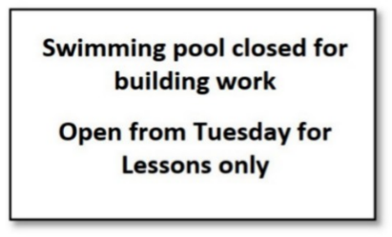
A. All regular activities B. Only swimming lessons
C. The notice doesn't specify allowed activities D. Building work and swimming lessons
Câu 9. Look at the signs. Choose the best answer for the question.
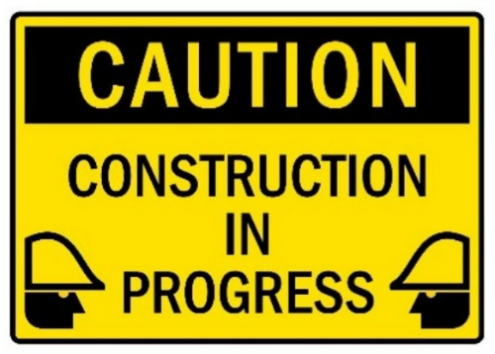
A. Be careful because building work is happening. B. You have to construct buildings with caution.
C. There is careful construction. D. Construction must be carefully done in progress.
Câu 10. Look at the signs. Choose the best answer for the question.
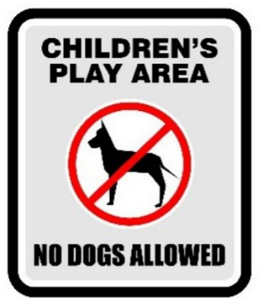
A. Dogs are not safe for children in this play area.
B. Dogs cannot be taken into this place as it is a children’s play area.
C. Don’t let your children play here because of the dogs.
D. Dogs are not allowed to play with children in this area.
----HẾT---

