School: ……………………………………….. | Date:……………………………..
Class: ……………………………..................... | Period: ………………………......

UNIT 5: FOOD and DRINKS
Lesson 1.1 – New words and Listening (Page 36)

I. OBJECTIVES
By the end of the lesson, Ss will be able to:
1.1. Language knowledge and skills
- know more words about ingredients and measurements (spaghetti, lemon, tomato, onion, tablespoon, teaspoon, grams, milliliters, sugar, oil, flour, milk).
- talk about what food they need to buy.
- Listen to and understand a talk between a boy and his mom (for general and specific details).
- ask for repetition to check an amount or quantity.
1.2. Competences
- improve communication, collaboration, and critical thinking skills.
1.3. Attributes
- help family with the housework.
- eat healthily.

II. TEACHING AIDS AND LEARNING MATERIALS
1. Teacher’s aids: Student book and Teacher’s book, class CDs, Digital Book (DCR phần mềm tương tác SB, DHA (từ vựng/ cấu trúc) phần mềm trò chơi tương tác), projector/interactive whiteboard / TV (if any), PowerPoint slides.
2. Students’ aids: Student’s book, workbook, notebook.

III. ASSESSMENT EVIDENCE
Performance Tasks | Performance Products | Assessment Tools
- Number the picture. | - Ss’ answers. | - T’s feedback/Peers’ feedback
- Listen and repeat. | - Ss’ presentation. | - T’s feedback/Peers’ feedback
- Practice saying units of measurement with the ingredients using the numbers below. | - Ss’ presentation. | - T’s feedback/Peers’ feedback.
- Listen to Logan talking to his mom. Where are they? | - Ss’ answers. | - T’s feedback/Peers’ feedback.
- Listen and write the amounts or quantities they need. | - Ss’ answers. | - T’s feedback/Peers’ feedback.
- Speak: What do you usually buy at the supermarket? | - Ss’ answers/ presentation. | - T’s observation and feedback.

IV. PROCEDURES
A. Warm up: (5’)
a) Objective: Introduce the new lesson and set the scene for Ss to acquire new language; get students' attention at the beginning of the class by enjoyable and short activities as well as to engage them in the follow-up steps.
b) Content: Introduce words about ingredients and measurements / Make a shopping list.
c) Expected outcomes: Ss get to know some new words they are going to study in the lesson.
d) Organization of the activity:
TEACHER’S ACTIVITIES | STUDENTS’ ACTIVITIES
- Option 1: Number the pictures. Listen and repeat.  - Use the “New words” part a.– page 36 for the warm-up activity.  - Show words and pictures using DCR, have Ss look and number the pictures (in pairs).  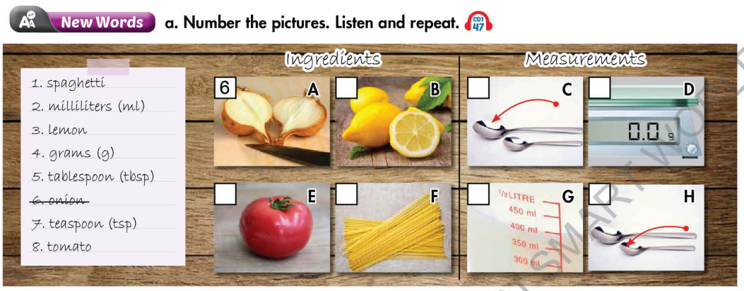  - Call Ss to give answers.  - Give feedback and show correct answers.  - Lead to the new lesson.  - Play the audio (CD1 – Track 47), have Ss listen and repeat.  - Correct Ss’ pronunciation if necessary.  - Option 2: Make a shopping list.  - Let Ss imagine they are going to prepare dinner for a family of about 4-5 people.  - Have Ss work in groups of 4 to make a shopping list for things to buy to prepare dinner.  - Remind Ss to add quantity of the things they intend to buy.  - Have some groups share their answers with the whole class.  - Give feedback and evaluation.  - Lead to the new lesson. | - Work in pairs to number the pictures.  - Give answers.  - Listen.  - Listen and repeat.  Answer keys  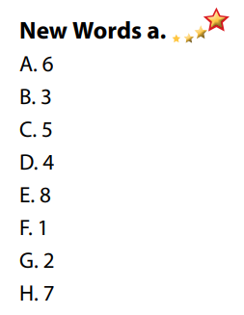  - Work in groups of 4.  - Give answers.  - Listen.

B. New lesson (35’)
- Activity 1: Pre-Listening (Vocabulary) (12’)
a) Objective: Ss get to know words about ingredients and measurements.
b) Content:
- Vocabulary study (spaghetti, lemon, tomato, onion, tablespoon, teaspoon, grams, milliliters).
- Speaking: Say units of measurements with the ingredients using the given numbers.
c) Expected outcomes: Ss know how to pronounce the new words correctly and use them when talking about food and its quantities.
d) Organization of the activity:
TEACHER’S ACTIVITIES | STUDENTS’ ACTIVITIES
Task a. Number the pictures. Listen and repeat.  - Option 1 (If the teacher hasn’t used this part for the Warm-up activity)  - Demonstrate the activity on DCR, using the example.  - Have Ss number the pictures.  - Divide class into pairs and have them check their answers with their partners.  - Call Ss to give answers (read or write).  - Check answers as a whole class using DCR.  - Play audio (CD1 – Track 47). Have Ss listen and repeat.  - Correct Ss’ pronunciation.  - Option 2: Ingredients and Measurements (If the teacher has used part a. for the Warm-up activity)  - Give many words about ingredients and measurements (or pictures, if so, T uses different pictures from those in Task a).  - Have Ss work in pairs to divide the given words / pictures into 2 groups: ingredients and measurements.  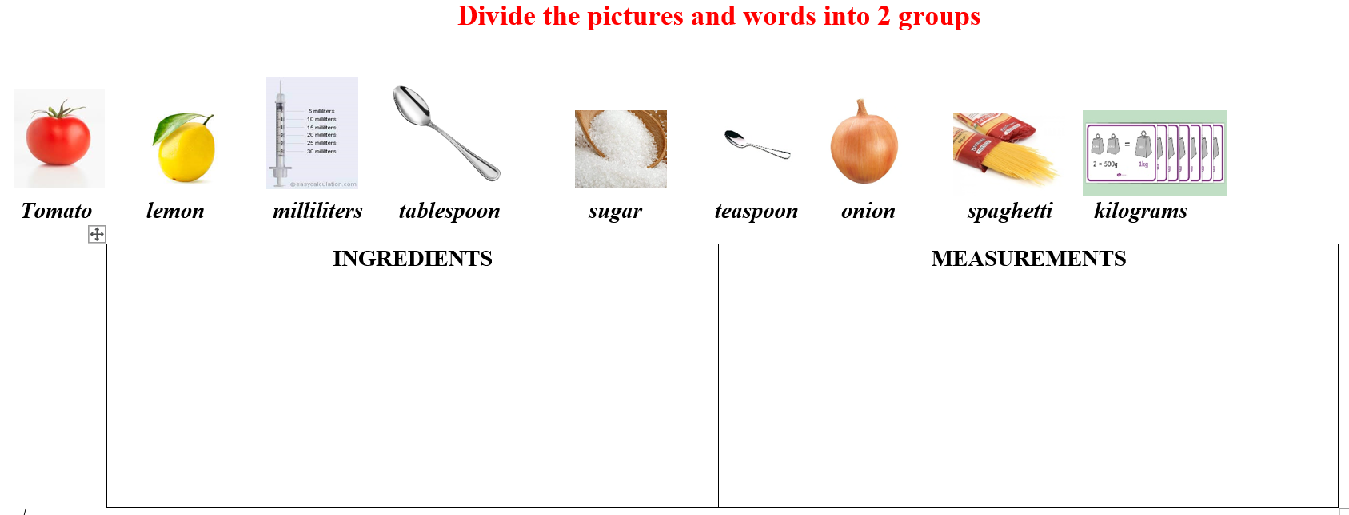  - Have Ss give answers and tell the meaning of words / phrases again.  - Check answers as a whole class.  - Call some Ss to read the words again.  - Correct Ss’ pronunciation if necessary.  Task b. In pairs: Practice saying units of measurement with the ingredients using the numbers below.  - Have Ss work in pairs to say units of measurement with the ingredients using the numbers in the table.  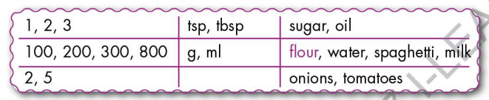  - Go round and give help if necessary.  - Have some pairs demonstrate the activity in front of the class.  - Give feedback and evaluation. | - Look and listen.  - Work individually.  - Work in pairs.  - Give answers.  - Listen and repeat.  Answer keys  - Work in pairs.  - Give answers, explain.  - Read.  Answer keys  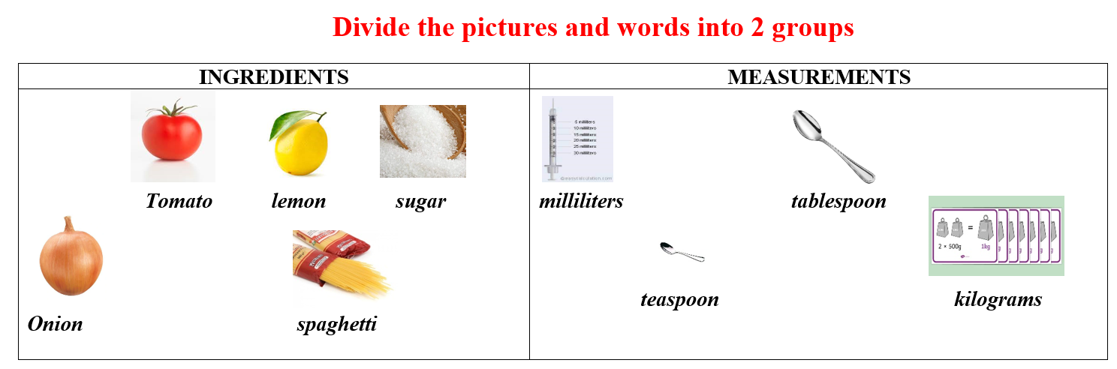  - Work in pairs.  - Present.  Sample answers  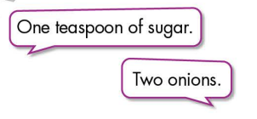
- Activity 2: While - Listening (17’)
a) Objective: Students can develop their listening skill.
b) Content:
- Listen to Logan talking to his mom. Where are they?
- Listen and write the amounts or quantities they need.
c) Expected outcomes: Students can listen and understand general and specific information about making a shopping list.
d) Organization of the activity:
TEACHER’S ACTIVITIES | STUDENTS’ ACTIVITIES
Task a. Listen to Logan talking to his mom. Where are they?  - Have Ss read the phrases, guess the answer.  - Play audio (CD1 - Track 48).  - Have Ss listen and circle the correct answer.  - Check answers as a whole class using DCR.  Task b. Now, listen and write the amounts or quantities they need.  - Have Ss read the through the content of Task b.  - Play the audio again (CD1 - Track 48).  - Have Ss listen and write the amounts or quantities they need.  - Ask Ss to pay attention to the way to say numbers.  - Have Ss check answers with their partners.  - Call Ss to give answers.  - Give feedback and show correct answers using DCR. | -Work individually.  - Listen.  - Circle the correct answers.  Answer keys  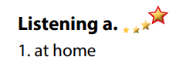  - Read.  - Do the task.  - Exchange answers.  Answer keys  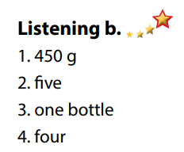

- Activity 3: Post - Listening (6’)
a) Objective: Students can use the vocabulary and the content in listening part to develop their speaking skill.
b) Content: Speaking: What do you usually buy at the supermarket?
c) Expected outcomes: Students can think of their shopping list in the supermarket.
d) Organization of the activity:
TEACHER’S ACTIVITIES | STUDENTS’ ACTIVITIES
Conversation skill  - Have Ss look at the Conversation skill box and read.  - Play audio (CD 1 - Track 49), have Ss listen and repeat.  - Ask Ss to find more ways to ask for repetition.  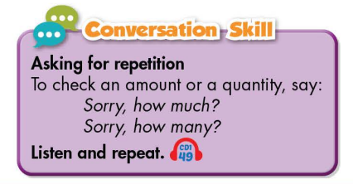  Task c. In pairs: What do you usually buy at the supermarket?  - Have Ss work in pairs to discuss.  - Observe and give help if necessary.  - Call some pairs to share their ideas with the class.  - Give feedback and evaluation. | - Look and read.  - Listen and repeat.  - Give answers.  - Work in pairs.  - Present.

C. Consolidation and homework assignments (5’)
* Consolidation:
- Words about ingredients and measurements: spaghetti, lemon, tomato, onion, tablespoon, teaspoon, grams, milliliters, sugar, oil, flour, milk.
- Language to ask for repetition to check an amount or quantity: Sorry, how much? / Sorry, how many?

* Homework
- Learn the new words by heart.
- Practice talking about what to buy at the supermarket.
- Do the exercises in WB: New words and Listening (pages 26, 27 – WB).
- Do the vocabulary exercise in Tiếng Anh 7 i-Learn Smart World Notebook (page 28).
- Play consolation games in Tiếng Anh 7 i-Learn Smart World DHA App on www.eduhome.com.vn
- Prepare: Lesson 1.2 – Grammar (page 37 – SB).

D. Reflection
a. What I liked most about this lesson today:
…………………………………………………………………………………………
- What I learned from this lesson today:
…………………………………………………………………………………………
c. What I should improve for this lesson next time:
…………………………………………………………………………………………

