GLOBAL SUCCESS 8
UNIT 6 TEST: LIFESTYLES
Name: ___________________________ Class: _____________ Date: _____________
PART I LISTENING (1.25 pts)
Listen to a teenager talking about daily lifestyle habits. Choose the best answer A, B, or C. You will listen twice.
1. What is the talk mainly about?
A. A school sports event B. A teenager’s daily lifestyle C. A family holiday
2. Where does the speaker usually have breakfast?
A. At home B. At a street-food stall C. In the school canteen
3. How does the speaker greet teachers?
A. By using their first names B. By saying only “Hi” C. By using a title and surname
4. How often does the speaker study online?
A. Twice a week B. Every morning C. Once a month
5. What will the speaker do next month?
A. Join a traditional craft club B. Move to another country C. Stop using technology
PART II PHONETICS (1.0 pt)
Task 1. Choose the word whose bold part is pronounced differently from the others.
6. A. bridge B. breakfast C. practice D. broccoli
7. A. programme B. present C. precious D. breakfast
Task 2. Choose the word whose stress pattern is different from the others.
8. A. lifestyle B. social C. native D. enjoy
9. A. traditional B. practical C. delicious D. amazing
PART III LANGUAGE USE (2.5 pts)
Choose the best answer A, B, C, or D to complete each sentence.
10. The women in the village know how to ________ colourful baskets.
A. greet B. weave C. serve D. celebrate
11. The patterns on these clothes are examples of ________ art.
A. native B. online C. modernly D. daily
12. In parts of Alaska, a ________ is still used for travelling across snow.
A. food stall B. dog sled C. tribal dance D. greeting
13. This restaurant ________ delicious local food every evening.
A. practises B. serves C. weaves D. keeps
14. My brother is ________ studying online after dinner.
A. in the habit of B. interested to C. certain on D. native at
15. I think online learning ________ more common in the future.
A. becomes B. became C. will become D. becoming
16. If the weather is bad tomorrow, the outdoor market ________.
A. closes B. closed C. will close D. closing
17. Choose the best response to complete the dialogue.
Tom: “Do you think people will still make traditional crafts in the future?”
Mai: “________________________. Many young people are learning them now.”
A. I’m certain they will B. I don’t know where
C. No, they don’t D. That’s a restaurant
Choose the sentence that is closest in meaning to the original one.
18. I am sure that online learning will continue to grow.
A. Online learning will certainly continue to grow.
B. Online learning stopped growing yesterday.
C. Online learning may never be used again.
D. Nobody is certain about online learning.
19. Leave now, or we will miss the bus.
A. If we leave now, we will miss the bus.
B. If we do not leave now, we will miss the bus.
C. We will miss the bus because we left early.
D. We will not miss the bus if we stay here.ART IV PRACTICAL SKILLS (1.0 pt)
Task 1. Look at the signs and choose the best answer.
20. What should people do near this room?
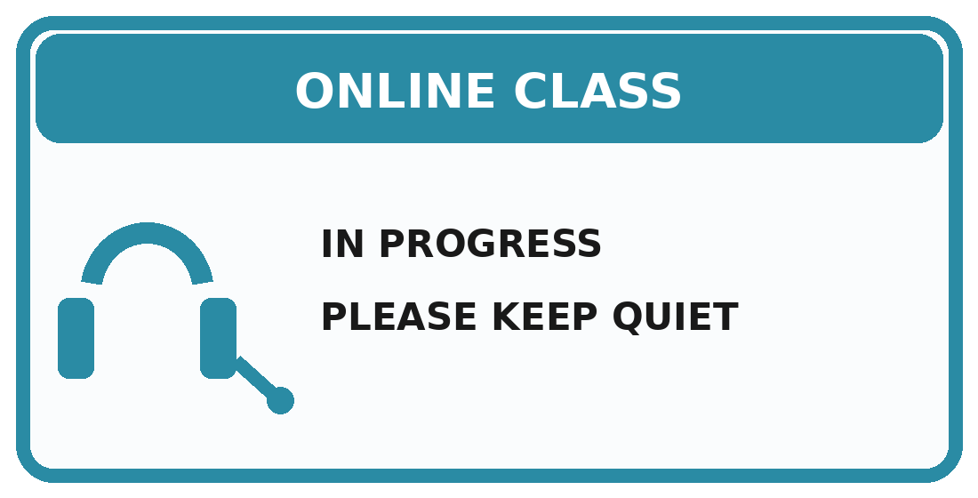
A. Speak loudly during the lesson. B. Keep quiet because an online class is taking place.
C. Enter the room without permission. D. Turn off every computer in the building.
21. What is the main message of this sign?
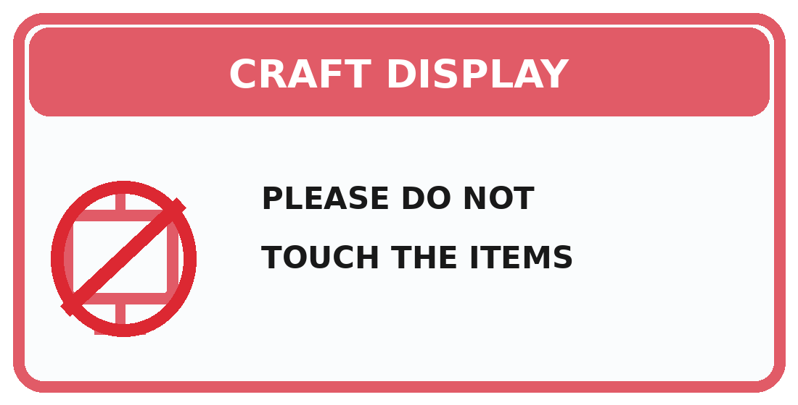
A. Visitors may move the craft items. B. The display is closed permanently.
C. Students should make new items here. D. Visitors must not touch the displayed crafts.
Task 2. Read the notice and choose the best answer.
GREEN VALLEY LOWER SECONDARY SCHOOL
LIFESTYLE EXCHANGE DAY
Discover different lifestyles from Viet Nam and around the world.
Activities: greeting demonstration, street-food talk, native art exhibition, and online-learning workshop.
Time: 2.00 p.m.–4.00 p.m., Friday, 15 March Place: School Hall
Bring one photo showing a lifestyle activity. Register with your English teacher by Tuesday.
22. What is the main purpose of the notice?
A. To invite students to a Lifestyle Exchange Day B. To announce a school examination
C. To advertise a new restaurant D. To organise a football competition
23. What should each student bring?
A. A traditional meal B. A dog sled
C. One photo of a lifestyle activity D. A computer
PART V READING (2.25 pts)
Task 1. Read the announcement and choose the correct option A, B, C, or D for each blank.
CULTURAL CENTRE VISIT
Next Saturday, our class will visit a cultural centre. We (24) ________ traditional crafts and learn how people maintain their lifestyles.
If the weather is fine, we (25) ________ the outdoor street-food area.
Students should bring notebooks because they will (26) ________ useful information.
The trip will show us that modern technology and tradition can exist (27) ________.
24. A. see B. saw C. will see D. seeing
25. A. visit B. will visit C. visited D. visits
26. A. record B. weave C. serve D. greet
27. A. side by side B. yesterday C. carelessly D. abroad
Task 2. Read the text and choose the correct answer A, B, C, or D.
Mai is thirteen and lives in a coastal town. Her grandparents make fishing nets by hand and sell snacks at a small street stall. Mai’s parents run a local restaurant. During the week, Mai attends school, and twice a week she studies coding online. She likes online learning because she can replay difficult parts of a lesson, but she sometimes misses discussing ideas face to face. At weekends, she helps her grandmother weave small decorations and uploads photos of them to the school website. Mai believes technology can help preserve traditions. Next month, she will create a short video about her family’s craft. If her classmates show enough interest, her grandmother will lead a workshop at school.
28. What do Mai’s parents do?
A. They teach coding. B. They run a local restaurant.
C. They make dog sleds. D. They work at her school.
29. What advantage of online learning does Mai mention?
A. She can replay difficult parts. B. She never has homework.
C. She studies only at weekends. D. She does not need teachers.
30. What does Mai sometimes miss?
A. Buying street food B. Making fishing nets
C. Discussing ideas face to face D. Visiting another countryRT V
31. What will Mai create next month?
A. A new restaurant menu B. A short video about her family’s craft C. A dog-sled route D. A school uniform
32. What may happen if Mai’s classmates are interested?
A. Her grandmother will lead a workshop. B. Mai will stop studying online.
C. Her parents will close the restaurant. D. The family will move to another town.
PART VI ORDERING (0.5 pt)
Arrange the sentences to make a complete dialogue.
33.
a. Yes, I’m certain it will.
b. Do you think online learning will become more popular?
c. Why are you so sure?
d. Because it gives students more flexible ways to study.
A. b – a – c – d B. b – c – a – d C. a – b – d – c D. c – d – b – a
34.
a. Great! I’ll bring my camera.
b. What will we do if the weather is fine?
c. We’ll visit the outdoor street-food market.
d. Then we can take photos for our project.
A. c – b – a – d B. b – c – a – d C. b – a – d – c D. a – d – b – c
PART VII WRITING (1.5 pts)
Task 1. Rewrite the sentences so that the second sentence has a similar meaning. (1.0 pt)
35. I plan to join the online workshop tomorrow.
→ I will __________________________________________________________________.
36. Hurry up, or you will miss the opening ceremony.
→ If you do not ____________________________________________________________.
37. I am certain that traditional crafts will remain important.
→ Traditional crafts will _____________________________________________________.
38. The weather may be fine. In that case, we will visit the outdoor market.
→ If the weather ____________________________________________________________.
TASK 2 PARAGRAPH WRITING (0.5 pt)
Write a paragraph of 80–100 words about the advantages and disadvantages of online learning.
You should include:
• when and where students can learn online;
• at least two advantages;
• at least one disadvantage;
• your opinion about online learning.
Write your paragraph
………………………………………………………………………………………………….
………………………………………………………………………………………………….
………………………………………………………………………………………………….
………………………………………………………………………………………………….
………………………………………………………………………………………………….
………………………………………………………………………………………………….
………………………………………………………………………………………………….
………………………………………………………………………………………………….
………………………………………………………………………………………………….
………………………………………………………………………………………………….
………………………………………………………………………………………………….

GLOBAL SUCCESS 8
UNIT 6: LIFESTYLES
ANSWER KEY & LISTENING TRANSCRIPT
LISTENING TRANSCRIPT
Part I. Listening – Questions 1–5
Teacher’s instructions: Give students 30 seconds to read the questions. Play or read the recording twice. Pause briefly between the two readings, then give students 30 seconds to check their answers.
Hello, I’m Nam. Let me tell you about my daily lifestyle. On school days, I get up at six and usually have breakfast at a street-food stall near my house. I sometimes eat at home at weekends, but I do not normally have breakfast in the school canteen. At school, I greet my teachers by saying “Good morning, Mr Long” or “Good morning, Ms Hoa”. I do not call them by their first names, and I never say only “Hi”. After school, I help my parents and do my homework. I study English online twice a week, not every morning or just once a month. Technology is useful, but I also enjoy traditional activities. Next month, I will join a traditional craft club to learn how to weave small baskets. I am not moving to another country, and I certainly will not stop using technology. I like combining modern learning with traditional skills.
Listening answers: 1B – 2B – 3C – 4A – 5A
ANSWER KEY
SECTION | ANSWERS
PART I. LISTENING | 1B, 2B, 3C, 4A, 5A
PART II. PHONETICS | 6C, 7D, 8D, 9B
PART III. LANGUAGE USE | 10B, 11A, 12B, 13B, 14A, 15C, 16C, 17A, 18A, 19B
PART IV. PRACTICAL SKILLS | 20B, 21D, 22A, 23C
PART V. READING | 24C, 25B, 26A, 27A, 28B, 29A, 30C, 31B, 32A
PART VI. ORDERING | 33A, 34B
PART VII. WRITING – Suggested answers
35. I will join the online workshop tomorrow.
36. If you do not hurry up, you will miss the opening ceremony.
37. Traditional crafts will certainly remain important.
38. If the weather is fine, we will visit the outdoor market.
Equivalent answers that preserve the required meaning and grammatical structure may also be accepted.
39. Sample paragraph (about 90 words)
Online learning allows students to study at home or anywhere with an internet connection. It is convenient because learners can save travelling time and replay difficult parts of a lesson. It also gives students access to many useful videos and digital exercises. However, online learning has some disadvantages. Students may feel lonely, become distracted by social media, or have problems with weak internet connections. In my opinion, online learning is very helpful when it is combined with face-to-face lessons and when students manage their screen time carefully.
Teacher note
• Question 34 is keyed as B because it is the only complete sequence offered in the test. For a future revision, “b – c – d – a” would also form a natural dialogue.

