ĐỀ THI THỬ SỐ 14  TRƯỜNG THCS : …………………………….  LỚP : …………………………………………...  ( Đề theo cấu trúc mới Format 40 câu ) | SỞ GD – ĐT THÀNH PHỐ HỒ CHÍ MINH  KỲ THI TUYỂN SINH VÀO LỚP 10  KHÓA NGÀY……THÁNG……NĂM 20…  (Thời gian làm bài 90 phút)

I. Choose the word (A, B, C or D) whose underlined part is pronounced differently from the others.
1. A. museum B. cultural C. drum D. sculpture
2. A. kits B. photographs C. laughs D. chores
II. Choose the word (A, B, C or D)whose main stress is placed differently from the others in each group.
3. A. apply B. supply C. device D. order
4. A. dictionary B. emotional C. computer D. technology
III. Choose the word / phrase (A, B, C or D) that best fits the space in each sentence.
5. Wearing uniforms helps students be proud __________ their school.
A. about B. in C. at D. of
6. A young man was here __________ you this afternoon.
A. allowing for B. sticking up for C. asking for D. accounting for
7. The dish __________ I ordered was delicious.
A. where B. why C. that D. who
8. Things will get easier as time __________.
A. goes by B. turn over C. keeps up D. lets off
9. the most persuasive talker often dominates the decision __________.
A. range B. task C. process D. endurance
10. The stores were overrun with __________ rats and mice.
A. an B. the C. a D. no article
11. What is the ___________ of your dress? Is it made of silk?
A. design B. material C. clothing D. fashion
12. Conan Edogawa is a genius ___________.
A. detective B. character C. policeman D. investigator
13. ___________ a Vietnamese citizen, we would like Vietnam to be a dragon in Asia.
A. Such as B. As C. Like D. All are correct
14. He __________ regretted having been so unkind.
A. awfully B. bitterly C. severely D. fully
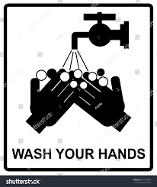
IV.Choose the best answer (A, B, C or D) for the following picture or sign.
15. On the way, you can see this sign and it warns that:
A. You can’t wash your hands before meals.
B. You want to have some soap to wash hands.
C. Your hands need some water.
D. You must wash your hands before meals.

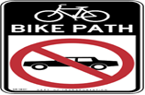
16. At the public, when we can see this sign, it means:
A. You can park here.
B. This is path for cars only.
C. Only bikes are allowed here.
D. You are allowed to drive cars here.

V. Choose the word (A, B, C or D) that best fits the blank space in the following passage.
Tips To Improve Your English Today! You can (17)___ the language on your phone and computer operation system to English. You may already watch or read the news on a daily basis; now try doing it (18)____ English. Listening to music in English is great but do you struggle to understand all of the (19)____ that they are singing? You can search (20)____ the lyrics on the Internet and learn the lyrics. Write about what you did each day in English or write a story. Try to find someone to speak English (21)____; whether it is a friend, family member or colleague from your work. Watching cartoons is a great activity for (22)____ English. What action will you take today to learn English?
17.A.change B.changing C.to change D.changed
18.A.with B.in C.by D.of
19.A.word B.words C.note D.notes
20.A.to B.into C.for D.in
21.A.with B.for C.by D.about
22.A.learn B.improve C.teaching D.learning
VI.Read the passage, then decide if the statements that follow it are True or False
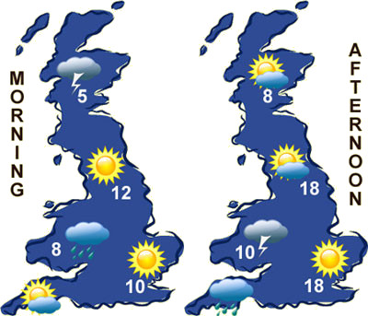

23. It will stay dry in the Southeast the whole day.
24. The maximum temperature will be around 18 degrees Celsius.
25. It will rain all day in the Southwest.
26. The temperatures in the afternoon will be higher than in the morning
27. The picture mainly mentioned:
A.a weather forecast report for a day
B.a weather forecast report for a week
C.a weather forecast report for a month
D.a weather forecast report in the morning
28.There will some rain in the Southwest :
A. in the morning B. in the afternoon C. in the evening D. all day
VII. Use the correct form of the word given in each sentence
29.WHO has therefore made the …………................... that COVID-19 can be characterized as a pandemic. (assess)
30.The company needs more …………..................assistant from the government. (finance)
31.We were all surprised at her …………........................ to help. (refuse)
32.Health care was ………….....................in ancient time. There was no hospital or doctor then. (exist)
33.Mr. Brown felt ………….................. that people have spoiled that area. (disappoint)
34.My friend has been nominated as one of the most effective ………………………….. in the town charity program. (active)
VIII. Put the words in the correct order to make meaningful sentences.
35.and door latches/ there must be / all the window / strong wind blowing / should check / since / We //
- We …………......................................................................................................................
36.today/ for students / uniforms / it isn’t necessary / to wear //
- It ……………………………………………………………………………………….…
IX. Rewrite each of the following sentences in another way so that it means almost the same as the sentence printed before it

37.I think we shouldn’t use electricity to catch fish.
I suggested not …………………………………………………………………………..
38.Eat less meat or you will have high cholesterol in your blood.
If you …………………………………………………………………………………......
39.Smoke filled the rooms when she wakes up.
The rooms ………………………………………………………………………………..
40.I met a generous man on my way home yesterday.
The man………………………………………………………………………………….

ĐÁP ÁN ĐỀ THI THỬ SỐ 14
PHẦN TRẮC NGHIỆM
1.A | 2.D | 3.D | 4.A | 5.D | 6.C | 7.C | 8.A
9.C | 10.D | 11.B | 12.A | 13.B | 14.A | 15.D | 16.C
17.A | 18.B | 19.B | 20.C | 21.A | 22.D | 27.A | 28.B
PHẦN TỰ LUẬN.
CHỌN TRUE/FALSE

23.TRUE
24.TRUE
25.FALSE
26.TRUE
TỪ LOẠI
29.assessment
30.financial
31.refusal
32.non-existent
33.disappointed
34.activists
GHÉP CÂU
35.We should check all the window and door latches since there must be strong wind blowing.
36.It isn’t necessary for students to wear uniforms today.
VIẾT CÂU
37.I suggested not using electricity to catch fish.
38.If you eat less meat, you won’t have high cholesterol in your blood.
If you eat A LOT OF/ MUCH meat, you will have high cholesterol in your blood.
If you have high cholesterol in your blood, you MUST eat less meat.
39.The rooms were filled with smoke when she wakes up.
40.The man whom I met on my way home yesterday is generous.

