|  |  |
| --- | --- |
|  | *Thời gian làm bài: 40 phút (Không kể thời gian giao đề)*  *-------------------------* |

**Họ tên thí sinh: .................................................................**

**Số báo danh: ......................................................................**

**Mã Đề: 010.**

**Câu 1.** Who should students contact if they have lost their phone?

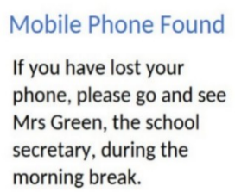

**A.** Mrs Green  **B.** The janitor  **C.** The principal  **D.** Their teacher

**Câu 2.** What is the offer for the swim class?

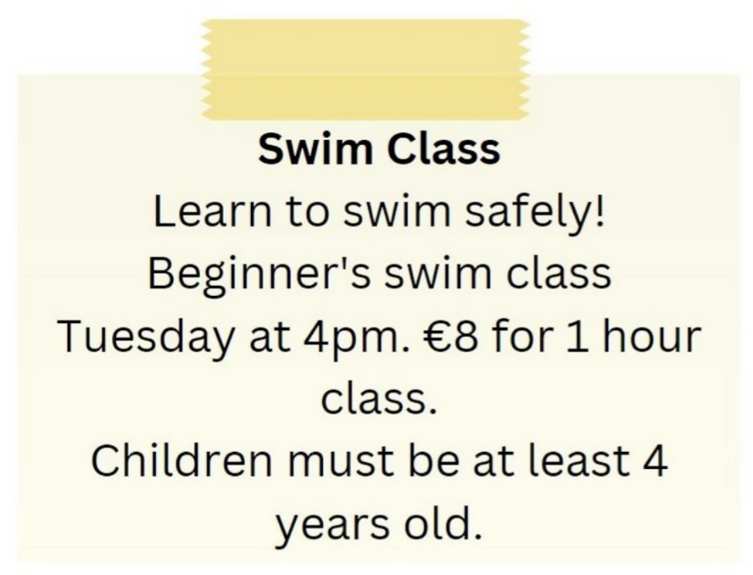

**A.** Beginner's swim class on Tuesday at 5pm for €10

**B.** Advanced swim class on Tuesday at 4pm for €8

**C.** Beginner's swim class on Tuesday at 4pm for €8

**D.** Beginner's swim class on Wednesday at 4pm for €8

**Câu 3.** **Look at the signs. Choose the best answer for the question.**

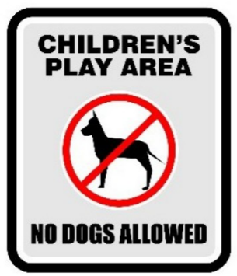

**A.** Dogs are not allowed to play with children in this area.

**B.** Dogs cannot be taken into this place as it is a children’s play area.

**C.** Dogs are not safe for children in this play area.

**D.** Don’t let your children play here because of the dogs.

**Câu 4.** Which day is the City Zoo closed?

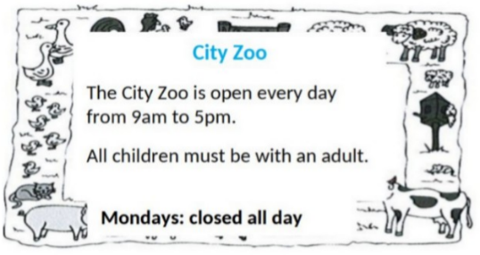

**A.** Sunday  **B.** Friday  **C.** Saturday  **D.** Monday

**Câu 5.** What activities will be allowed when the pool reopens?

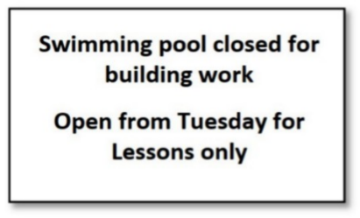

**A.** All regular activities  **B.** Only swimming lessons

**C.** The notice doesn't specify allowed activities  **D.** Building work and swimming lessons

**Câu 6.** **Look at the signs. Choose the best answer for the question.**



**A.** You must look after your cameras in this area.  **B.** Cameras can be used in this area.

**C.** This area is supervised by camera.  **D.** Cameras can only be used for security purposes.

**Câu 7.** **Look at the signs. Choose the best answer for the question.**

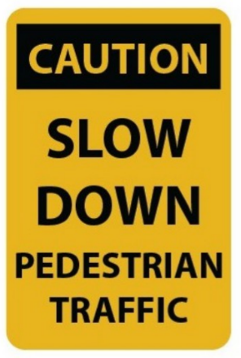

**A.** Pedestrians should walk slowly.

**B.** You should drive carefully because of slow pedestrians.

**C.** You should slow your speed and pay attention to pedestrians.

**D.** Pedestrians will slow down the traffic.

**Câu 8.** **Look at the signs. Choose the best answer for the question.**

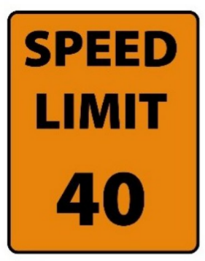

**A.** You can drive 40 miles per hour or more.  **B.** You must drive at 40 miles per hour.

**C.** You cannot drive faster than 40 miles per hour.  **D.** The minimum speed is 40 miles per hour.

**Câu 9.** What does this sign mean?

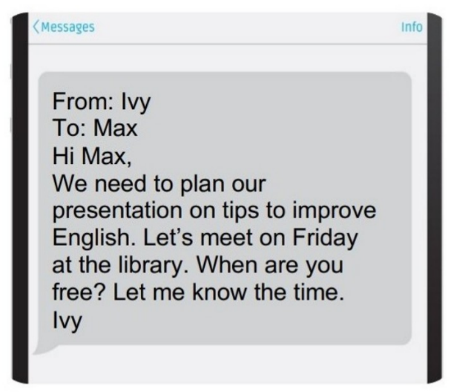

**A.** Ivy wants to remind Max of the project's deadline.

**B.** Ivy wants to thank Max for doing the presentation.

**C.** Ivy wants to find out more about the project from Max.

**D.** Ivy wants to know when they will meet to work on the project.

**Câu 10.** **Look at the signs. Choose the best answer for the question.**

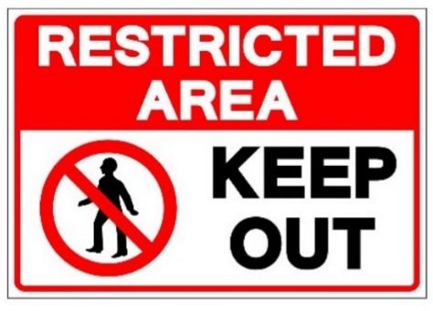

**A.** We should keep this area out.  **B.** People aren’t allowed to enter this area.

**C.** This area is kept open.  **D.** This area is open to everyone.

**----HẾT---**