Full name: ……………………………………………….  Class: …………………………………………………….  School: …………………………………………………. | Mark:

SPEAKING TEST 5 (UNITS 9 & 10)

TASK 1 |  |  | Tell your friend how your city uses energy sources.  The following questions may help you.
 | 1. | What kind of energy sources is your city using?
 | 2. | What is the most popular type of energy source in your city?
 | 3. | What are the benefits of energy sources in your city?
 | 4. | What may be problems from the use of energy sources in your city?
 | 5. | What do you think can save energy sources in your city?

TASK 2 | Work in pairs. Each of you receives a card. Use the clues on your card to make questions about your friend’s picture. Use the picture on your card to answer your friend’s questions.

CARD A
Ask your friends about his / her picture. Listen to his / her answers. |  | 
1. | What / kind of festival?
2. | What / main activities?
3. | What activities / like / best?
4. | Why / lion dance?
5. | What / kind of gift / like best? Why?
 |  | Answer your friend’s questions about this picture.

CARD B
Ask your friends about his / her picture. Listen to his / her answers.

1. | What / kind of festival? | 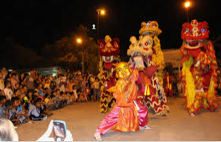
2. | What / main activities?
3. | What activities / like / best?
4. | Why / coloured lights?
5. | What / kind of gift / like best? Why?
 |  | Answer your friend’s questions about this picture.

