Họ tên thí sinh: .................................................................
Số báo danh: ......................................................................
Mã Đề: 016.
Câu 1. Look at the signs. Choose the best answer for the question.
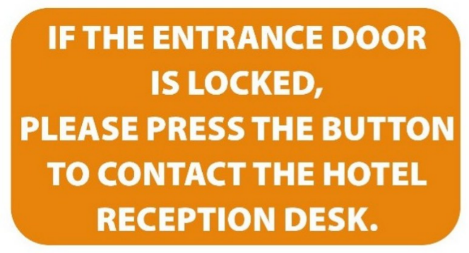
A. Contact the hotel reception if you want to press the button.
B. When the entrance door is locked, press the button to open it.
C. You need to contact the receptionist if you cannot lock the door.
D. Use this button to call the hotel staff when you can’t get in.
Câu 2. What is the offer at the Tennis Club?
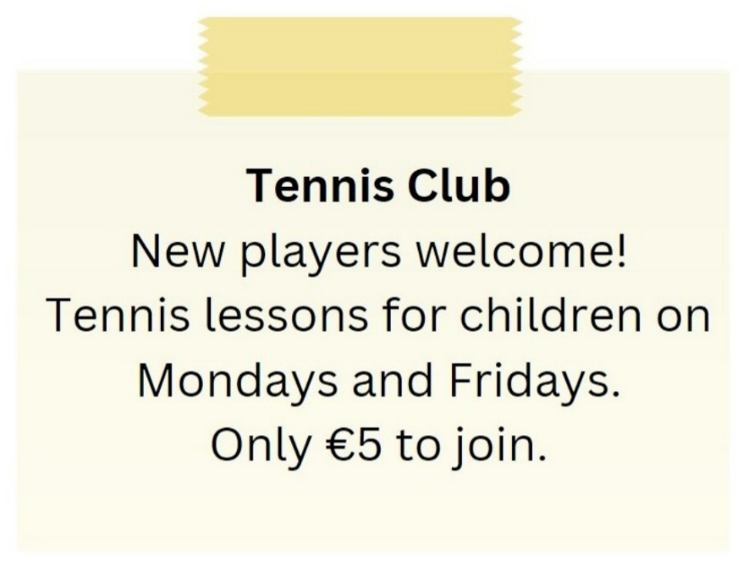
A. Tennis lessons for children on Mondays and Fridays for €5 to join
B. Tennis lessons for children on Tuesdays and Thursdays
C. Tennis lessons for adults on Mondays and Fridays
D. €10 to join the club
Câu 3. What has Tim booked for himself and Ben?

A. Concert tickets B. Theater tickets C. Movie tickets D. Sports game tickets
Câu 4. Look at the signs. Choose the best answer for the question.
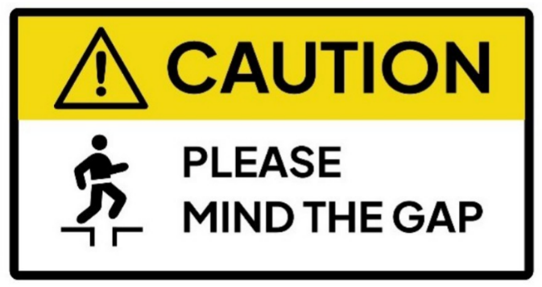
A. You need to remember the gap. B. You need to stay away from the gap.
C. You need to think about the gap. D. You need to be careful about the gap.
Câu 5. What subject does John need help with?
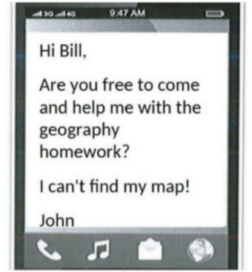
A. English B. History C. Math D. Geography
Câu 6. Which of the following statements is true?
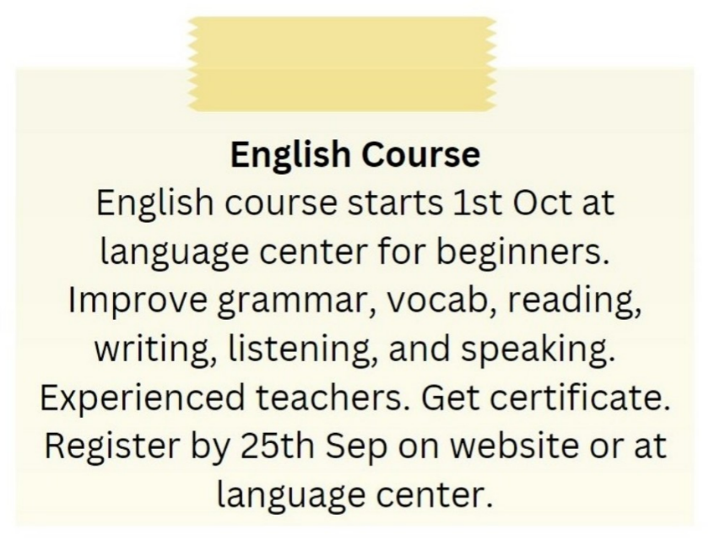
A. The English course is for advanced learners.
B. The English course starts on 1st September.
C. The English course is taught by experienced teachers.
D. The English course does not provide a certificate.
Câu 7. What is true about the New Zealand advertisement?
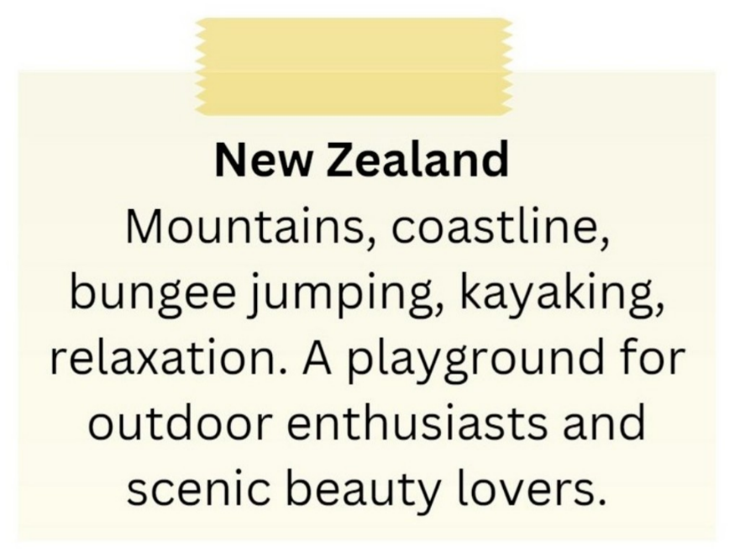
A. It is a destination for indoor activities and cultural experiences.
B. It is not suitable for outdoor enthusiasts.
C. It highlights mountains, coastline, bungee jumping, and kayaking.
D. It primarily appeals to relaxation enthusiasts.
Câu 8. Look at the signs. Choose the best answer for the question.
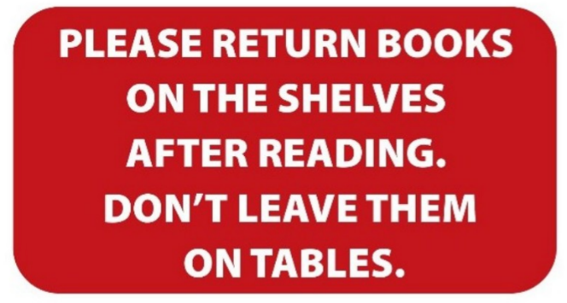
A. You need to put the books both on the table and the shelves.
B. Books should be left on the tables instead of the shelves.
C. You can leave books either on the shelves or on the tables.
D. After you finish reading, you have to put the books back on the shelves.
Câu 9. Look at the signs. Choose the best answer for the question.
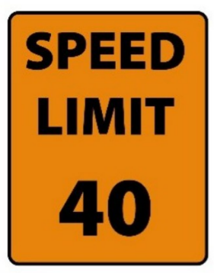
A. The minimum speed is 40 miles per hour. B. You cannot drive faster than 40 miles per hour.
C. You can drive 40 miles per hour or more. D. You must drive at 40 miles per hour.
Câu 10. Look at the signs. Choose the best answer for the question.
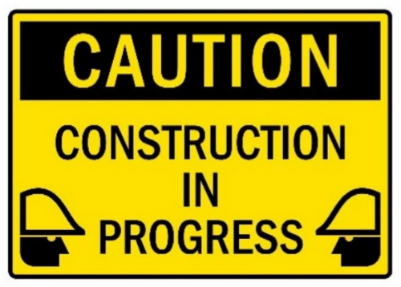
A. Be careful because building work is happening. B. You have to construct buildings with caution.
C. There is careful construction. D. Construction must be carefully done in progress.
----HẾT---

