Họ tên thí sinh: .................................................................
Số báo danh: ......................................................................
Mã Đề: 017.
Câu 1. What is the offer at the Tennis Club?
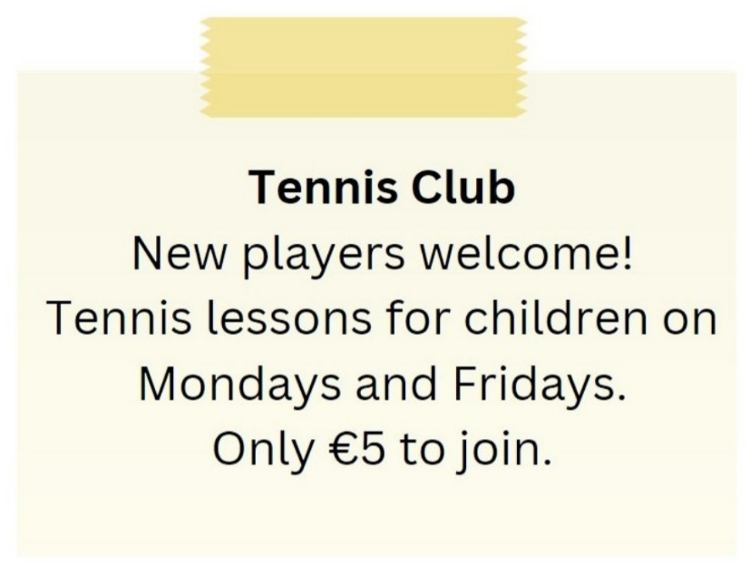
A. Tennis lessons for children on Tuesdays and Thursdays
B. Tennis lessons for children on Mondays and Fridays for €5 to join
C. Tennis lessons for adults on Mondays and Fridays
D. €10 to join the club
Câu 2. Look at the signs. Choose the best answer for the question.
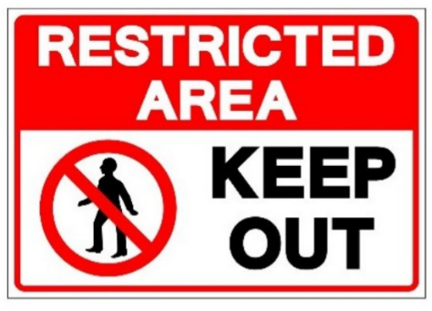
A. People aren’t allowed to enter this area. B. This area is open to everyone.
C. We should keep this area out. D. This area is kept open.
Câu 3. How long is the flight to France?
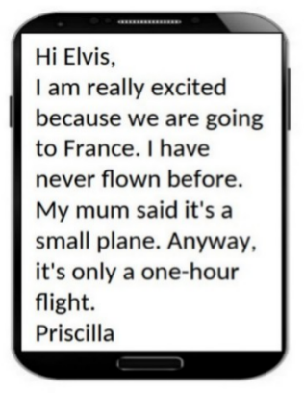
A. One hour B. Two hours C. Three hours D. 30 minutes
Câu 4. Where is the proposed meeting location for the activity?
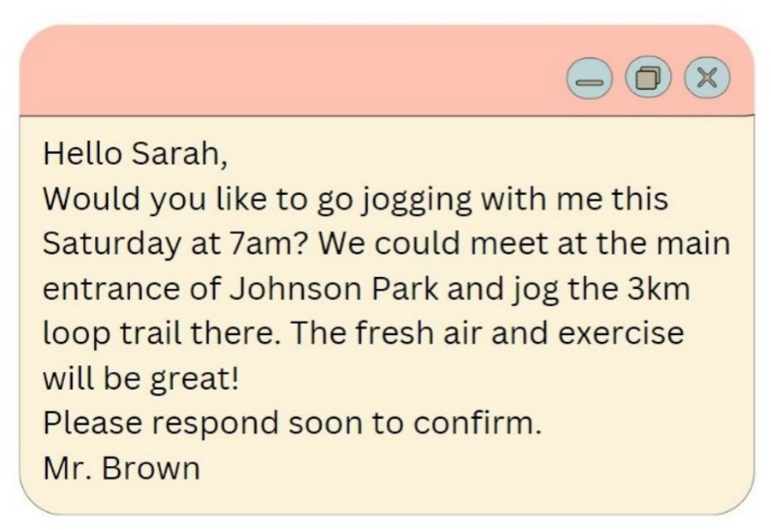
A. Central Park B. Smith Park C. Hyde Park D. Johnson Park
Câu 5. What does this sign mean?
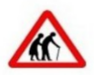
A. Be careless as elderly people may be crossing the road.
B. Be cautious as elderly people may be crossing the road.
C. They are wearing traditional clothing.
D. There are two old people here.
Câu 6. Look at the signs. Choose the best answer for the question.

A. You mustn’t throw trash on the ground. B. Waste is not available in this place.
C. Littering is not good for the environment. D. You don’t need to litter in this place.
Câu 7. What does this sign mean?
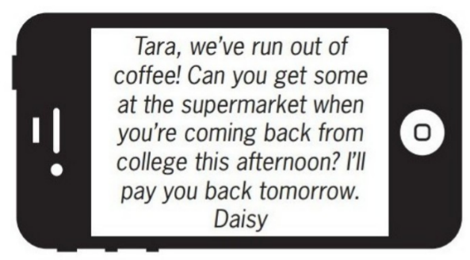
A. Daisy wants Tara to buy some coffee this afternoon.
B. Tara should give Daisy some money to buy coffee.
C. Tara will go to the supermarket tomorrow.
D. Daisy will buy coffee tomorrow when she returns home.
Câu 8. Look at the signs. Choose the best answer for the question.
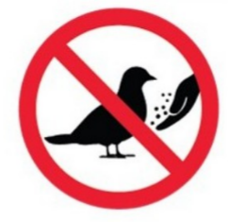
A. Do not touch the birds with your hands. B. You can’t catch any birds in this area.
C. There aren’t any birds in this area. D. Do not feed the birds.
Câu 9. Look at the signs. Choose the best answer for the question.
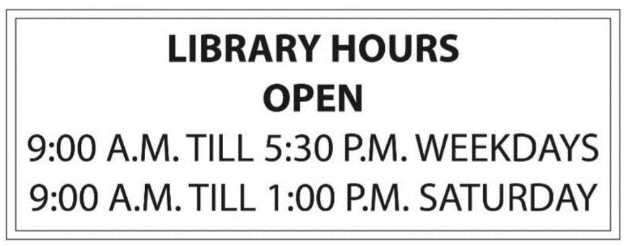
A. The library closes after 1 o’clock on Saturday afternoons.
B. The library is not open at noon.
C. People cannot come to the library on the weekends.
D. People can come to the library from 9 a.m. to 5.30 p.m. every day.
Câu 10. What is the discount amount when buying two shirts?
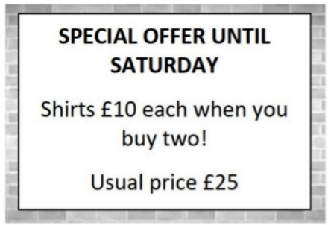
A. £25 off the total purchase B. £10 off each shirt
C. £15 off each shirt D. £5 off each shirt
----HẾT---

