UNIT | VOCABULARY | GRAMMAR
Unit 4  COMMUNITY SERVICES | - Suggest and plan a charity event  - Pronunciation: /d/, /ɪd/, /t/ of verb endings -ed" | - Should, Let's and How about  - Past Simple with regular verbs

Tiếng Anh 7 – i-LEARN SMART WORLD

UNIT 4 TEST
Note: Each correct answer earns 0.2 points.

I. PRONUNCIATION (0.8 points)
A. Choose the word whose underlined part is pronounced differently.
1. A. washed B. picked C. cleaned D. helped
2. A. reused B. recycled C. raised D. donated
B. Choose the word that has a different stressed syllable from the rest.
3. A. support B. talent C. event D. collect
4. A. volunteer B. charity C. organize D. decorate

II. VOCABULARY AND GRAMMAR (2.4 points)
Choose the best option (A, B, C or D) to complete each of the following questions.
5. Every child has the __________ to get an education.
A. talent B. activity C. right D. event
6. Last summer, my class collected bottles and cans for __________.
A. recycling B. raising C. cleaning up D. reducing
7. We __________ old textbooks, unused notebooks and spare stationery to help students in mountainous areas.
A. raised B. picked C. took D. donated
8. A(n) __________ is someone who does work without getting any money for it.
A. charity B. volunteer C. organization D. community
9. We __________ organize a charity car wash. It’s an easy and fun way to raise money.
A. shouldn’t B. need C. should D. would like
10. __________ are a popular way to raise money for schools and clubs because lots of people love cakes, cookies, muffins, pies and biscuits.
A. Bake sales B. Craft fairs C. Talent shows D. Garage sales
11. We took part ______ the charity walk for Children in Need yesterday, and it was great fun.
A. on B. in C. with D. for
12. Many schools hold __________ every year because they are fun and give students a chance to show off their special skills, such as singing, dancing or doing magic tricks.
A. school fairs B. car washes C. art shows D. talent shows
13. Last month, we __________ a lot of trees in the schoolyard. It was so much fun.
A. collected B. raised C. planted D. donated
14. Student A: “What did you do to help our community?”
Student B: “_________”
A. I want to volunteer at a soup kitchen.
B. I made cards to sell at the school fair.
C. I like planting trees in the park.
D. I think I will donate books and clothes.

15. Read the poster and choose the correct statement.
 | A. You have to wear a pink uniform.  B. There are events for both children and adults.  C. It’s free to take part in the fun run.  D. You can check in at 8 a.m.

16. Read the poster and choose the correct statement
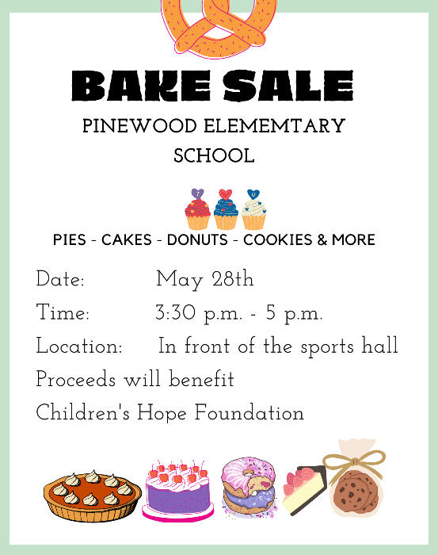 | A. The bake sale takes place all day.  B. The bake sale takes place indoors.  C. The bake sale is for elementary students.  D. The bake sale raises money for Children’s Hope Foundation.

III. WORD FORMATION (1.2 points)
Write the correct form or compound of the words in brackets.

There are (17) __different_____ ways that you can do to help the community.  - Work as a volunteer at an animal shelter. You can help taking care of (18) __homeless________ animals by feeding or bathing them.  - Make a (19) __donation________ to charity projects.  - Spend some time at an orphanage. You can bring (20) ___happiness_______ to orphan kids by playing with them or teach them music and crafts.  - Take part in community (21) __clean-ups________. You can pick up rubbish on the streets, sidewalks, beaches and parks, or clean the graffiti off the walls.  Little things you do can have an (22) _amazing_______ impact on the society. | (DIFFER)  (HOME)  (DONATE)  (HAPPY)  (CLEAN)  (AMAZE)

IV. LISTENING (2 points)
A. You will listen to Ms. White interviewing Annie Williams – a middle school student. For questions 23-27, complete the notes with NO MORE THAN TWO WORDS.

Last month, Annie donated (23) ___warm clothes_______ and old toys to (24) _(the) poor______ children.
Last week, Annie cleaned up the (25) _park_________ and planted flowers and trees there.
(26) _Yesterday_________, Annie volunteered at a (27) _soup kitchen_________ with her friends.

B. You will listen to a radio show. For each question from 28 to 32, listen and choose the correct option A, B, C or D.

28. Green Steps organized clean-ups in _______ cities and towns.
A. 14 B. 30 C. 40 D. 56
29. Volunteers cleaned up parks and rivers in _____.
A. Palmdale B. Crabtree C. Greendale D. Pearl
30. In Crabtree, Green Steps volunteers ________.
A. picked up trash on the beach B. cleaned up the city
C. organized World Environment Day D. worked with local people
31. How many people took part in the clean-up at Pearl Beach?
A. 12 B. 20 C. 13 D. 800
32. Ms. Carrie Ford believes _______ is a serious problem.
A. trash along the streets B. plastic pollution
C. dirty beaches and rivers D. the environment

V. READING (2 points)
A. Read the following passage. For each of the questions from 33 to 37, write T if the statement is TRUE, F if the statement is FALSE and NI if there is NO INFORMATION on it.

Girl Scouts of the USA is the largest organization for girls in the world. Juliette "Daisy" Gordon Low organized the first group of Girl Scouts on March 12th, 1912. She wanted to give girls the opportunity to get out of the house and help their community. Girl Scouts of the USA started with 18 members. Today, there are about 2.5 million girl and adult members worldwide. The girls work on a variety of projects. Simple projects may involve sewing, or collecting toys for kids who live in shelters. Other community services for older girls includes volunteering at a soup kitchen, planting trees, doing car washes or cleaning up litter in their community. Girl Scouts is famous for raising money by selling delicious Girl Scout cookies. The girls bake cookies at home with their mums volunteering as an advisor. The organization believes that selling cookies helps Girl Scouts practice life skills like teamwork and money management. When they complete goals, they earn badges for their work which they wear on their sashes.

33. There were 18 girls joining the first Girl Scouts group. True
34. Girl Scouts members do different community services. True
35. To raise money, the girls sell cookies that their mothers make. False
36. Girl Scouts raised a lot of money by selling cookies. NI
37. After finishing one goal, the girls receive a sash. False

B. Read the passage. For questions from 38 to 42, choose the correct option A, B, C or D that best suits each blank.

Hi Ethan,
Last week, I (38) __________ in a color run in my city. It was a fundraising event for disabled children. More than two thousand people joined the event. It was a 5K run, and there were five stations around the track. Volunteers threw color powder at (39) __________ when they made their way through each station. The powder was cornstarch, so it was natural and safe. The (40) __________ part was the colored gel – it was cold and wet and coming at the runners from huge water guns. Runners started out wearing white T-shirts, and by the end of the run, they were covered in colors of red, green, purple and orange. It looked quite crazy, dirty and messy, (41) __________ it was super fun. After the run, there was a big music party with DJs and rock bands. It was so amazing. A color run is definitely something to do with friends. I want to do another one soon. Would you like (42) __________?
See you,
Nathan

38. A. had B. went C. took part D. organized
39. A. participants B. participation C. participated D. participating
40. A. most B. most interested C. more exciting D. best
41. A. because B. but C. however D. so
42. A. coming B. come C. to come D. to coming
VI. WRITING (1.6 points)
A. Rewrite the following sentences without changing their meaning. Use the given word(s) if any.
43. Let’s have a craft fair to raise money for children with special needs.
→ How about having a craft fair to raise money for children with special needs?
→ How about we have a craft fair to raise money for children with special needs?
44. We shouldn’t have the concert outdoors because it might be cold in the evening.
→ Let’s not have the concert outdoors because it might be cold in the evening.
45. Why don’t we take part in the fun run next Sunday? (TAKE)
→ How about we take part in the fun run next Sunday?
46. It’s a good idea to host a school-wide yard sale on the weekend.
→ We should host a school-wide yard sale on the weekend.

B. Use the given words or phrases to make complete sentences.
47. Last month, my school/ organize/ a fun run/ raise money/ the local soup kitchen.
→ Last month, my school organized a fun run to raise money for the local soup kitchen.
48. My brother/ work/ a volunteer/ Kenya/ last year.
→ My brother worked as a volunteer in Kenya last year.
49. I/ go/ a clean-up/ the forest/ last week.
→ I went to a clean-up in the forest last week.
50. you/ donate/ money/ help/ flood victims/ yesterday?
→ Did you donate money to help flood victims yesterday?

***End – Of – Test***

Audio scripts
Listening 1:
Ms. White: Welcome to Teen Talk. I’m talking to Annie Williams. She’s a middle school student, and this month she has been busy helping our community.
Annie: Hi.
Ms. White: So, Annie, let’s talk about what you did to help our community.
Annie: Last month, I donated warm clothes and my old toys. My sister donated some comics. They went to the poor children.
Ms. White: Great. What else did you do?
Annie: Last week, I cleaned up the park near my house. It was dirty, so we picked up the garbage. We also planted flowers and trees there. Now, kids can enjoy playing in the park.
Ms. White: Fantastic. Can you tell us about your volunteer work?
Annie: Well, yesterday, my friends and I volunteered at Fair View’s soup kitchen.
Ms. White: Wow! You guys did a great job to help our community.
Annie: Thank you, Ms. White.

Listening 2:
M: Good morning! As you all know, yesterday was World Environmental Day. Green Steps, an organization with more than four thousand members, organized clean-ups in forty cities and towns across the country. In Palmdale, fifty-six volunteers worked together to clear trash from parks and rivers. In Crabtree, thirty Green Steps members joined hands with eight hundred local people to pick up trash along the streets. In Greendale, twenty volunteers cleaned up trash on Pearl Beach. Earlier I spoke to Ms. Carrie Ford, the leader of Green Steps. Here’s what she had to say:
W: “Plastic pollution is a serious problem in our country. We hope that when people see us cleaning up all this trash, they will realize that together we can make a big change.”
M: Next, the government announced that …

