LỚP HỌC THẦY (CÔ) ___________________________ ĐỀ ÔN TẬP: READING SIGNS/ NOTICES – A2
Test 13
Thời gian làm bài: [Time]
Họ và tên: ________________________________________________ Lớp: 9/___
Nội dung:
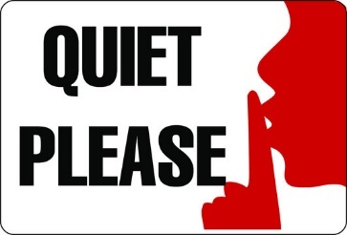
Question 1: What does this sign mean?
A. Noise is not allowed.
B. Noise is encouraged here.
C. Noise is allowed at times.
D. Please keep noise low.

Question 2: Read the sentences in italics. Then choose the correct meaning.
Please try to return books to the correct shelf.
Thank you.

A Put books back in the correct place.
B Bring books back at the correct time
C. Leave the books on the floor after using them.
D. Return books to any shelf, as it does not matter where.
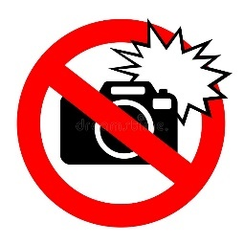
Question 3: What does this sign mean?
A. Flash photography is allowed.
B. Flash photography is encouraged here.
C. Flash use is not allowed at certain times.
D. Taking pictures with a flash is not allowed.

Question 4: Read the sentences in italics. Then choose the correct meaning.
Please keep the area clean and tidy. Thank you.
A. The area will be cleaned by someone else. B. Leave the area messy as it is not important.
C. Clean the area only once a week. D. Make sure the area is neat and free of trash.
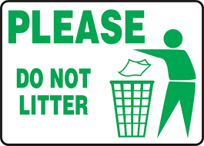
Question 5: What does this sign mean?
A. Throwing trash on the ground is allowed.
B. The area is clean.
C. Littering is allowed at times.
D. Please use the bins to keep the area clean.

Question 6: Read the sentences in italics. Then choose the correct meaning.
Remember to switch off the lights when you leave.

A. Keep the lights on until someone tells you otherwise.
B. Leave the lights on for safety.
C. Only switch off the lights at night.
D. Turn off the lights before you go.
Question 7: What does this sign mean?

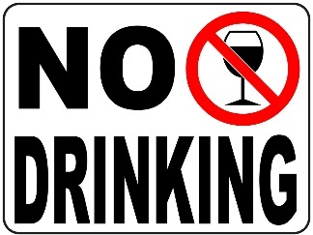
A. "The sign means that you are not allowed to drink here."
B. "The sign means that you are allowed to drink in this area."
C. "The sign means that drinking is allowed only at certain times here."
D. "The sign means that drinking is encouraged and you are welcome to drink here."
Question 8: Read the sentences in italics. Then choose the correct meaning.
Please use the designated bins for recycling.

A. Dispose of all waste in any available bin. B. Mix recyclables with regular trash.
C. Throw recyclables in the specific bins provided. D. Recycle only glass and plastic bottles.
Question 9: What does this sign mean?
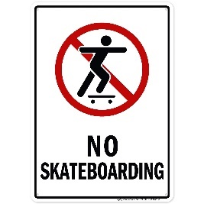
A. Skateboarding is allowed, meaning you can skateboard here.
B. Skateboarding is not allowed, meaning you cannot skateboard here.
C. Skateboarding is not allowed at specific times, meaning you cannot skateboard here at any time.
D. Skateboarding is encouraged, meaning you are welcome to skateboard here.

Question 10: Read the sentences in italics. Then choose the correct meaning.
Please keep your noise level low in this area.

A. Only reduce noise during office hours. B. Speak loudly so everyone can hear you.
C. Make sure to be quiet and not disturb others. D. Noise level does not matter in this area.

[HẾT]

