School: ……………………………………….. | Date: …………………………………..
Class: ……………………………..................... | Period: ………………………….........

UNIT 9: ENGLISH IN THE WORLD
Lesson 1.1 – New words and Reading (page 68)

I. OBJECTIVES
By the end of the lesson, Ss will be able to:
1.1. Language knowledge and skills
- know some new words about tourism and cultures. (tour guide, stadium, flight, historic, jog, ferry).
- talk about tourist attractions and cultures of English - speaking countries.
- read an email about tourist attractions and culture of the USA to understand general and specific information.
1.2. Competences
- improve communication, collaboration, analytical and critical thinking skills.
1.3. Attributes
- love studying English.
- respect cultures of other countries in the world.

II. TEACHING AIDS AND LEARNING MATERIALS
1. Teacher’s aids: Student book and Teacher’s book, class CDs, Digital Book (DCR phần mềm tương tác SB, DHA (từ vựng/ cấu trúc) phần mềm trò chơi tương tác), projector/interactive whiteboard / TV (if any), PowerPoint slides, pictures.
2. Students’ aids: Student’s book, workbook, notebook.

III. ASSESSMENT EVIDENCE
Performance Tasks | Performance Products | Assessment Tools
- Match the words with the definitions. | - Ss’ answers. | - T’s feedback/Peers’ feedback.
- Listen and repeat. | - Ss’ answers/ presentation. | - T’s observation / feedback.
- Do you know any historic places? Tell your partner. | - Ss’ answers. | - T’s feedback/Peers’ feedback.
- Read Jane's email to her friend. Where is Jane? | - Ss’ answers. | - T’s feedback/Peers’ feedback.
- Read and circle the correct answer. | - Ss’ answers. | - T’s feedback/Peers’ feedback.
- Speak: What do you know about the United States? Would you like to visit it? | - Ss’ answers/ presentation. | - T’s feedback/Peers’ feedback.

IV. PROCEDURES
A. Warm up: (5’)
a) Objective: Introduce the new lesson and set the scene for Ss to acquire new language; get students' attention at the beginning of the class by enjoyable and short activities as well as to engage them in the follow-up steps.
b) Content: Introduce: English speaking countries.
c) Expected outcomes: Ss have general ideas about the topic of the new lesson: English speaking countries.
d) Organization of the activity:
TEACHER’S ACTIVITIES | STUDENTS’ ACTIVITIES
- Option 1: Introduce English speaking countries.  - Show flags of some English - speaking countries.  - Have Ss observe the flags and guess the names of these countries.  - Call Ss to give answers.  - Give feedback and show correct answers.  - Lead to the new lesson: English in the world.  *Illustration:  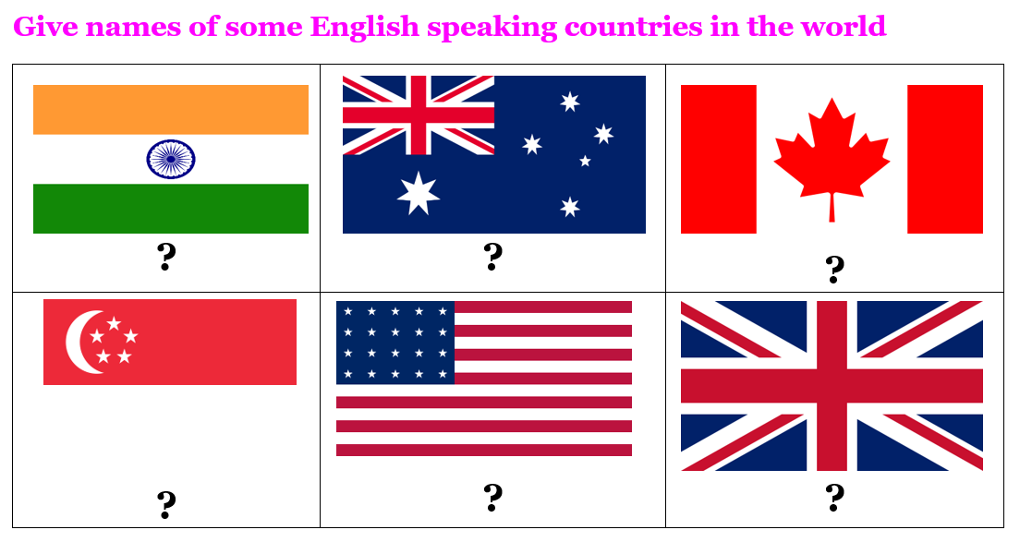  - Option 2: Top 10 tourist attractions in the USA  - Have Ss watch a video clip about Top 10 tourist attractions in the USA.  - Then, ask Ss some questions:  1 Can you list some tourist attractions from the clip?  2 Which tourist attraction in the USA impresses you much? Explain for your choice  3 What do you need to travel to the USA?  - Call Ss to give answers.  - Give feedback.  - Introduce the new lesson: English in the world.  *Illustration:  Suggested link: https://www.youtube.com/watch?v=98H5AN_vfOY  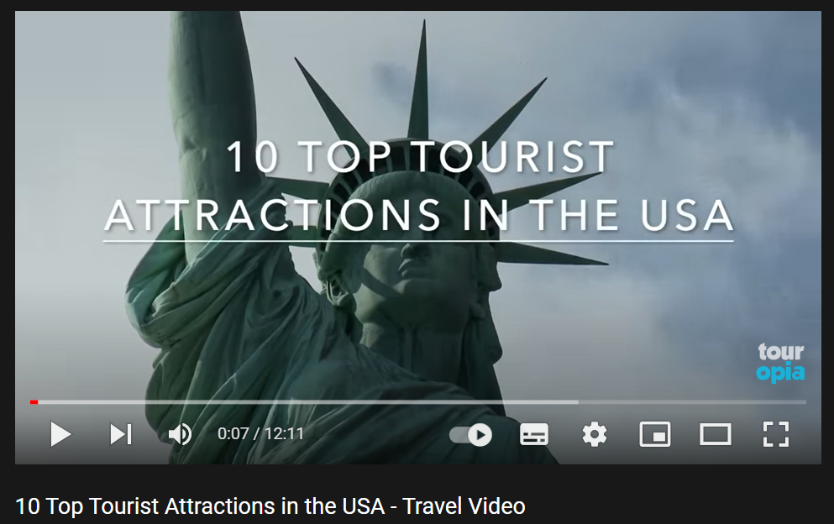 | - Observe the flags and guess the names of these English - speaking countries.  - Give answers.  Answer keys  From left to right, top to bottom:  1. India  2. Australia  3. Canada  4. Singapore  5. The USA  6. The UK  - Watch the video clip, then give answers.  - Listen.

B. New lesson (35’)
- Activity 1: Pre-Reading (Vocabulary) (12’)
a) Objective: Ss know some words about tourism.
b) Content:
- Vocabulary study: tour guide, stadium, flight, historic, jog, ferry.
- Match the words with the definitions. Listen and repeat.
- Speaking: Do you know any historic places? Tell your partner.
c) Expected outcomes: Ss know how to pronounce the new words correctly and use them in appropriate situations.
d) Organization of the activity:
TEACHER’S ACTIVITIES | STUDENTS’ ACTIVITIES
Task a. Match the words with the definitions. Listen and repeat.  - Option 1  - Demonstrate the activity on DCR, using the example.  - Have Ss match the words with the definitions.  - Divide class into pairs and have them check their answers with their partners.  - Call Ss to give answers (read or write).  - Check answers as a whole class using DCR.  - Play audio (CD2 – Track 12). Have Ss listen and repeat.  - Correct Ss’ pronunciation.  - Option 2:  - Demonstrate the activity, using the example.  - Have Ss match the words with the definitions.  - T uses pictures to illustrate the definitions.  - Divide class into pairs and have them check their answers with their partners.  - Call Ss to give answers (read or write).  - Check answers as a whole class.  - Play audio (CD2 – Track 12). Have Ss listen and repeat.  - Correct Ss’ pronunciation.  *Illustration:  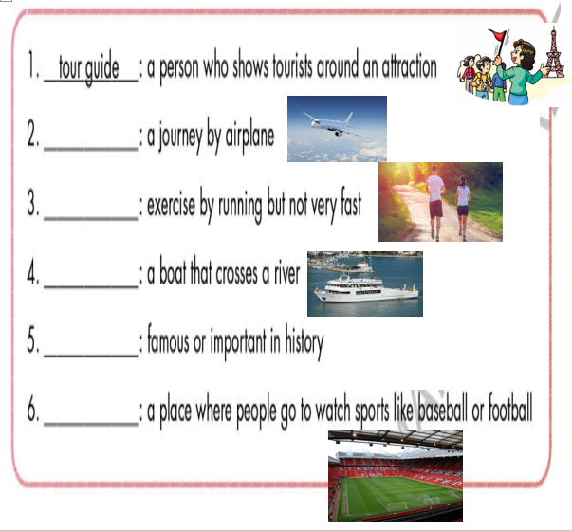  Task b. Do you know any historic places? Tell your partner.  - Have pairs discuss and list some historic places.  - Have Ss share their answers in front of the class.  - Give feedback and evaluation. | - Look and listen.  - Work individually.  - Work in pairs.  - Give answers.  - Listen and repeat.  Answer keys  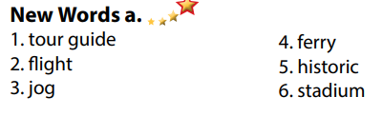  - Look and listen.  - Work individually.  - Work in pairs.  - Give answers.  - Listen and repeat.  Answer keys  - Work in pairs.  - Present.  Sample answers  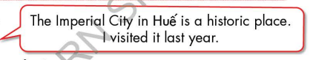
- Activity 2: While - Reading (18’)
a) Objective: Students can develop their reading skill.
b) Content:
- Read Jane's email to her friend. Where is Jane?
- Read and circle the correct answer.
c) Expected outcomes: Students can read an email and understand more about some tourist attractions in the USA.
d) Organization of the activity:
TEACHER’S ACTIVITIES | STUDENTS’ ACTIVITIES
Task a. Read Jane's email to her friend. Where is Jane?  - Ask Ss to scan the email, then choose the correct answer.  - Remind Ss to underline or highlight the keywords or supporting ideas for their answers.  - Have some Ss share their answers with the class (read), explain for their answers.  - Give feedback.  - Give feedback and correct Ss’ answers if necessary.  Task b. Read and circle the correct answer.  - Have Ss look at the content of task b.  - Have Ss scan the text again and circle the correct answer.  - Elicit answers from different pairs.  - Give feedback and evaluation. | - Work individually.  - Read answers, explain.  - Check answers.  Answer keys    - Read.  - Work in pairs to circle the correct answer.  - Read answers.  Answer keys  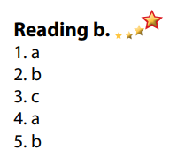
- Activity 3: Post - Reading (5’)
a) Objective: Students can use the vocabulary and ideas from the reading text to develop their speaking skill.
b) Content: Speaking: What do you know about the United States? Would you like to visit it?
c) Expected outcomes: Students can have a free talk about the USA.
d) Organization of the activity:
TEACHER’S ACTIVITIES | STUDENTS’ ACTIVITIES
Task c. In pairs: What do you know about the United States? Would you like to visit it?  - Have Students work in pairs to answer the questions.  - Go round and give help if necessary.  - Call some Ss to share their ideas with the whole class.  - Give feedback and evaluation. | - Discuss in pairs.  - Present.  - Listen.

C. Consolidation and homework assignments (5’)
* Consolidation:
- Words about tourism and cultures: (tour guide, stadium, flight, historic, jog, ferry).
* Homework:
- Learn the new words by heart.
- Practice talking about your favorite English - speaking country that you would like to visit.
- Do the exercises in WB: New words + Reading (Page 50).
- Do the vocabulary exercise in Tiếng Anh 7 i-Learn Smart World Notebook (page 54).
- Play consolation games in Tiếng Anh 7 i-Learn Smart World DHA App on www.eduhome.com.vn
- Prepare: Unit 9 - Lesson 1.2 – Grammar (page 69 – SB).

D. Reflection
a. What I liked most about this lesson today:
…………………………………………………………………………………………
- What I learned from this lesson today:
…………………………………………………………………………………………
c. What I should improve for this lesson next time:
…………………………………………………………………………………………

