

A. VOCABULARY
No. | Word/ Phrase | Type | IPA | Meaning
1. | bicycle | (n) | /ˈbaɪsɪkl/ | xe đạp
2. | bin | (n) | /bɪn/ | thùng rác
3. | bookcase | (n) | /ˈbʊkkeɪs/ | tủ sách
4. | calculator | (n) | /ˈkælkjuleɪtə(r)/ | máy tính bỏ túi
5. | clock | (n) | /klɒk/ | đồng hồ treo tường
6. | coloured pencils | (n phr) | /ˈkʌləd ˈpenslz/ | bút chì màu
7. | compass (compasses) | (n) | /ˈkʌmpəs/ | compa
8. | computer | (n) | /kəmˈpjuːtə(r)/ | máy vi tính
9. | desk | (n) | /desk/ | bàn học
10. | dictionary | (n) | /ˈdɪkʃənəri/ | từ điển
11. | English | (n) | /ˈɪŋɡlɪʃ/ | môn tiếng Anh
12. | exercise | (n) | /ˈeksəsaɪz/ | bài tập
13. | football | (n) | /ˈfʊtbɔːl/ | bóng đá
14. | globe | (n) | /ɡləʊb/ | quả địa cầu
15. | glue | (n) | /ɡluː/ | keo, hồ dán
16. | History | (n) | /ˈhɪstri/ | môn lịch sử
17. | homework | (n) | /ˈhəʊmwɜːk/ | bài tập về nhà
18. | judo | (n) | /ˈdʒuːdəʊ/ | môn võ Judo
19. | lesson | (n) | /ˈlesn/ | bài học
20. | lunch box | (n) | /ˈlʌntʃ bɒks/ | hộp cơm trưa
21. | map | (n) | /mæp/ | bản đồ
22. | Music | (n) | /ˈmjuːzɪk/ | môn âm nhạc
23. | notebook | (n) | /ˈnəʊtbʊk/ | vở ghi chép
24. | paper clip | (n) | /ˈpeɪpə klɪp/ | kẹp giấy
25. | pen | (n) | /pen/ | bút mực
26. | pencil case | (n) | /ˈpensl keɪs/ | hộp bút
27. | pencil sharpener | (n) | /ˈpensl ˈʃɑːpnə(r)/ | gọt bút chì
28. | Physics | (n) | /ˈfɪzɪks/ | môn vật lý
29. | projector | (n) | /prəˈdʒektə(r)/ | máy chiếu
30. | rubber | (n) | /ˈrʌbə(r)/ | cục tẩy, gôm
31. | ruler | (n) | /ˈruːlə(r)/ | thước kẻ
32. | school bag | (n) | /ˈskuːl bæɡ/ | cặp sách
33. | school lunch | (n) | /ˈskuːl lʌntʃ/ | bữa trưa ở trường
34. | Science | (n) | /ˈsaɪəns/ | môn khoa học
35. | scissors | (n) | /ˈsɪzəz/ | cái kéo
36. | student | (n) | /ˈstjuːdnt/ | học sinh
37. | textbook | (n) | /ˈtekstbʊk/ | sách giáo khoa
38. | vocabulary | (n) | /vəˈkæbjuləri/ | từ vựng

B. WORD FORM
- advise (v): khuyên bảo, cho lời khuyên  - advice (n): lời khuyên  - advisable (adj): nên làm, khôn ngoan  - advisedly (adv): có cân nhắc, thận trọng  - sharpen (v): mài sắc, làm nhọn  - sharpener (n): cái gọt (bút chì), dụng cụ mài  - sharp (adj): sắc bén, nhọn  - sharply (adv): sắc sảo, gay gắt  - nation (n): quốc gia, dân tộc  - national (adj): thuộc về quốc gia, dân tộc  - international (adj): quốc tế  - nationally (adv): trên toàn quốc, theo quốc gia | - interest (v): làm thích thú, gây hứng thú  - interest (n): sự thích thú, sự quan tâm, lãi suất  - interested (adj): quan tâm, thích thú (chỉ cảm xúc của người)  - interesting (adj): thú vị, hấp dẫn (chỉ tính chất của vật/việc)  - interestingly (adv): một cách thú vị  - word (v): diễn đạt bằng lời, viết  - word (n): từ, lời nói  - wordy (adj): nhiều lời, dài dòng  - wordlessly (adv): không nói một lời

C. GRAMMAR
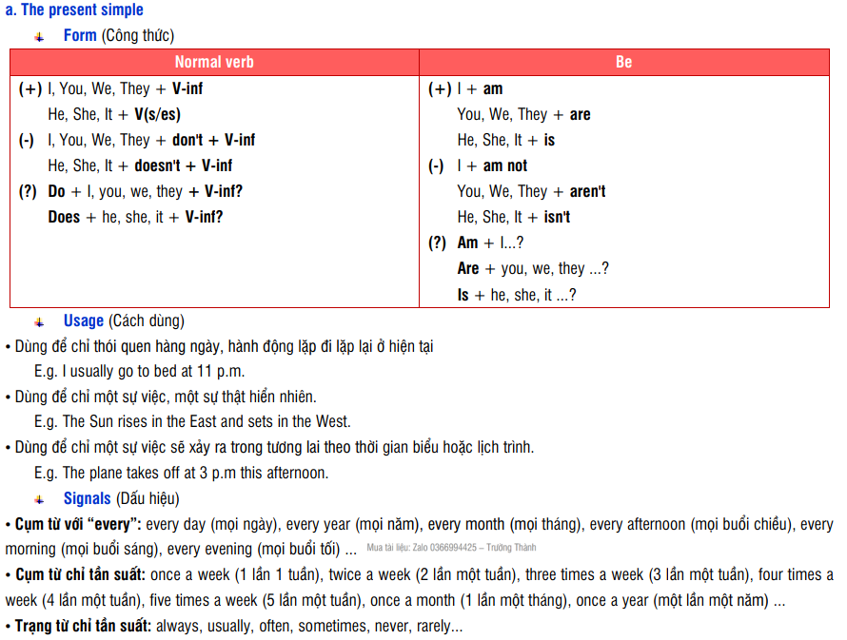

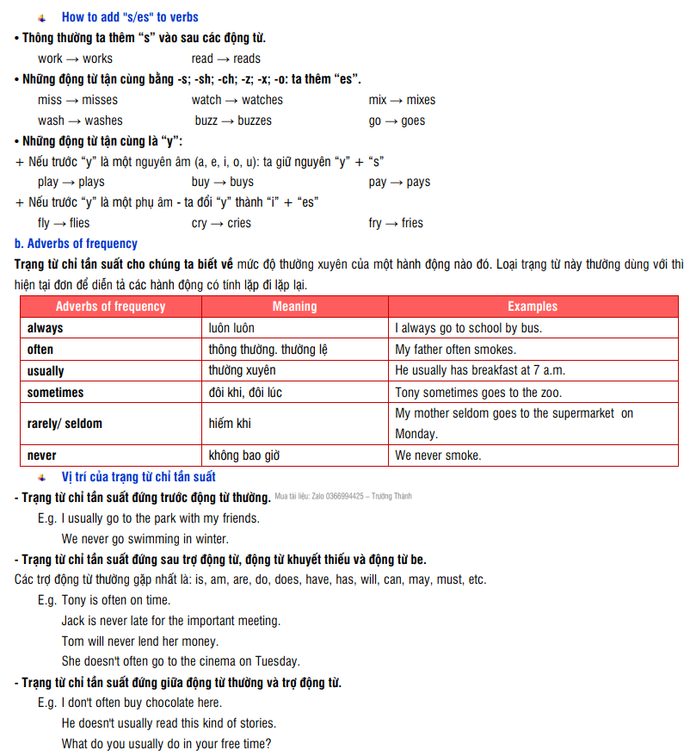

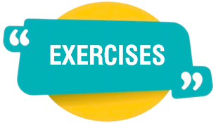
EXERCISES

- PHONETIC

Exercise 1: Mark the letter A, B, C, or D to indicate the word whose underlined part differs from the other three in pronunciation in each of the following questions.
1. A. large B. sharpener C. hat D. star
2. A. country B. group C. young D. double
3. A. March B. smart C. warm D. art
4. A. husband B. study C. uncle D. turn
5. A. grammar B. star C. hard D. start
6. A. study B. lunch C. sun D. computer
7. A. calculator B. car C. fast D. father
8. A. come B. someone C. brother D. volleyball
9. A. mother B. no C. Monday D. love
10. A. subject B. study C. fun D. computer
11. A. unit B. umbrella C. under D. study
12. A. classmate B. compass C. smart D. fast
13. A. uniform B. Sunday C. music D. unique
14. A. other B. son C. some D. short
15. A. bad B. last C. sharpener D. large
16. A. class B. fast C. dancing D. library
17. A. brother B. lovely C. homework D. honey
18. A. notebook B. love C. above D. Monday
19. A. smart B. dollar C. start D. guitar
20. A. study B. computer C. understand D. sunny

Exercise 2: Mark the letter A, B, C, or D to indicate the word that differs from the other three in the position of primary stress in each of the following questions.
1. A. remember B. uniform C. secondary D. exercise
2. A. surround B. swimming C. compass D. history
3. A. interview B. library C. creative D. badminton
4. A. creative B. equipment C. excited D. uniform
5. A. notebook B. supply C. boarding D. pencil
6. A. physics B. lesson C. judo D. exciting
7. A. boarding B. textbook C. around D. history
8. A. international B. kindergarten C. interesting D. calculator
9. A. biology B. breakfast C. classroom D. science
10. A. sometimes B. listen C. canteen D. pocket

- VOCABULARY AND GRAMMAR
Exercise 3 Mark the letter A, B, C, or D to indicate the correct answer to each of the following questions.
1. Most schools require children to wear school ____.
A. equipment B. favourite C. uniforms D. creative
2. We play ____ at break time.
A. exercise B. History C. judo D. football
3. Children will work hard if the lessons are ____.
A. pleasant B. nice C. disappointing D. interesting
4. Let’s ____ our school uniform and go to school.
A. wear on B. put on C. take off D. put off
5. My friends do ____ to protect themselves.
A. exercise B. judo C. football D. Science
6. In many schools in Vietnam students have to wear a ____.
A. coat B. suit C. clothing D. uniform
7. ____ school is a school where students study and live during the school year.
A. Primary B. Creative C. International D. Boarding
8. AIS is an ____ school in Viet Nam. It provides American education.
A. international B. favourite C. creative D. excited
9. Every day, I ride my ____ to school.
A. computer B. bicycle C. school bag D. football
10. My sister is very ____. She is very good at painting pictures.
A. favourite B. creative C. international D. excited
11. We usually have ____ in the school canteen.
A. school lunch B. homework C. vocabulary D. lessons
12. What's your ____ subject? - I like English.
A. excited B. creative C. international D. favourite
13. Duy’s friends are waiting for him to put on his ____ so they can go to school together.
A. uniform B. notebook C. subject D. exercise
14. It’s difficult calculation. Can I borrow your ____?
A. ruler B. schoolbag C. pencil case D. calculator
15. In ____ lessons, they learn about animals and plants.
A. history B. music C. English D. science
16. We have some new ____ in this school year: physics, computer science, etc.
A. teachers B. equipment C. subjects D. friends
17. Wellspring Saigon is an ____ school.
A. internation B. internationality C. internationalise D. international
18. Children like to play ____.
A. football B. lesson C. housework D. physic
19. In many schools in Viet Nam students have to wear a ____.
A. suit B. uniform C. coat D. clothing
20. The children look very ____ while playing games during break time.
A. excited B. exciting C. excite D. excitement
21. There are 30 ____ in my class.
A. students B. teachers C. lessons D. friends
22. Vy and Phong are ____ about their first day at secondary school.
A. favourite B. international C. creative D. excited
23. You can use a ____ to draw circles.
A. notebook B. book C. compass D. rubber
24. Today we have two Art ____.
A. students B. computers C. projects D. lessons
25. I rarely do ____ in the morning, but my sister usually does.
A. have B. marks C. exercise D. do
26. Thang is good at playing ____. He is the best footballer in my class.
A. exercise B. basketball C. football D. judo
27. Does your brother ____ English and literature on Mondays?
A. have B. marks C. exercise D. do
28. We learn about ____ in IT.
A. bicycle B. projector C. computer D. globe
29. That is the ____ where we do all our experiments.
A. laborious B. labor C. laboratorian D. laboratory
30. I usually do my ____ after dinner.
A. exercise B. lessons C. vocabulary D. homework
31. They are ____ because they do judo every day.
A. healthfulness B. healthily C. healthy D. healthful
32. In the ____ you can read books and newspapers or borrow them to read at home.
A. canteen B. library C. gym D. classroom
33. I stick new words on the wall to learn ____.
A. English B. vocabulary C. homework D. Physics
34. Nam lives far from school, so he studies at a ____ school.
A. international B. boarding C. creative D. favourite
35. Susan usually gets good ____ in exams.
A. do B. have C. marks D. exercise
36. Our school has one ____. This connects to a computer.
A. desk B. projector C. clock D. globe
37. The school gym has lots of new and modern ____.
A. library B. uniforms C. equipment D. classmates
38. Carol believes that do ____ regularly is a good way to be healthy.
A. gymnast B. gymnastically C. gymnastics D. gymnasium
39. The students always remember to ____ their homework.
A. do B. marks C. exercise D. have
40. Thanh and Duy are in the same class at school. They are ____.
A. teachers B. friends C. classmates D. students
41. After school they usually ____ football.
A. study B. play C. make D. do
42. When my friend misses the lessons, I always ____ him my notes.
A. lend B. borrow C. takes D. send
43. Jenny put ____ coat and went out.
A. about B. on C. in D. at
44. A good friend is ready to ____ things with his/ her classmates.
A. study B. share C. do D. play
45. I'm always nervous when I'm ____ an exam.
A. working B. making C. taking D. writing
46. -" ____ class are you in?" - "Class 6B."
A. Which B. When C. Whose D. Where
47. That is the laboratory ____ we do all our experiments.
A. which B. when C. that D. where
48. - "How's your class this year?"
- "Great. ____ forty-seven students, and they are good friends."
A. There're B. It's C. They're D. There's
49. School ____ at 4.30 p.m every day.
A. are finishing B. finishes C. finish D. is finishing
50. Cuong and Minh ____ their bicycles to school form Monday to Friday.
A. are riding B. is riding C. rides D. ride
51. They sometimes go home ____ weekends.
A. about B. on C. at D. in
52. I'm absolutely not good ____ all any kind of sport.
A. on B. for C. at D. with
53. We have English and Vietnamese ____ Tuesday.
A. on B. in C. at D. about
54. The children are excited ____ the holiday.
A. on B. at C. about D. in
55. She goes home ____ 4 o'clock every day.
A. in B. about C. on D. at
56. Phong is doing her homework ____ the library.
A. on B. in C. at D. about
57. What do they usually do ____ break time?
A. about B. at C. in D. on
58. We play football ____ the playground in the morning.
A. in B. on C. about D. at
Exercise 4: Mark the letter A, B, C, or D to indicate the word(s) CLOSEST in meaning to the underlined word(s) in each of the following questions.
1. All the lessons at my new school are very interesting.
A. boring B. exciting C. outgoing D. humorous
2. There are 30 children in his class, and it’s difficult for the teacher to teach all of them.
A. hard B. simple C. early D. easy
3. Do you like learning English?
A. singing B. studying C. writing D. speaking
4. Let me put on my dress. Then we can go.
A. wear B. remove C. change D. open
5. She often rides her bicycle to school.
A. car B. motorbike C. bike D. train
Exercise 5: Mark the letter A, B, C, or D to indicate the word(s) OPPOSITE in meaning to the underlined word(s) in each of the following questions.
1. Everyday, he comes to school very early to open all the windows and clean the blackboard.
A. close B. start C. clean D. learn
2. Jim went for a walk and found a big box between some rocks.
A. same B. small C. large D. modern
3. It has big buildings and modern equipment.
A. new B. beautiful C. smart D. old
4. How is your old school?
A. big B. small C. new D. beautiful
5. Hoa goes to the same school as me.
A. different B. similar C. alike D. equal
Exercise 6: Put the verbs in brackets in the present simple.
1. We sometimes _______________ books. (read)
2. Emily usually _______________ to the disco. (go)
3. It often _______________ on Sundays. (rain)
4. Pete and his sister often _______________ the family's car. (wash)
5. I always _______________ to the bus stop. (hurry)
6. I _______________ lemonade very much. (like)
7. The girls always _______________ to pop music. (listen)
8. _______________ Minh and Hoa _______________ to work by bus every day? (go)
9. Mr Smith _______________ Spanish and French. (teach)
10. Mary often _______________ her homework after school. (do)
11. My mom always _______________ delicious meals. (make)
12. Charlie _______________ eggs. (not eat)
13. Susie _______________ every week. (go)
14. Janet never _______________ jeans. (wear)
15. _______________ your parents _______________ with your decision? (agree)
16. Where _______________ he _______________? (come)
17. Where _______________ your father _______________? (work)
18. Jimmy _______________ usually _______________ the trees. (not water)
19. Who _______________ the washing in your house? (do)
20. They _______________ out once a month. (eat)
21. It _______________ a fact that smart phone _______________ us a lot in our life. (be)/ (help)
22. I often _______________ to some of my favorite destinations every summer. (travel)
23. Our Math lesson usually _______________ at 4.00 p.m. (finish)
24. The reason why Susan _______________ meat is that she _______________ a vegetarian. (not eat)/ (be)
25. People in Ho Chi Minh City _______________ very friendly and they _______________ a lot. (be)/ (smile)
26. The flight _______________ at 6 a.m every Thursday. (start)
27. Peter _______________ very hard. He never gets high scores. (not study)
28. I like oranges and she _______________ apples. (like)
29. My mom and my sister _______________ lunch every day. (cook)
30. They _______________ breakfast together every morning. (have)
Exercise 7: Write the sentences again. Put the adverbs in the correct place.
1. I help my mother in the kitchen. (always)

2. William listen to the radio. (usually)

3. Jack doesn’t play football with his friends. (usually)

4. The children do their homework after dinner. (often)

5. They play computer games in the evening. (sometimes)

6. My teacher is late for lessons. (never)

7. Do you go to the zoo with your parents? (often)

8. I am late for class. (sometimes)

9. We don’t surf the Internet before sleeping. (always)

10. They eat fast food because it is not good for their health. (rarely)

Exercise 8: Complete each sentence with the correct form of the word in brackets.
1. Do you often listen to your friend’s _______________? (advise)
2. Can you lend me your pencil _______________? (sharpen)
3. Dream is an _______________ school in Hanoi. There are many students from different countries. (nation)
4. In the afternoon, students can join many _______________ clubs after school. (interest)
5. This is my notebook for writing English _______________. (word)

- COMMUNICATION
Exercise 9: Mark the letter A, B, C or D to indicate the option that best completes each of the following exchanges.
1. “Do you go to boarding school?” “ ___________ ”
A. Yes, I do B. I have a class. C. Don’t do that D. I’m sorry I can’t
2. “Hi, Nam. Nice to meet you.” “ ___________ ”
A. Hi, Lan. Nice to meet you, too. B. Why?
C. This is my friend. D. Hi, What’s your name?
3. “When do you have English?” “___________ ”
A. I have English at school B. I have it on Monday and Friday.
C. I always learn English in the library. D. I don’t like English
4. “How often do you study English?” “___________ ”
A. I study English at home. B. I don’t go to school to learn English
C. Twice a week D. I learn English by reading books.
5. - Trung: “Why do you think most people learn English?" - Phong: “___________”
A. Because I like it B. Because it's useful to them
C. I hear it is very good D. All of them are
Exercise 10: Mark the letter A, B, C or D to arrange the following sentences into a meaningful conversation.
1.
a. Ally: Hey Brian, do you need any new school supplies?
b. Ally: You should definitely try Office Depot. They have everything you need, and the prices are great!
c. Brian: I do! Where should I go to buy them?
A. a-b-c B. a-c-b C. c-a-b D. b-a-c
2.
a. Brian: I really like science. We do lots of fun experiments!
b. Ally: What’s your favorite subject in school, Brian?
c. Ally: That sounds interesting! I prefer art because I love to draw.
A. a-b-c B. b-a-c C. c-a-b D. a-c-b
3.
a. Brian: It's great, Ally! The teachers are really nice.
b. Ally: Hi Brian! How's your new school?
c. Ally: Wow, that sounds like a wonderful school!
d. Brian: Yes, they are! And there's a big library.
e. Ally: That's good to hear. Are your classes interesting?
A. b-a-e-d-c B. a-b-c-d-e C. b-e-a-d-c D. c-a-d-e-b

- READING
Exercise 11: Look at the sign or the notice. Choose the best answer (A, B, C or D) for these questions.
 | 1. What does the notice mean?  A. You can use the lights here.  B. You can't use the lights here.  C. Switch off the lights when you don't use them.  D. Turn on the lights when you don't use them.
 | 2. What does the sign mean?  A. You can pick flowers.  B. Don't pick flowers.  C. There aren't any flowers here.  D. You can't plant flowers here.
 | 3. What does the notice mean?  A. The café opens on 24th July.  B. The café opens at 7 o'clock.  C. The café closes at 7 o'clock.  D. The café is always open.
 | 4. What does the sign mean?  A. You can use soap in this area.  B. Play with soap.  C. Wash hands regularly.  D. Don't waste water.
 | 5. What does the sign mean?  A. Departures  B. Arrivals  C. Delays  D. You mustn't stop.

Exercise 12: Read the following advertisement / announcement and mark the letter A, B, C or D to indicate the correct option that best fits each of the numbered blanks

🍽 Delicious School Lunch Awaits You! 🍽
Come and (1) ______ tasty, healthy meals in our school canteen every day! 🍲 We (2) _____ fresh vegetables, warm soups, yummy sandwiches, and sweet fruits. Our friendly staff are ready (3) _____ you. Eating a good lunch gives you (4) _____ to study and play. Don’t miss today’s special menu! Visit the canteen and have a wonderful meal with your friends!
1. A. enjoy B. build C. play D. make
2. A. served B. will serves C. serves D. are serving
3. A. to helping B. to help C. helping D. help
4. A. judo B. projector C. map D. energy

📚 Let’s Talk About Your Favourite Subject! 📚
Do you love Math, Science, or English? 🌟 Every (1) _____ helps you learn new things and grow. When you study your favourite subject, you feel happy and (2) _____. 😊 Share your favourite subject (3) _____ your friends and teachers. Let’s have fun learning together and make every lesson special. Remember: learning (4) _____ the key to your bright future! 🔑✨
1. A. computer B. subject C. exercise D. globe
2. A. disappointed B. tired C. bad D. excited
3. A. to B. at C. with D. on
4. A. be B. am C. will be D. is

🎒 Welcome to My New School! 🎒
I am so happy (1) _____ at my new school! 🏫 The classrooms are bright and clean. The teachers are kind and helpful. I have made (2) _____ new friends. 😊 There are fun (3) _____ like sports, music, and art. Every day is exciting and full (4) _____ learning. 📚 I love my new school because it feels like home. Let’s enjoy this wonderful journey together! 🌟
1. A. study B. to study C. studying D. to studying
2. A. few B. many C. much D. any
3. A. desks B. glues C. activities D. lessons
4. A. about B. with C. of D. for
Exercise 13: Read the following passage and mark the letter A, B, C, or D to indicate the correct word that best fits each of the numbered blanks.
Hi there, I’m Nam, I have a sister, Vy. We have different hobbies. I spend time (1) _____ my family most evenings. At (2) _____ weekends, I hang out with my friends at the park (3) _____ in the playground in the local woods. If it rains, I like to go to (4) _____ a film with my friends. My sister belongs to a chess clubs. The club meets twice a month, and once a year they go (5) _____. They stay in tends on a (6) _____ and have picnics and barbecues. My sister is a friendly person. We get on well with each other.
1. A. with B. to C. of D. in
2. A. a B. the C. an D. no article.
3. A. and B. or C. but D. so
4. A. learn B. play C. do D. see
5. A. camp B. to camp C. camping D. camps
6. A. lovely camp site B. lovely site camp C. camp lovely site D. site lovely camp.
I am a grade 6 student at Shakespeare School in Birmingham. I often walk to school (1) _____ I live nearby. I don’t wear a (2) _____ only when I have physical education (P. E). Then I have to (3) _____ a white T- shirt with the school’s name, blue shorts and white socks. Besides English, I learn Spanish and German as foreign languages. My school is well- equipped. There (4) _____ a laboratory to do experiments, a library to read books, a music room to (5) _____ musical instruments, and a computer room to learn how to use a computer. There is also a large (6) _____ where we can have lunch and a small snack bar to buy some drinks.
1. A. because B. so C. when D. before
2. A. hat B. uniform C. jacket D. dress
3. A. wear B. to wear C. wearing D. to wearing
4. A. are B. is C. has D. have
5. A. do B. have C. play D. take
6. A. canteen B. theatre C. schoolyard D. garden
My name is Suzy. I come from China, but now I (1) _____ in London with my sister and study in a secondary school there. It is far from my house, so it is very difficult to get there. At my new school, there are some (2) _____ I must follow: arrive at school (3) _____ time; wear uniform; finish the homework (4) ____ going to school; do not eat or drink in class and do not copy your friend’s test, either. I like my new school; the teachers are kind and (5) ______. The school building is large and modern. And I (6) _____ some new friends in my classroom. And after school, I get the same orders at home. My mother keeps telling me: “get up, don’t be late, and make your bed”. Some things never change!
1. A. live B. lived C. will live D. lives
2. A. rubbers B. paper clips C. rules D. bins
3. A. in B. at C. on D. to
4. A. before B. after C. when D. while
5. A. interesting B. unfriendly C. mean D. helpful
6. A. do B. play C. make D. study
Exercise 14: Read the following passage and mark the letter A, B, C, or D to indicate the correct answer to each of the questions.

Hi Sam,
Just a quick email to say that sounds like a great idea. Saturday is better for me because I don’t have classes on Sunday. So if that’s still good for you, why don’t you come here? Then you can see our new flat. We can eat at home and then go for a walk in the afternoon. It’s going to be so good to catch up finally. I want to hear all about your new school!
Our dress is 50 Hilton Road, but it’s a bit difficult to find because the house numbers are really strange here. If you turn left at the post office and keeping going past the big while house on Charles Road, there’s a small side street behind it with the houses 50-56 in.
Let me know if there’s anything you do/ don’t like to eat.
See you soon!
John
1. What is the main idea of the passage?
A. John wants to invite Sam to a new restaurant.
B. John is giving Sam directions to his new flat and arranging a meeting.
C. John wants to visit Sam's new school.
D. John is asking Sam for help with his new flat.
2. What day is better for John to meet?
A. Friday B. Monday C. Sunday D. Saturday
3. What does John want to do in the afternoon?
A. Go to the cinema. B. Visit Sam's school.
C. Go for a walk. D. Go shopping.
4. Why is John's address difficult to find?
A. The house numbers are strange. B. It's on a busy road.
C. It's far from the post office. D. There are no clear landmarks.
5. What does the word "catch up" in the passage mostly mean?
A. To play a game together.
B. To meet after a long time and talk about recent events.
C. To run quickly to reach someone.
D. To finish homework together.
Eton College is very famous private school near London. It is over 570 years old. There are about 1, 300 students and they all live in the school during the term. There aren’t any girls in this school- only boys. Most students stay here until they are 18 years old.
This school is very expensive and it costs about 30,000 a year to study there. Most Eton students come from very wealthy families, for example, Prince William and Prince Harry!
There are about 100 classrooms, lots of science lab, ICT rooms, music rooms a concert hall, two theatres, a gym, two swimming pool, twenty tennis courts and an athletics track and a golf court. The school has 160 teachers. There is one teacher for 80 students.
(Adapted from: Solutions_2nd_ Edition_ Elementary_ Oxford)
1. What can be the best title for the passage?
A. Eton College: A Prestigious Private School B. A Day at a British School
C. Prince William's School Life D. How to Get into a Famous School
2. How old is Eton College?
A. Less than 100 years old. B. Around 1300 years old.
C. More than 570 years old. D. Exactly 18 years old.
3. The word "they" in line 3 refers to _______.
A. teachers B. families C. students D. classrooms
4. Which of the following facilities is NOT mentioned at Eton College?
A. A gym B. A football pitch C. Tennis courts D. A concert hall
5. How many teachers are there at Eton College for every 80 students?
A. 100 B. 2 C. 160 D. 1
Linda is a musician. She's tall and beautiful. She works in a studio and a con-cert hall. She plays the piano. Every day she gets up at nine o'clock in the morning. She takes a shower and gets dressed. She drinks a cup of coffee and eat some toast. At ten o'clock, she takes a taxi to the studio. In the studio, she plays the piano. She writes new songs and makes CDs. At one o'clock, she goes to the restaurant. She eats lunch with her friends. At three o'clock, she goes to the studio again. She plays more music and sings. At six o'clock, she goes home and has dinner. She goes to the concert hall at eight o'clock. She plays her music for lots of people. They like her songs. She goes home at eleven o'clock. She is very tired and she goes to bed.
1. What is the main idea of the passage?
A. Linda's daily routine as a musician. B. How to play the piano in a studio.
C. The different types of music Linda plays. D. Linda's favorite foods and drinks.
2. What instrument does Linda play?
A. The guitar B. The drums C. The piano D. The violin
3. The word "tired" in line 7 is closest in meaning to __________.
A. energetic B. happy C. exhausted D. bored
4. Where does Linda go at one o'clock?
A. To the concert hall. B. To a restaurant. C. To her home. D. To another studio.
5. What does Linda do in the studio in the morning?
A. She has dinner. B. She sings for people.
C. She writes new songs and makes CDs. D. She meets her friends for lunch.
Exercise 15: Four phrases/sentences have been removed from the text below. Choose the correct answer to complete the text. Write only the letter A-D in each blank.
Hi! My name's Lilly Browns. I'm eleven years old. I'm now in grade 6 at Dream School. I like it here because (1) ____________. The teachers in my school are nice and very helpful, (2) ____________. He teaches us physics. I have three hours to study Vietnamese in the afternoon. (3) ____________ and do my homework at break time. We wear our uniforms every day, (4) ____________, as we're going to have an outing to the National Park.
A. but today we aren't
B. Usually I read books in the library
C. I like to study in an international school
D. and my favourite teacher is Mr Oily

MAI'S SCHOOL
Hello, my name is Mai. I am 11 years old. I go to a public school called Nguyen Du Secondary School. I am in grade 6. In our class there are 27 students, (1) ____________.
My classroom is big and nice. Our teacher is Miss Thuy. She likes decorating the walls of the class with posters and maps. In our class (2) ____________.
My desk and my chair are brown. My pencil case is on my desk. It's colorful. (3) ____________ in my pencil case: a pencil sharpener, two pencils, a rubber, three paper clips and a purple pen.
I go to school by bicycle with my friends. (4) ____________, a big gym and a fantastic music room with many instruments.
A. We like our school because there are playgrounds
B. 15 girls and 12 boys
C. there is a computer and a blackboard
D. I have lots of things

- WRITING
Exercise 16: Complete the sentences using the guided words and phrases
1. there/ a modern gym/ a big playground/ a large library/ my school/.

2. Girl students/ not often play chess/ cards/ break time/.

3. pupils/ sometimes/ go/ computer room/ do/ projects or homework.

4. some boys/ like/ play football/ playground / after school/.

5. Phong/ sometimes / play/ violin/ the music room/.

Exercise 17: Put these words and phrases in the correct order to make meaningful sentences.
1. vegetables / Do you / and fruits / always / eat/?

2. She / her daughter / her homework / with / rarely / helps /.

3. at / studies /Mai/Nguyen Du Secondary School

4. six/ morning /at/up/she/ gets / o'clock / every

5. breakfast / she / 6:30 / at /has / 7:00 / school/to/at/ goes / and

6. at / starts / The school day / 7:30 a.m./ at / and / ends / 4:00 p.m.

7. usually / coffee / My dad / in the morning / drinks /.

8. students / always / their / These / homework / don't / carefully / do /.

9. gets / John / early / school / to / often /.

10. rains / here / never / in the summer/ It /.

11. do / Some students / at / exercises / break time.

12. home/work/she/ but /6:00 / finishes / at /papers/ takes / some / Linda

13. the / sees / at /she/ friends / weekend / her

14. often/go/film/they/ see /to/a

15. her / sometimes / friends / she / dinner / has / with

Exercise 18: Rewrite the sentence so that it is closest in meaning to the original one.
1. She likes English.
Her
2. Mr Ba rides his motorbike to work everyday.
Mr Ba gets
3. The school is big.
It
4. We go to the supermarket on foot.
We walk
5. What time does she go to work?
When
6. Janet goes to Dream School, and Ngoc goes to that school, too.
Janet and Ngoc
7. Is Tom good football player?
Does Tom
8. Is there a computer room at your school?
Does
9. Both maths and English are interesting to him.
He is
10. Susan always walks to school with her friends.
Susan always goes
11. Nam likes Maths the best.
Nam’s favourite
12. There are 25 classes in my school.
My school
13. Hoa's school has more than 500 students.
There
14. Janet doesn't like watching sports on TV.
Janet is not keen
15. How much time do you spend learning English every day?
How long
16. My house is near Sunrise Boarding School.
My house is not
17. We often ride our bicycle to school.
We often
18. Tracy always comes to class on time.
Tracy
19. Jim’s favourite subject is history.
Jim
20. My pencil case contains two rulers, a compass and a calculator.
There
Exercise 19: Mark the letter A, B, C or D to indicate the correct arrangement of the sentences to make a meaningful paragraph/letter in each of the following questions.

a. Uniforms also help create equality, as there are no obvious differences between rich and poor students.
b. Wearing uniforms to school has many benefits.
c. Finally, wearing a uniform can make students feel proud to be part of their school community.
d. Firstly, students don't have to waste time choosing what to wear each morning.
e. This can lead to better behaviour and a more focused learning environment.
A. b-d-a-e-c B. b-a-d-e-c C. d-b-a-e-c D. b-d-e-a-c

Dear Brian,
a. The teachers are very kind, and I’ve already made some new friends.
b. How are you? I want to tell you about my new school!
c. My favorite is art, because we get to draw and paint every week.
d. It’s really big, and I have lots of interesting classes.
e. The canteen food is good too! I hope you can visit soon and see it for yourself.
Best,
Ally
A. d-b-c-a-e B. b-a-d-c-e C. b-d-c-a-e D. a-b-d-c-e
Exercise 20: Mark the letter A, B, C or D to indicate the correct answer to each of the following questions.

"Dear Adam,
(1) ________! (2) _______. On the first day, we had Maths, English, and Art. At break time, I explored the big library. My first day was really exciting, and everyone seems very friendly! I can't wait to tell you more.
Best,
Ally"
Choose the sentence that can BEGIN the email most appropriately.
A. My new school is very big.
B. I want to tell you about my new school!
C. How are you, Adam?
D. Guess what? Today was my first day at my new school, Greenwood High!
Put the sentences (a-c) in the correct order, then fill in the blank to make a logical text from the middle part of the email.
a. This term, we have seven subjects, and my favorites are Science and History.
b. I'm in Class 8B, which is on the second floor.
c. It's in the city center, not far from my house.
A. c - b – a B. a - b – c C. b - a – c D. c - a - b

School uniforms offer several important benefits for students. Firstly, they help create equality among students, so nobody feels judged by their clothes or wealth. __________.
Put the sentences (a-c) in the correct order to form a logical paragraph that introduces the benefits of school uniforms.
a. Lastly, uniforms build a sense of unity and pride, making students feel more connected to their school community.
b. Overall, uniforms contribute to a more focused and positive learning environment for everyone.
c. Secondly, when students wear uniforms, they often behave better, showing more respect for their school.
A. a - c - b B. c - a - b C. b - a - c D. a - b - c
Choose the sentence that can BEST conclude the text above.
A. Additionally, uniforms can save parents money on clothing.
B. However, some people argue that uniforms restrict students' individuality.
C. Clearly, the advantages of school uniforms extend beyond just appearance.
D. Therefore, schools should consider implementing uniform policies.

- LISTENING

Exercise 21: Listen to the recording and choose the best answer A, B, C, or D for each question below:
1. What does Phong say when Vy arrives at his door?
A. "Come in!" B. "Just a minute." C. "Are you ready?" D. "Let's go!"
2. Who is Duy?
A. Phong's old friend. B. Vy's new friend. C. Phong's brother. D. Vy's cousin.
3. What do Duy and Phong have in common?
A. They live in the same house. B. They have the same new books.
C. They go to the same school. D. They wear the same casual clothes.
4. Why does Duy's school bag look heavy?
A. He has his old toys inside. B. He has new books and new subjects.
C. He has a lot of food for lunch. D. He is carrying Phong's books.
5. What does Phong compliment Duy on?
A. His new shoes. B. His heavy school bag.
C. His new uniform. D. His new haircut.
Exercise 22: Listen to the audio and decide whether those sentences are TRUE (T) or FALSE (F):
1. Janet is in year 6 at Palmer School. _____
2. Janet's favorite teacher teaches her English. _____
3. Janet studies Vietnamese for two hours a week. _____
4. Janet usually does her homework in her classroom. _____
5. Janet is wearing her uniform today. _____
--- THE END ---

