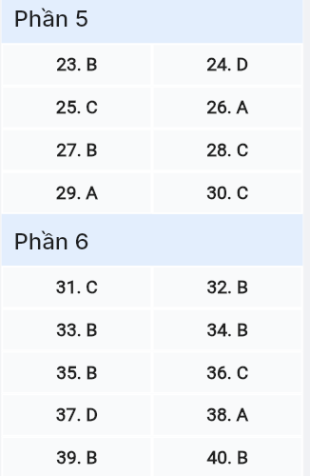
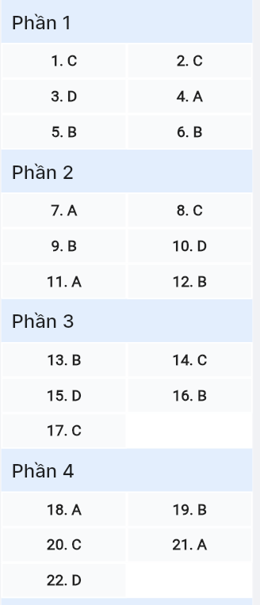
ĐỀ MINH HỌA SỐ 21
KỲ THI TỐT NGHIỆP TRUNG HỌC PHỔ THÔNG NĂM 2025
(Đề thi có 08 trang)
Môn thi: TIẾNG ANH
Thời gian làm bài: 50 phút, không kể thời gian phát đề

Read the following advertisement and mark the letter A, B, C or D on your answer sheet to indicate the option that best fits each of the numbered blanks from 1 to 6.

Technology has revolutionized the way we learn, (1) ______ a multitude of educational tools that enhance the learning experience. One notable tool is EduTech, which helps students stay organized and manage their study schedules for upcoming exams. The platform provides students (2) ______ an interactive interface to track their progress (3) __________. GIA SƯ TẠI HUẾ ( 079.3833272)
By using this platform, students can easily plan their study sessions, making it easier to (4) ______ track of their assignments. Many students also appreciate the feature that allows them (5) ______ their academic performance regularly, which can be highly encouraging. It’s an efficient way to ensure that (6) ______ are met.
Question 1 [697753]: A. is provided B. provided C. providing D. that provides
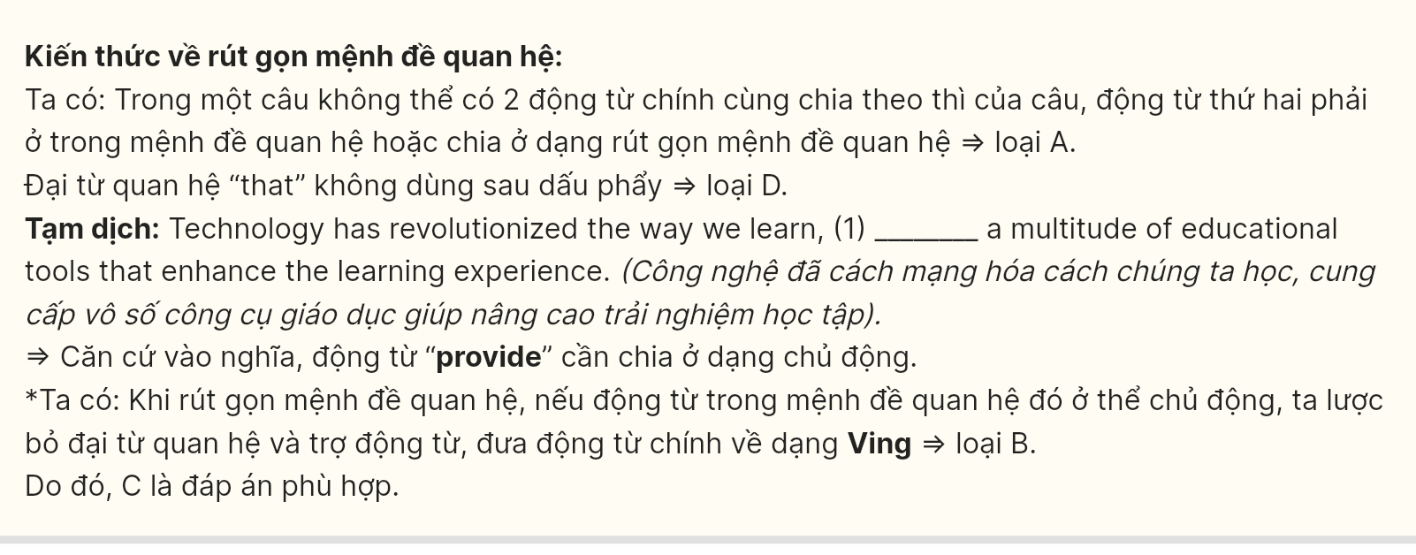
Question 2 [697754]: A. at B. to C. with D. by

Question 3 [697755]: A. affect B. effective C. effectiveness D. effectively
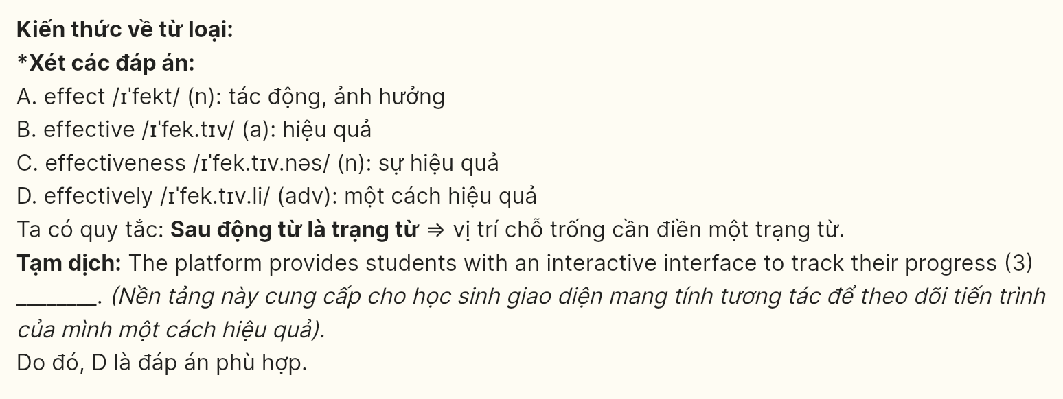
Question 4 [697756]: A. keep B. pay C. set D. take

Question 5 [697757]: A. monitoring B. to monitor C. monitor D. to monitoring

Question 6 [697758]: A. all study goals B. all study goals
C. goals study all D. all goals study

Read the following leaflet and mark the letter A, B, C or D on your answer sheet to indicate the option that best fits each of the numbered blanks from 7 to 12.
City Living: The Cost of Development
Modern urban development presents significant challenges. Statistics show there isn’t (7) ______ space for parking in downtown areas as new residential towers continue to rise. The urban landscape is changing dramatically.
As major retail chains dominate the market, traditional family businesses have (8) ______ at an alarming rate. This trend threatens the neighborhood’s unique character.
The city council promises new (9) ______ to serve the growing population. However, residents question whether these improvements will benefit everyone equally.
(10) ______, some neighborhoods have prioritized better-integrated transportation infrastructure. This represents a major shift in urban planning policy.
Question 7 [697759]: A. much B. many C. a little D. few
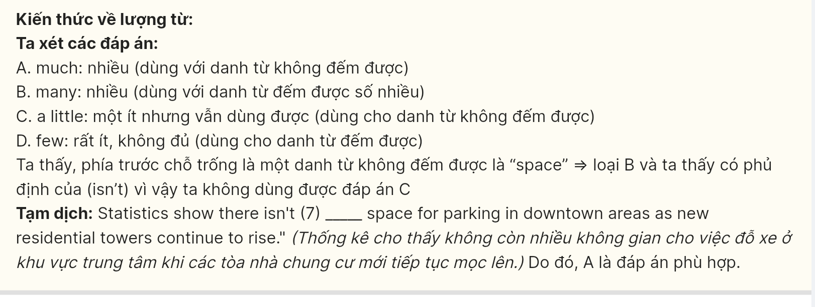
Question 8 [697760]:A. gone down B. gone through C. gone under D. gone over
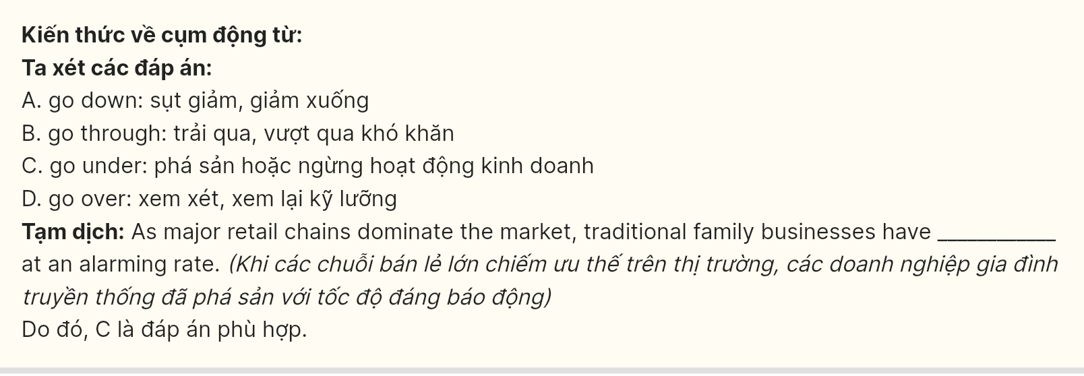
Question 9 [697761]: A. abilities B. ambitions C. capabilities D. utilities
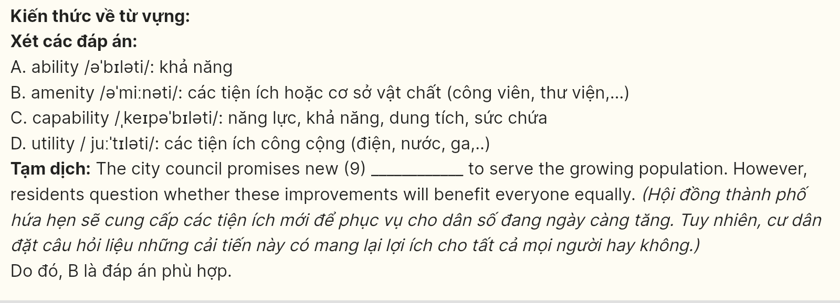
Question 10 [697762]: A. on top of B. for the sake of C. at the peak of D. on account of
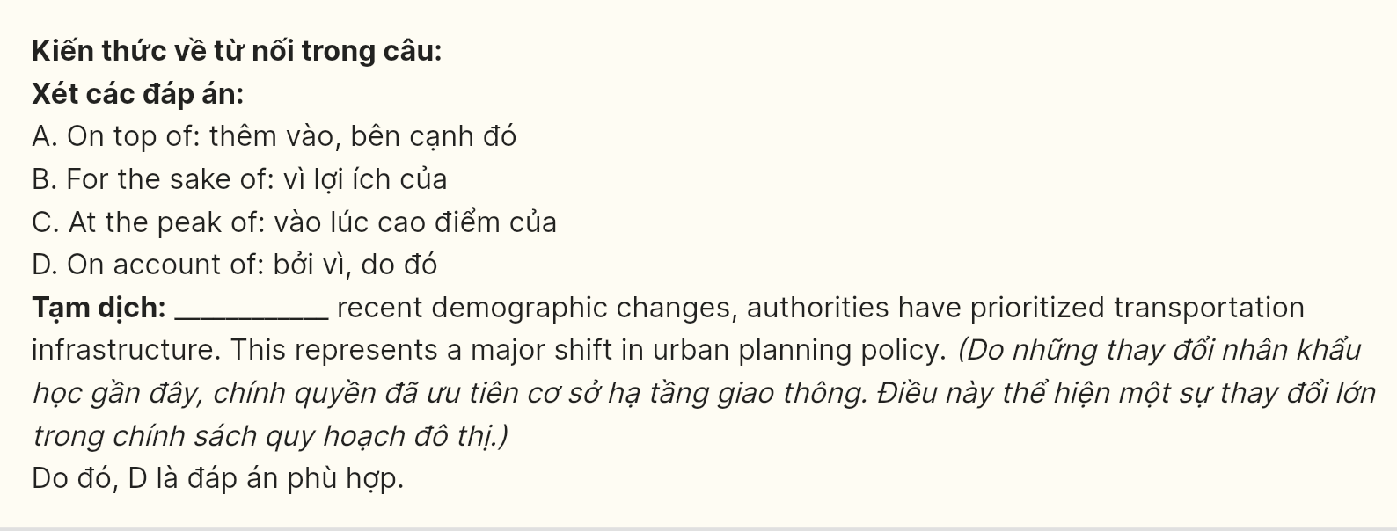
Question 11 [697763]: A. mushroom B. sprout C. emerge D. arise
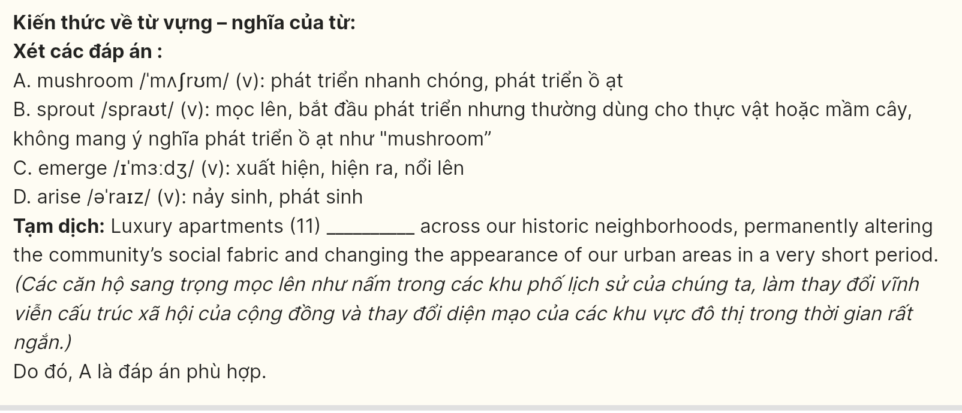
Question 12 [697764]: A. discern B. dissect C. dispatch D. distill
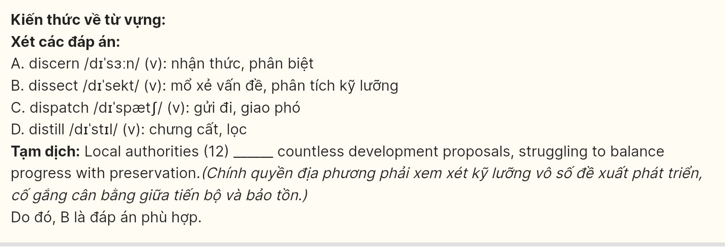
Mark the letter A, B, C or D on your answer sheet to indicate the best arrangement of utterances or sentences to make a meaningful exchange or text in each of the following questions from 13 to 17.
Question 13 [697765]:
a. Julia: Their Korean-inspired tacos are absolutely amazing!
b. Julia: Have you tried that new fusion restaurant downtown?
c. Alex: Not yet. What’s their specialty?
A. c-a-b B. b-c-a C. a-c-b D. a-b-c

Question 14 [697766]:
a. Emma: It talked about the immense pressure we face to excel in so many areas of life.
b. Olivia: No, I haven’t seen it. What did it cover? GIA SƯ TẠI HUẾ (0793833272)
c. Emma: Hey, did you catch that new documentary about the challenges facing teens today?
d. Olivia: I know what you mean. It feels like we have to be perfect at everything.
e. Emma: Exactly! And then there’s the constant social media scrutiny. It’s exhausting.
A. c-a-b-d-e B. b-a-c-e-d C. c-b-a-d-e D. b-c-a-e-d
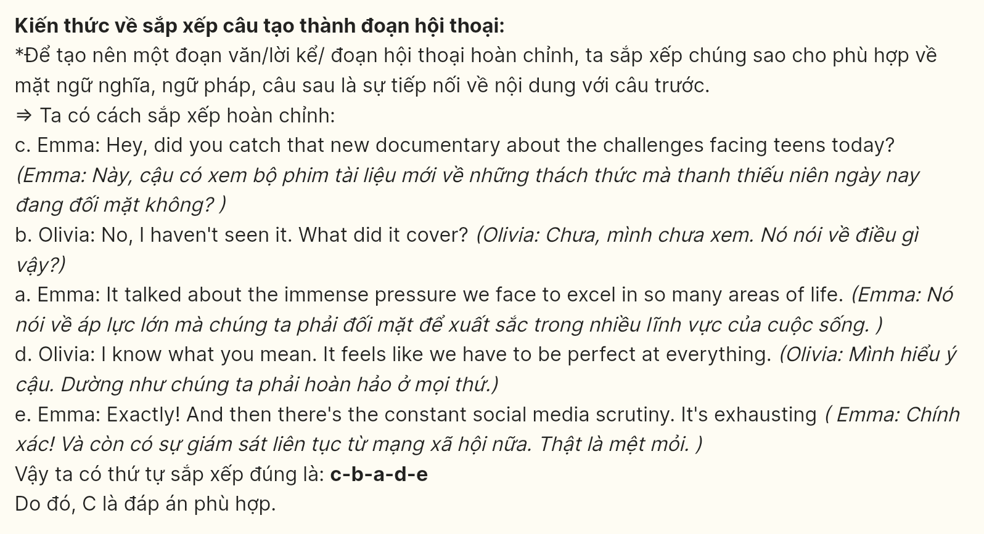
Question 15 [697767]:
Dear Neighbor,
a. I’m writing to share an exciting opportunity to help improve our community park.
b. Your participation, whether for a few hours or a regular commitment, would make a real difference.
c. We’re organizing a community-wide cleanup and restoration project next month.
d. As you may have noticed, our beloved park needs some renovation and care.
e. Together, we can transform this space into something we can all be proud of.
Best regards,
The Neighborhood Association
A. a-d-b-c-e B. a-b-d-c-e C. a-b-e-c-d D. a-d-c-b-e
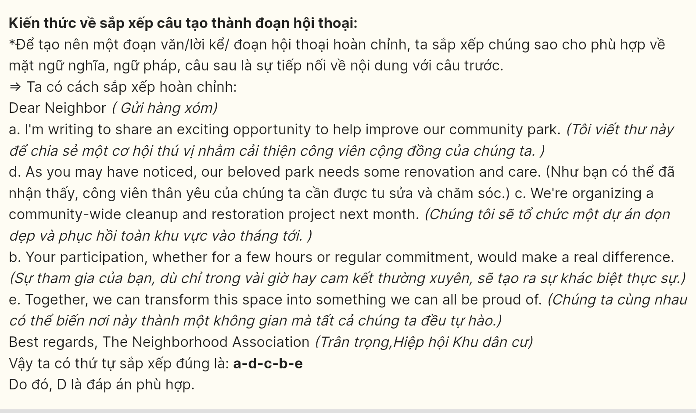
Question 16 [697768]:
a. Skyscrapers and shopping centers have replaced historical buildings and local markets.
b. The modern cityscape has transformed dramatically over the past decade.
c. While development brings economic opportunities, it also raises concerns about cultural preservation.
d. Finding the balance between progress and preservation remains the city’s greatest challenge.
e. Many residents struggle to adapt to these rapid changes in their neighborhoods.
A. b-d-c-a-e B. b-a-c-e-d C. b-a-c-d-e D. b-d-c-e-a
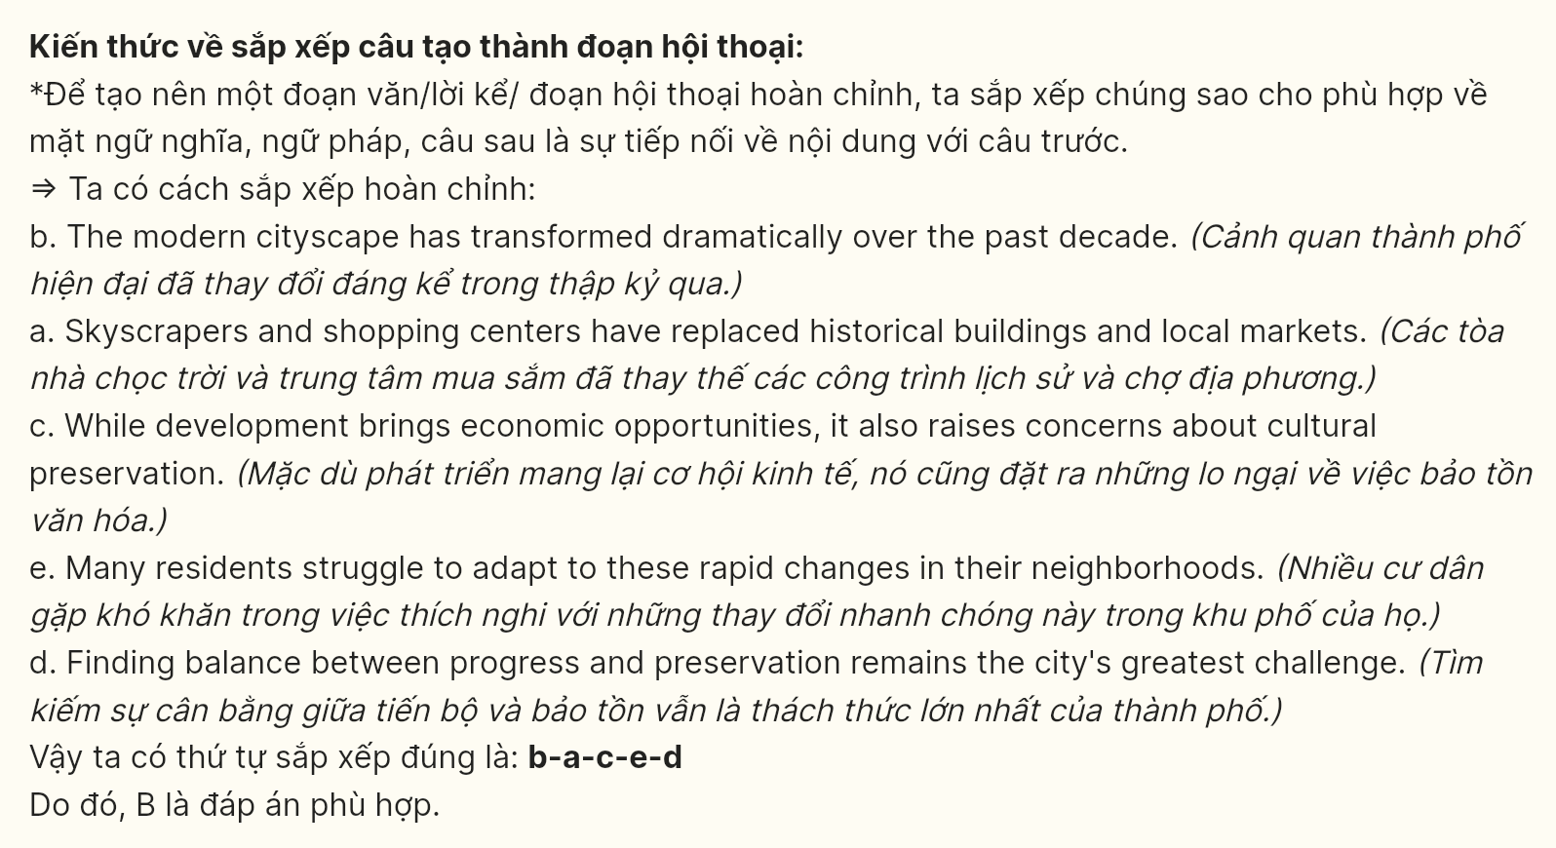
Question 17 [697769]:
a. The simplicity of those times stands in stark contrast to today’s fast-paced world.
b. Each photograph captures moments of joy, celebration, and sometimes bittersweet goodbyes.
c. Looking through old family albums often triggers a flood of childhood memories.
d. These precious memories serve as a reminder of how far we’ve come and what truly matters.
e. Holiday gatherings, summer picnics, and weekend adventures fill these yellowing pages.
A. b-a-c-d-e B. c-b-a-d-e C. c-b-a-e-d D. b-d-c-e-a

Read the following passage about Japanese sushi culture and mark the letter A, B, C or D on your answer sheet to indicate the correct answer for each blank from 18 to 22.

The art of sushi-making, deeply rooted in Japanese culinary heritage, reflects precision and tradition that spans generations. The careful selection of fresh fish and rice, essential to authentic sushi preparation, (18) ______. A recent global study presents new findings about ancient sushi techniques (19) ______. This discovery has revolutionized our understanding of traditional Japanese cuisine. GIA SƯ TẠI HUẾ ( 079.3833272)
Creating traditional nigiri sushi demands years of dedicated training and unwavering dedication to culinary excellence. In particular, (20) ______. Master chefs spend decades perfecting their knife skills and rice preparation, ensuring each piece meets the highest standards of quality. In prestigious kitchens, (21) ______. The Tokyo Sushi Academy’s research into traditional methods has revealed the importance of temperature control in rice preparation, leading to enhanced flavor profiles and texture. Contemporary sushi masters continue to honor these time-tested principles while adapting to modern tastes.
Determined to preserve authentic sushi-making techniques, (22) ______. This dedication ensures that traditional sushi craftsmanship continues to thrive in an era of fusion cuisine and modernization.
Question 18 [697770]:
A. has stood as a fundamental principle of master craftsmanship
B. standing as a fundamental principle of master craftsmanship
C. that stands as a fundamental principle of master craftsmanship
D. of which master craftsmanship stands as a fundamental principle

Question 19 [697771]:
A. whose centuries-old practices reveal detailed documentation
B. which has documented centuries-old practices in detail
C. having documented centuries-old practices in detail
D. attempted to meticulously document centuries-old practices

Question 20 [697772]:
A. experienced sushi chefs selecting strict rice preparation and fish with quality standards maintained
B. maintaining strict quality standards, sushi is prepared with rice and select fish by experienced chefs
C. experienced sushi chefs maintain strict quality standards for rice preparation and fish selection
D. the maintenance of quality standards for rice preparation and fish selection by chefs is strict

Question 21 [697773]:
A. incorporating seasonal ingredients, master chefs create distinctive flavors in traditional dishes
B. master chefs create distinctive flavors in traditional dishes, they can incorporate seasonal ingredients
C. without master chefs, distinctive flavors in traditional dishes could be created by incorporating seasonal ingredients
D. the creation of distinctive flavors in traditional dishes and master chefs incorporate seasonal ingredients
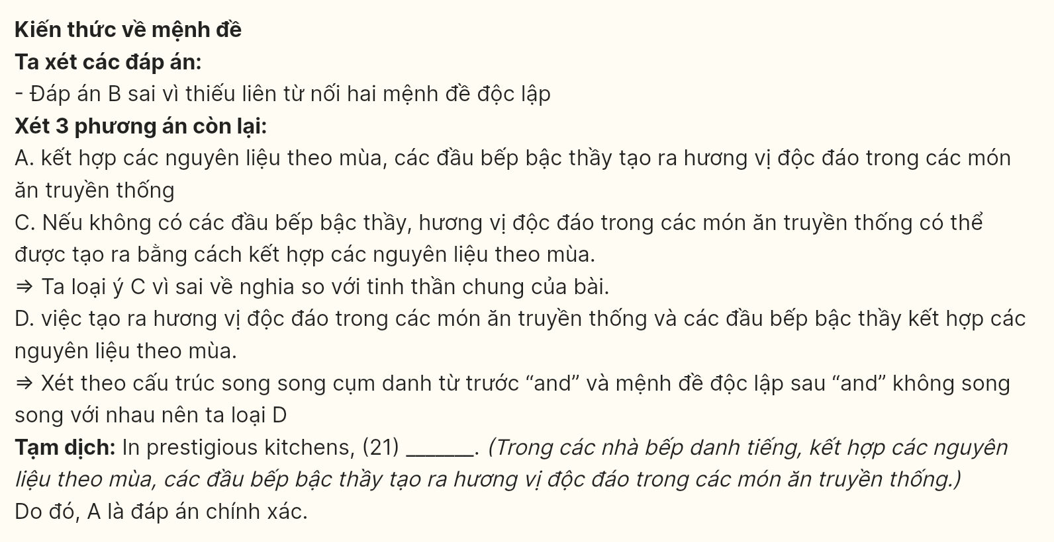
Question 22 [697774]:
A. traditional techniques and quality standards must be upheld consistently by professional sushi masters
B. upholding traditional techniques and quality standards needs professional sushi masters
C. the consistent existence of traditional techniques and quality standards must be upheld
D. professional sushi masters must uphold traditional techniques and quality standards consistently
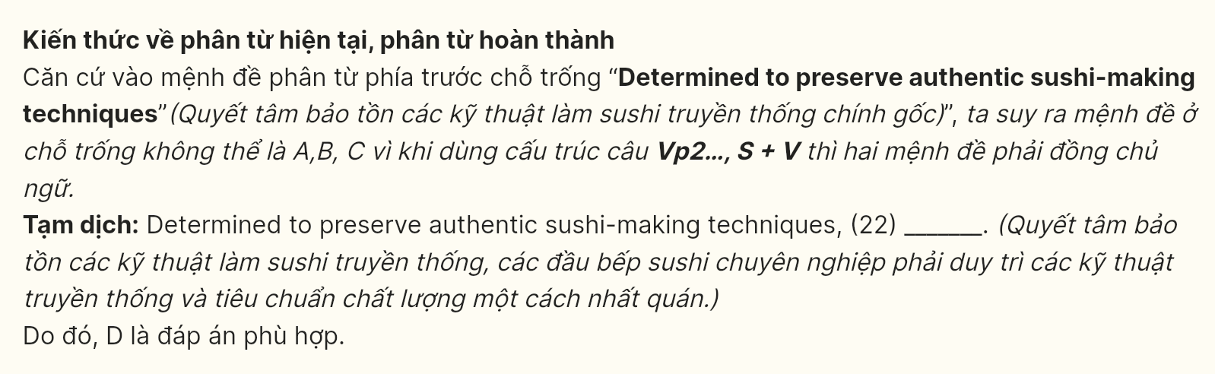
Read the following passage about the impact of cyberspace communication and mark the letters A, B, C, D on your answer sheet to indicate the best answer to each of the following questions from 23 to 30.

Teens don’t understand the big fuss. As the first generation to grow up in a digital world, they hardly know a time when computers weren’t around, and they leap at the chance to spend hours online, chatting with friends. So what? But researchers nationwide are increasingly concerned that, as cyberspace replaces the pizza parlor as the local hangout, adolescents are becoming more isolated, less adept at interpersonal relationships, and perhaps numb to the small and large deceptions that are prevalent in the email world. Researchers are questioning how the futures of teenagers are changing when so many of them are spending an hour or two on the Internet each day, replacing face-to-face contact with computer screens.
Social psychologists, including Robert Kraut, have expressed concern about the "opportunity costs" of so much online time for youths. He found that teens who used computers, even just a few hours a week, showed increased signs of loneliness and social isolation. In his study of 100 families using the Internet, Kraut noted that their computer time replaced hours they would have spent with others. "Chatting online may be better than watching television, but it is worse than hanging out with real friends," he said.
Today’s teens, however, don’t see anything strange in the fact that the computer screen occupies a central place in their social lives. “School is stressful and busy. There’s almost no time to hang out," said Parker Rice, 17. “Talking online is just catch-up time.” Many teens acknowledge there’s an unreal quality to their cyberspace communication, including their odd shorthand terms, such as POS (parent over shoulder) or LOL (laughing out loud). Psychologists see this code as part of the exclusive shared language that teenagers love.
When it comes to email exchanges, teens also show a remarkable tolerance for each other’s fudges or deceptions. Nor are they surprised when a mere acquaintance shares a personal secret through email. Nobody seems to expect the online world to be the same as the real world.
(Adapted from Strategic Reading by Richards and Eckstut-Didier)
Question 23 [697775]: Which of the following is NOT mentioned as being impacted by teens’ going online excessively?
A. their relationship B. their health C. their communication D. their future
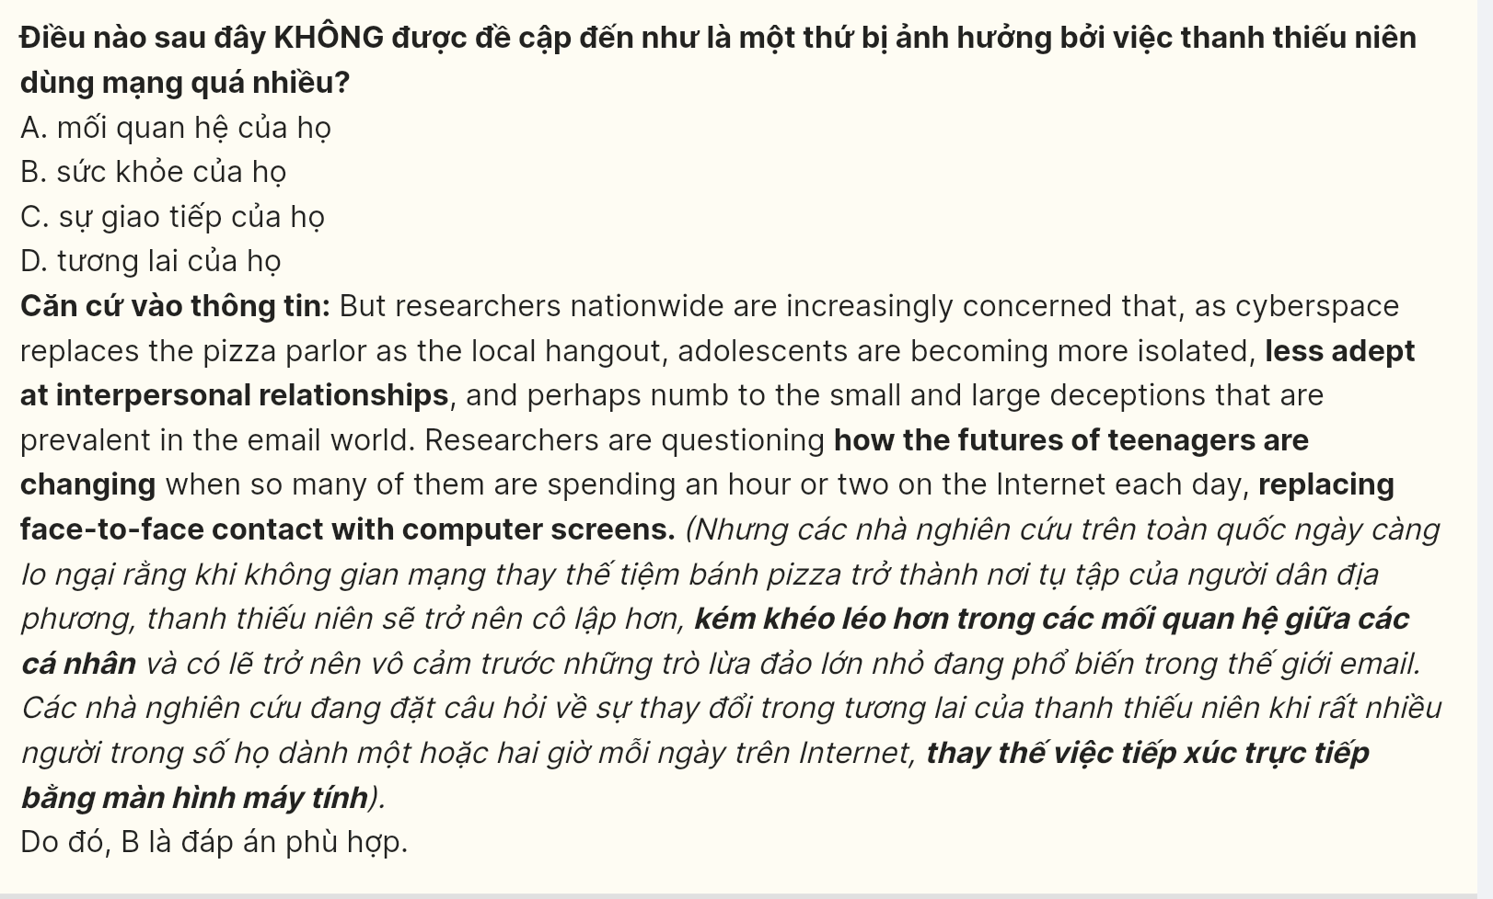
Question 24 [697776]: The word “adept” in paragraph 1 is closest in meaning to ______.
A. swift B. affable C. adopted D. skillful
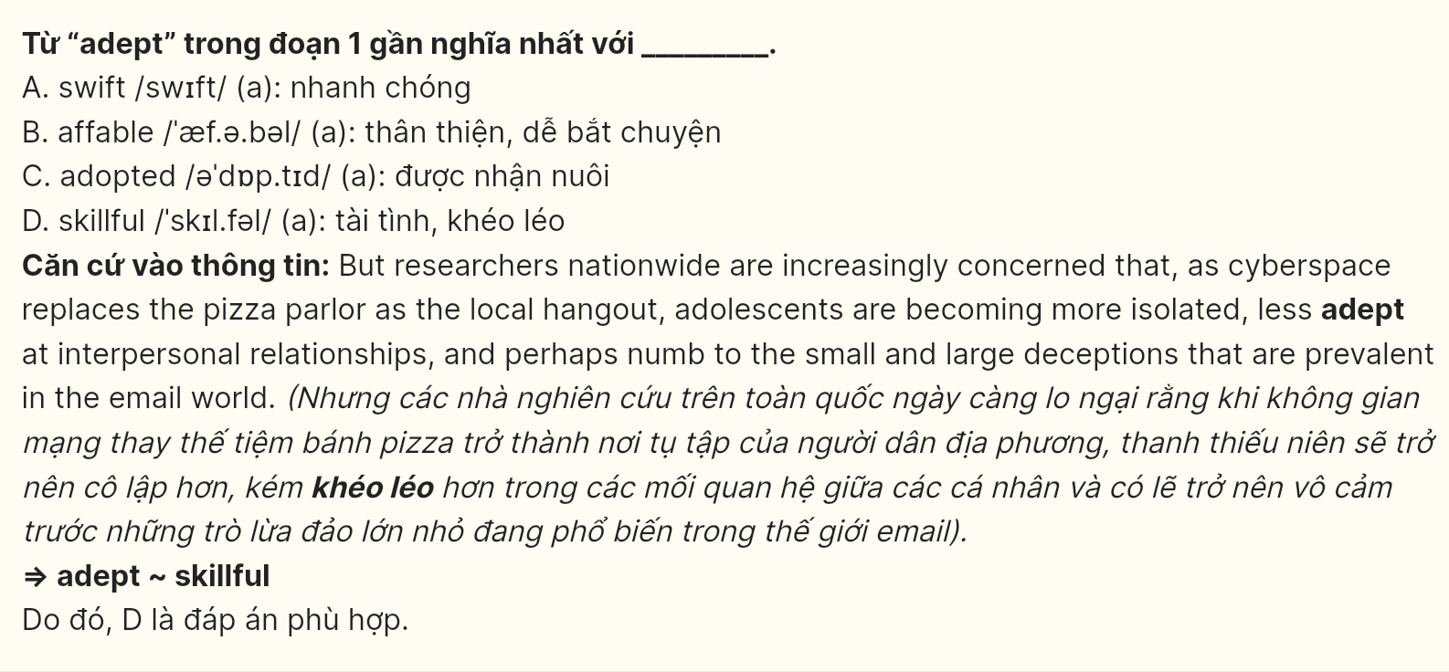
Question 25 [697777]: The word “it” in paragraph 2 refers to ______. GIA SƯ TẠI HUẾ ( 079.3833272)
A. having fewer friends B. online time C. chatting time D. loneliness
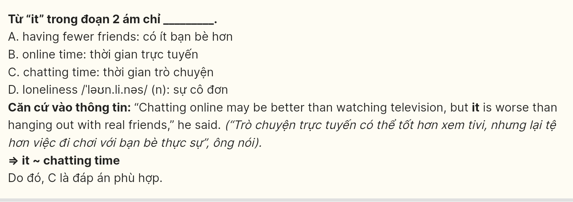
Question 26 [697778]: The word “unreal” in paragraph 3 is OPPOSITE in meaning to ______.
A. genuine B. vague C. incredible D. sensitive
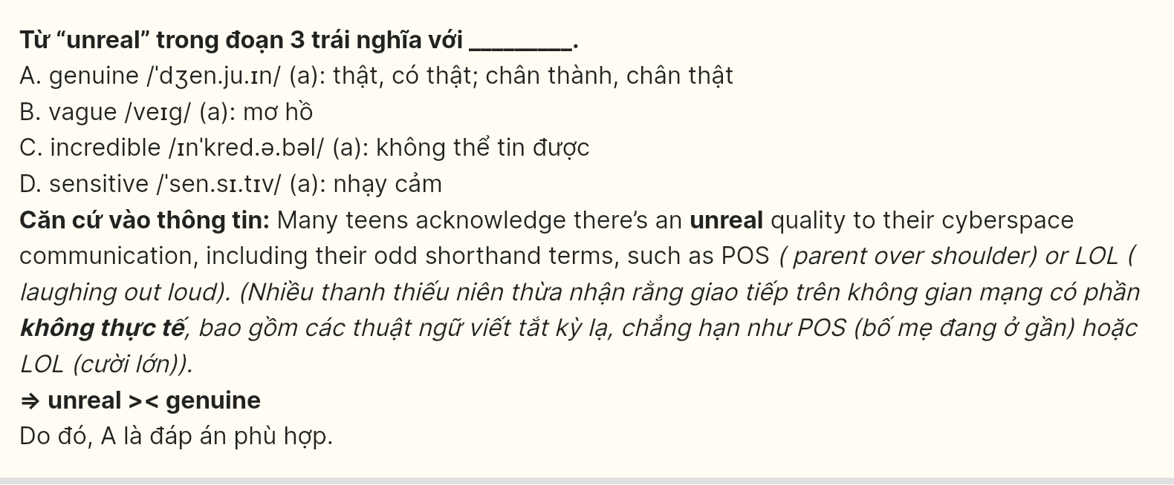
Question 27 [697779]: Which of the following best paraphrases the underlined sentence in paragraph 3?
A. Teens today find it unusual that computers play such an important role in their social interactions.
B. Teens today believe it’s normal for computers to be a major part of their social lives.
C. Teens today feel uncomfortable with how much computers are involved in their social lives.
D. Teens today worry that computers are taking over their social lives.
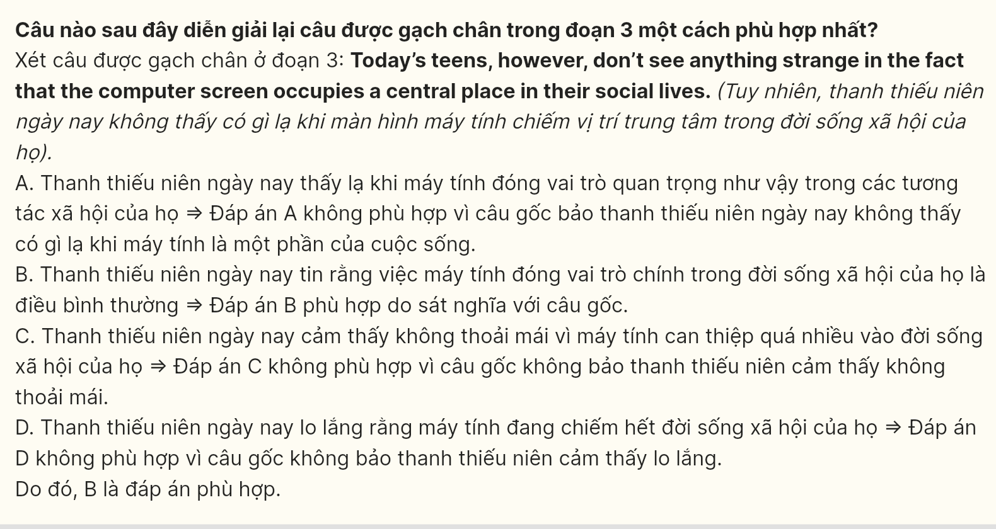
Question 28 [697780]: According to the passage, which of the following statements is NOT true?
A. Stress and tension in schools could probably be a reason for the increasing number of teens going online.
B. Teens tend to be more tolerant towards each other’s fudges or deceptions.
C. Anybody believes that the online world should be exactly like the real world.
D. Spending just a few hours a week using computers can also increase signs of loneliness in teens.

Question 29 [697781]: In which paragraph does the writer mention concerns about isolation and interpersonal relationships?
A. Paragraph 1 B. Paragraph 2 C. Paragraph 3 D. Paragraph 4
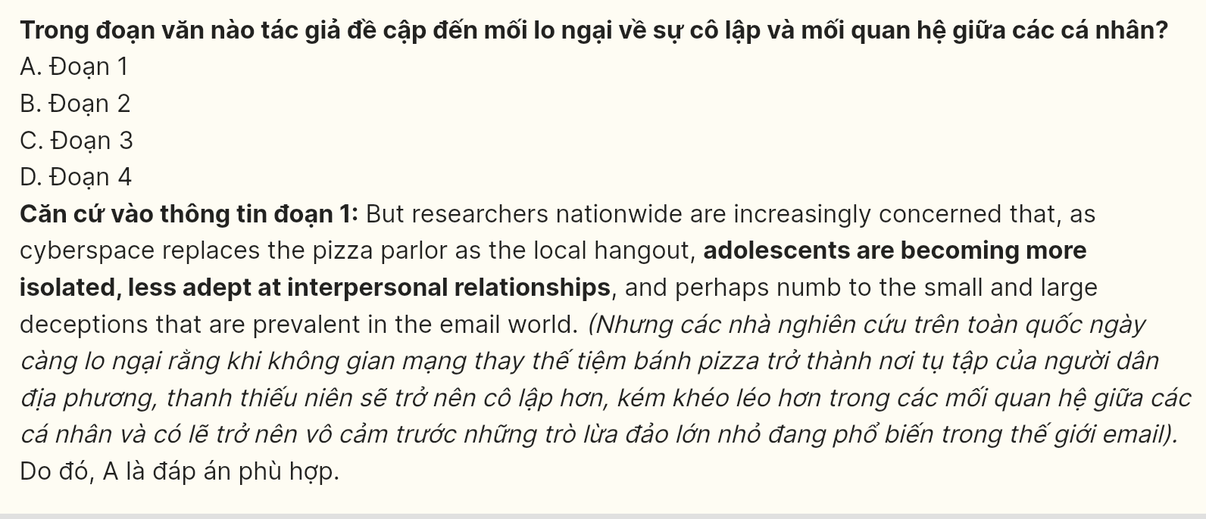
Question 30 [697782]: In which paragraph does the writer discuss teens’ perception of their online communication?
A. Paragraph 1 B. Paragraph 2 C. Paragraph 3 D. Paragraph 4
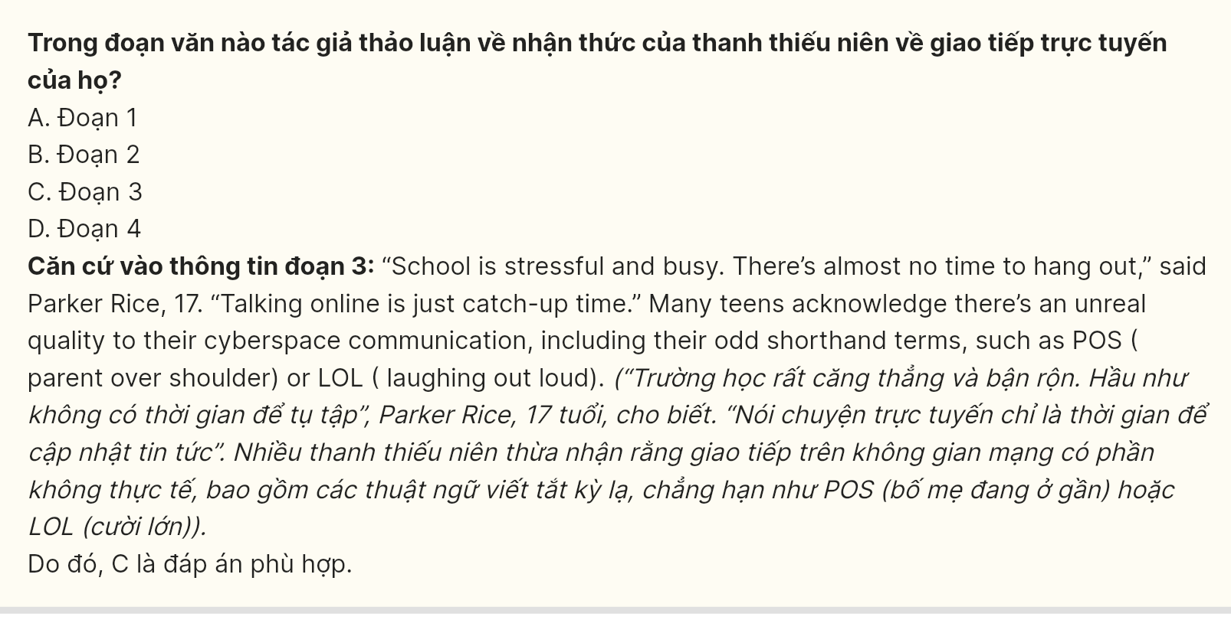
Read the following passage and mark the letter A, B, C or D on your answer sheet to indicate the best answer to each of the following questions from 31 to 40.
- The trend of remote work has surged dramatically in recent years, largely accelerated by technological advancements and the COVID-19 pandemic. [I] Many employees now have the flexibility to work from home. Various factors contribute to this shift, resulting in both benefits and challenges for individuals and urban environments. GIA SƯ TẠI HUẾ ( 079.3833272)
- There are several advantages that encourage the adoption of remote work. For example, employees can enjoy a better work-life balance, saving time and money on commuting. [II] This flexibility can result in increased productivity and job satisfaction, as individuals can tailor their work environment to their preferences. Studies have shown that many remote workers report feeling less stressed and more engaged in their tasks, as they can create a workspace that best suits their needs. [III] Many urban areas may see a decline in local businesses that rely on foot traffic, such as cafes and shops, as fewer people commute to work. This decline could lead to job losses and economic challenges for small businesses that thrive on daily visitors.
- The rise of remote work also has significant implications for urban living. [IV] With fewer people commuting daily, traffic congestion may decrease, potentially leading to improved air quality in cities. Conversely, this trend can also contribute to a decline in public transportation usage, which could jeopardize funding for these essential services.
- To address these evolving dynamics, urban planners and policymakers need to adapt to the changing landscape of work. By promoting mixed-use developments that accommodate both remote work and vibrant community spaces, cities can create environments that support both residents and local businesses. Ultimately, understanding the long-term effects of remote work will be crucial for shaping future urban living.
Question 31 (697783): Where in this passage does the following sentence best fit?
However, there are challenges associated with this shift.
A. [I] B. [II] C. [III] D. [IV]
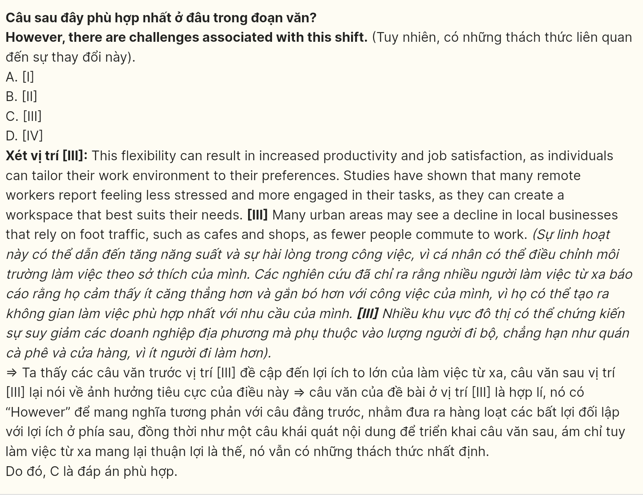
Question 32 (697784): The phrase resulting in in paragraph 1 could be best replaced by ______.
A. firing up B. leading to C. resulting from D. bringing up
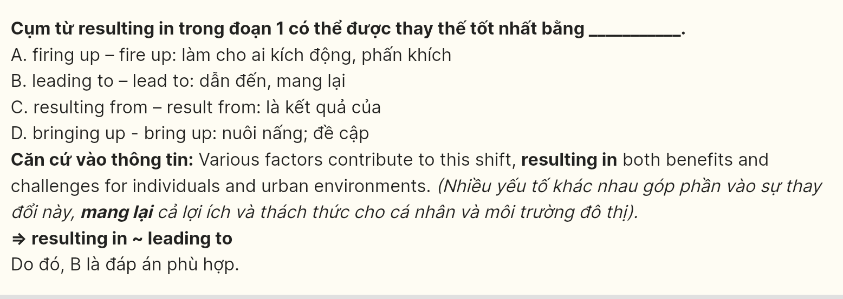
Question 33 (697785): The word their in paragraph 2 refers to ______.
A. tasks B. remote workers C. individuals D. studies GIA SƯ TẠI HUẾ ( 079.3833272)
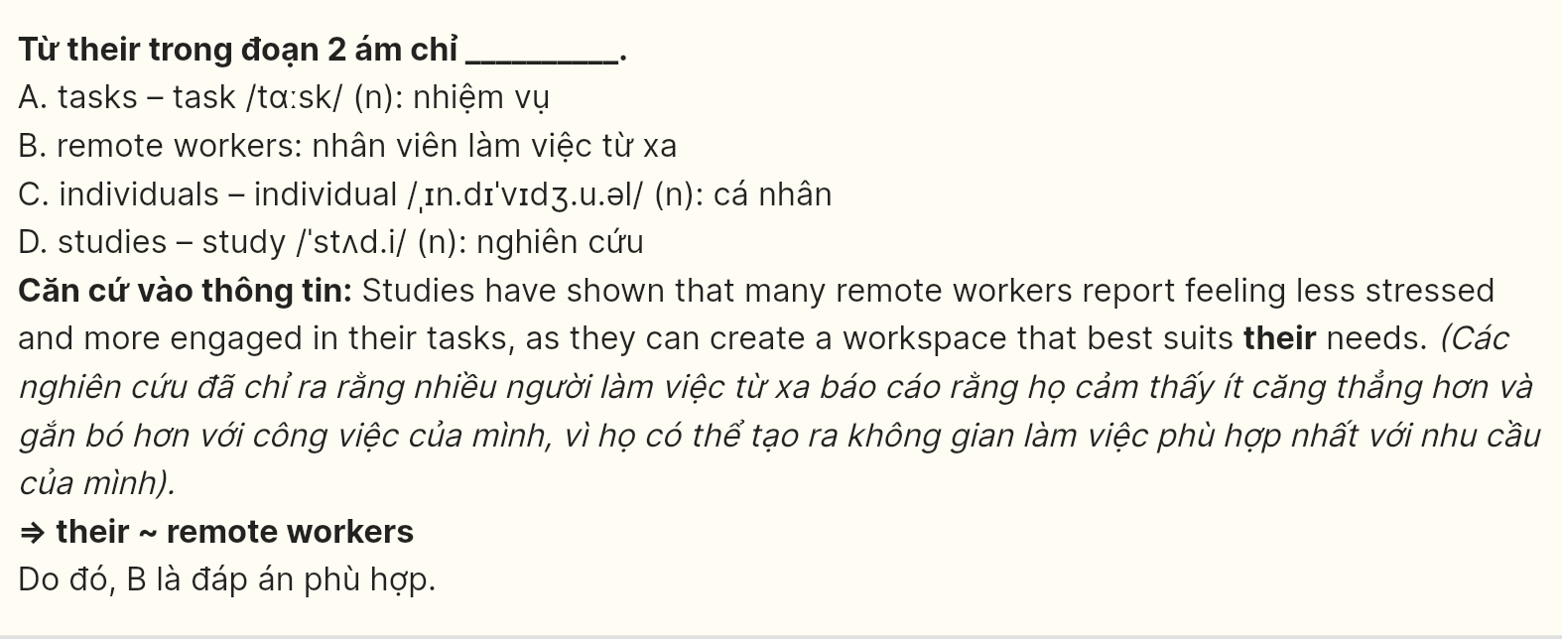
Question 34 (697786): According to paragraph 2, which of the following is NOT an advantage of remote work?
A. Better work-life balance
B. Increased commuting time
C. Increased productivity
D. Job satisfaction
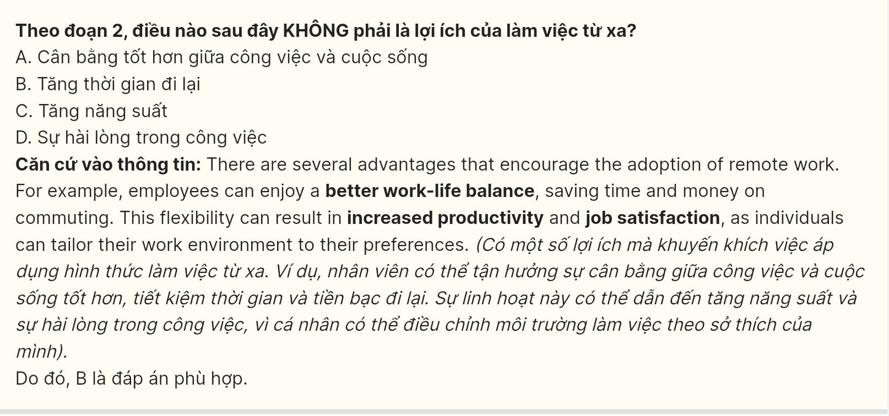
Question 35 (697787): Which of the following best summarises paragraph 3?
A. Fewer commuters bring economic advantages to local businesses and urban infrastructure.
B. Remote work reduces commuting, improving urban air quality but risks public transport funding.
C. Remote work causes higher stress levels and a lack of engagement among employees.
D. The rise of remote work contributes to greater traffic congestion and deteriorates air quality in urban areas.

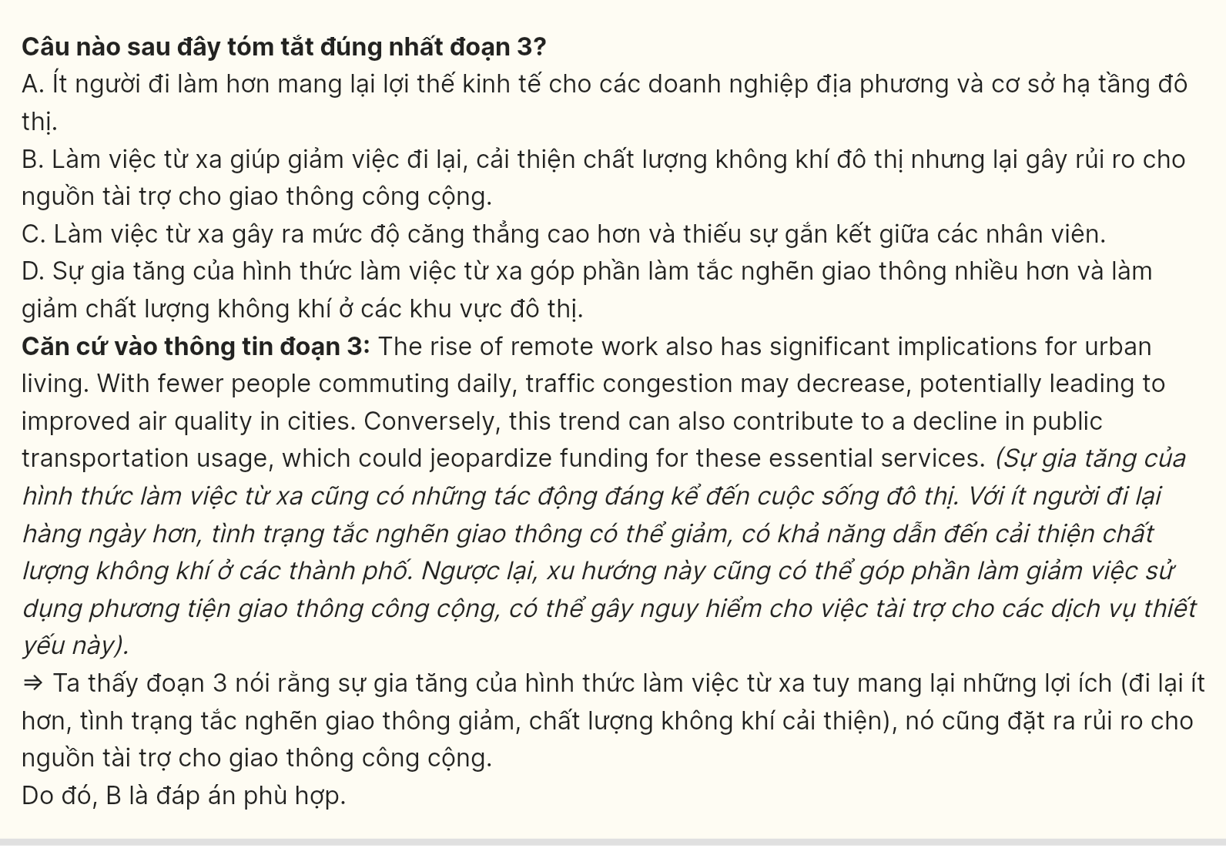Question 36 (697788): The word promoting in paragraph 4 is OPPOSITE in meaning to ______.
A. facilitating B. dignifying C. hindering D. elevating
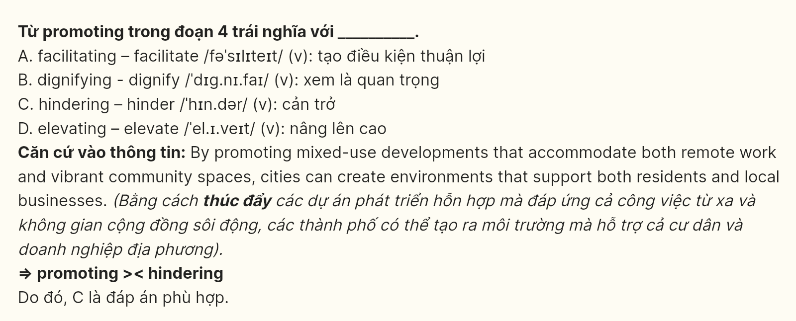
Question 37 (697789): Which of the following is TRUE according to the passage?
A. The rise of remote work has significantly decreased job satisfaction among employees as they prefer working in traditional office spaces. GIA SƯ TẠI HUẾ ( 079.3833272)
B. Most remote workers feel more stressed and disconnected from their tasks than when they work in an office.
C. The transition to remote work has resulted in a notable rise in the use of public transportation in urban settings.
D. Remote work offers employees the chance to improve their work-life balance and overall health.
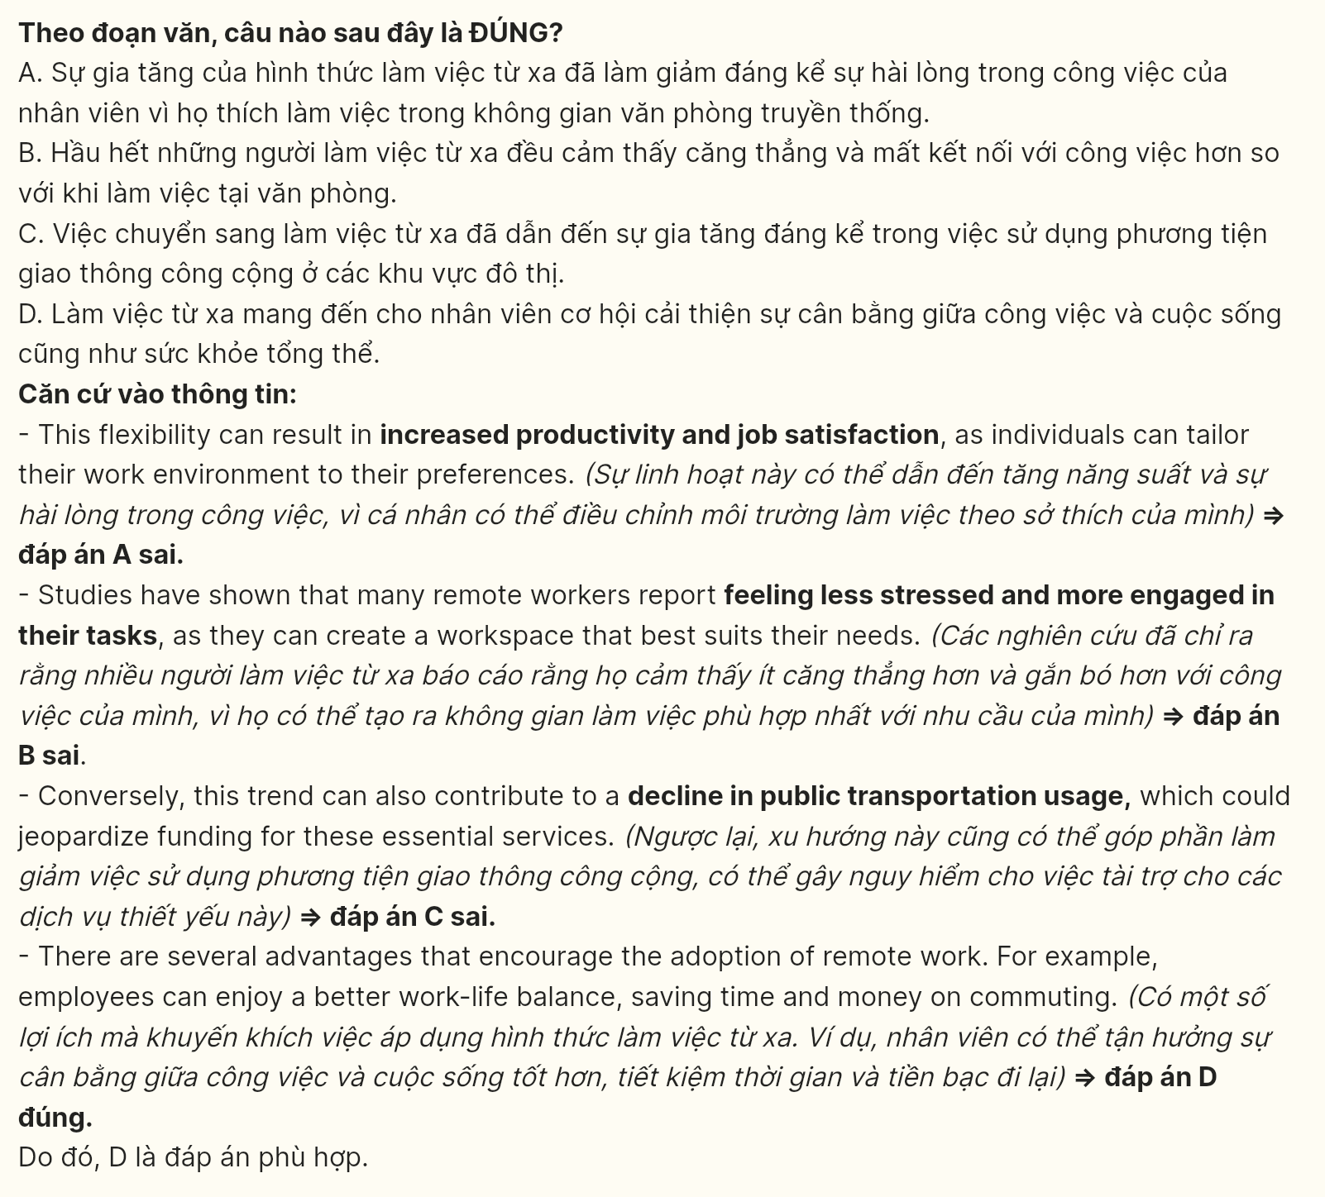
Question 38 (697790): Which of the following best paraphrases the sentence in paragraph 2?
A. A reduction in commuters could harm local businesses dependent on daily visitors, like shops and cafes.
B. Urban businesses that rely on customer visits, including cafes, are likely to thrive with more remote work.
C. Increased remote work may benefit local cafes and shops that depend on foot traffic.
D. Fewer commuters will boost the economy of urban areas by increasing customer visits to local businesses.
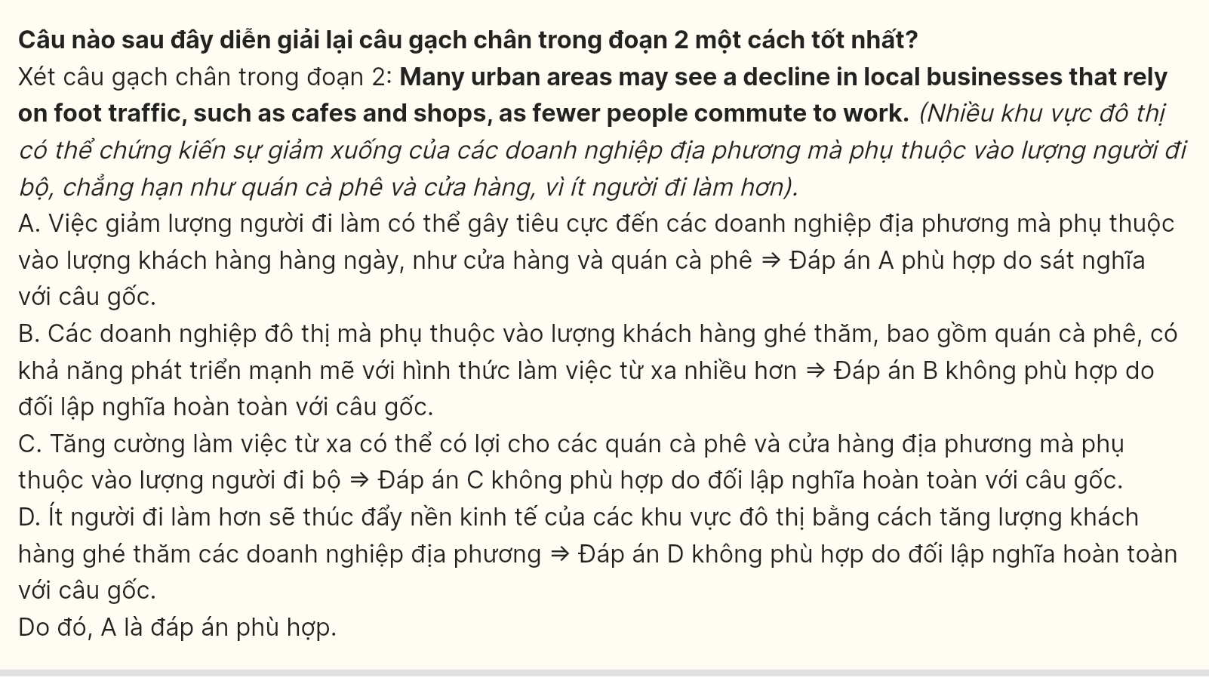
Question 39 (697791): Which of the following can be inferred from the passage?
A. Remote work will likely decrease the demand for housing in city centers.
B. The shift to remote work may require new strategies for urban development.
C. More people will move back to urban centers as remote work declines.
D. Local businesses will easily adapt to the trend of remote work without issues.
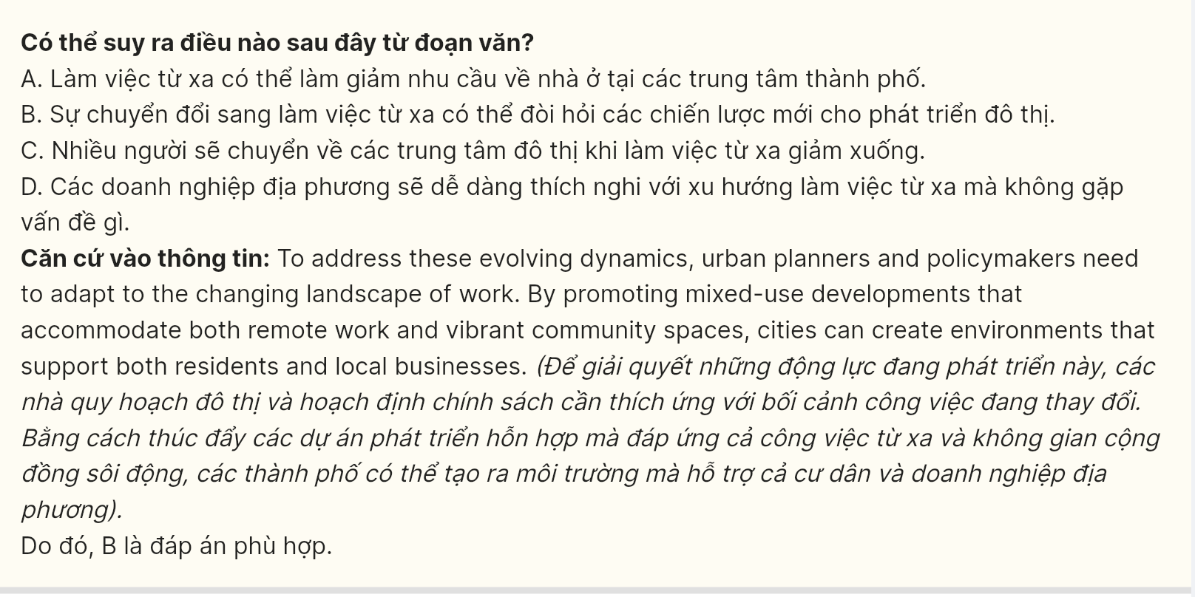Question 40 (697792): Which of the following best summarises the passage?

A. Remote work is a temporary trend that will not have any lasting effects on urban environments or theworkforce.
B. Remote work has expanded due to technology and the pandemic, offering benefits like flexibility but also challenges for urban areas.
C. Urban planners must completely redesign cities to accommodate a future without remote work.
D. Remote work has become popular due to the COVID-19 pandemic, but it only benefits employees and has no impact on urban areas.
