ĐỀ SỐ 8
Mark the letter A, B, C, or D on your answer sheet to indicate the word whose underlined part differs from the other three in pronunciation in each of the following questions.
Question 1. A. thunder B. erupt C. commune D. bustling
Question 2. A. assignment B. teenager C. congestion D. hygiene
Mark the letter A, B, C, or D on your answer sheet to indicate the word that differs from the other three in the position of primary stress in each of the following questions.
Question 3. A. historic B. terrific C. delicious D. functional
Question 4. A. minority B. independence C. emergency D. facility
Mark the letter A, B, C, or D on your answer sheet to indicate the correct answer to each of the following questions.
Question 5. He was told he could join the Volunteer Group when he ______ old enough.
A. would be B. should be C. was D. were
Question 6. The fire is going to go out. Can you go and get ______ wood?
A. any B. some C. a D. much
Question 7. My grandmother didn't work outside her home ______ she was young. She only did her jobs in the house.
A. when B. for the time C. as soon as D. whenever
Question 8. They didn't sell the family-owned workshop; they ______ to the next generation.
A. passed it on B. kept it up C. carried it out D. moved it up
Question 9. Cu Chi Tunnels are among Viet Nam's most ______ historic sights.
A. impress B. impressing C. impression D. impressive
Question 10. It's difficult to ______ what our lives would be like without the Internet.
A. expect B. imagine C. remember D. see
Question 11. It is honest of him to return ______.
A. a wallet back to its original owner B. to its original owner the wallet
C. the wallet to its originally owner D. the wallet to its original owner
Question 12. Tom: "Thank you very much for your lovely gift! I really like it." - Maria: “______”
A. I'm pleased B. Oh, it's OK C. You're welcome D. It's not good
Read the following conversation and mark the letter A, B, C, or D on your answer sheet to indicate the correct option that best fits each of the numbered blanks from 13 to 16.
If you're applying for jobs for the first time, it's useful to know the steps in your journey to finding the right job.
1. Understand your career ambitions: It may seem obvious, but it's important to be (13) ______ about the kind of job you want.
2. (14) ______ your CV: This also helps you complete the application forms.
3. Complete the application form: Answer each question as fully and (15) ______ as possible.
4. Produce a covering email or letter.
5. Prepare for interview: It's advisable to research and read the job (16) ______ and your application.
Overall, good preparation is the key to success.
Question 13. A. clear B. successful C. excellent D. special
Question 14. A. Create B. Perform C. Construct D. Write
Question 15. A. entirely B. accurately C. decisively D. certainly
Question 16. A. picture B. orientation C. description D. knowledge
Mark the letter A, B, C, or D to indicate the correct answer to each of the following questions from 17 to 18.
Question 17. Put the sentences (a-c) in the correct order, then fill in the blank to make a logical text.
Maybe one day people will live on Mars or in huge space stations. There are lots of materials like metals, ice, and hydrocarbons in our solar system. We can make fuel for rockets, and build spacecraft. ______
a. In a hundred years from now, we will have new technologies and new ways to explore space.
b. We can also use these materials to produce oxygen and water, and to grow food.
c. If we invent very fast spacecraft, maybe we will explore other solar systems one day, too.
A. a-b-c B. b-c-a C. b-a-c D. c-a-b
Question 18. Choose the sentence that can end the text (in Question 17) most appropriately.
A. What does a spacecraft look like in about a hundred years' time?
B. Where will you choose to live then, on land, in the sea, or in space?
C. What do you think our life will be like then, and where do you think we will live?
D. When will you move to other solar systems to live, and what do you like then?
Read the following passage and mark the letter A, B, C, or D on your answer sheet to indicate the correct word or phrase that best fits each of the numbered blanks from 19 to 24.
Sports are a fun way to stay active and healthy. They help us improve our physical fitness and can-also be a great way to make (19) _____ friends. There are many types of sports to choose from, such as football, basketball, swimming, and tennis. Each sport has its own (20) _____ and skills, so everyone can find something they enjoy. Playing sports teaches us teamwork, discipline, and (21) _____ both winning and losing. Many people play sports in teams, which makes it exciting and social. For those who prefer to exercise alone, activities like running, cycling, or yoga are great options. (22) _____ in sports can help reduce stress and improve our mood. It is important to have fun and enjoy the game, (23) _____ we are beginners or experienced players. Overall, sports are not just about competition; they are about having fun, staying healthy, and (24) _____. So, whether you like playing or watching, sports can bring joy to our lives!
Question 19. A. fresh B. good C. bright D. new
Question 20. A. rules B. policies C. arrangements D. plans
Question 21. A. what to handle B. how to handle C. what handling D. how handling
Question 22. A. Organising B. Performing C. Participating D. Functioning
Question 23. A. no matter if B. no matter when C. matter no what D. not matter but
Question 24. A. friendships building B. building friendships
C. to build friendships D. friendships built
Mark the letter A, B, C or D on your answer sheet to indicate the sentence that is closest in meaning to the original sentence in each of the following questions.
Question 25. He cannot practise diving because he has a weak heart.
A. The fact that he has a weak heart cannot stop him practising diving.
B. Diving makes him suffer from having a weak heart.
C. The reason why he cannot practice diving is that he has a weak heart.
D. He has a weak heart, but he continues to practise diving.
Question 26. She knows a lot more about space travel than I do.
A. She doesn't know as much about space travel as me.
B. Who knows a lot more about space travel, she or I?
C. She even knows less about space travel than I do.
D. I don't know so much about space travel as she does.
Mark the letter A, B, C, or D on your answer sheet to indicate the sentence that is made from the given cues in each of the following questions.
Question 27. Google Maps /find / quickest route / my house / airport
A. I use Google Maps to find quickest route from my house to the airport.
B. I used Google Maps to find the quickest route from my house to the airport.
C. I used Google Maps finding a quickest route from my house to the airport.
D. I use Google Maps to find the quickest route between my house and the airport.
Question 28. very dangerous / drive 100 kph / wear / safety belt
A. It's very dangerous to drive 100 kph with wearing the safety belt.
B. It's very dangerous driving 100 kph without wearing the safety belt.
C. It's very dangerous to drive 100 kph without wearing the safety belt.
D. It's very dangerous to drive 100 kph wearing the safety belt.
Read the following sign or notice and mark the letter A, B, C, or D on your answer sheet to indicate the correct answer to each of the following questions.
Question 29. What does this sign say?
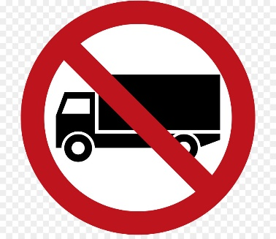 | A. No vehicles are allowed.  B. Only lorries are allowed.  C. Lorries go this way.  D. Lorries are forbidden.
Question 30. What does the notice say?
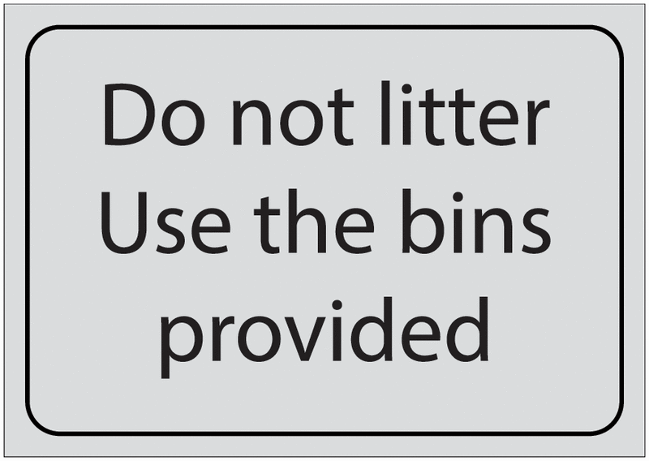 | A. Don't use the bins to litter.  B. You must put rubbish in the bins.  C. You must provide more bins.  D. Don't litter the bins with rubbish.
Read the following passage and mark the letter A, B, C, or D on your answer sheet to indicate the correct answer to each of the following questions from 31 to 36.
In October 2024, Typhoon Yagi made landfall in Ha Noi, causing significant damage to the city. This powerful storm brought strong winds and heavy rain, leading to widespread flooding in many districts. It was one of the worst storms the capital city had experienced in recent years. Thousands of people were evacuated from low-lying areas to prevent further harm from rising water levels.
During the storm, many roads in the city were flooded, making transportation difficult. Schools and businesses were closed to ensure the safety of the public. The government acted quickly by providing emergency shelters and organizing rescue teams. Many people in affected areas received food and water supplies from these teams.
Despite the challenges, the damage could have been worse if there had not been early warnings. The authorities issued alerts days before the storm arrived, allowing people to prepare and evacuate on time. This quick response helped save lives and minimize damage to properties.
In conclusion, Typhoon Yagi in 2024 had a major impact on Ha Noi, but thanks to early preparations and quick action by the government, the city was able to recover quickly.
Question 31. What is the main idea of the passage?
A. Typhoon Yagi did not cause any problems in Ha Noi.
B. Typhoon Yagi caused damage to Ha Noi, but early preparation helped reduce the impact.
C. The authorities of Ha Noi were not prepared for Typhoon Yagi.
D. People in Ha Noi received the warnings about Typhoon Yagi but ignored them.
Question 32. The word evacuated in paragraph 1 is CLOSEST in meaning to _____.
A. stayed B. ignored C. moved to safety D. returned home
Question 33. The word closed in paragraph 2 is OPPOSITE in meaning to _____.
A. opened B. shut C. locked D. left
Question 34. What can be inferred about the impact of Typhoon Yagi on Ha Noi?
A. It caused hardly any damage to the city.
B. Early warnings helped save lives and reduce the damage.
C. The government did not respond quickly to the storm.
D. People were not affected by the flooding.
Question 35. Which of the following is NOT TRUE according to the passage?
A. Typhoon Yagi caused severe flooding in Ha Noi.
B. Many people were evacuated from low-lying areas.
C. Schools and businesses remained open during the storm.
D. The government provided emergency shelters for the public.
Question 36. According to the passage, what did the authorities do to prepare for Typhoon Yagi?
A. Allowed people to stay in their homes.
B. Repaired he roads before the storm.
C. Built new homes for the evacuees.
D. Issued alerts before the storm arrived.
Four phrases/ sentences have been removed from the text below. For each question, mark the letter A, B, C, or D on your answer sheet to indicate the correct option that best fits each of the numbered blanks from 37 to 40.
Communication in the Future
In the future, communication will change a lot. Technology will make it easier for people to connect, no matter where they are in the world. We will use devices like smart glasses or special earphones that help us talk to others instantly. (37) _____.
Social media will continue to grow, but it may look different. Instead of just texting or posting pictures, (38) _____. People will feel like they are in the same room, even if they are far away.
Moreover, artificial intelligence (AI) will help us communicate better. (39) _____. It can also help us understand other cultures (40) _____.
Overall, the future of communication will be more interactive and connected. It will allow us to share ideas and experiences quickly and easily, making the world feel smaller and more united.
A. AI can suggest words or phrases while we write, making our messages clearer.
B. we might use virtual reality to meet friends online
C. by providing information about customs and traditions
D. Imagine speaking with someone in another country and hearing their language translated into yours!
Question 37. _____ Question 38. _____ Question 39. _____ Question 40. _____

