Period
LESSON PLAN
TIẾNG ANH 10 FRIENDS GLOBAL
UNIT 2: ADVENTURE
LESSON 2E: WORD SKILLS – WORD BUILDING
I. OBJECTIVES:
By the end of the lesson, Ss will be able to:
1. Knowledge:
- understand parts of speech and dictionary entries
- discuss about a problem in group
2. Ability:
- main skills: reading and writing skills
- sub skills: listening and speaking skills
- discuss and share ideas about teen exploration
3. Quality:
- have positive attitude in English language learning so that they can participate enthusiastically in all classroom activities, especially with the topic conducted by the teacher
- keen on studying English
II. TEACHER AIDS AND LEARNING MATERIALS:
Lesson plan, PPT slides, student’s book, workbook, notebook, personal computer (if any), projector/TV, speakers, IWB software.
III. PROCEDURES:
A. Warm-up (7’)
a) Objective: Introduce the new lesson and set the scene for Ss to acquire new language; get students' attention at the beginning of the class by means of enjoyable and short activities as well as to engage them in the steps that followed.
b) Content: Task 1 page 27
c) Outcomes: Students can gain more confidence and interest in the lesson.
d) Competence: communication, collaboration, guessing
e) Organisation of the activity:

TEACHER’S ACTIVITIES | STUDENT’S ACTIVITIES | CONTENTS
WARM-UP. T-Ss/ S-S/ Indiv  Activity 1 (4’): Read the text and find the name of the person in the photo.  - Ask students to read the text and find the name of the person in the photo.  - Invite some students to give the answers.  - Check the answers.  Activity 2 (3’): Ask the question: “Kids dream more than adults”.  - Ask students the question and let them discuss in pairs.  - Ask some students to share their ideas with the class.  - Correct students’ pronunciation if needed.  - Lead in the lesson. | - Read and find the name of the boy in the photo.  - Volunteer to answer.  - Check the answers with the teacher.  - Work in pairs and discuss the question above. Give reasons to their opinions.  - Volunteer to share ideas. |   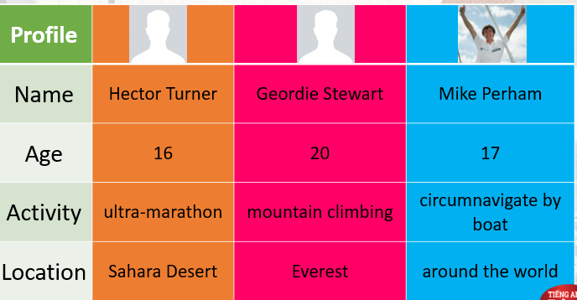  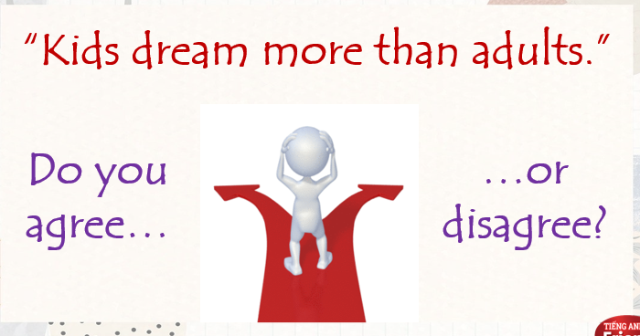

B. New lesson (33’)
- Activity 1: Presentation (6’)
a) Objective: Students know how to use LONGMAN Dictionary and related nouns and verbs properly.
b) Content:
Grammar
Reading
c) Outcomes: Students understand the way to finds words in an online dictionary.
d) Competence: communication, presentation, guessing
e) Organisation of the activity:

TEACHER’S ACTIVITIES | STUDENT’S ACTIVITIES | CONTENTS
PRESENTATION. T-Ss/ S-S/ Indiv  Activity 1 (3’): Task 2 page 27.  - Ask students to complete the table with words from the text in exercise 1.  - Check answers as a class.  - Make sure students can pronounce the verbs and nouns correctly.  Activity 2 (3’): Introduce ‘Longman Dictionary’.  - Show students how to use Longman Dictionary to look up words.  - Make sure students understand how to use it. | - Read the text again and complete the table.  - Check answers with the teacher. Pronounce words correctly. | 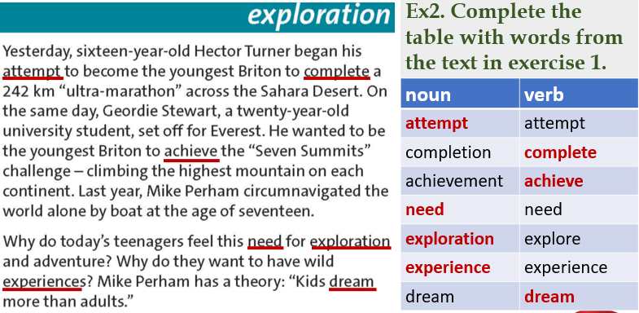  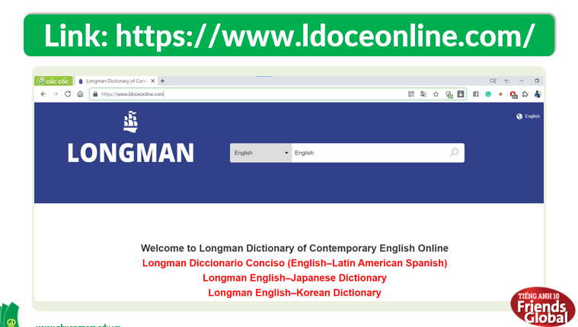  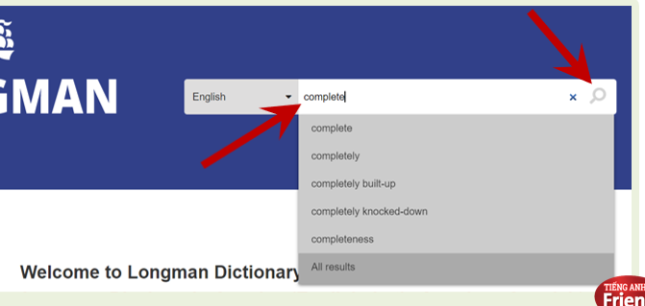  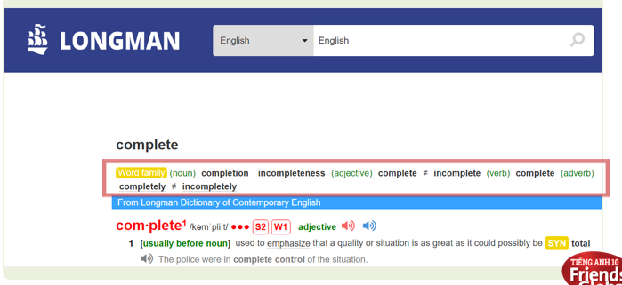
- Activity 2: Practice (17’)
a) Objective: Students can answer the questions to critical thinking, and they can finish the tasks in the textbook. Critical thing skills (guessing/ reasoning) and communication can also be practiced.
b) Content: Students read and find words, use dictionary to find the appropriate words and meanings, listen and underline the stress, complete sentences.
c) Outcomes: Students know how use online dictionary to find words properly.
d) Competence: communication, collaboration, presentation
e) Organisation of the activity:
TEACHER’S ACTIVITIES | STUDENT’S ACTIVITIES | CONTENTS
PRESENTATION. T-Ss/ S-S/ Indiv  Activity 1 (4’): Task 3 page 27.  - Go through the Learn this! Box with students.  - Highlight main ideas.  - Ask students to find the noun suffixes in the text in ex 1.  - Check answers as a class.  Activity 2 (3’): Work in pairs. Task 4 page 27.  - Ask students to work in pairs and use dictionary to find the nouns related to the verbs and check their meaning.  - Check the answers as a class.  Activity 3 (5’): Task 5 page 27.  - Ask students to listen to the words and underline the stress. Have them practice pronouncing these words.  - Play the recording.  - Check the answers.  - Make sure students pronounce words properly.  Activity 4 (5’): Task 6 page 27.  - Ask students to complete sentence b in each pair with correct noun formed from the underlined verb in sentence a. Students can use a dictionary for help.  - Give the answers to class. | - Listen to the teacher and take note.  - Do what teacher asked.  - Check the answers with the teacher.  - Work in pairs and use dictionary to find the nouns related to the verbs and check meanings.  - Check the answers with the teacher.  - Understand what to do.  - Listen to the audio and underline stress.  - Check the answers with the teacher.  - Complete the task. Students can use a dictionary if necessary.  - Check the answers with the teacher. | 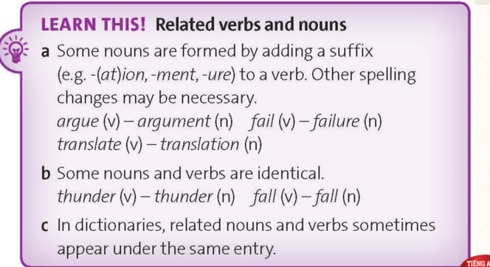  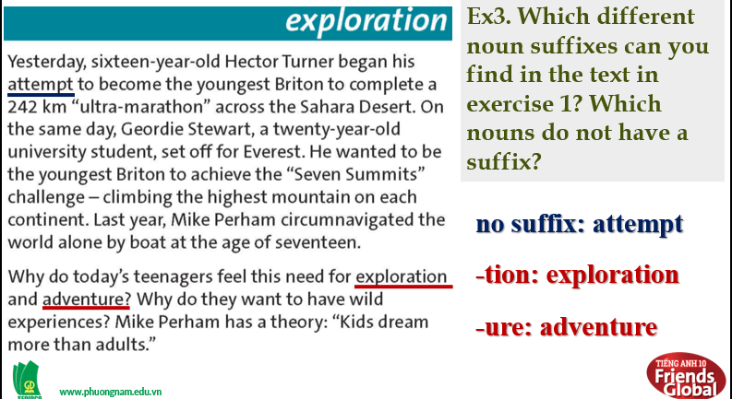  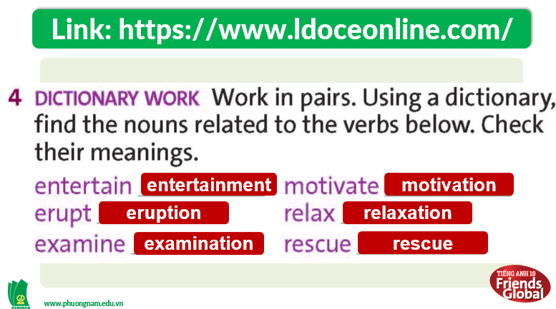  Answers:  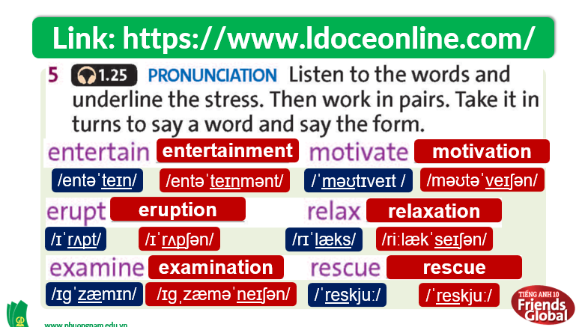  Answers:  1. b. accomplishments  2. b. employment  3. b. preparation  4. b. development  5. b. dream

- Activity 3: Outcomes (10’)
a) Objective: Students can answer the questions to critical thinking. Communication can also be practiced.
b) Content: Students work in pairs and discuss the sentences in exercise 6.
c) Outcomes: Students practice speaking and apply some structures they learnt in discussion.
d) Competence: Collaboration, communication, guessing
e) Organisation of the activity:
TEACHER’S ACTIVITIES | STUDENT’S ACTIVITIES | CONTENTS
PRODUCT. T-Ss/ S-S/ Indiv  - Ask students to work in pairs and discuss if they agree or disagree with the sentences.  - Invite some pairs to share their ideas.  - Correct students’ pronunciation and give feedbacks. | - Work in pairs and discuss the sentences.  - Volunteer to share the answers. | 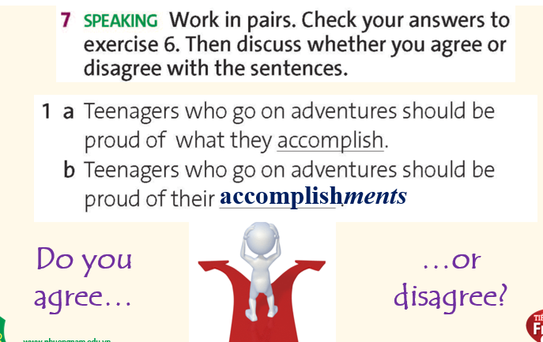
C. Consolidation (3’)
- Students understand parts of speech and dictionary entries.
- Students can use related verbs and nouns to discuss teen exploration.
D. Homework (2’)
- Review and practice using Longman Dictionary to look up words.
- Do exercise
- Prepare: Unit 2 – F- (page 28 – SB)

