School: ……………………………………….. | Date:……………………………………..
Class: ……………………………..................... | Period: …………………………….........

UNIT 1: FREE TIME
Lesson 3.1 - Listening and Reading (Page 10)

I. OBJECTIVES
By the end of the lesson, Ss will be able to:
1.1. Language knowledge and skills
- talk about extreme sports.
- practice listening and understanding general and specific information about extreme sports.
- read an invitation email for gist and detail.
1.2. Competences
- improve communication, collaboration, analytical and critical thinking skills.
1.3. Attributes
- take up a sport and practice it regularly.
- be careful when trying extreme sports.

II. TEACHING AIDS AND LEARNING MATERIALS
1. Teacher’s aids: Student book and Teacher’s book, class CDs, Digital Book (DCR phần mềm tương tác SB, DHA (từ vựng/ cấu trúc) phần mềm trò chơi tương tác), projector/interactive whiteboard / TV (if any), PowerPoint slides.
2. Students’ aids: Student’s book, workbook, notebook.

III. ASSESSMENT EVIDENCE
Performance Tasks | Performance Products | Assessment Tools
- Activate the extreme sports that Ss may know.  - Match the extreme sports to the pictures. Name 3 other extreme sports.  - Listen to a talk about extreme sports. How does the speaker feel about them?  - Listen again and circle.  - Read Mark’s email. What is the email about?  -Read again and answer the questions.  -Speaking: Which extreme sports would you like to try? Why? | - Ss’ answers.  - Ss’ answers.  - Ss’ answers.  - Ss’ answers.  - Ss’ answers.  - Ss’ answers / presentation.  - Ss’ answers / presentation. | - T’s feedback.  - T’s feedback.  - T’s feedback/Peers’ feedback.  - T’s feedback/Peers’ feedback.  - T’s observation/ DCR and T’s feedback.  - T’s observation/ DCR and T’s feedback.

IV. PROCEDURES
A. Warm up: (5’)
a) Objective: Introduce the new lesson and set the scene for Ss to acquire new language; get students' attention at the beginning of the class by giving enjoyable and short activities as well as to engage them in the follow-up steps.
b) Content: Name of some extreme sports.
c) Expected outcomes: Ss have general ideas about extreme sports, which they are going to listen and read in the new lesson.
d) Organization of the activity:
TEACHER’S ACTIVITIES | STUDENTS’ ACTIVITIES
- Option 1: Let’s talk!  - Use the “Let’s talk!” part in the textbook– page 10 for warm-up activity.  - Show pictures and words (using DCR), have Ss match the name of extreme sports to the pictures (in pairs).  - Call Ss to give answers.  - Give feedback and show correct answers.  - Have Ss discuss the questions.  - Elicit answers from some students.  - Lead to the new lesson.  - Option 2:  - Have Ss watch a clip about extreme sports: Best of Extreme Sports Compilation 2019.  - Link: https://www.youtube.com/watch?v=wsg8k-2HYXA  - Ask Ss whether they know any names of the sports in the clip.  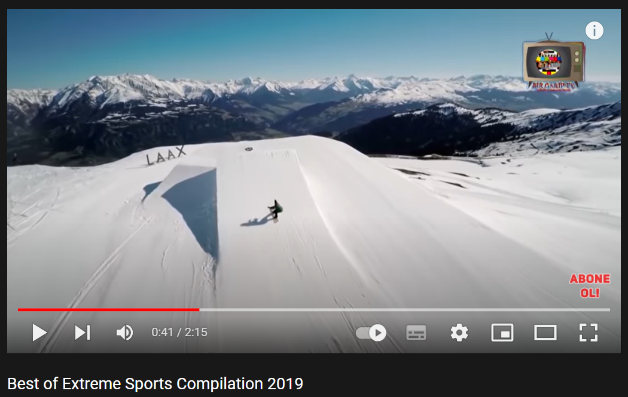  - Lead to the new lesson: Extreme sports. | - Work in pairs to match the name of extreme sports to the pictures.  - Give answers.  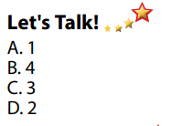  Answer keys  - Discuss the questions, then give answers.  Suggested some other extreme sports: waterskiing, scuba diving, bungee jumping, parasailing, ice climbing, slacklining,…  - Listen  - Watch and try to give names of some extreme sports in the clip.  - Listen.

B. New lesson (35’)
- Activity 1: Pre-Listening (Vocabulary) (5’)
a) Objective: Ss know names of some extreme sports.
b) Content:
- Vocabulary study (skateboarding, surfing, rock climbing, zorbing, …)
- Speaking: Would you like to try any of the extreme sports in the pictures? Name 3 others extreme sports.
c) Expected outcomes: Ss know how to pronounce the new words correctly, understand the meaning and have good preparation for the listening part.
d) Organization of the activity:
TEACHER’S ACTIVITIES | STUDENTS’ ACTIVITIES
Let’s Talk!: Match the name of extreme sports to the pictures. Would you like to try any of them? Can you name three other extreme sports?  - Option 1 (If the teacher hasn’t used this part for the Warm-up activity.)  - Use DCR to show the task.  - Have Ss match the name of extreme sports to the pictures (in pairs).  - Call Ss to give answers.  - Give feedback and show correct answers.  - Have Ss discuss the questions.  - Elicit answers from some students.  - Option 2: Matching (If the teacher has used the Let’s Talk! part for the Warm-up activity)  - T reads names of some extreme sports that Ss have learnt as a model.  - Have Ss practice reading the names of some extreme sports again.  - Call some Ss to read again.  - Correct Ss’ pronunciation if necessary. | - Work in pairs to do the matching activity.  - Give answers.  Answer keys  - Discuss in pairs, then give answers.  - Listen.  - Listen.  - Practice reading the names of some extreme sports again.  - Read.
- Activity 2: While - Listening (10’)
a) Objective: Students can develop their listening skill.
b) Content: Listening to a talk about extreme sports.
c) Expected outcomes: Students can practice listening and understanding general + specific information about extreme sports.
d) Organization of the activity:

TEACHER’S ACTIVITIES | STUDENTS’ ACTIVITIES
Task a. Listen to a talk about extreme sports. How does the speaker feel about them?  - Use DCR to show the task.  - Have Ss read the questions and guess the answers.  - Play audio (CD1 - Track 12).  - Have Ss listen and choose the correct answers.  - Call Ss to give answer, explain.  - Check answers as a whole class using DCR.  Task b. Now, listen and circle.  - Use DCR to show the task.  - Have Ss read the sentences first.  - Play the audio again (CD1 - Track 12).  - Have Ss listen and circle the correct answers.  - Have Ss check answers with their partners.  - Call Ss to give answers, explain.  - Check answers as a whole class using DCR. | - Read.  - Listen and choose the correct answers.  Answer keys  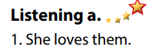  - Read.  - Listen and circle the correct answers.  - Exchange answers.  - Give answers.  Answer keys  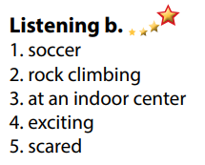

- Activity 3: Reading (20’)
a) Objective: Students can develop their reading skill.
b) Content: Reading an invitation email, choosing the main idea of the email, then answering comprehension questions.
c) Expected outcomes: Students can read an invitation email for gist and detail, and they can talk about the extreme sport they would like to try.
d) Organization of the activity:
TEACHER’S ACTIVITIES | STUDENTS’ ACTIVITIES
Task a. Read Mark’s email quickly. What is the email about?  - Use DCR to show the task.  - Have Ss read the question and guess the answer.  - Ask Ss to read the email quickly and circle the correct answer.  - Call 1 S to give answer.  - Check answers as a whole class using DCR.  Task b. Now, read and answer the questions.  - Use DCR to show the task.  - Have Ss read the questions and underline the key words.  - Have Ss read the email again and answer the questions.  - Have Ss check their answers with a partner.  - Call Ss to give answers (read or write on the board).  - Check answers as a whole class using DCR.  Task c. Speaking: In pairs: Which extreme sport would you like to try? Why?  - Have Ss discuss the questions in pairs.  - Call Ss some s to share their answers with the whole class.  - Give feedback and evaluation. | - Read and guess.  - Scan the email for general idea.  - Give answer.  Answer keys  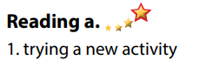  - Read and underline the key words.  - Read the email again for detail.  - Exchange answers.  - Give answers.  Answer keys  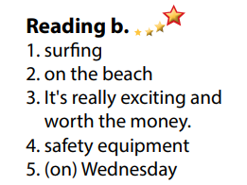  - Discuss in pairs.  - Present.

C. Consolidation and homework assignments (5’)
*Consolidation:
- Vocabularies: Name of some extreme sports: skateboarding, surfing, rock climbing, zorbing, waterskiing, scuba diving, bungee jumping, parasailing, ice climbing, slacklining …

*Homework
- Learn by heart the new vocabularies.
- Practice talking about the extreme sport you like.
- Do the exercises in WB: Lesson 3 – Listening and Reading (page 6).
- Do the vocabulary exercise in Tiếng Anh 7 i-Learn Smart World Notebook (page 8).
- Play consolation games in Tiếng Anh 7 i-Learn Smart World DHA App on www.eduhome.com.vn
- Prepare: Lesson 3 – Writing and Speaking (page 11 – SB).

D. Reflection
a. What I liked most about this lesson today:
…………………………………………………………………………………………
- What I learned from this lesson today:
…………………………………………………………………………………………
c. What I should improve for this lesson next time:
…………………………………………………………………………………………

