1. **Listening:**
2. **Listen and draw lines. There is one example (1 point)**

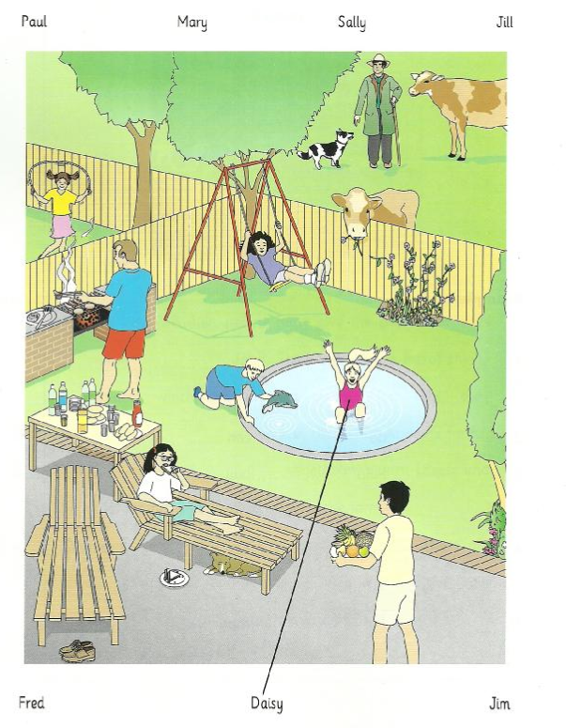

**II. Listen and write. There is one example (1 point)**

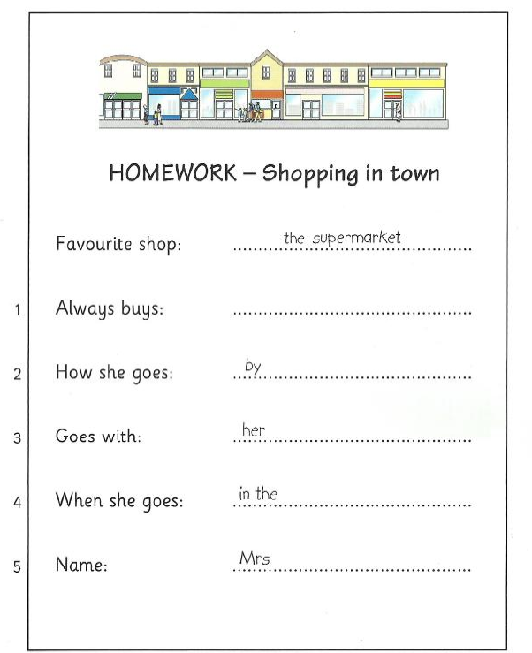

**Answer key:**

**I. Listen and draw lines (1 point).**

***Lines should be drawn between***

1. Fred and the man cooking, with no shoes.

2. Mary and the girl on the sun chair, eating a sandwich.

3. Jim and the blond boy with a dolphin.

4. Jill and the girl skipping in the garden next door.

5. Paul and the man with the cows and the dog.

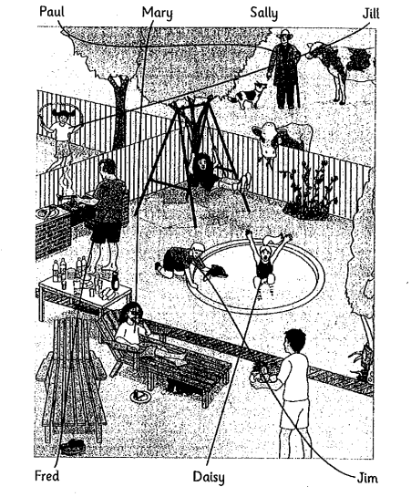

**II. Listen and write (1 point).**

1. vegetables

2. bus

3. daughter

4. afternoon

5. Rich