Mã đề 6.1.15
ĐỀ KIỂM TRA GIỮA KỲ I
MÔN: TIẾNG ANH LỚP 6
Thời gian làm bài: 60 phút
SECTION A: LISTENING (2.0 POINTS)
Task 1: Listen and tick the correct box. (1 pt)
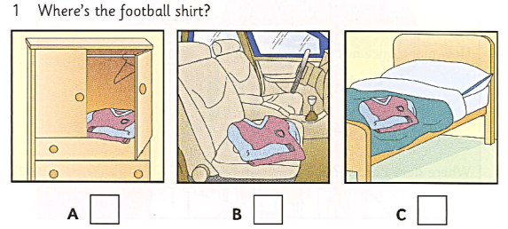
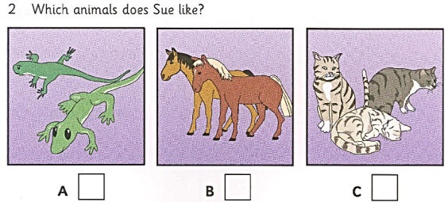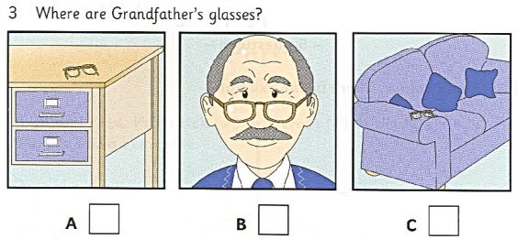

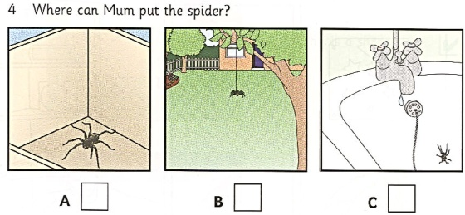
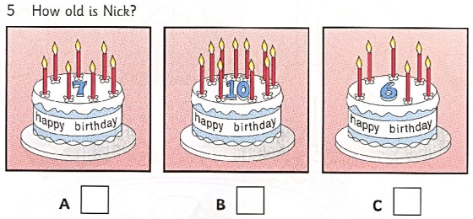
Task 2: Listen to the recording twice. Write a word or a number to each blank. (1 point)

1. What’s Pat’s friend’s name? ___________
2. How many girls are in Pat’s class? ___________
3. Who is the woman in Pat’s picture? Mrs. _______
4. How many mice has the woman got? ___________
5. Where does Pat live? _______Street
SECTION B: LANGUAGE (3.0 POINTS)
Choose the best option (A, B , C or D) to complete these sentences.
1. My father is an ________. He works in a big factory.
A. teacher B. doctor C. farmer D. engineer
2. We ________ to the judo club twice a month.
A. go B. have C. make D. take
3. There ________ one pencil on the desk.
A. are B. is C. was D. being
4. The wardrobe is ________ the fridge and the bed.
A. next B. behind C. between D. front
5. Doctors work in a ________.
A. hotel B. police station C. hospital D. bookstore
6. We should brush our ________ twice a day.
A. feet B. teeth C. hair D. toe
7. ________ is your brother? - He is thirteen.
A. What time B. How far C. How old D. How long
8. How many chairs ________ there in the house?
A. are B. is C. do D. does
9. In ________, we do some experiments.
A. Math B. History C. Chemistry D. English
10. Where is ________ computer?
A. Nick B. Nicks C. Nick’s D. Nickes
11. Look! He ________ football now.
A. is playing B. plays C. played D. was playing
12. Tony: “What does your best friend look like?” – Peter: “________”
A. He is funny B. He is kind C. He is clever D. He is handsome
13. My brother brushes ________ teeth every morning.
A. his B. my C. her D. your
14. He ________ breakfast at six o’clock every morning.
A. have B. having C. to have D. has
15. Lan: ‘Where do you live?’ – Ba: ‘________’
A. On the floor. B. In a town house.
C. In the kitchen. D. Next to the bookshelf.
SECTION C: READING (3.0 POINTS)
I. Choose the best option marked A, B or C for each gap to complete the passage. (1.5 points)
It is a small room. There is some (1)_________ in the room. There is a bed on the right of the picture. It is a bed for one person. Above the bed there are some pictures on the wall. Next to the door, on the left, there is a (2)_________. On the table (3)_________some objects - a jug, a glass and a bowl. Behind the bed there are some pictures (4)_______ the wall but they (5)_______ easy to see. Of course, there aren’t any modern things in the room and it isn’t very comfortable.
1. A. furniture B. picture C. people D. pictures
- A. beds B. chairs C. window D. houses
- A. there is B. there are C. there isn’t D. they are
- A. on B. in C. from D. to
- A. isn’t B. is C. aren’t D. are
DII. Read the passage and choose the best answer to complete the sentences(1.5 points)
I’m Max. My friend Helen is very beautiful. She is taller than me. She has blonde hair, chubby
cheek and round blue eyes. She’s clever, patient and funny. She loves telling jokes. Her jokes
are so funny that they make us laugh a lot. I love being with her because she helps me with a
lot of things. On the weekend, she often goes to my house and does homework with me. But
this weekend, we are going to the cinema to see a new film, Annabelle. It would be fun.
1. Is the writer taller than Helen?
A No, Helen is shorter than Max. B. Yes, Helen is taller than Max.
C. Yes, Max is taller than Helen. D. No, Max isn’t taller than Helen.
2. Why does the writer love being with Helen?
A. She’s funny B. She’s helpful C. She tells jokes D. She’s beautiful
3. What do they often do on the weekends?
A. study together B. do housework C. make cakes D. ride horses
4. What does Helen have?
A. pale yellow hair B. rosy cheek C. round brown eyes D. long hair
5. What are they going to do this weekend?
A. watch TV B. see a film C. do homework D. go to school
SECTION D: WRITING (2.0 POINTS)
I. Rewrite the sentences with unchanged meanings as the root ones ( 1point)
1. My sister rides her bike to school.
→ My sister goes ____________________________________
2. The table is in front of the bed.
→ The bed is _______________________________________
3. I have a cat.
→This is __________________________________________
4. I have a bookshelf in my bedroom.
→There ____________________________________________
5. She has a high nose.
→ Her nose _________________________________________
II. Use the given words to make complete sentences about a friend. (1 point)
1. My best friend/ Nam.
____________________________________________
2. He/ my/ neighbour.
____________________________________________
3. He/ short/ chubby. He/ big/ nose/ large/ shoulders.
____________________________________________
4. He/ very/ active,/ kind/ creative.
____________________________________________
5. I/ like/ him/ because/ he/ kind/ me.
------- The end -------

ANSWER KEY
SECTION A: LISTENING (2.0 POINTS)
Task 1: Listen to the recording twice.
(1 point)
1. C 2. A 3. B 4. B 5. C

Task 2: Listen to a dialogue between a woman and Bill TWICE then write a number or a name. (1 pt)
1. TOM 2. 8/ eight 3. BIRD 4. 9/ nine 5. GREY
SECTION B: LANGUAGE (3.0 POINTS)
Choose the best option (A, B , C or D) to complete these sentences.
1. D 2. A 3. B 4. C 5. C
6. B 7. C 8. A 9. C 10. C
11. A 12. D 13. A 14. D 15. B
SECTION C: READING (3.0 POINTS)
I. Read the passage, then choose the word which best fits each gap (1.5 points)
1.A 2.C 3 B 4.A 5C
II. Read the passage and choose the best answer to complete the sentences(1.5 points)
1. B 2. B 3. A 4. A 5. B
SECTION D: WRITING (2.0 POINTS)
I. Rewrite the sentences with unchanged meanings as the root ones ( 1point)
- My sister goes to school by bike.
- The bed is behind the table.
- This is my cat.
- There is a bookshelf in my bedroom.
- Her nose is high.
II. Use the given words to make complete sentences about a friend. (1 point)
- My best friend is Nam.
- He is my neighbour.
- He is short and chubby. He has a big nose and large shoulders.
- He is very active, kind and creative.
- I like him because he is kind to me.

------- The end -------

