UNIT 8.
SPORTS AND GAMES
PART 1. THEORY
I. VOCABULARY
No. | English | Type | Pronunciation | Vietnamese
1 | athletics | n | /æθ'letɪks/ | điền kinh
2 | badminton racquet | n | /’bædmɪntən ‘rækɪt/ | vợt cấu lông
3 | baseball bat | n | /'beɪsbɔ:d bæt/ | gậy bóng chày
4 | boxing | n | /'bɒksɪη/ | đăm bốc
5 | boxing gloves | n | /'bɒksɪη glʌvz/ | găng tay đấm bốc
6 | canoeing | n | /kə'nu:ɪη/ | chèo thuyền ca-nô
7 | cycling | n | /'saɪklɪη/ | đạp xe
8 | fishing | n | /'fɪʃɪη/ | câu cá
9 | fishing rod | n | /'fɪʃɪη rɒd/ | cần câu cá
10 | football boots | n | /'fʊtbɔ:l bu:ts/ | giày đá bóng
11 | golf | n | /gɒlf/ | môn đánh gôn
12 | golf club | n | /gɒlf klʌb/ | gậy đánh gôn
13 | hockey | n | /'hɒkɪ/ | khúc côn cầu
14 | hockey stick | n | /'hɒkɪ stɪk/ | gậy chơi khúc côn cấu
15 | horse racing | n | /hɔ:s 'reɪsɪη/ | đua ngựa
16 | ice hockey | n | /aɪs 'hokɪ/ | khúc côn cấu trên sân băng
17 | ice skating | n | /ais 'skeɪtɪη/ | trượt băng
18 | jogging | n | /'dʒɒgɪη/ | chạy bộ
19 | judo | n | /'dʒu:dəʊ/ | võ judo
20 | karate | n | /kə'rɑ:tɪ/ | vô karate
21 | loser | n | /'lu:zər/ | người thua cuộc
22 | match | n | /mætʃ/ | trận đấu
23 | motor racing | n | /'məʊtər 'reɪsɪη/ | đua ô tô
24 | mountain climbing | n | /'maʊntən 'klaɪmɪη/ | leo núi
25 | opponent | n | /ə'pəʊnənt/ | đối thủ
26 | rugby | n | /rʌgbɪ/ | bóng bầu dục
27 | sailing | n | /'seɪhrɪ/ | chèo thuyền
28 | score | n | /skɔ:r/ | tỉ sô'
29 | scuba diving | n | /'sku:bə daivɪη/ | lặn có bình khí
30 | skateboarding | n | /'skeɪtbɔ:dɪη/ | trượt ván
31 | spectator | n | /spek'teɪtər/ | khán giả
32 | umpire | n | /'ʌmpaɪər/ | trọng tài
33 | victory | n | /'vɪktərɪ/ | chiến thắng
34 | weightlifting | n | /'weɪtlɪftɪη/ | môn cử tạ
35 | windsurfing | n | /'wɪndsɜ:fɪη/ | môn lướt ván buồm
36 | winner | n | /'wɪnər/ | người thắng cuộc
37 | wrestling | n | /'reslɪη/ | môn đấu vật

Một số từ khác
No. | English | Type | Pronunciation | Vietnamese
1 | draw | V | /drɔ:/ | hòa
2 | lose | V | /lu:z/ | thua
3 | win | V | /wɪn/ | thắng

II. GRAMMAR
1. PAST SIMLE (THÌ QUÁ KHỨ ĐƠN)
a. Form (Cấu trúc)
Normal Verb | To be
(+) S + V-ed  (-) S + didn’t + V-inf  (?) Did + S + V-inf | You, We, They + were  I, He, She, It + was  You, We, They + weren’t  I, He, She, It + wasn’t  Were + you, we, they ?  Was + I, he, she, it ?
Ex 1: She walked to school yesterday. (Hôm qua cô ẩy đi bộ tới trường.)
Ex 2: She didn’t walk to school yesterday. (Hôm qua cô ấy không đi bộ tới trường.)
Ex 3: Did she walk to school yesterday? (Hôm qua cô ấy có đi bộ tới trường hay không?)
- Yes, she did./ No, she didn’t. (Có, cô ấy có./ Không, cô ấy không.)
b. Usage (Cách sử dụng)
- Thì quá khứ đơn diễn tả một hành động đã xảy ra và kết thúc hoàn toàn trong quá khứ.
Ex 1: Tony visited his parents last weekend. (Tony đã đến thăm ba mẹ anh ấy vào cuối tuần trước.)
Ex 2: Linda went to the zoo last Friday. (Linda đã đi sở thú vào thứ Sáu tuần trước.)
- Thì quá khứ đơn diễn tả các hành động xảy ra nối tiếp nhau trong quá khứ.
Ex 1: She came home, ate a cake and drank a glass of water. (Cô ấy đã về nhà, ăn một cái bảnh và uống một ly nướC.)
- Thì quá khứ đơn diễn tả một hành động xen vào một hành động đang diễn ra trong quá khứ
Ex 1: When I was having dinner, the light went out. (Khi tôi đang ăn tối thì mất điện.)
Ex 2: When I was cooking, Linda came. (Khi tôi đang nấu ăn, Linda đến.)
c. Signals
- yesterday (hôm qua), at that moment (lúc đó), last night (tối hôm qua)
- last + week/ month/ year: tuần/ tháng/ năm vừa rồi - Khoảng thời gian + ago (cách đầy ...): two days ago (cách đây 2 ngày), three
- years ago (cách đây 3 năm)
- In + năm: in 2000 (năm 2000)
d. How to turn infinitive verbs into past form
Động từ được chia làm 2 loại: có quy tắc và bất quy tắc.
Đối với động từ có quy tắc, khi chuyển sang dạng quá khứ, ta thêm đuôi “ed”.
walk walked
want wanted
Nếu động từ kết thúc bằng nguyên âm + y, ta thêm đuôi “ed” như bình thường.
play played
stay stayed
Nếu động từ kết thúc bằng phụ âm + y: ta đổi y ied.
cry cried
study studied
Đối với động từ bất quy tắc: tra dạng quá khứ trong Bảng động từ bất quy tắc.
go went
put put
2. IMPERATIVES (CÂU MỆNH LỆNH)
a. Form (Cấu trúc)
(+) V(+prep)!
(-) Don’t + V!
b. Usage (Cách sử dụng)
Câu mệnh lệnh thường được sử dụng để yêu cầu ai làm gì đó, đưa ra lời gợi ý, lời khuyên hoặc lời chỉ dẫn.
Example
- Stand up! (Hãy đứng lên!)
- Listen to the teacher! (Hãy lắng nghe cô giáo!)
- Don’t play with the dog! (Đừng đùa với con chó!)

iii. PHONETICS
Cách phát âm âm /e/ và /æ/.

1. Âm /e/
a. Cách phát âm âm /e/
Âm /e/ là 1 nguyên âm ngắn. Để phát âm âm này, ta mở rộng miệng và để lưỡi thấp xuống, đầu lưỡi chạm phần răng phía dưới. Nó tương tự âm /e/ trong tiếng Việt.

Các em tập thực hành phát âm các từ sau:
check /tʃek/ | member /'membər/
head /hed/ | jealous /'dʒeləs/
scent/sent/ | ready /'redɪ/
met /met/ | many /'menɪ/
bell /bel/ | breakfast /'brekfəst/
b. Dấu hiệu nhận biết
* “a” được phát âm là /e/:
Examples | Transcription | Meaning
many | /’menɪ/ | nhiều
anyone | /'enɪwʌn/ | bất cứ người nào
- “e” được phát âm là /e/ đối với những từ có một âm tiết mà có tận cùng bằng một hay nhiều phụ âm (ngoại trừ “r”) hoặc trong âm tiết được nhấn mạnh của một từ.
Examples | Transcription | Meaning
send | /send/ | gửi di
debt | /det/ | nợ nần, công nợ
them | /ðem/ | chúng nó
get | /get/ | có, trở nên
bed | /bed/ | cái giường
- “ea” thường được phát âm là /e/ trong một số trường hợp như sau:
Examples | Transcription | Meaning
dead | /ded/ | chết
head | /hed/ | cái đầu
bread | bred/ | bánh mỳ
ready | /'redɪ/ | sẵn sàng
heavy | /’hevɪ/ | nặng
2. Âm /æ/
a. Cách phát âm âm /æ/
Âm /æ/ là một nguyên âm ngắn. Để phát âm âm này, ta mở rộng miệng. Lưỡi được đưa xuống thấp. Đầu lưỡi chạm vào phần lợi của hàm dưới. Sau đó phần thân lưỡi được đẩy cong lên. Và ta phát âm /æ/.
Các em hãy tập thực hành phát âm các từ sau:
cat /kæt/  bag /bæg/  black /blæk/ | hand /hænd/  map /mæp/  candle /'kændl/ | narrow /'nærəʊ/  captain /'kæptɪn/  manner /'mænər/
b. Dấu hiệu nhận biết
- “a” được phát âm là /æ/ trong các từ có một âm tiết mà tận cùng bằng một hay nhiều phụ âm.
Examples | Transcription | Meaning
hat | /hæt/ | cái mũ
sad | /sæd/ | buồn
fat | /fæt/ | béo
bank | /bæηk/ | ngân hàng
- Khi ở trong một âm tiết được nhấn mạnh của một từ có nhiều âm tiết và đứng trước hai phụ âm.
Examples | Transcription | Meaning
candle | /’kændl/ | cây nến
captain | /’k æptm/ | đại úy, thuyền trưởng
narrow | /'nærəʊ/ | chật, hẹp
manner | /'mænər/ | cách thức, thể cách

PART 2. LANGUAGE
I. VOCABULARY
Exercise 1. Look at the picture and complete with the name of sport.
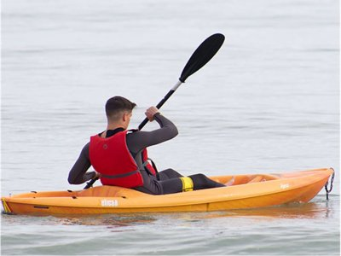 | 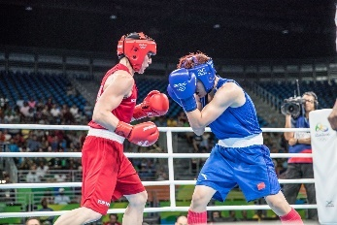 | 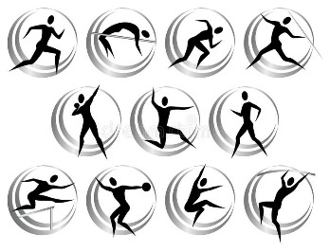 | 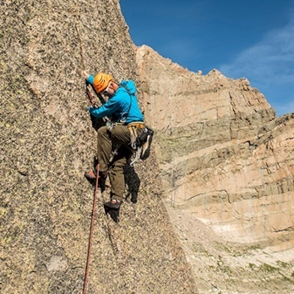
1. | 2. | 3. | 4.
 | 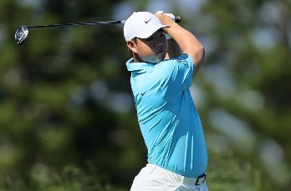 | 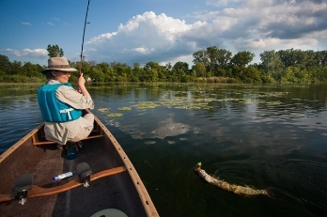 | 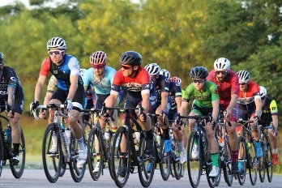
5. | 6. | 7. | 8.
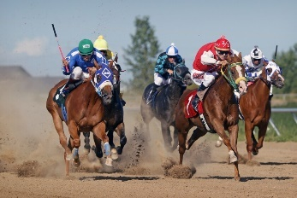 | 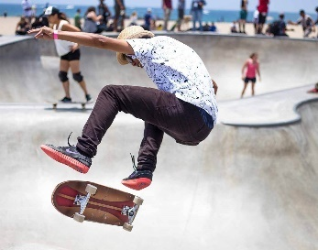 | 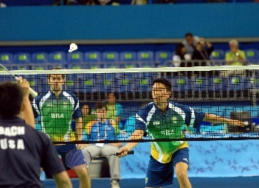 | 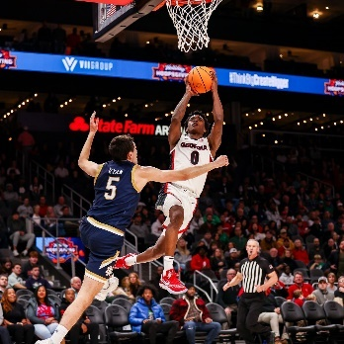
9. | 10. | 11. | 12.
Exercise 2. Look at the things and write the name of sports.
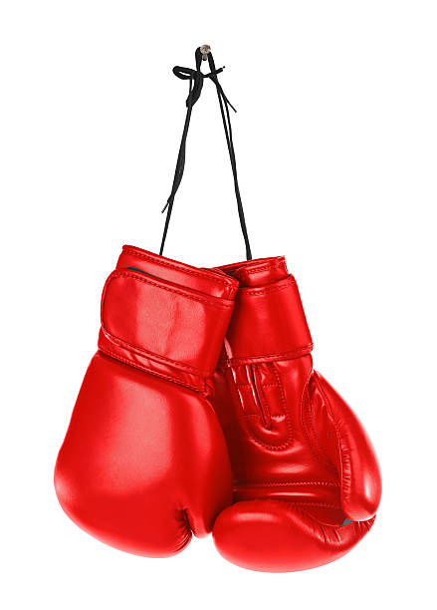 | 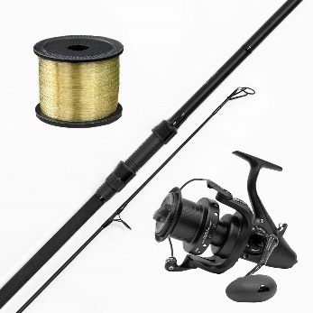 | 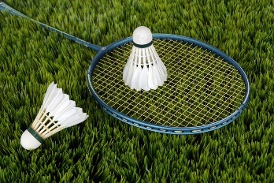 | 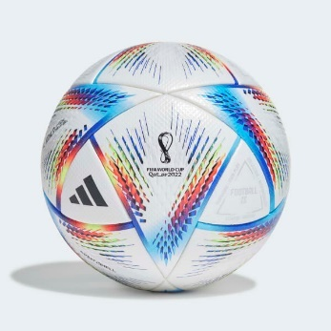
1. | 2. | 3. | 4.
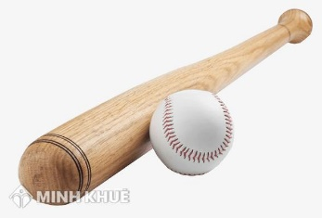 | 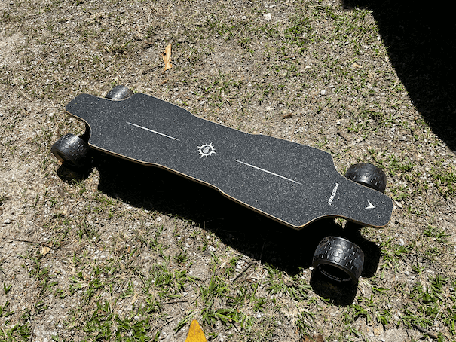 | 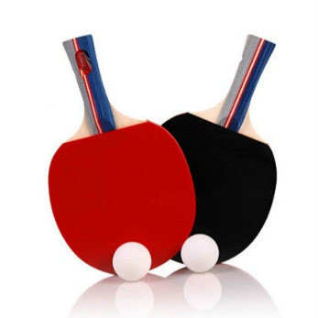
5. | 6. | 7. | 8.
Exercise 3. What sports are often played by an individual or by a team? Complete the table with the suitable name of sport.
judo | football | badminton | rugby | hockey | tennis
basketball | athletics | skiing | cycling | swimming | volleyball

Individual sports | Team sports
Exercise 4. Put the words or phrases into the correct column.
aerobics | badminton | shopping | soccer | volleyball
swimming | homework | camping | table tennis | fishing
cycling | tennis | jogging | video games | housework

do | go | play
Exercise 5. Give the correct form of the word in brackets.
1. I love playing football. I want to become a ______________ in the future. (FOOTBALL)
2. I am ______________ in practising yoga every day to help me relax. (INTEREST)
3. Many people do exercise regularly to keep fit and ______________. (HEALTH)
4. Peter can play a lot of sports such as football, volleyball, basketball and tennis, etc. He looks quite ______________. (SPORT)
5. I won the car in a ______________. (COMPETE)
6. This helps explain the ______________ of underwater photography. (POPULAR)
Exercise 6. Choose the best option to complete the sentence.
1. My friend Mark is very good ______________ volleyball. He plays volleyball very well.
A. in B. on C. at D. with
2. We often go swimming ______________ Sunday morning.
A. in B. on C. at D. for
3. Football is an example of a ______________ sport where you play with several other people.
A. team B. individual C. indoor D. dangerous
4. We were very upset when our favourite team didn’t ______________ even one goal.
A. play B. kick C. point D. score
5. Badminton requires only a net, a racket, and a birdie or ______________.
A. ball B. ski C. shuttlecock D. goggles
6. The person who makes sure that a game is played according to the rules is called a ______________.
A. coach B. referrer C. judge D. player
7. ______________ up the tree! You’ll fall down.
A. Climb B. Climbing C. Not to climb D. Don’t climb
8. ______________ spectator sports in Britain are cricket and football.
A. More popular B. The more popular
C. Most popular D. The most popular
9. ______________ are the Olympic Games held? - Every four years.
A. When B. Where C. How long D. How often
10. Which sport happens in a ring?
A. Boxing B. Basketball C. Aerobics D. Swimming
II. GRAMMAR
Exercise 1. Put the verbs into the past simple form.
V infinitive | V2 (past simple) | V infinitive | V2 (past simple)
1. become |  | 14. dream
2. begin |  | 15. drink
3. break |  | 16. eat
4. bring |  | 17. sing
5. build |  | 18. sit
6. buy |  | 19. sleep
7. choose |  | 20. stand
8. come |  | 21. swim
9. cost |  | 22. take
10. cut |  | 23. teach
11. do |  | 24. tell
12. win |  | 25. think
13. write |  | 26. wear
Exercise 2. Put the sentence into the negative and interrogative form.
1. Nam wrote an essay in Literature class this morning.
(-) _______________________________________________________________________________
(?) _______________________________________________________________________________
2. I watched TV yesterday morning.
(-) _______________________________________________________________________________
(?) _______________________________________________________________________________
3. Nam and you were in the English club last Tuesday.
(-) _______________________________________________________________________________
(?) _______________________________________________________________________________
4. They ate noodles two hours ago.
(-) _______________________________________________________________________________
(?) _______________________________________________________________________________
5. We always had a nice time on Christmas holiday in the past.
(-) _______________________________________________________________________________
(?) _______________________________________________________________________________
6. My father decorated the Christmas tree.
(-) _______________________________________________________________________________
(?) _______________________________________________________________________________
7. She bought a new dress yesterday.
(-) _______________________________________________________________________________
(?) _______________________________________________________________________________
8. They were late for school.
(-) _______________________________________________________________________________
(?) _______________________________________________________________________________
9. Mr. Tam took his children to the museum last Sunday.
(-) _______________________________________________________________________________
(?) _______________________________________________________________________________
10. They painted their house yellow.
(-) _______________________________________________________________________________
(?) _______________________________________________________________________________
Exercise 3. Put the verbs in brackets in the past simple form.
1. I ______________ at my mom’s home yesterday. (stay)
2. Hanh ______________ to the theatre last Sunday. (go)
3. I and my classmates ______________ a great time in Da Nang last year. (have)
4. My holiday in California last summer ______________ wonderful. (be)
5. Last January I ______________ Sword Lake in Ha Noi. (visit)
6. My grandparents ______________ very tired after the trip. (be)
7. I ______________ a lot of gifts for my older brother. (buy)
8. James and Belle ______________ sharks, dolphins and turtles at Vinpearl Aquarium. (see)
9. Gary ______________ chicken and rice for lunch, (eat)
10. We ______________ about their holiday in Ca Mau. (talk)
Exercise 4. Put the verbs in brackets in the past simple form.
On Friday, the children (1. talk) ____________ about a day out together in the country. The next morning, they (2. go) ____________ to the country with their two dogs and (3. play) ____________ together. Ben and Dave (4. have) ____________ some kites. Some time later the dogs (5. be) ____________ not there. So they (6. call) ____________ them and (7. look) ____________ for them in the forest. After half an hour, the children (8. find) ____________ them and (9. take) ____________ them back. Charlie (10. be) ____________ very happy to see them again. At lunch time, Nick (11. go) ____________ to the bikes and (12. fetch) ____________ the basket with some meat sandwiches. Then they (13. play) ____________ football. Nick and Dave (14. win) ____________. In the evening they (15. ride) ____________ home.
Exercise 5. Write in complete sentences using the past simple form.
1. It/be/cloudy/yesterday.
__________________________________________________________________________________
2. We/ move/ to another city/ in 1990/.
__________________________________________________________________________________
3. When/ you/ get/ the first gift.
__________________________________________________________________________________
4. She/ not/ go/ to the church/ five days ago.
__________________________________________________________________________________
5. How/ be/ he/ yesterday?
__________________________________________________________________________________
6. Mrs. James/ come back home/ and/ have/ lunch/ late/ last night.
__________________________________________________________________________________
7. They/ happy/ last holiday?
__________________________________________________________________________________
8. How/ you/ get there?
__________________________________________________________________________________
9. I/ play/ football/ stadium/ last/ Sunday.
__________________________________________________________________________________
10. My/ mother/ make/ two/ cake/ four/ days/ ago.
__________________________________________________________________________________
11. Tuyen / visit/ his/ grandmother/ last/ month.
__________________________________________________________________________________
12. John / go/ zoo/ five/ day/ ago.
__________________________________________________________________________________
13. We/ have/ lot/ fun/ yesterday.
__________________________________________________________________________________
14. My/ father/ not/ at the office/ the day/ before yesterday.
__________________________________________________________________________________
Exercise 6. Complete the imperatives with the verbs in the box.
Wash | Don't fight | Don’t make | Don't forget | Switch off
Underline | Install | Put | Water | Don’t lose
1. ______________ to feed the hamster!
2. ______________ the nouns in these sentences!
3. ______________ your books into the bags!
4. ______________ your keys! They are on the table.
5. ______________ these dirty plates, please.
6. ______________ these programmes on the computer!
7. ______________ with the boys at school!
8. ______________ off the light, please.
9. ______________ the flowers, please.
10. ______________ noise! Your little brother is sleeping.
III. PHONETICS
Exercise 1. Put the words in the correct column according to the pronunciation.
measure | pleasure | cat | cheque | bag | pen | perhaps | dead
bell | sad | had | hell | hand | tent | November | pat
shall | axe | paddle | gel | eleven | peg | jam | heavy
stretch | member | bang | black | man | jealous | bad | extend

/e/ | /æ/

Exercise 2. Underline the word containing sound /e/ and double underline the word containing sound /æ/ then read aloud these sentences.
1. Have a snack, Jack?
__________________________________________________________________________________
2. Ben never gets upset.
__________________________________________________________________________________
3. Fred said it again and again.
__________________________________________________________________________________
4. Peg slept from six until ten and then left.
__________________________________________________________________________________
5. Sad is the opposite of happy.
__________________________________________________________________________________
6. There is a man with black pants.
__________________________________________________________________________________

PART 3. COMMUNICATION SKILLS
I. LISTENING
Listen and do the tasks followed.
Exercise 1. Listen and answer the question. Track 03
1. When did the Olympics start for the first time?
__________________________________________________________________________________
2. How often is the Olympics Games held?
__________________________________________________________________________________
3. Where is the Olympics Games held?
__________________________________________________________________________________
4. Where will the 2016 Olympics Games be held?
__________________________________________________________________________________
5. When will the Olympics Torch relay begin?
__________________________________________________________________________________
6. When will the Olympics Torch relay finish?
__________________________________________________________________________________
7. When will the 2016 Olympics Games finish?
__________________________________________________________________________________
Exercise 2. Listen again and decide if each statement is True (T) or False (F) or Not Given (NG). Track 04
1. In the 2016 Olympics Games, there will be about 10.000 athletes take part in. __________
2. The official list of athletes will be kept secret. __________
3. There will be about 100 medals in total. __________
II. SPEAKING
Exercise 1. Complete the passage with a suitable word from the box then practise speaking it.
game | twice | favourite | tennis | often | sport
Jenny: What’s your (1) ____________ sport, Matthew?
Dave: Hmm, probably basket. But I also like (2) ____________.
Jenny: Are you a good tennis player?
Dave: I’m OK, I think.
Jenny: How (3) ____________ do you play a week?
Dave: What? Tennis or basketball?
Jenny: Both.
Dave: Well, I play tennis (4) ____________ a week, and basketball four times a week. I’m in a team.
Jenny: Oh really? You do a lot of sport.
Dave: True. What about you? What’s your favourite (5) ____________?
Jenny: Watching basketball on TV.
Dave: Oh, would you like to watch tomorrow’s (6) ____________ with me?
Jenny: Sure, why not?
Exercise 2. Write questions for the underlined parts.
Huyen: (1) ______________________________, Phong?
Tuan: I watched a football match on TV last night.
Huyen: (2) ______________________________.
Tuan: It was on The Thao HD Channel.
Huyen: Well...I don’t like sports, so I don’t know this channel. (3) ______________________________.
Tuan: I like football best. I really love playing and watching it.
Huyen: (4) ______________________________
Tuan: I play football every weekend.
Huyen: You are really fit! (5) ______________________________.
Tuan: I often play it in a stadium near my house.
Huyen: (6) ______________________________
Tuan: My favourite football player is Cristiano Ronaldo.
Huyen: (7) ______________________________
Tuan: Yes, I did. Last Sunday, our school’s team played against another school and we won.
Huyen: Congratulations!
Tuan: Thanks a lot.
III. READING
Exercise 1. Read the following text and choose the option A, B, C or D.
The story of Diego Maradona, the Argentina footballer, is the story of the rise and fall of a poor man who became a world star, but paid the price of fame. At 33 years of age, he is now at the end of a career which saw him in the 1980s, as the bright star of World Cup football.
Maradona was born in the poor area of Furito in Buenos Aires. Early in his life, he was able to realize a dream of most poor boys, the dream that way out of povertytrap is through success in sport. Sport in the world around is an activity open to all people, no matter what their background is.
Diego Maradona is one of eight children. His father is an Indian and his mother is an Italian. The games of football played in the dirty street outside his small white, one-storied home in Furito were to provide him with a passport out of the small town. Today, poorly-dressed boys still run and kick balls around the street from which their hero traveled to become one of the world’s great football artists.
1. Who is Diego Maradona?
A. a story B. a footballer C. a world star D. both B and C
2. How old was he when he wasn’t a footballer anymore?
A. 23 B. 33 C. 43 D. 53
3. Where was he born?
A. Furito B. India C. Asia D. Brazil
4. What was his dream?
A. A movie star is the way to get out of poverty.
B. A football coach to teach football for poor children.
C. A music star performs in the final football match.
D. Success in sport is the way out of poverty-trap.
5. How many children are there in his family?
A. 8 B. 9 C. 10 D. 11
6. What is his parents’ nationality?
A. Argentinean B. Indian C. Italian and Indian D. Italian
Exercise 2. Read the following text and do the tasks below.
Water rugby became the most popular of water sports, but somehow the water polo name became a popular name for it.
As played in England, the object of the game was for a player to touch the ball, with both hands, at the goal of the pool. The goaltender stood on the poll deck, ready to dive on any opponent who was about to score.
Water polo quickly became a very rough sport, filled with underwater fights away from the ball, and it wasn’t unusual for players to pass out for the lack of air.
In 1877, the sport was tamed in Scotland by the addition of goalposts. The Scots also replaced the original small, hard rubber ball with a soccer ball and adopted rules that prohibited taking the ball under the surface or, tackling a player unless he had the ball.
a. Answer the questions:
1. What is the different name of water rugby?
2. What was the purpose of the game in England?
3. What did the goaltender do when an opponent was about to score?
4. When was the sport tamed by the addition of goalposts?
5. What kind of ball did the Scots replace the original small, hard rubber ball with?
b. Read the text again. Then decide whether the sentences are true (T) or false (F).
Sentence | True (T) | False (F)
1. Water rugby was less popular than water polo.
2. As played in Scotland, the purpose of the game was for a player to touch the ball, with both hands.
3. The goaltender is not allowed to dive on any opponent who was about to score.
4. Scots put goalposts to the sport in 1877.
5. Water polo is a very rough sport.

IV. WRITING
Exercise 1a. Rewrite the sentences without changing the meaning of the original ones.
1. My sister can run very fast.
My sister is
2. Hoang is a good footballer.
Hoang plays football
3. Linh is a careful driver.
Linh
4. Peter likes playing badminton most.
Peters favourite
5. Mike runs faster than his brother does.
Mike’s brother doesn’t run so
6. Hugo finds it interesting to play sports in his free time.
Hugo is interested
Exercise 1b. Rearrange the given words or phrases to make meaningful sentences.
1. they/ to/ movies/ do/ How/ go/ the/ often/ ?/
________________________________________________________________________________
2. your eyes/ swimming/ should/ when/ goggles/ You/ you/ go/ wear/ to protect.
________________________________________________________________________________
3. usually/ his/ swimming/ with/ friends/ He/ goes.
________________________________________________________________________________
4. go/ do/ weekend/ at/ always/ fishing/ parents/ their/ ?/
________________________________________________________________________________
5. their/ fiends/ camping/ they/ go/ Do/ sometimes/ with/ ?/
________________________________________________________________________________
6. What/ TV/ you/ do/ on/ sports/ watching/ like?
________________________________________________________________________________
Exercise 2. Use the given words to write complete sentences.
1. Play/ sport I be/ good/ health.
________________________________________________________________________________
2. My sister/ enjoy/ play/ volleyball/ free time.
________________________________________________________________________________
3. I can’t/ soccer/ classmates/ this afternoon/ because/I/ busy.
________________________________________________________________________________
4. That/ channel/ tell/ people/ life/ animals/ world.
________________________________________________________________________________
5. I/ take part/ swimming competition/ school/ last week/ and/ win/ third prize.
________________________________________________________________________________
6. How many/ kinds/ sports/ there/ world?
________________________________________________________________________________
7. We/ be/ tired/ so/ we/ stop/ walk/ last night.
________________________________________________________________________________
8. My father/ play/ tennis / good/ but/ he/ football/ bad.
________________________________________________________________________________
Exercise 3. Write a paragraph about 80 - 100 words to describe a sport that you like doing in your free time using the following prompts.
Which sports or games do you like doing in your free time?
What do you need to play it?
Where do you play it?
With whom do you play it?
Is it a team sport or an individual sport?
Why do you like it?

