UNIT 8: SHOPPING

Lesson 1: Getting started – My favourite shopping place

I. OBJECTIVES
By the end of this lesson, Ss will be able to:
1. Knowledge
- Gain an overview about the topic Shopping
- Gain vocabulary to talk about shopping
2. Competences
- Develop communication skills and creativity
- Be collaborative and supportive in pair work and teamwork
- Actively join in class activities
3. Personal qualities
- Love talking about themselves and their problems

II. MATERIALS
- Grade 8 textbook, Unit 8, Getting started
- Computer connected to the Internet
- Projector / TV/ pictures and cards
- Phần mềm tương tác hoclieu.vn

Language analysis
Form | Pronunciation | Meaning | Vietnamese equivalent
1. open-air market (n) | /ˌəʊpən ˈeə(r) ˈmɑːkɪt/ | A market happening or existing outside rather than inside a building | Chợ họp ngoài trời
2. home-grown (adj) | /ˌhəʊm ˈɡrəʊn/ | (of plants, fruit and vegetables) grown in a person’s garden | Tự trồng
3. home-made (adj) | /ˌhəʊm ˈmeɪd/ | made at home, rather than produced in a factory and bought in a shop | Tự làm
4. bargain (v) | /ˈbɑːɡən/ | to discuss prices, conditions, etc. with somebody in order to reach an agreement that is acceptable | Mặc cả
5. farmers’ market (n) | /ˈfɑːməz mɑːkɪt// | a place where farmers and growers sell food directly to the public | Chợ nông sản
6. price tag (n) | /ˈpraɪs tæɡ/ | ​a label on something that shows how much you must pay | Nhãn ghi giá mặt hàng
7. convenience store (v) | /kənˈviːniəns stɔː(r)/ | a small local shop that sells food, newspapers, etc. and has long opening hours | Cửa hàng tiện lợi

Assumption
Anticipated difficulties | Solutions
Ss may not know enough vocabulary relating to the topic to understand the conversation. | Provide the necessary vocabulary for students to understand the conversation.

III. PROCEDURES
1. WARM-UP (5 mins)
a. Objectives:
- To create an active atmosphere in the class before the lesson;
- To review the previous unit;
- To lead into the new unit.
- Review the previous unit before Ss open their books:
b. Content:
- Have some warm-up activities to create a friendly and relaxed atmosphere to inspire Ss to warm up to the new class.
c. Expected outcomes:
- Having a chance to speak English and focus on the topic of the lesson.
d. Organisation

TEACHER’S AND STUDENTS’ ACTIVITIES | CONTENTS
CHATTING  - T asks ss some questions about the topic:  1. Do you like shopping?  2. Where do you often go shopping?  3. Can you name some markets or supermarkets that you know?  4. Do you prefer shopping in an open-air market or in a supermarket?  - T leads to the new unit. Write the unit title SHOPPING on the board. Ask Ss to guess what they are going to learn about in this unit. | UNIT 8: SHOPPING  Lesson 1: Getting started – My favourite shopping place

e. Assessment
- T checks ss’ vocabulary and give feedback

2. ACTIVITY 1: PRESENTATION (5 mins)
a. Objectives:
- To set the context for the introductory dialogue;
- To introduce the topic of the unit.
b. Content:
- Learn some new words. Read the conversation and find out new words.
c. Expected outcomes:
- Know more new words
- Understanding the conversation; topic of the lesson,…
d. Organisation

TEACHER’S AND STUDENTS’ ACTIVITIES | CONTENTS
Vocabulary pre-teaching  - Teacher introduces the vocabulary.  - Teacher explains the meaning of the new vocabulary by pictures/ explanation/ examples.  - Teacher reveals that these seven words will appear in the reading text and asks students to open their textbooks to discover further. | New words:  1. open-air market (n)  2. home-grown (adj)  3. home-made (adj)  4. bargain (v)  5. farmers’ market (n)  6. price tag (n)  7. convenience store (n)
e. Assessment
- Teacher checks students’ pronunciation and gives feedback.

3. ACTIVITY 2: PRACTICE (25 mins)
a. Objectives:
- To help Ss read for specific information about markets.
- To help Ss learn words and phrases related to different markets and their features;
- To help Ss further understand the text.
b. Content:
- Listen and read the conversation, Listing activity, Matching activity, Sentence Completing activity.
- To learn some more words about some places for shopping and some features of diferent markets.
c. Expected outcomes:
- Know more new words about different markets and their features, understand the conversation; topic of the lesson
d. Organisation

TEACHER’S AND STUDENTS’ ACTIVITIES | CONTENTS
Task 1. Listen and read. (6 mins)- IW-PW
Set the context:  - Teacher has Ss to look at the pictures in the book and answer the questions.  - T encourages ss to answer the questions, but doesn’t confirm their answers.  - Teacher plays the recording for ss to listen and read along. Then invite some pairs of Ss to read the conversation aloud.  - T refers to the questions previously asked and confirms the correct answer. | Questions:  - What do you think Mai and Alice are talking about?  - What are pictures of?  - What are the people in the pictures doing  Suggested answer:  - Mai and Alice are talking about different types of markets.  - The pictures are of Bac Ha Open-Air Market.  - The people in the picture are buying and selling things.
Task 2. Mai and Alice mentioned four places where they can buy things. Complete the list.
(6 mins)-PW
- Encourage ss to do the task without reading the conversation again. If they can’t, let them refer to the conversation for the answers.  - Teacher checks the answers as a class and gives feedback. | Answer key:  1. open-air market  2. farmers’ market  3. supermarket  4. convenience store
Task 3. Match the types of markets with the features. (6 mins)- PW
- Ask Ss to look at the two types of markets first and see if they can remember any information about them from the conversation. Encourage them to say it.  - Ask ss to do the task individually or in pairs  Ask Ss to say the words / phrases aloud. Make sure they pronounce the words and phrases correctly.  - Teacher checks the answers as a class and gives feedback. | Answer key:  1. a, c  2. b, d, e
Task 4. Complete the sentences with the words and phrases from the box. (7 mins)- IW
- Call on some ss to read the words and phrases in the box aloud. Correct their pronunciation if needed.  - Ask ss to work independently to fill each blank with a word or phrase from the box.  - Check the answers as a class. | Answer key:  1. bargaining  2. convenience store  3. home-grown  4. price tag  5. home-made

e. Assessment
- Teacher checks students’ exercise individually and give feedback.

4. ACTIVITY 3: PRODUCTION (5 mins)
a. Objectives:
- To introduce various types of speciality shops.
- To create a fun atmosphere in the class.
b. Content:
- Ask and answer questions about various types of speciality shops
c. Expected outcomes:
- Ss can list as many various types of speciality shops as possible.
d. Organisation

TEACHER’S AND STUDENTS’ ACTIVITIES | CONTENTS
Task 5: GAME: Listing- Work in groups. Quickly write down the names of some speciality shops. The group with the most correct answers wins.  - To lead in, write the word “music shop” and “sports shop” on the board. Ask Ss what they can buy from each shop. Then write the word “speciality shops” above the two shops.  - Allow Ss some time to write down the names of as many speciality shops as possible.  - Call on some Ss to read aloud their list. Find the Ss with the most correct answers. | Questions:  clothes shop, florist’s, bakery, butcher’s, bookshop, greengrocer’s, stationer’s, dairy, candy shop, café, music shop, computer shop, barber’s, hairdresser’s, gift shop, pet shop, shoe shop, etc.
e. Assessment
- T and other Ss listen and comment.
5. CONSOLIDATION (5 mins)
a. Wrap-up
- Ask Ss to name some shops they have learnt about in the lesson.
- If there is an overhead projector in the classroom, show the dialogue, highlight the key words related to the topic.
b. Homework
- Name some places for shopping they have learnt about in the lesson.
- Learn the new words and phrases by heart.
- Do Exercise ………..page ……Unit 8/Workbook

BOARD PLAN

Date of teaching
Unit 8: Shopping
Lesson 1: Getting started
* Vocabulary
1. open-air market (n)
2. home-grown (adj)
3. home-made (adj)
4. bargain (v)
5. farmers’ market (n)
6. price tag (n)
7. convenience store (n)
* Practice:
Task 1: Listen and read.
Task 2: Mai and Alice mentioned four places where they can buy things. Complete the list.
Task 3: Match the types of markets with the features.
Task 4: Complete the sentences with words and phrases from the box.
Task 5: Game: Listing.
*Homework

UNIT 8: SHOPPING

Lesson 2: A closer look 1

I. OBJECTIVES
By the end of this lesson, Ss will be able to:
1. Knowledge
- Identify some nouns related to the topic of shopping, some types of shops and their characteristics as well.
-Distinguish two sounds /sp/and /st/ correctly
2. Competences
- Develop competencies of communication, cooperation, and self-management.
- Be collaborative and supportive in pair work and teamwork
- Actively join in class activities
3. Personal qualities
- Raise ss’ knowledge of shopping
- Have good attitude to shopping
II. MATERIALS
- Grade 8 textbook, Unit 8, A closer look 1.
- Computer connected to the Internet
- Projector / TV/ pictures and cards
- Phần mềm tương tác hoclieu.vn

Language analysis
Form | Pronunciation | Meaning | Vietnamese equivalent
1. shopaholic (n) | /ˌʃɒpəˈhɒlɪk/ | a person who enjoys shopping very much and spends too much time or money doing it | Người nghiện mua sắm
2. on sale (adv) | /ɒn seɪl/ | being offered at a reduced price | đang (được bán) hạ giá
3. discount shop (n) | /ˈdɪskaʊnt /ʃɒp/ | a shop that sells things very cheaply, often in large quantities or from a limited range of goods | Cửa hàng hạ giá
Assumption
Anticipated difficulties | Solutions
Ss may lack vocabulary related to the topic of shopping, some types of shops, and their characteristics.  , so they may have difficulty completing the tasks | T is willing to provide them with enough vocabulary related to the topic

III. PROCEDURES
1. WARM-UP (5 mins)
a. Objectives:
- To create an active atmosphere in the class before the lesson;
b. Content:
- Have some warm-up activities to create a friendly and relaxed atmosphere to inspire Ss to warm up to the new class.
c. Expected outcomes:
- Having a chance to speak English and focus on the topic of the lesson.
d. Organisation

TEACHER’S AND STUDENTS’ ACTIVITIES | CONTENTS
Game: Clip watching  - Give Ss a few minutes to watch a clip and ask ss some questions about the clip.  - T leads in the new lesson. | 
e. Assessment
- T checks ss’ vocabulary and give feedback

2. ACTIVITY 1: PRESENTATION (6 mins)
a. Objectives:
- To introduce visually some nouns related to the topic of shopping.
b. Content:
- Learn some nouns related to the topic of shopping.
c. Expected outcomes:
- Know more new nouns related to the topic of shopping.
d. Organisation

TEACHER’S AND STUDENTS’ ACTIVITIES | CONTENTS
I. VOCABULARY  Vocabulary pre-teaching  - Teacher introduces the vocabulary.  - Teacher explains the meaning of the new vocabulary by pictures/ explanation/ examples.  Task 1. Circle the correct options to complete the phrases- PW  - Ask Ss to read the words and phrases, then look at the pictures and do the matching.  - Check the answers as a class.  - Have Ss then read the words and phrases aloud. Correct their pronunciation if needed.  - If necessary, ask Ss for the Vietnamese equivalents of these words and phrases. | New words:  1. shopaholic (n): người nghiện mua sắm  2. on sale (adv): đang được bán hạ giá  3. discount shop (n): cửa hàng hạ giá  Key:  1. price tag 2. shopaholic 3. on sale  4. browsing 5. Internet access
e. Assessment
- Teacher checks students’ pronunciation and gives feedback.

3. ACTIVITY 2: PRACTICE (25 mins)
a. Objectives:
- To introduce more types of shops and their characteristics.
- To provide ss with an opportunity to use some vocabulary in sentences
- To help Ss identify how to pronounce the sounds /sp/ and /st/;
- To help Ss practise pronouncing the sounds /sp/ and /st/ correctly in sentence
b. Contents:
- Use the nouns in 1 to match with their characteristics
- To pronounce the sounds /sp/ and /st/ correctly; Listen and repeat.
c. Expected outcomes:
- Knowing how to use learned words/phrases in context.
- Pronouncing the sounds /sp/ and /st/correctly;

d. Organisation

TEACHER’S AND STUDENTS’ ACTIVITIES | CONTENTS
Task 2. Match the shopping places with their characteristics. (6 mins)-IW
- Ask Ss to read the names of different places for shopping and see if they know any of their characteristics.  - Allow Ss some time to do the matching.  - Call on some Ss to give their answers.  - Check the answers as a class. | Answer key:  1. e  2. a  3. d  4. b  5. c
Task 3. Complete the sentences with the words and phrases from the box. (7 mins)- PW
- Ask Ss to read the words and phrases provided.  - Ask Ss to work individually.  - Call on some Ss to say their answers.  - Check Ss’ answers as a class.  - T can also ask some Ss to read out their answers. Then have Ss read the sentences aloud as a class. Correct Ss’ pronunciation if necessary. | Answer key:  1. specialty shops  2. browsing  3. bargain  4. range of products  5. shopaholic
Task 4. Listen and repeat the words. Pay attention to the sounds /sp/ and /st/.(6 mins)- IW
- Have some Ss read out the words. Correct them if needed.  - Play the recording for them to listen and repeat the words as a class, in groups, and individually. Play the recording as many times as necessary. | /sp/ /st/  Spend Stall  Speciality Staff  Space Outstand  Respect Honest  Clasp Waste
Task 5. Listen and repeat the sentences. Pay attention to the underlined words. (6 mins)-IW
- Have Ss read the sentences, paying attention to the underlined words with the sounds /sp/ and /st/.  - Play the recording for Ss to listen and repeat each sentence. Correct them if needed.  - Call on some Ss to read the sentences individually.  - Check the answers as a class.  - Call some Ss to read the sentences individually. | Answer key:  - There is a three-storey s ports centre in my neighbourhood.  - The a ssistant at her shop always gives us special attention.  - The shop owner treats his customers with a lot of respect.  - The food at that restaurant is too spicy for me.  - Tom s pent half of his savings in that music store.
e. Assessment
- Teacher checks students’ answers and their pronunciation and gives feedback.

4. ACTIVITY 3: PRODUCTION (5 mins)
a. Objectives:
- To test students' quick reaction to the targeted sounds
b. Content:
- To distinguish between the sounds /sp/ and /st/ correctly; Listen and repeat
c. Expected outcomes:
- Distinguish between the sounds /sp/ and /sp/
d. Organisation
TEACHER’S AND STUDENTS’ ACTIVITIES | CONTENTS
GAME: WHISPERING-GW
- Teacher explains the rule:  RULE:  + Work in 2 teams  + Players stand in a line.  + The teacher whispers 5 words one by one from one person to the next until it gets to the end of the line. The last person in the line repeats the words.  + The team with more correct words will win. | 

e. Assessment
- T and other Ss listen and give corrections to others’ pronunciation
4. CONSOLIDATION (4 minutes)
a. Wrap-up
- Ask Ss to summarise what they have learned in the lesson.
- Ask them to list some nouns related to shopping learned in the lesson.
- Ask them to list some shopping places and characteristics
- Ask ss to give 2 sounds learned in the lessons and give examples.

b. Homework
- Do Exercise ………..page ……Unit 8/Workbook

BOARD PLAN

Date of teaching
Unit 8: Shopping
Lesson 2: A closer look 1
I. Vocabulary
1. shopaholic (n): người nghiện mua sắm
2. on sale (adv): đang được bán hạ giá
3. discount shop (n): cửa hàng hạ giá
* Practice:
Task 1: Write the words and phrases under the correct pictures.
Task 2: Match the shopping places and their characteristics.
Task 3: Complete the sentences with the words and phrases from the box.
II. Pronunciation
Task 4: Listen and repeat the words. Pay attention to the sound /sp/ and /st/.
Task 5: Listen and practice the sentences. Pay attention to the underlined words.
*Homework

UNIT 8: SHOPPING

Lesson 3: A closer look 2

I. OBJECTIVES
By the end of this lesson, Ss will be able to:
1. Knowledge
- revise and use some adverbs of frequency
- identify how to use the present simple for future actions.
- understand the difference in the use of present simple and future simple when talking about future activities.
2. Competences
- Develop competencies of communication, cooperation, and self-management.
- Be collaborative and supportive in pair work and teamwork
- Actively join in class activities
3. Personal qualities
- Be encouraged to know more about making plans, timetables, and schedules
- Develop self-study skills
II. MATERIALS
- Grade 8 textbook, Unit 8, A closer look 2.
- Computer connected to the Internet
- Projector / TV/ pictures and cards
- Phần mềm tương tác hoclieu.vn

Language analysis
Types of sentences | Definition | Examples
1. Adverbs of frequency | To say how often we do things and how often things happen.  There are six main adverbs of frequency that we use in English: always, usually (or normally), often, sometimes, rarely, and never | - They usually buy discount goods.
2. Present simple for future events | We use the present simple with a future meaning to talk about timetables or schedules. | - The train leaves at 4:30, so we still have a lot of time

Assumption
Anticipated difficulties | Solutions
Ss may get confused about the use of present simple and future simple when talking about future activities. | T should be ready to find examples and give clear explanations to distinguish them.

III. PROCEDURES
1. WARM-UP (4 mins)
a. Objectives:
- To create an active atmosphere in the class before the lesson;
b. Content:
- Have some warm-up activities to create a friendly and relaxed atmosphere to inspire Ss to warm up to the new class.
c. Expected outcomes:
- Having a chance to speak English and focus on the topic of the lesson.
d. Organisation

TEACHER’S AND STUDENTS’ ACTIVITIES | CONTENTS
Game: BRAIN-STORMING
- Ss work in two teams.
- Give Ss 2 minutes to write as many adverbs of frequency as possible.
- The team with the most correct sentences wins.
- T leads in the lesson A CLOSER LOOK 2 on page 85.

e. Assessment
- T checks ss’ answers and gives feedback

2. ACTIVITY 1: PRESENTATION (7 mins)
a. Objectives:
- To review ss’ knowledge of adverbs of frequency
- To revise ss’ knowledge of the simple sentences
b. Content:
- Review some adverbs of frequency and their use.
- Revise simple sentences
c. Expected outcomes:
- Recall the main adverbs of frequency and their use.
- Recall the form of the simple sentences
- Know the use of present simple for future actions.
d. Organisation
TEACHER’S AND STUDENTS’ ACTIVITIES | CONTENTS
Grammar:  1. Adverbs of frequency  - T gets ss to list all the adverbs of frequency they can remember and the elicits the use of adverbs of adverbs of frequency from ss.  - T confirms the answer and gets ss to take notes  2. Present simple  - T asks ss to recall the forms and uses of the present simple.  - T introduces the use of the present simple for future actions. | 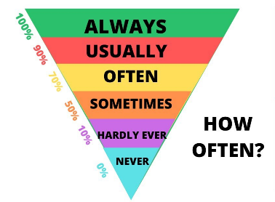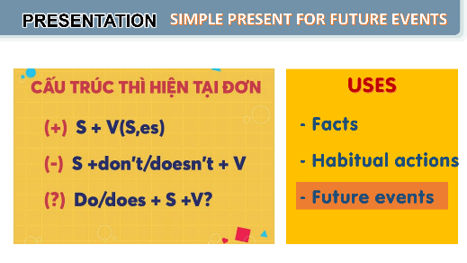
e. Assessment
- Teacher listens to students’ answers and gives feedback.

3. ACTIVITY 2: PRACTICE (24 mins)
a. Objectives:
- to revise and use some adverbs of frequency.
- to apply the use of present simple for future actions.
- to understand the difference in the use of present simple and future simple when talking about future activities.
b. Content:
- Use some adverbs of frequency to complete the sentences.
- Distinguish the difference in the use of present simple and future simple
c. Expected outcomes:
- Recall the main adverbs of frequency and their use.
- Recall the form and use of the simple sentences
- Remember the use of present simple for future actions.
d. Organisation

TEACHER’S AND STUDENTS’ ACTIVITIES | CONTENTS
Task 1. Complete the sentences with the adverbs of frequency from the box. (4 mins)-IW
- Ask Ss to do the activity individually.  - Have Ss read the sentences and decide which adverb in the box best describes the frequency of the action.  - Call on some Ss to read aloud their answers.  - Check the answers as a class. Explain if needed. | Answer key:  1. always  2. rarely  3. never  4. often  5. sometimes
Task 2. Read the schedule for the grade 8 field trip tomorrow, and underline the verbs in the sentences. Then answer the questions. (5 mins)- PW
- Have Ss do this activity individually or in pairs.  - Ask them to read the schedule and underline the verb in each sentence.  - Allow them some time to answer the questions.  - Call on some Ss to give their answers.  - Confirm the correct answers as a class.  - Have Ss read the Remember! box. Explain if needed. | Answer key:  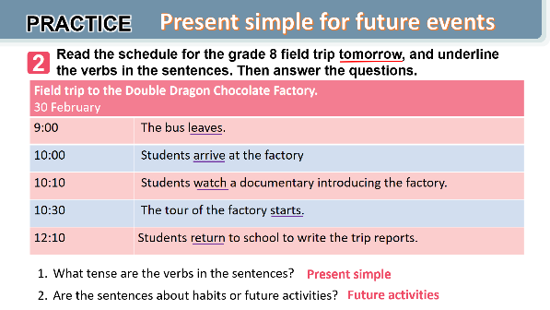
Task 3. Write A next to a sentence if it relates to a timetable, schedule or plan, and B if it is an unplanned future action. (6 mins)- IW
- Write scheduled future activity and unplanned future activity on the board. Say two sentences The bus leaves at 11:00 and we have plenty of time. and Don’t move. I’ll answer the phone. Ask Ss which sentence is a scheduled future activity and which one is an unplanned future activity. Then write them underneath their correct categories.  - Ask Ss to work individually or in pairs.  - Call on 2 - 3 Ss to read aloud their answers.  - Confirm the correct answers as a class. Explain if needed. | Answer key:  1. B  2. A  3. A  4. A  5. B
Task 4. Choose the correct answer to complete each sentence. (5 mins)- IW
- Have Ss do this activity individually.  - Ask Ss to read each sentence carefully and decide which option best completes the sentence.  - Call on some Ss to read out their answers.  - Confirm the correct answers as a class. | Answer key:  1. opens  2. will make  3. won’t buy  4. is  5. Does
Task 4. In pairs, ask and answer to check planning events for the community fair next month.. (5 mins)- PW
- Have Ss work in pairs.  - Ask Ss to read the example so that they know what they have to do.  - Allow Ss some time to read the schedule and ask and answer about the time of different events.  - Call on some pairs to say their questions and answers. Ask the whole class to follow and correct if they make a mistake. | 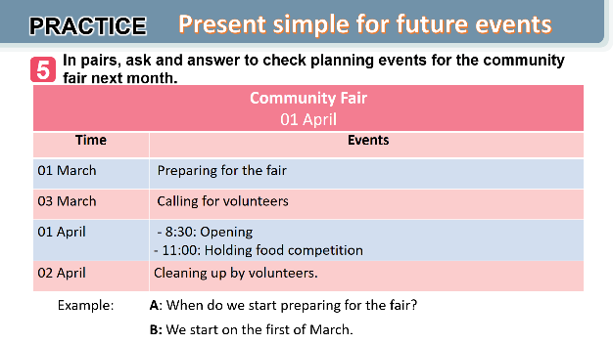
e. Assessment
- Students do peer correction
- Teacher checks students’ answers as a class and give feedback.

4. ACTIVITY 3: PRODUCTION (5 mins)
a. Objectives:
- To enable Ss to use the present simple to talk about events.
b. Content:
- To report the events for the community fair.
c. Expected outcomes:
- Reporting the events for the community fair correctly and fluently.
d. Organisation

Task 6. Reporting the events for the community fair- GW
- Instruct Ss to practice talking about the events for the community fair in groups. Make sure they use simple present tense for the events.
- Call one student of each group to report their result in front of the class.
- T asks ss to listen and give remarks.
- T gives feedback on the content and pronunciation

e. Assessment
- T corrects any grammar and pronunciation mistakes if necessary.

4. CONSOLIDATION (4 minutes)
a. Wrap-up
- Ask Ss to summarise what they have learnt in the lesson.
- Have them say out loud the adverbs of frequency they learned in the lesson.
- Have them retell the form and uses of the present simple
b. Homework
- Learn the use of adverbs of frequency by heart.
- Make 5 sentences of the simple present for future meaning
- Do Exercise ………..page ……Unit 8/Workbook

BOARD PLAN

Date of teaching
Unit 8: Shopping
Lesson 3: A closer look 2
I. Grammar:
1. Adverbs of frequency
100% | Always
90% | Usually
80% | Normally
70% | Often
40% - 50% | Sometimes
20% - 30% | Occasionally
5% - 10% | Rarely
0% | Never
2. Present simple
a. Form:
(+) S+ V/ V(e)s
(-) S + don’t/ doesn’t + Vbare
(?) Do/ Does + S + Vbare?
b. Uses:
II. Practice:
Task 1: Complete the sentences with the adverbs of frequency from the box.
Task 2: Read the schedule for the grade 8 field trip tomorrow, and underline the verbs in the sentences. Then answer the questions.
Task 3: Write A next to a sentence if it relates to a timetable, schedule or plan, and B if it is an unplanned future action.
Task 4: Choose the correct answer to complete each sentence.
Task 5: In pairs, ask and answer to check planning events for the community fair next month.
Task 6: Report the events for the community fair.
*Homework

UNIT 3: SHOPPING

Lesson 4: Communication

I. OBJECTIVES
By the end of this lesson, Ss will be able to:
1. Knowledge
- identify how to make complaints in English
- know about one’s favourite shopping place.
2. Skills:
- Make complaints in English
- Listen and talk about one’s favourite shopping place.
3. Competences
- Develop competencies of communication, cooperation, and self-management.
- Be collaborative and supportive in pair work and group work.
4. Personal qualities
- Raise ss’ awareness of favourite shopping places.
- Have good attitude to making polite complaints
II. MATERIALS
- Grade 8 textbook, Unit 8, Communication.
- Computer connected to the Internet
- Projector / TV/ pictures and cards
- Phần mềm tương tác hoclieu.vn

Language analysis
Making complaints | Examples
- I’m calling/ writing to make a complaint about….  - I’m not happy with …. | - I’m calling to make a complaint about the backpack I ordered from you last week.  - I’m not happy with the colour.

Assumption
Anticipated difficulties | Solutions
Some Ss may have difficulty getting enough information to ask and answer what each person likes about their shopping | T should give suggestions or let ss listen more times to get enough information.

III. PROCEDURES
1. WARM-UP (3 mins)
a. Objectives:
- To create an active atmosphere in the class before the lesson;
b. Content:
- Have some chatting to create a friendly and relaxed atmosphere to inspire Ss to warm up to the new class.
c. Expected outcomes:
- Having a chance to speak English and focus on the topic of the lesson.
d. Organisation

TEACHER’S AND STUDENTS’ ACTIVITIES | CONTENTS
Chatting:  - T gives ss a situation:  Supposing you ordered a hat online, but when you got it, it didn’t have the same color as you ordered. What would you do in that case?  - T leads in the new lesson: - If we aren’t satisfied with sth you ordered, we can make complaints. There are two ways of making complaint that we will learn in Lesson 4. Communication.  - Ask Ss to look at COMMUNICATION on page 86. | Expected answers:  - Making complaints

e. Assessment
- T checks ss’ answers and give feedback

2. ACTIVITY 1: PRESENTATION (6 mins)
a. Objectives:
- To introduce how to make a complaint;
- To help Ss practise making a complaint.
b. Content:
- Use everyday expressions to develop language skills (Making a complaint)
c. Expected outcomes:
- Leaning how to make a complaint
d. Organisation
TEACHER’S AND STUDENTS’ ACTIVITIES | CONTENTS
I. Everyday English: Making a complaint  Task 1: Listen and read the dialogue. Pay attention to the highlighted sentences  - Play the recording for Ss to listen and read the conversation where Tom makes complaints about the SMART backpack he bought the previous week. Ask Ss to pay attention to the highlighted parts.  - Elicit the structures for making a complaint. Have Ss practise the conversation in pairs. | To make a complaint, you can use:  - I’m calling/ writing to make a complaint about….  - I’m not happy with ….
Task 2: Work in pairs. In turns, make complaints about the situations below.
- Ask Ss to work in pairs to make similar dialogues.  - Tell them to use the contexts given and the sample requests.  - Give feedback on their dialogues. | 1. The cans of fish you bought at the shop expired five days ago.  • I’m calling to make a complaint about the cans of fish I bought at your shop five days ago. It was expired.  2. An assistant at the shop was not very helpful.  I’m not happy with an assistant at the shop. She was not very helpful.
e. Assessment
- Teacher listens to students’ pronunciation and gives feedback.

3. ACTIVITY 2: PRACTICE (20 mins)
a. Objectives:
- To help Ss practise listening for general and specific information.
- To provide Ss with some samples to help them talk about their favourite shopping places.
b. Content:
- Listen to some samples of favourite shopping places.
- Ask and answer about what the people in 3 like about the places they shop.
c. Expected outcomes:
- Knowing some different favourite shopping places
- Practising listening for general and specific information
d. Organisation

TEACHER’S AND STUDENTS’ ACTIVITIES | CONTENTS
Task 3. Listen to three people talking about their favourite shopping places and tick (v) the place they mention. (10 mins)-PW
- Have Ss read the instruction and the table so that they know what they have to do while listening to the recording.  - Play the recording and ask Ss to listen and tick the correct answers.  - Call on some Ss to read their answers.  - Confirm the correct answers as a class. | Answer key:  People Open-air market Discount shop Convenience store  1. Mai   2. Nam   3. Alice 
Task 4. Work in pairs. Take turns to ask and answer what each person in 3 likes about their shopping place (10 mins)- PW
- Have Ss work in pairs.  - Have Ss take turns to ask and answer about what each person in 3 likes about the place where they shop.  - Call on 2 - 3 pairs to share their lists. Make comments. | Model dialogue:  A: What does Nam like about shopping at a convenience store?  B: It saves him time.  Suggested answers:  Mai:  The products are home-grown and home-made. The market goers know one another.  They chat happily while selling and buying. Nam:  They are convenient because they are everywhere. You can save time.  Alice:  There is a wide range of goods there. Everything is cheaper than at other places.
e. Assessment
- T listens to ss’ reports and gives feedback on their pronunciation and content.

4. ACTIVITY 3: PRODUCTION (10 mins)
a. Objectives:
- To provide Ss with an opportunity to talk about what they like about their favourite places to shop.
b. Content:
- Talk about what they like about their favourite places to shop.
c. Expected outcomes:
- Apply what they have learnt so far in this unit (ideas, vocabulary, grammar) to talk about their favourite places to shop.
d. Organization

Task 5. Work in groups. Share your favourite shopping place with your group.- GW
- Have Ss work in groups.  - T gets Ss to apply what they have learnt so far in this unit (ideas, vocabulary, grammar) to talk about their favourite places to shop.  - Allow Ss some time to talk in their groups. Go round and give support if needed.  - Ask some Ss to share their ideas with the class. | You can conclude:  - The name of the place  - The reason(s) why you like it
e. Assessment
- T corrects any grammar and pronunciation mistakes if necessary.
- T gives feedback on their reports.

4. CONSOLIDATION (4 minutes)
a. Wrap-up
- Ask Ss what they have learnt in the lesson.
- Ss retell 2 ways of making complaints and list some favourite shopping places
b. Homework
- Learn the ways to make complaints by heart.
- Write a paragraph of 50-70 words about your favourite shopping place.
- Do Exercise ………..page ……Unit 8/Workbook

BOARD PLAN

Date of teaching
Unit 8: Shopping
Lesson 4: Communication
I. Everyday English: Making a complaint
- I’m calling/ writing to make a complaint about….
- I’m not happy with ….
Task 1: Listen and read the conversation, paying attention to the highlighted parts.
Task 2: Work in pairs. In turns, make complaints about the situations below.
II. My favourite shopping place
Task 3: Listen to three people talking about their favourite shopping places and tick (v) the place they mention.
Task 4: Work in pairs. Take turns to ask and answer what each person in 3 likes about their shopping place
Task 5: Work in groups. Share your favourite shopping place with your group.
*Homework

UNIT 8: SHOPPING

Lesson 5: Skills 1

I. OBJECTIVES
By the end of this lesson, Ss will be able to:
1. Knowledge
- recognize reading skills for specific information and general information about the reason(s) people go shopping.
- remember the lexical items related to the reason(s) people go shopping.
- recognize how to make a conversation to ask and answer about a new shopping centre and
2. Skills:
- develop their reading skill for specific information (scanning) through multiple-choice questions.
- improve their reading skill for specific information (scanning) through the gap-filling exercise.
- practise asking and answering questions for information about a new shopping centre about a shopping place in their own area.
3. Competences
- develop communication skills and creativity
- be collaborative and supportive in pair work and teamwork
- develop presentation skill
- actively join in class activities
4. Personal qualities
- raise ss’ awareness of shopping places and the reason(s) people go shopping.
- have a good attitude to going shopping to a shopping place.
II. MATERIALS
- Grade 8 textbook, Unit 8, Skills 1
- Computer connected to the Internet
- Projector / TV/ pictures and cards
- Phần mềm tương tác hoclieu.vn
Language analysis
Form | Pronunciation | Meaning | Vietnamese equivalent
1. customer (n) | /ˈkʌstəmə(r)/ | a person or an organization that buys goods or services from a shop or business | Khách hàng
2. try on (v) | /traɪ ɒn/ | to put on a piece of clothing to see if it fits and how it looks | Thử (quần áo)
3. decoration (n) | /ˌdekəˈreɪʃn/ | a thing that makes something look more attractive on special occasions | Đồ trang trí
4. wander (v) | /ˈwɑːndər/ | to walk slowly around or to a place, often without any particular sense of purpose or direction | Đi lang thang, thả bộ
Assumption
Anticipated difficulties | Solutions
1. Ss may lack knowledge about some lexical items. | Provide Ss with the meaning and pronunciation of words.
2. Ss may not have sufficient reading, speaking and cooperating skills. | Let Ss read the text again (if needed).  Create a comfortable and encouraging environment for Ss to speak.  Encourage Ss to work in pairs, and in groups so that they can help each other.  Provide feedback and help if necessary.

III. PROCEDURES
1. WARM-UP (3 mins)
a. Objectives:
- To create an active atmosphere in the class before the lesson;
- To elicit from Ss some reasons why they go shopping
b. Content:
- Have Chatting activities to elicit some reasons why Ss go shopping
c. Expected outcomes:
- Having a chance to speak English and focus on the topic of the lesson.
d. Organisation

TEACHER’S AND STUDENTS’ ACTIVITIES | CONTENTS
Chatting:  - Ask ss two questions to elicit from ss the reasons why they go shopping.  + Do you like shopping?  + How often do you go shopping?  + Why do you go to shopping centers?  - Ask Ss to discuss the reasons why they go shopping  - Ask Ss to look at SKILLS 1 on page 87-88. | Expected answers:  - Yes/ No  - I go shopping twice a week/ every day….  - I like shopping because….

e. Assessment
- T listens to ss’ answers and gives feedback

2. ACTIVITY 1: PRESENTATION (6 mins) PRE-READING
a. Objectives:
- To set the context for the reading;
- To introduce some new words
- To help Ss reflect on the reason(s) they go shopping.
b. Content:
- Learn some new words.
- Read the list of the reason(s) people go shopping and tick.
c. Expected outcomes:
- Know more new words and some reason(s) people go shopping.
d. Organisation
TEACHER’S AND STUDENTS’ ACTIVITIES | CONTENTS
Task 1: Read the list below and tick (v) the most common reason(s) why you go shopping. (3 mins)- IW
- Have Ss work individually.  - Ask Ss to read the words and phrases and tick the one(s) that is / are correct for them.  - Call on some Ss to share their answers with the class. | 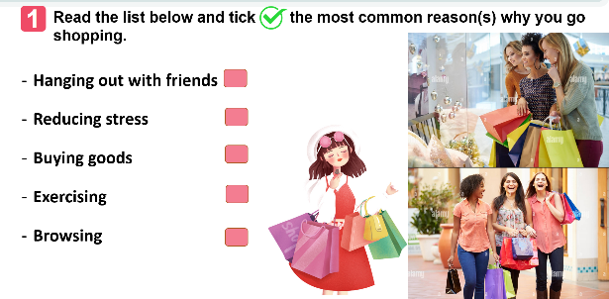
Vocabulary pre-teaching  - Teacher asks ss to look through the text and pay attention to the underlined words.  - Teacher gets ss to guess the meaning of the new vocabulary through context  - Teacher confirms the answers then gets ss to read orally and take notes of all the four words in their notebooks. | * Vocabulary:  1. customer (n): khách hàng  2. try on (v): thử (quần áo)  3. decoration (n): đồ trang trí  4. wander (v): lang thang
e. Assessment
- Teacher listens to students’ pronunciation and gives feedback.

3. ACTIVITY 2: PRACTICE (20 mins) WHILE-READING
a. Objectives:
- To help Ss develop their reading skill for specific information (scanning)
b. Content:
- Read the conversation about the reasons why people go shopping and decide choose the best answer to the questions and fill in the gaps.
c. Expected outcomes:
- Understanding the text about the reasons why people go shopping by choosing the correct answer to the questions and filling in the gaps.
d. Organisation

TEACHER’S AND STUDENTS’ ACTIVITIES | CONTENTS
Task 2. Read the passage and choose the correct answer A, B, or C. (10 mins)-IW
- Have Ss read the text in detail first. Then ask them to read each question and choose the correct answer for it.  - Ask ss to find the information in the reading text.  - Call on some Ss to share their answers. Ask them where they find the information for their answers.  - Confirm the correct answers as a class. Explain if needed. | Answer key:  1. C  2. A  3. B  4. B  5. A
Task 3. Fill in each blank with ONE word from the passage. (10 mins)- IW
- Ask Ss to read each sentence carefully, then refer to the text to look for the answer. Have them complete the task.  - Have Ss compare their answers in pairs and discuss if there are any differences in their answers.  - Call on some Ss to share their answers with the class. Ask them where they find the information for their answers.  - Confirm the correct answers as a class. | Suggested answer:  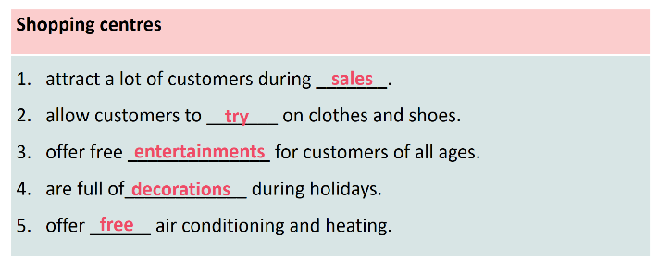
e. Assessment
- T checks the answers as a class and give feedback
4. ACTIVITY 3: PRODUCTION (15 mins)- POST-READING (SPEAKING)
a. Objectives:
- To help Ss practise asking and answering questions for information about a new shopping center
- To provide an open opportunity for Ss to talk about a shopping place in their own area.
b. Content:
- Practise asking and answering questions for information about a new shopping center;
- Practise talking about a shopping place in their own area.
c. Expected outcomes:
- Speak about a new shopping center and a shopping place in their own area.
d. Organisation

TEACHER’S AND STUDENTS’ ACTIVITIES | CONTENTS
Task 4. Work in pairs. Ask and answer about a new shopping centre- PW (9 minutes)
- Ask Ss to work in pairs, each having their card (A or B). Make sure that they know how to work with the cards.  - Allow them some time to prepare the questions and to read the information for the answers. Then ask them to start asking and answering about the new shopping centre. Go around and monitor. Give help if needed.  - Call on some Ss to share their conversation with the class. Comment on their conversation.  - This activity helps prepare Ss for 5. | Suggested questions:  1. Where is the new shopping centre?  2. How many shops are there / does it have?  3. What kind of entertainment does it offer / have / can we find there?  4. What are its opening hours?  5.What date does the shopping centre open?
Task 5. Work in pairs. Ask and answer about a shopping centre, a supermarket, or an open-air market in your area. Take notes of your partner’s answers and report them to the class- PW(5 minutes)
- Have Ss work in pairs.  - Ask Ss to reflect on the conversation in 4 and read the suggestions for 5.  - Allow Ss some time to carry out their conversation. Remind them to take notes of their partner’s answers. Go round and offer help if needed.  - Call on some Ss to report to the class what they find out about their partner’s shopping place. Comment on their presentation. | 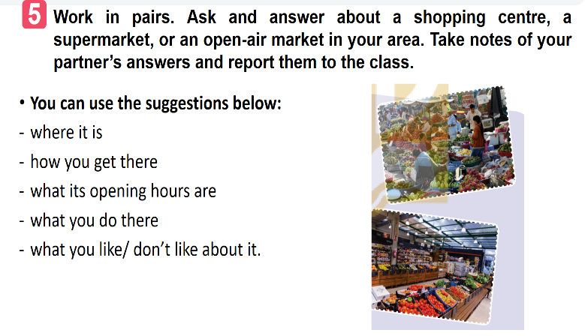
e. Assessment
- T asks the class to give feedback on their questions and answers, and pronunciation.
- T gives feedback on their reports in terms of language, reasoning skills, and pronunciation.

4. CONSOLIDATION (3 minutes)
a. Wrap-up
- Ask Ss what they have learnt in the lesson.
- Ss retell the reasons why we go to shopping centres and information about new shopping centres.
b. Homework
- Learn the new words by heart.
- Make a speech introducing a new shopping centre in your city.
- Do Exercise ………..page ……Unit 8/Workbook

BOARD PLAN

Date of teaching
Unit 8: SHOPPING
Lesson 5: Skills 1
I. Reading
Task 1. Read the list below and tick (v) the most common reason(s) why you go shopping.
* Vocabulary:
1. customer (n): khách hàng
2. try on (v): thử (quần áo)
3. decoration (n): đồ trang trí
4. wander (v): lang thang
Task 2. Read the passage and choose the correct answer A, B, or C.
Task 3. Fill in each blank with ONE word from the passage.
II. Speaking
Task 4. Work in pairs. Ask and answer about a new shopping centre.
Task 5. Work in pairs. Ask and answer about a shopping centre, a supermarket, or an open-air market in your area. Take notes of your partner’s answers and report them to the class.
*Homework

UNIT 8: SHOPPING

Lesson 6: Skills 2

I. OBJECTIVES
By the end of this lesson, Ss will be able to:
1. Knowledge
- recognize listening skills for specific information about online shopping.
- remember the lexical items related to online shopping.
- recognize how to write a paragraph about the advantages and disadvantages of a type of shopping.
2. Skills:
- improve the skill of listening for specific information.
- improve listening comprehension and note-taking skills.
- improve the writing skill of writing a paragraph presenting advantages and disadvantages
3. Competences
- develop communication skills and creativity
- be collaborative and supportive in pair work and group work
- actively join in class activities
4. Personal qualities
- raise ss’ awareness of online shopping
- have the right attitude toward the advantages and disadvantages of different types of online shopping.
II. MATERIALS
- Grade 8 textbook, Unit 8, Skills 2
- Computer connected to the Internet
- Projector / TV/ pictures and cards
- Phần mềm tương tác hoclieu.vn
Language analysis
Form | Pronunciation | Meaning | Vietnamese equivalent
1. access (n) | /ˈækses/ | the opportunity or right to use something or to see somebody/something | Quyền truy cập vào
2. purchase (v) | /ˈpɜːtʃəs/ | to buy something | Mua sắm
3. shipping (n) | /ˈʃɪpɪŋ/ | the activity of carrying people or goods from one place to another by ship or by some other means | Việc chuyển hàng,  giao hàng
4. overshopping (v) | /ˈəʊvə(r) ˈʃɒpɪŋ/ | the activity of going to shops and buying too many things or ordering too many things online | Mua sắm quá đà

Assumption
Anticipated difficulties | Solutions
1. Ss may lack knowledge about some lexical items. | Provide Ss with the meaning and pronunciation of words.
2. Ss may not have sufficient listening, writing and co-operating skills. | Let Ss listen the text again (if needed).  Encourage Ss to work in pairs, in groups so that they can help each other.  Provide feedback and help if necessary.

III. PROCEDURES
1. WARM-UP (3 mins)
a. Objectives:
- To create an active atmosphere in the class before the lesson;
- To help ss focus on the listening writing topic
b. Content:
- Have a Chatting activity to elicit what people need when doing online shopping.
c. Expected outcomes:
- Having a chance to speak English and focus on the topic of the lesson.
d. Organisation

TEACHER’S AND STUDENTS’ ACTIVITIES | CONTENTS
Chatting:  - Ask ss two questions to elicit from ss the reasons why they go shopping.  Have you ever shopped online?  What do you need to shop online?  - Ask Ss to discuss the reasons why they go shopping  - Ask Ss to look at SKILLS 2 on page 89. | Suggested answers:  - Yes/ No  - To shop online, we need…
e. Assessment
- T check ss’ answers and gives feedback

2. ACTIVITY 1: PRESENTATION (5 mins) PRE-LISTENING
a. Objectives:
- To help Ss focus on the topic and prepare for the listening text.
- To help Ss brainstorm keywords/phrases for listening.
- To set the context for the listening;
b. Content:
- Learn some new words.
c. Expected outcomes:
- Know more new words
d. Organisation
TEACHER’S AND STUDENTS’ ACTIVITIES | CONTENTS
Vocabulary pre-teaching  - Teacher introduces the vocabulary.  - Teacher explains the meaning of the new vocabulary by pictures or explanation  - Teacher reveals that these four words will appear in the listening text and asks students to open their textbooks to discover further.  Task 1. Work in pairs. Discuss and tick (v) the things related to online shopping.  - Have Ss work individually.  - Ask Ss to read the word and phrases and tick the one(s) they think is / are correct.  - Call on some Ss to share their answers. | * Vocabulary:  1. access (n)  2. purchase (v)  3. shipping (n)  4. over shopping (v)  Suggested answer:  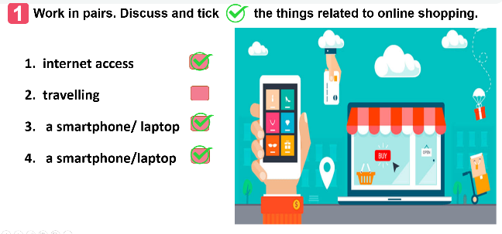
e. Assessment
- Teacher listens to students’ pronunciation and gives feedback.

3. ACTIVITY 2: PRACTICE (20 mins) WHILE- LISTENING
a. Objectives:
- To improve Ss’ skill of listening for specific information.
- To improve Ss’ listening comprehension and note-taking skills.
b. Content:
- Listen to a talk and fill in each blank.
- Listen to the talk and choose the correct answer
c. Expected outcomes:
- Understanding the talk about online shopping.
d. Organisation

TEACHER’S AND STUDENTS’ ACTIVITIES | CONTENTS
Task 2. Listen to a talk about online shopping and fill in each blank with a suitable word.
(10 mins)-IW
- Have Ss read the sentences carefully and decide what information they need to fill in each blank.  - Play the recording for Ss to do the task.  - Have Ss share their answers in pairs.  - Invite some Ss to share their answers with the class.  - Confirm the correct answers as a class.  - Play the recording again if needed, stopping at places where Ss are having difficulties. | Answer key:  1. service  2. seller’s  3. money  4. shipping  5. shopaholic
Task 3. Listen again and choose the correct answer A, B, or C. (10 mins)- IW
- Play the recording again if needed. Have Ss do the task individually.  - Invite some pairs to share their answers with the class.  - Confirm the correct answers as a class.  - Play the recording again if needed, stopping at the place where Ss are having difficulties. | Suggested answers:  1. When you shop online, you can pay______ ways.  A. one B. two C. three  2. The talk does NOT describe online shopping as_______.  convenient B. ease C. interesting  3. The talk is mainly about _______ of online shopping.  A. always B. sometimes C. rarely
e. Assessment
- T checks the answers as a class and gives feedback
4. ACTIVITY 3: PRODUCTION (15 mins)- POST-LISTENING (WRITING)
a. Objectives:
- To provide Ss with vocabulary and ideas about the advantages and disadvantages of different types of shopping.
- To improve ss’ skill of writing a paragraph about the advantages and disadvantages of a type of shopping.
b. Content:
- Choose a type of shopping from the list. Discuss and take notes of its advantages and disadvantages.
- Write a paragraph about the advantages or disadvantages of a type of shopping.
c. Expected outcomes:
- Know the advantages and disadvantages of different types of shopping.
- Write a paragraph about the advantages or disadvantages of a type of shopping.

d. Organization

TEACHER’S AND STUDENTS’ ACTIVITIES | CONTENTS
Task 4. Work in pairs. Choose a type of shopping from the list. Discuss and take notes of its advantages and disadvantages.- PW (4 minutes)
- Have Ss work in pairs.  - Ask Ss to read the list and choose the one they would like to talk about.  - Allow Ss some time to discuss and take notes of the advantages and disadvantages of the type of shopping they have chosen. Remind them to listen for the structures and expressions. Move around to oﬀer help if needed.  - Invite some Ss to share their answers to the class. | 1. Shopping online  2. Shopping at a supermarket  3. Shopping at an open-air market
Task 5. Write a paragraph (80-100 words) about the advantages or disadvantages of a type of shopping. Use the ideas in 4. (10 minutes)
- Ask Ss to read the notes of their discussion in 4.  - Allow them some time to write out the paragraph. Go round and offer help if needed.  - Call on some Ss to read aloud their writings to the class. Comment on their writings. | You can use the suggestions below:  Shopping…….. is interesting/ convenient/ safe/ ………  Firstly, ……  Secondly, …..  Sample writing:  I often go shopping at the open-air market near my house. However, there are some things I don’t like about it. First, it is outdoor. On rainy or hot days, it is uncomfortable to shop. Secondly, the sellers usually ask for a higher price than the value of the goods and you have to bargain. It’s not easy if you don’t know the actual price of an item. Another disadvantage is hygiene. Fresh products like vegetables are often not very clean.
e. Assessment
- T gives feedback on their writing in terms of spelling, grammatical mistakes, cohesion, and content.
4. CONSOLIDATION (3 minutes)
a. Wrap-up
- Ask Ss what they have learned in the lesson.
- Ss tell the whole class about the advantages or disadvantages of a kind of shopping.
b. Homework
- Do Exercise ………..page ……Unit 8/Workbook

BOARD PLAN

Date of teaching
Unit 8: Online shopping
Lesson 6: Skills 2
I. Listening
* Vocabulary:
1. access (n)
2. purchase (v)
3. shipping (n)
4. over shopping (v)
Task 1. Work in pairs. Discuss and tick (v) the things related to online shopping.
Task 2. Listen to a talk about online shopping and fill in each blank with a suitable word.
Task 3. Listen again and choose the correct answer A, B, or C.
II. Writing
Task 4. Work in pairs. Choose a type of shopping from the list. Discuss and take notes of its advantages and disadvantages.
Task 5. Write a paragraph (80-100 words) about the advantages or disadvantages of a type of shopping. Use the ideas in 4.
*Homework

UNIT 8: SHOPPING

Lesson 7: Looking back and project

I. OBJECTIVES
By the end of this lesson, Ss will be able to:
1. Knowledge
- Repeat and distinguish the uses of adverbs of frequency
- Memorize the use of the present simple with future actions
- Memorize some words related to shopping and online shopping.
2. Skills:
- Use adverbs of frequency to do exercises.
- Distinguish the uses of the present simple to do exercises
- Use words related to shopping and online shopping to do exercises.
- Apply what they have learnt (vocabulary and grammar) into practice through a project
3. Competences
- Develop communication skills and creativity
- Develop presentation skill
- Develop critical thinking skills
- Be collaborative and supportive in pair work and teamwork
- Actively join in class activities
4. Personal qualities
- consolidate ss’ awareness of shopping and online shopping.
- have a positive attitude toward shopping places and dream shopping place.
II. MATERIALS
- Grade 8 textbook, Unit 8, Looking back and project
- Computer connected to the Internet
- Projector / TV/ pictures and cards
- Phần mềm tương tác hoclieu.vn

Assumption
Anticipated difficulties | Solutions
1. Ss may not have sufficient speaking, writing and co-operating skills when doing the project. | - Encourage Ss to work in pairs, in groups so that they can help each other.  - Provide feedback and help if necessary.

III. PROCEDURES
1. WARM-UP (3 mins)
a. Objectives:
- To create an active atmosphere in the class before the lesson;
- To help ss focus on the listening writing topic
b. Content:
- Have ss play the game “Kim’s game”
c. Expected outcomes:
- Having a chance to speak English and focus on the topic of the lesson.
d. Organisation

TEACHER’S AND STUDENTS’ ACTIVITIES | CONTENTS
Kim’s game:  - T asks students to work in groups of three or four students  - Get ss to watch a video clip and try to remember all types of shops mentioned in the clip without taking notes.  - After finishing watching the clip, ss write down as many stores/ shops as possible.  - T gets ss to swap the posters among groups and give correction after T shows the answers.  -The group with the most correct answers will win.  - T leads in the lesson. | Answers:  1. bakery  2. fruit store  3. butcher shop  4. fish market  5. pastry shop  6. flower shop  7. shoe shop  8. toy store  9. stationery shop  10. book store  11. hardware store  12. jewelry store  13. pharmacy
e. Assessment
- T check ss’ answers and gives feedback
2. ACTIVITY 1: PRACTICE- LOOKING BACK (22 mins)
a. Objectives:
- To help Ss review the vocabulary learnt.
- To help Ss review adverbs of frequency
- To help Ss use the present tense correctly
b. Content:
- review some new words related to the topic
- review adverbs of frequency and present simple with future meaning
c. Expected outcomes:
- Remember the vocabulary learnt
- Remember adverbs of frequency and present simple with future meaning
d. Organisation
TEACHER’S AND STUDENTS’ ACTIVITIES | CONTENTS
I. VOCABULARY  Task 1. Match the words and phrases (1-5) with the meanings (a-e).  - Have Ss do this activity individually.  - Ask Ss to read the words and phrases (1 - 5) and the meanings (a - e) and match them.  - Allow them to compare their answers with their partners.  - Call on some Ss to share their answers with the class.  - Confirm the correct answers.  Task 2. Complete the sentences with the words and phrases from the box.  - Have Ss do this activity individually.  - Ask Ss to read the sentences carefully, then refer to the words and phrases in the box to choose the correct answers.  - Allow Ss to compare their answers with their partners.  - Confirm the correct answers as a class. | VOCABULARY  Task 1.  Suggested answers:  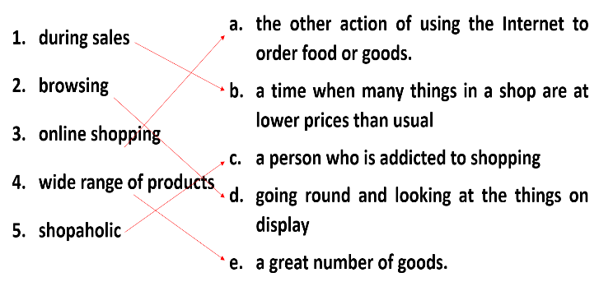  Task 2.  1. on sale  2. bargain  3. Internet access  4. home-grown  5. offline
II. GRAMMAR  Task 3. Complete each sentence with a suitable adverb of frequency.  - Have Ss do this activity individually.  - Ask Ss to read the sentences and decide which adverb of frequency to use for each sentence.  - Call on some Ss to share their answers with the class.  - Confirm the correct answers as a class.  Task 4. Use the correct tense and form of the verbs in brackets to complete the sentences.  - Ask Ss to read each sentence carefully and decide which tense to use.  - Call on some Ss to read their answers and explain their choices.  - Confirm the correct answers as a class. Explain if needed. | GRAMMAR  Task 3.  Suggested answers:  1. always  2. always – usually  3. never  4. often / usually  5. rarely  Task 4.  Suggested answers:  1. leaves  2. is  3. can use  4. lasts  5. don’t have
e. Assessment
- Teacher checks students’ answers and corrects Ss’ language and pronunciation if necessary.

3. ACTIVITY 2: PRODUCTION- PROJECT (20 mins)
a. Objectives:
- To help Ss brainstorm ideas about a shopping place ss would like to have in their neighbourhood;
- To encourage Ss to use their imagination to design a dream shopping place.
- To improve Ss’ teamwork and public speaking skills.
b. Content:
- Imagine a shopping place ss would like to have in their neighbourhood;
- Draw a picture or find a picture similar to that shopping place.
- Present the picture to the class
c. Expected outcomes:
- Present the picture of a shopping place ss would like to have in their neighbourhood.
d. Organisation

TEACHER’S AND STUDENTS’ ACTIVITIES | CONTENTS
Task 1. Imagine a shopping place you would like to have in your neighbourhood. (3 mins)-GW
- Have Ss work individually.
- Ask Ss to read the instructions and suggestions carefully.
- Encourage Ss to use their imagination to develop a dream shopping place that they would like to have.
Task 2. Draw it or find a picture similar to it. (10 mins)- GW
- Ask Ss to find or draw a picture to illustrate their dream shopping place.
- Provide Ss an opportunity to present their ideas to the class.
Task 3. Present it to the class. (5mins)
- T ask 2 or 3 groups to present their picture.  - 1 or 2 students of each group will present in front of the class  - Ss listen and give feedback to each group’s presentation | You can include:  - The name of the shopping place.  - How beautiful/convenient it is.  - Range of products/ services/ entertainment it offers.  - What is special about it.
- If time is limited, T can assign the project in earlier lessons such as in GETTING STARTED lesson.
Make sure you guide them in detail and check their progress after each lesson. In the last lesson (LOOKsING BACK), ask Ss to present their poster.
e. Assessment
- T checks ss’ grammatical and spelling mistakes on their poster, listens to their presentation, and gives feedback
4. CONSOLIDATION (2 minutes)
a. Wrap-up
- Reviewing vocabulary in Unit 8
- Reviewing present simple and adverbs of frequency
NOW I CAN …
- Ask Ss to complete the self-assessment table.
- Identify any difficulties and provide further practice.
b. Homework
- Do Exercise ………..page ……Unit 8/Workbook

BOARD PLAN

Date of teaching
Unit 8: Shopping
Lesson 7. Looking back and project
I. Vocabulary:
Task 1. Match the words and phrases (1-5) with the meanings (a-e)
Task 2. Complete the sentences with the words and phrases from the box.
II. Grammar
Task 3. Complete each sentence with a suitable adverb of frequency.
Task 4. Use the correct tense and form of the verbs in brackets to complete the sentences.
III. Project
Task 1. Imagine a shopping place you would like to have in your neighbourhood.
Task 2. Draw it or find a picture similar to it.
Task 3. Present it to the class.
*Homework

