Đề Tiếng Anh_11  (Đề thi gồm 16 trang) | KỲ THI CHỌN HỌC SINH GIỎI  LẦN THỨ XVII, NĂM 2026  ĐỀ THI MÔN: Tiếng Anh - LỚP 11  Thời gian làm bài: 180 phút  (không kể thời gian giao đề)

I. LISTENING (5.0 points)
- The listening section is in FOUR parts. The recordings of Part 1 and Part 2 will be played ONCE only, and the recordings of Part 3 and Part 4 will be played TWICE. At the start of each recording, you will hear a sound.
- There will be a piece of music at the beginning and at the end of the listening section. You will have TWO minutes to check your answers at the end of the listening section.
- All the other instructions are included in the recording.
Part 1. Listen to a conversation about taking a emojis ONCE and do the tasks that follow.
For questions 1 - 5, decide whether each of the following statements is True (T), False (F), or Not Given (NG) according to what you hear. Write T, F, or NG in the corresponding numbered boxes provided.
- The content of the conversation is set to increase in complexity.
- Neil’s use of emojis is context-based.
- According to Neil, when any one writes their own name in brackets in Skype, an emoji appears.
- Emojis have an influence on people’s writing skills.
- Nishma often successfully interprets people’s feelings through emojis.
For questions 6 - 10, decide whether the following are mentioned by only one of the guests, or by both of them. In the corresponding numbered boxes provided,
write F for Female guest (Jo);
M for Male guest (Niel);
B for Both of the guests.
- Emojis almost never appeared in workplace communication several years ago.
- The smiley face emoji is included in order to create a cheerful the tone.
- The heart emoji is unfit in professional settings.
- The use of emojis could cause problems.
- Emojis should be used with vigilance.
Your answers:
Part 2. Listen to a talk about gig economy workers and app-based companies ONCE and do the tasks that follow.
For questions 11 - 12, choose TWO letters from A-E to indicate TWO true statements about the gig economy. Write your answers in the corresponding numbered boxes provided.
- The majority of gig economy workers in the US obtain their assignments through digital platforms.
- The term "gig" originated in the entertainment industry before being applied to modern labor arrangements.
- Uber's launch represented the first significant application of app-based technology to gig work.
- Traditional employees receive predetermined work schedules as part of their employment terms.
- A final legal definition of gig workers cannot be established.
For questions 13 - 15, choose THREE letters from A-G to indicate THREE true statements about being an independent contractor. Write your answers in the corresponding numbered boxes provided.
- Independent contractors possess autonomy over client selection and scheduling decisions.
- The US social safety net infrastructure was designed with traditional employment relationships as its foundation.
- Independent contractors receive equivalent workplace protections to those guaranteed for employees.
- State governments seek reclassification of gig workers primarily to expand worker protections.
- California has implemented more aggressive gig worker classification reforms than other US states.
- Independent contractor status eliminates workers' ability to pursue workplace discrimination claims.
- State governments prioritize worker protection over revenue generation when addressing gig worker classification.
For questions 16 - 20, write the letter A, B, C or D in the corresponding numbered boxes provided to indicate the correct answer to each of the following questions according to what is stated or implied by the speaker.
- What does the ABC test primarily determine?
A. Whether a company can legally operate in California
B. Whether workers qualify as independent contractors
C. Whether businesses must provide employee benefits
D. Whether app-based companies can hire gig workers
- The B standard requires that workers _______.
A. have their own registered business entity
B. exercise independent control over their work
C. perform tasks unrelated to the company's main business
D. operate outside the company's direct supervision
- App-based companies have responded to Assembly Bill Five by doing all of the following EXCEPT _______.
A. launching a petition campaign to overturn the law
B. seeking the authority to co-draft amendments to Assembly Bill Five
C. filing lawsuits challenging the law's enforcement
D. investing capital in opposition efforts
- What is the main appeal of a third worker classification for gig companies?
A. It would exempt them from existing employment laws
B. It would reduce legal challenges from workers and regulators
C. It would allow benefits to transfer across different platforms
D. It would enable companies to maintain labor force
- The The speaker suggests that current employment laws are _______.
A. too rigid to accommodate modern work arrangements
B. intentionally designed to favor traditional employers
C. gradually being updated to address gig work
D. insufficient to protect gig economy workers
Your answers:
Part 3. For questions 21 - 25, listen to part of a talk about the world’s most powerful tidal current, TWICE and answer each of the following questions with no more than TWO words taken from the recording. Write your answers in the corresponding spaces provided.
- What phrase does Douglas Adams use to describe the land in the north of the Arctic Circle in Norway?
__________________________________________________________________________
- What type of water feature is the fjord described as in the passage?
__________________________________________________________________________
- What does the narrator compare the main channel to in terms of how water flows through it?
__________________________________________________________________________
- What two phenomena does the narrator say are created by each little twist in the tide and the water?
__________________________________________________________________________
- What kind of vessel do tour groups use into the channel?
__________________________________________________________________________
Part 4. For questions 26 - 35, listen to part of a talk TWICE, and complete the following summary with no more than THREE words and/or A number taken from the recording for each space. Write your answers in the corresponding numbered boxes provided.
Why Your Brain Is In Your Head
Brains are nearly always housed inside heads throughout the animal world. It’s curious that evolution failed to shield this vital organ beyond a mere (26)______. Early animals lacked brains or heads entirely. Around (27)______ years ago animals with bilateral symmetry split from radial forms. Radial ones relied on just (28)______, seeming almost flat. Bilateral forms gained a distinct front and back, unlocking huge new options.
Hox genes organize every bilateral body, directing the (29)______ of many other genes. Arranged in matching order along the (30)______, they form the ancient body blueprint that shaped nematodes, toads, waterbears, and so on. Complex animals like human beings hold more Hox genes than flies, but they're quite similar. Through time these Hox genes were copied, allowing the extras to specialize and (31)______.
Early animals transformed scattered nerves into tip-to-tail lines without brains or (32)______. Eyes triggered brain development: sense organs gathered at the feeding entrance, prompting nerves to (33)______ - marking brain origins. Stronger senses like eyes and (34)______ made brains worth guarding. Craniates wrapped them in skulls, enabling tougher jaws and fins.
The first terrestrial vertebrates would (35)______ a wide variety of animals, yet but their blueprint was set: skull-enclosed brain, at eating end, near sensors.
Your answers:

II. READING (8.0 points)
II.1. LANGUAGE IN USE (3.0 points)
Part 1. For questions 36- 40, read the passage below and decide which answer (A, B, C, or D) best fits each space. Write the letter A, B, C, or D in the corresponding numbered boxes provided.
The world can be validly construed as forum for action, or as place of things.
The former manner of interpretation – more primordial, and less clearly understood – (36)______ the arts or humanities, in ritual, drama, literature, and mythology. The world as forum for action is a place of value, a place where all things have meaning. This meaning, which (37)______, is implication for action, or – at a higher level of analysis – implication for the configuration of the interpretive schema that produces or guides action.
The latter manner of interpretation – the world as place of things – finds its formal expression in the methods and theories of science. Science allows for (38)______, and for efficient utilization of precisely-determined things as tools (once the direction such use is to take has been determined, through application of more fundamental narrative processes).
No complete world-picture can be generated, without use of both modes of construal. The fact that one mode is generally set at odds with the other means only that (39)______ insufficiently discriminated. Adherents of the mythological world-view tend to regard the statements of their creeds as indistinguishable from empirical “fact,” even though such statements were generally formulated long before the notion of objective reality emerged. Those who, by contrast, accept the scientific perspective – who assume that it is, or might become, complete – forget (40)______what is from what should be.
36. A. finds itself expressed in B. itself finds expression in
C. finds its expression in D. has its expression found in
37. A. consequently shapes itself through social interaction
B. is shaped as a consequence of social interaction
C. consequently shapes social interaction
D. itself is a socially interactive consequence
38. A. the increasingly validatable properties of things to be consensually determined with precision
B. an increase in the precision in determining the consensual validatability of properties of things
C. the validatable properties of things which are consensual to be determined with increasing precision
D. increasingly precise determination of the consensually validatable properties of things
39. A. by nature, their domains remain respectively
B. the respective nature of their domains remains
C. the nature of their respective domains remains
D. their domains, by nature, remains respectively and
40. A. a gulf currently impassable that divides
B. that an impassable gulf currently divides
C. that an impassable gulf is what currently divides
D. a current gulf that impassably divides
Your answers:
Part 2. For questions 41- 45, read the passage below and decide which answer (A, B, C, or D) best fits each space. Write the letter A, B, C, or D in the corresponding numbered boxes provided.
Climate change is driving a public mental health crisis that (41)______, and unjustly, affects the world’s young people. Despite the growing evidence for harm to the next generation, the medical community has largely been hesitant to take the next step and act on the evidence. We propose that the medical community has a responsibility to do more.
Drawing from our (42)______ experience in paediatrics and psychiatry, we call for our profession to take the ‘leap’ beyond the walls of our clinics and laboratories, and take a courageous stance on the topic of climate change. We argue that the medical profession must adopt a broader (43)______ of health and its determinants—or a ‘social lens’—if it is to move beyond (44)______ to action.
Viewing climate change as a clear determinant of mental health opens up potential avenues of action, both as individual clinicians and as a profession as a whole. We offer the beginnings of a framework for action (45)______ climate change and youth mental health, before calling for our profession to re-examine its role - and its very purpose - to better address the climate crisis.
- A. overwhelmingly B. disproportionately C. indiscriminately D. predominantly
- A. intercultural B. intermediary
C. intercollegiate D. interdisciplinary
- A. perception B. conception C. intensified D. extended
- A. discourse B. ideology C. rhetoric D. deliberation
- A. in the absence of B. in the wake of
C. in the face of D. in the context of
Your answers:
Part 3. For questions 46 - 50, complete the passage by filling in each space with one of the words given in the box in its correct form. There are FOUR extra words, and the first one, (0), has been done as an example. Write your answers in the corresponding numbered boxes provided.
PRODUCE | INUNDATION | MAKE | PASS | BACK
BANK | CROSS | PRESERVE | GATE | SAFE
Floodwaters have surged over two meters in Bac Ninh Province, home to (0) ______ facilities of global giants like Samsung and Foxconn, forcing residents to use boats for transportation as the military works to build dikes to prevent further flooding. The Cau River has overflowed, flooding residential areas on both sides in Tam Giang Commune.
Bac Ninh, which is (36) ______ by three major rivers—Cau, Thuong, and Luc Nam—has faced severe flooding. Waters from the Cau and Thuong rivers have either surpassed or are close to surpassing historical flood levels, resulting in widespread flooding across 38 out of 99 communes.
In Tho Ha Commune, floodwaters breached (37) ______, submerging the first floors of houses near the Cau River. About 10 kilometers away, the ancient village of Tho Ha in Van Ha Commune is flooded up to 2 meters deep. For the past three days, residents have used (38) ______ boats to move around. Essential items have been moved to higher ground for (39) ______.
In Tien Luc Commune, floodwaters receded by Thursday afternoon after two days of heavy flooding from the Thuong River, which (40) ______ 10 out of 61 villages.
Your answers:
0. production
Part 4. The passage below contains SIX grammatical mistakes. The first one, (0), has been identified. For questions 51 - 55, UNDERLINE the remaining FIVE mistakes and WRITE THEIR CORRECT FORMS in the numbered boxes provided as the example (0).
It was the human factor that contributes to the absolute majority of road accidents which involves the tremendous toll of fatalities each year. Other, less decisive causes are vehicle malfunctions or road shortcomings. Speeding motorists are notorious for failing to give their way at junctions, misjudging the situation on the road or unable to accurately estimate the distance while overtaking the “snailpacers” ahead.
Drinkers settled behind the wheel after one glass or two may be running the risk of causing a tragedy through their impaired perception, which is not so rare a case, again. Unfortunately, it is much simpler to introduce necessary alterations in traffic systems then change the behavioral patterns of drivers. There are voices that more severe disciplinary resolutions ought to be put into practice if vehicle users are to benefit from greater security on the road.
Your answers:
0. was is
II.2. READING COMPREHENSION (5.0 points)
Part 1. For questions 56 - 65, read the following passage and fill in each of the numbered spaces with ONE suitable word. Write your answers in the corresponding numbered boxes provided.
The first large-scale analysis of multiple cancer types in cats has uncovered genetic changes that may help guide new (56)______ for both animals and people.
Cats often share the same living environments as their (57)______, which means they can be exposed to similar cancer risk (58)______.
A group of researchers examined tumors from nearly 500 pet cats across five countries. Using DNA sequencing on tissue samples (59)______ collected for veterinary diagnostics, the study showed that several genetic patterns in feline cancers mirror (60)______ found in people. One notable example is the similarity between feline mammary cancer and human breast cancer.
The findings suggest that multiple genetic pathways involved in cancer could be explored further through genomics and clinical studies. This could eventually lead to treatments that target the (61)______ mutations in both cats and humans. This study marks the first time cat tumors have been analyzed at this (62)______, creating an open resource that researchers can use to advance feline cancer genomics.
The findings highlight opportunities to study cancer (63)______ species and potentially develop therapies that benefit both. One promising concept (64)______ from this work is the 'One Medicine' approach. This strategy encourages collaboration between human and veterinary medicine, allowing discoveries in one field to (65)______ the other. Treatments that prove effective in people could be tested in cats, and insights from veterinary trials could help guide human clinical research.
Your answers:
Part 2. For questions 66-72, rearrange the following sentences from A-H in order to make a complete and meaningful passage. Write your answers (A-H) in the corresponding numbered boxes provided. The first one, (0), has been done as an example.
- Olive oil, often lovingly called "liquid gold," is a cornerstone of Mediterranean cuisine, celebrated across the globe for its rich flavour, golden hue, and remarkable versatility in both cooking and culture.
- Once the paste is ready, it undergoes malaxation — a slow, controlled mixing process lasting 20 to 40 minutes — which allows tiny oil droplets to merge into larger ones, making extraction far more efficient and preserving the oil's natural nutrients.
- The journey begins in sun-drenched groves where olives are carefully harvested at just the right moment of ripeness, then transported to the mill and thoroughly cleaned to remove any leaves, twigs, or traces of dirt.
- So, the next time you drizzle olive oil over a fresh salad or let it sizzle in a hot pan, take a moment to appreciate the ancient craft, modern science, and dedicated hands that brought it from grove to your table.
- At the mill, the cleaned olives are ground — either by traditional stone wheels or modern steel crushers — into a thick, fragrant paste that holds both the oil and the essence of the fruit within.
- The oil is then separated from water and solids through a high-speed centrifuge, filtered or racked to remove remaining impurities, and rigorously tested for acidity and flavour before being sealed into bottles.
- Now bottled and ready, extra virgin olive oil stands as a living testament to over 2,000 years of Mediterranean tradition, embodying the patience, precision, and passion of every producer who has ever tended an olive tree.
- The result is a pure, luminous oil whose aroma alone — grassy, fruity, and faintly peppery — signals the extraordinary natural journey it has completed from ancient grove to gleaming bottle.
Your answers:
0. A
Part 3. Read the following passage and do the tasks that follow.
FREE EXCHANGE
How to put a price on a human life
- HOW MUCH is fresh air worth? Some, taking a deep, restorative breath at the top of a mountain or an Atlantic cliff-edge, might think it priceless. Fighting air pollution nevertheless costs actual money. Businesses need to spend on new devices; some industries might need to shrink or vanish; households need cleaner ways of cooking and heating their homes. On the other side of the ledger are the benefits from avoiding the health damage that breathing polluted air causes—especially to children, the already sick and the old. Deciding how much to spend on clean-up efforts is a classic economic problem, in that solving it involves weighing one side of the ledger against the other. But how can you perform cost-benefit analysis when the benefits involve people avoiding sickness or early death? Pricing fresh air turns into an even harder problem: putting a value on a human life.
- It is one that America’s environmental watchdogs have decided to stop grappling with. The Environmental Protection Agency (EPA) announced last month that, when carrying out cost-benefit analyses of regulations, it would no longer put a price on the health benefits of clean air. There is simply too much uncertainty, officials argued, over how much such benefits are worth. Sceptics see this as a means by which to water down regulation. What is not counted does not count, as the old adage goes, and so refusing to put a price on fresh air is a way of discounting its benefits.
- America’s federal government has required regulators to perform cost-benefit analyses since an executive order made in 1981 by Ronald Reagan, then president. His goal was to cut red tape to a level at which its costs could be clearly justified. Murray Weidenbaum, then the chair of the president’s Council of Economic Advisers, pointed out that if regulations on air pollution saved only a small number of lives, while costing a lot of money, it would be better spent elsewhere. Hospitals could receive the money to fund better cardiac care, for instance. Critics from the Democratic Party, sensing a ploy to advance business-friendly deregulation, responded that there was no way to put a monetary value on a human life. Squint, and that looks a bit like the EPA’s argument today.
- The EPA of the 1980s, however, reached for the concept of the value of a statistical life (VSL). This is not the same as how much a person is worth. Actuaries had previously suggested pricing up the benefits of life-saving investment—or indeed purchasing life insurance—using the loss of earnings if the person in question died. Wages represent, at least to some extent, the price at which someone is willing to sell the hours of their limited lifespan. Scale that up over a whole lifetime, calculate the proportion of it they still have ahead of them, and you can work out a market value for their remaining years. This approach became known as the “human-capital method”. It fell out of favour, though, once economists pointed out that it could not be applied to those without a market wage. The old, the sick and those who eschewed paid work (to care for children, say) would be assigned a price of zero. Lifetime earning potential is not the same as lifetime value.
- Thomas Schelling, who won the Nobel prize for economics in 2005, thought the human-capital method was badly flawed. The value of a life, he noted, depended on the evaluator’s perspective. The “identified life”, he pointed out, had a near-infinite value. “Let a six-year-old girl with brown hair need thousands of dollars for an operation that will prolong her life until Christmas, and the post office will be swamped with nickels and dimes to save her,” he wrote in 1968. “Ask for higher taxes to fund better hospital care, however, and few will open their pocketbooks.” The latter was the “statistical life”: the increased risk of mortality for some unidentifiable person. When it comes to regulatory policy, argued Schelling, what matters is how much people are willing to spend on this unknown person—who might turn out to be themselves.
- Schelling’s insight was that people continually take risks which might result in their death. Driving, for instance, always carries the potential for a fatal road crash. Spend a bit more on cars’ safety features and you reduce the chance of death. Find out how much people are willing to spend to lower the odds of death by a specified amount, and you can derive the VSL. If 100,000 people are willing to spend $100 each to avoid a 1-in-100,000 chance of death, for instance, then $10m has been spent to prevent one expected death. Again, this does not tell you how much a life is worth, but rather how much people will pay to prevent it being lost. The EPA has historically used a VSL of $7.4m in 2006 dollars ($12m today), mostly calculated from studies of the higher wages demanded by workers to perform jobs that raise their risk of death.
- Britons are even less squeamish. Their National Health Service rations care using quality-adjusted life years (QALYs), an approach which follows the same logic as the VSL but takes each individual year of life expectancy and weights it for some measure of utility. A treatment that leaves a patient alive for longer, but in chronic pain, may contribute fewer QALYs than a less efficacious one with fewer side-effects. All else equal, interventions to protect statistical children are deemed more valuable than those to protect statistical pensioners, who have fewer years left.
- These are all clever ways of trying to answer the unanswerable. Even so, the value of a life is definitely not zero. People tend to like being alive, and to be willing to pay to continue in this state. A best guess is better than none, and regulators need a benchmark against which to measure the costs of decisions. Economists are often accused of an anti-social coldness when they ask questions like how much a life is worth. Not asking would be far worse.
For questions 73 – 79, decide whether each of the following statements is True (T), False (F) or Not Given (NG). Write T, F, or NG in the corresponding numbered boxes provided.
- The EPA's recent decision stems from genuine methodological uncertainty rather than political motivation.
- Reagan's 1981 executive order primarily aimed to reduce governmental healthcare expenditure.
- The human-capital method valued individuals based on their future earning potential.
- Based on the statistical life concept, Schelling argued that governments should reduce public health taxation.
- VSL calculations assume wage premiums for dangerous jobs reflect workers' mortality risk valuation.
- Britain's QALY system measures treatment value based on age when medical factors cannot be quantified.
- It remains unclear whether assigning monetary values to human life improves policy-making.
Your answers:
For questions 80 – 87, choose from the sections (A-D). The sections may be selected more than once.
Write the letter A, B, C, or D in the corresponding numbered boxes provided.
Which section ______?
80. describes economic decisions requiring comparative assessment
81. acknowledges imperfect solutions as necessary tools
82. mentions alternative resource deployment for health outcomes
83. mentions a historical mandate establishing analytical requirements
84. suggests regulatory abandonment serves ulterior motives
85. contrasts responses to nameable versus anonymous beneficiaries
86. derives valuation from aggregated risk-mitigation expenditure
87. points to historical parallels in valuation disputes
Your answers:
Part 4. Read the following passage and do the tasks that follow.
Bringing the house down
Chinese homebuyers are enraged by shoddy building standards
- When Steven Shi got the keys to his new $1m flat in northern Shanghai, in December, things were not quite right. The walls were crooked. The balcony’s tiles had not been installed properly. The power outlets did not have an electrical connection but the mirror in the bathroom did, delivering a shock when he touched it.
- In January he and hundreds of neighbours banded together to insist that China Resources, a powerful state-owned real-estate developer, fix the most glaring problems. Some 200 angry homeowners gathered for hours outside a local government office, flanked by police. “I feel like I’ve been tricked,” says Mr Shi. He points out that the development was one of the most popular in Shanghai, which has perhaps China’s healthiest property market. “If it can happen here, it can happen anywhere.”
- China does indeed have widespread, long-standing problems with expensive yet shoddily built homes. A cap on the price developers could charge per square metre was put in place in 2016, prompting builders to cut corners. Two years later an executive at one of the country’s biggest developers described the homes then entering the market as some of the worst ever built. Then things got worse. In 2020 the central government restricted developers’ access to funding, triggering a crisis. Investment, construction, home sales and prices all collapsed. The funds raised by developers in 2025, including bond financing, were half those raised in 2021. Housing’s share of national fixed-asset investment shrivelled to 11%, from 19% in 2020. [I]
- One result of the funding crisis has been that developers have been unable to finish building millions of homes for which buyers have already paid. Many of those companies that continue to build seem to have dramatically cut costs for materials, and to be employing fewer, less experienced workers. [II] Meanwhile, local bureaucrats across the country have insisted to developers that they must hand over the keys to flats on time—imposing tight deadlines that make it even more tempting to cut corners. The officials’ fervour is understandable, since households making payments on homes they cannot live in can lead to social problems.
- The scramble to finish homes with strained budgets helps explain Mr Shi’s predicament: he feels like he has become an unpaid worker for China Resources, tasked with finishing their development project. The firm has acknowledged that not all its buildings are up to snuff, and has therefore given Mr Shi and many other families two years to request refurbishments to their units. After that, the company will shrug off any responsibility for carrying out such work. And so homeowners have had to hire third-party inspectors to investigate whether their homes have hidden problems. Mr Shi has so far identified 80 in his, and some of his neighbours need more than 200 things fixed.
- Shoddy construction is not just a problem for disappointed homebuyers. It is also causing people to think twice about buying newly built flats at all, thereby reducing the prospects of a recovery in the housing market. [III] Chinese people therefore prefer to buy existing homes rather than those which might end up incomplete or badly built. Less than a quarter of sales last year were for new homes, down from half in 2022. One common refrain among second-hand homebuyers is that they want a flat built between 2005 and 2016. Any earlier and buildings appear dilapidated; any later and they will have been victims of the price cap, so possibly of lower quality. [IV]
- The situation is a stark illustration of how policies set in Beijing can conflict with each other. The government last year removed the price cap and set out requirements for improving housing quality, such as standardising the height of ceilings. It has acknowledged that people are more likely to buy new homes that are in better shape. But the crackdown on borrowing by developers continues to undermine these goals. And local regulators seem unbothered by inferior work. Mr Shi says his district-housing regulator signed off on China Resources’ construction. This may have helped the developer meet its deadline.
- For the time being, he and his wife would be satisfied just by being able to live in the home for which they are already making payments. Their goal is to move in by the end of the year. They have a lot of work to do.
For questions 88 - 94, write A, B, C, or D in the corresponding numbered boxes provided to indicate the answer which fits best according to what is stated or implied in the passage.
- Mr. Shi's observation that "if it can happen here, it can happen anywhere" suggests that ______.
A. Shanghai's relatively strong property market offers no immunity from construction defects
B. quality issues in premium developments indicate systemic problems across the industry
C. even state-owned developers cannot maintain adequate construction standards
D. geographical location has become irrelevant to determining housing quality
- According to the passage, what initially triggered the deterioration in building quality?
A. Developers faced financial constraints that limited their ability to maintain standards
B. Government restrictions on property pricing created incentives to reduce construction costs
C. The property market collapse forced builders to economize on materials and labor
D. Regulatory pressure to complete projects on schedule compromised workmanship
- What does the passage imply about local officials' insistence on timely completion?
A. It reflects the deleterious impacts of delayed occupancy
B. It demonstrates misalignment between local and central government priorities
C. It prioritizes political stability over construction quality standards
D. It addresses homeowners' frustrations with incomplete developments
- As mentioned in paragraph 5, the two-year window for requesting refurbishments reveals that China Resources ______.
A. admits construction deficiencies while limiting its ongoing obligations
B. tries to appease public opinion with superficial solutions.
C. transfers the entire responsibility for quality assurance from the company to buyers
D. recognizes that completing necessary repairs will require extended timeframes
- What can be inferred about the district-housing regulator's approval of China Resources' construction in paragraph 7?
A. Official inspectors have proven incompetent in assessing compliance with building standards
B. Local authorities were more concerned about the consequences of delayed occupancy than substandard quality
C. Policy implementation is not stringent enough at local level.
D. Regulatory agencies may have facilitated completion adherence despite quality issues.
- The description of conflicting policies in paragraph 7 suggests that ______.
A. central government objectives cannot be achieved under current regulatory frameworks
B. the incomprehensiveness in policy reforms thwarts their efficiency.
C. coordination between policy domains will lead to improvements in construction standards
D. lending constraints on developers should be eliminated
- Where in the passage does the following sentence best fit?
There are no official statistics on complaints from buyers, but their dissatisfaction has become common knowledge.
A. [I] B. [II] C. [III] D. [IV]
Your answers:
For questions 95 - 100, complete the summary with no more than THREE words taken from the passage for each space. Write your answers in the corresponding numbered boxes provided.
Chinese homebuyers have exposed serious defects in newly built luxury properties. Quality erosion originates from 2016 price caps that incentivized cost-cutting, later compounded by 2020 restrictions on developers’ (95)______. As firms struggle to complete projects under tight official deadlines, construction standards are further compromised. China Resources permitted residents to request (96)______ within two years, after which liability lapses, leaving owners dependent on (97)______ for quality assessment.
Such deficiencies are hindering market (98)______. Buyers increasingly favor 2005–2016 builds, avoiding both ageing stock and price-cap-era housing. Meanwhile, Beijing’s policies continue to (99)______ with each other: despite lifting price controls and imposing quality mandates, the ongoing (100)______ on developer ability to secure loans undermines progress, perpetuating weak construction standards and dampening demand.
Your answers:
Part 5. In the passage below, five paragraphs have been removed. For questions 101 - 105, read the passage and choose from paragraphs A-G the one which fits each gap. There are TWO extra paragraphs which you do not need to use. Write the letters A-G in the corresponding numbered boxes provided.
TWO SYSTEMS
To observe your mind in automatic mode, consider the following. You look at a photograph of a young woman and, as surely and quickly as you notice that her hair is dark, you know she is angry. What you see extends into the future: you sense she is about to say something unkind, probably in a loud voice. A premonition of what she will do came to mind automatically and effortlessly. You did not intend to assess her mood. It just happened to you. It was an instance of fast thinking.
101
You knew immediately that this is a multiplication problem, and probably knew that you could solve it with paper and pencil. You had some vague intuitive knowledge of the range of possible results — you would be quick to recognize that both 12,609 and 123 are implausible. Without spending time on it, however, you could not be certain the answer is not 568. A precise solution did not come to mind, and you felt you could choose whether or not to engage in the computation. You experienced slow thinking as you proceeded through a sequence of deliberate steps.
102
In the unlikely event of this being read by a professional comedian, she may quickly reject all the alternatives, knowing these individuals to be too reasonable and too rigid. But for most readers, the names of the politicians and of the actor came to mind as plausible — perhaps even compelling — answers to the question of who is most likely to be unreasonable and erratic. Your System 1 has just been at work.
103
System 2 is activated when you do something that does not come naturally and requires effort and self-monitoring. Examples include: focusing on one voice in a noisy room, maintaining a faster walking pace than is natural, counting occurrences of a letter on a page, parking in a narrow space, or checking the validity of a complex logical argument. In all these situations you must pay attention, and if you are distracted, you will likely perform poorly or fail altogether.
104
The division of labor between System 1 and System 2 is highly efficient: it minimizes effort and optimizes performance. The arrangement works well most of the time because System 1 is generally good at what it does — its models of familiar situations are accurate, its short-term predictions are usually reliable, and its initial reactions are swift and generally appropriate. System 2 is activated when an issue arises for which System 1 does not offer a solution, and may then intrude with a slower, more effortful and more reliable process.
105
The best we can do is a compromise: learn to recognize situations in which mistakes are likely and try harder to avoid significant errors when the stakes are high. The premise of this book is that it is easier to recognize other people's mistakes than our own.
Missing paragraphs:
- The contrast becomes clear when you turn to a different kind of mental challenge. Consider the problem: 17 × 24. Unlike your reaction to the photograph, nothing here happened automatically. You were aware of a shift — a deliberate engagement of effort — the moment you looked at the numbers. This is what slow thinking feels like from the inside: the sense that you are doing something rather than something being done to you.
- The operations of System 1 are fast, automatic, effortless, associative, and often emotionally charged; they are governed by habit and difficult to control or modify. The operations of System 2 are slower, serial, effortful, and more likely to be consciously monitored and deliberately controlled; they are relatively flexible and potentially rule-governed.
- What comes to mind when you think of the following people: Bill Gates, Albert Einstein, Adolf Hitler? What comes to mind when you think of the following words: vomit, hug, sunrise? These mental events happen to you; your System 1 is at work. Now consider a harder question: Who among your current acquaintances most resembles, in their day-to-day behaviour, a particular public figure you distrust? A specific name probably surfaced — again, without effort or intention.
- The most important aspect of both systems is what they produce: impressions, intuitions, intentions, and feelings. System 2 can override System 1 in some cases, but its seal of approval is required to translate any impression into a belief or an action. Attention is effort, and it is System 2 that allocates it.
- In summary, most of what you think and do originates in System 1, but System 2 takes over when things get difficult, and it normally has the last word.
- Consider which of the following individuals strikes you as most likely to be unreasonable and erratic in their professional conduct: a well-known politician from your own country, a famous actor, or a respected mathematician. The answer almost certainly came to mind quickly and without any deliberate reasoning process.
- There are two ways to approach any judgment. One is to ask what careful analysis would conclude. The other is to ask what comes to mind immediately. The second is far easier — and far more likely to determine what you actually do.
Your answers:
III. WRITING (5.0 points)
Part 1. The tables below provide information about the share of Vietnamese children aged 7 to 14 with foundational reading and numeracy skills in 2022, disaggregated by sex, living area, and wealth quintile.
Summarise the information by selecting and reporting the main features, and make comparisons where relevant. You should write between 150 and 200 words.
Table 1: Share of children aged 7 to 14 with foundational reading skills
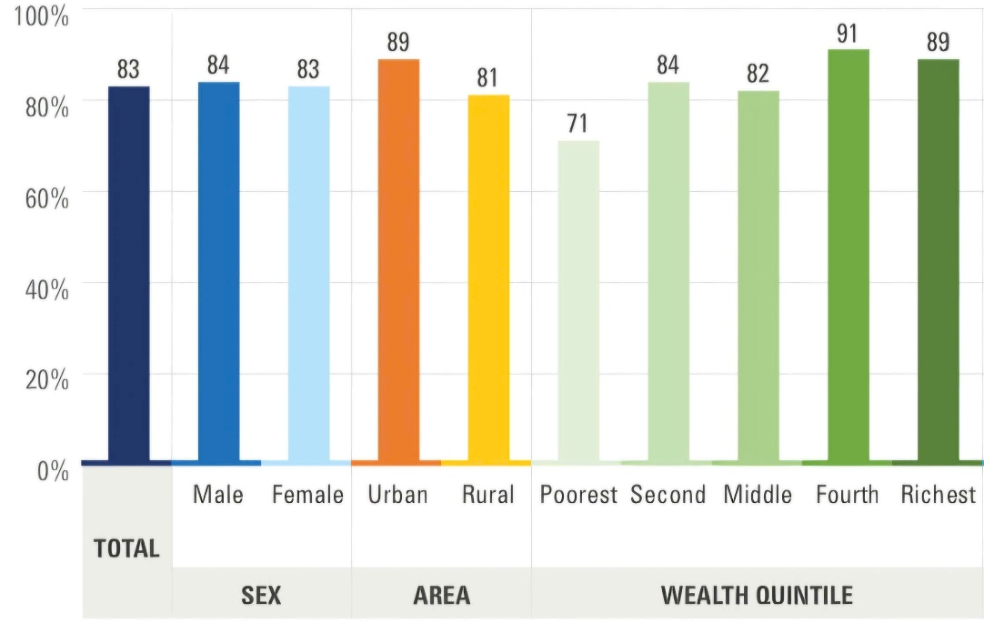
Table 2: Share of children aged 7 to 14 with foundational numeracy skills
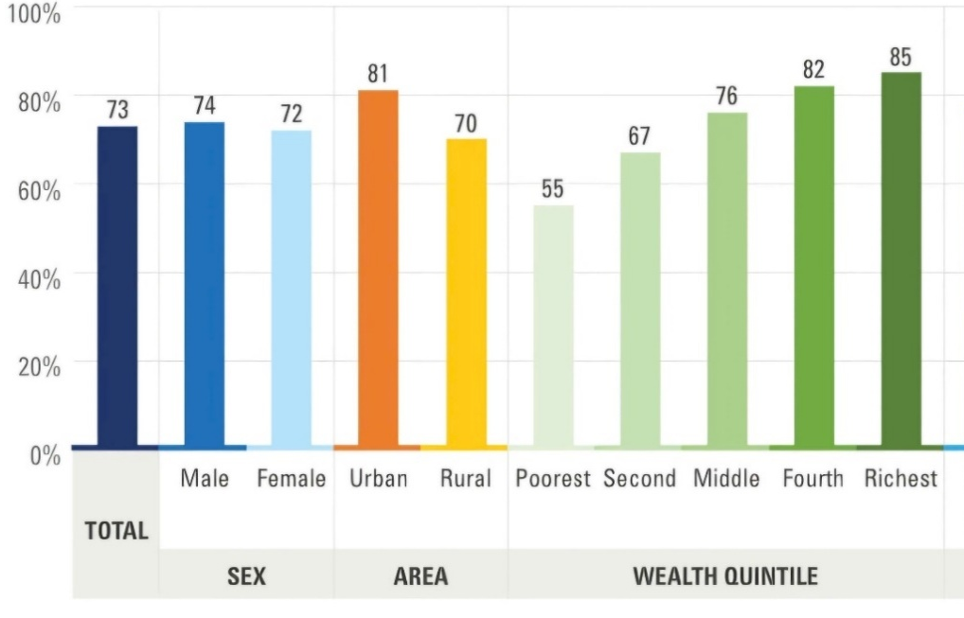
………………………………………………………………………………………………………….
………………………………………………………………………………………………………….
………………………………………………………………………………………………………….
………………………………………………………………………………………………………….
………………………………………………………………………………………………………….
………………………………………………………………………………………………………….
………………………………………………………………………………………………………….
………………………………………………………………………………………………………….
………………………………………………………………………………………………………….
………………………………………………………………………………………………………….
………………………………………………………………………………………………………….
………………………………………………………………………………………………………….
………………………………………………………………………………………………………….
………………………………………………………………………………………………………….
………………………………………………………………………………………………………….
………………………………………………………………………………………………………….
………………………………………………………………………………………………………….
………………………………………………………………………………………………………….
………………………………………………………………………………………………………….
………………………………………………………………………………………………………….
………………………………………………………………………………………………………….
………………………………………………………………………………………………………….
………………………………………………………………………………………………………….
………………………………………………………………………………………………………….
………………………………………………………………………………………………………….
………………………………………………………………………………………………………….
………………………………………………………………………………………………………….
………………………………………………………………………………………………………….
Part 2. Write an essay of at least 300 words on the following topic.
"Soft life" refers to a growing philosophy, particularly among young people, of deliberately choosing comfort, rest, and ease over ambition and struggle.
Some see "Soft life" as a healthy rejection of toxic productivity. Others argue it cultivates passivity and unpreparedness for life's inevitable hardships. A third view suggests it is an aspiration only accessible to the privileged, making it an exclusionary ideal.
Which view(s) do you agree with? Provide specific reasons and examples to support your answer.

………………………………………………………………………………………………………….
………………………………………………………………………………………………………….
………………………………………………………………………………………………………….
………………………………………………………………………………………………………….
………………………………………………………………………………………………………….
………………………………………………………………………………………………………….
………………………………………………………………………………………………………….
………………………………………………………………………………………………………….
………………………………………………………………………………………………………….
………………………………………………………………………………………………………….
………………………………………………………………………………………………………….
………………………………………………………………………………………………………….
………………………………………………………………………………………………………….
………………………………………………………………………………………………………….
………………………………………………………………………………………………………….
………………………………………………………………………………………………………….
………………………………………………………………………………………………………….
………………………………………………………………………………………………………….
………………………………………………………………………………………………………….
………………………………………………………………………………………………………….
………………………………………………………………………………………………………….
………………………………………………………………………………………………………….
………………………………………………………………………………………………………….
………………………………………………………………………………………………………….
………………………………………………………………………………………………………….
………………………………………………………………………………………………………….
………………………………………………………………………………………………………….
………………………………………………………………………………………………………….
………………………………………………………………………………………………………….
………………………………………………………………………………………………………….
………………………………………………………………………………………………………….
………………………………………………………………………………………………………….
………………………………………………………………………………………………………….
………………………………………………………………………………………………………….
………………………………………………………………………………………………………….
………………………………………………………………………………………………………….
………………………………………………………………………………………………………….
………………………………………………………………………………………………………….
………………………………………………………………………………………………………….
………………………………………………………………………………………………………….
………………………………………………………………………………………………………….
………………………………………………………………………………………………………….
………………………………………………………………………………………………………….
………………………………………………………………………………………………………….
………………………………………………………………………………………………………….
………………………………………………………………………………………………………….
………………………………………………………………………………………………………….
………………………………………………………………………………………………………….
………………………………………………………………………………………………………….
………………………………………………………………………………………………………….
………………………………………………………………………………………………………….
………………………………………………………………………………………………………….
………………………………………………………………………………………………………….
………………………………………………………………………………………………………….
………………………………………………………………………………………………………….
………………………………………………………………………………………………………….
………………………………………………………………………………………………………….
………………………………………………………………………………………………………….
………………………………………………………………………………………………………….
………………………………………………………………………………………………………….………………………………………………………………………………………………………….
………………………………………………………………………………………………………….
………………………………………………………………………………………………………….
………………………………………………………………………………………………………….
………………………………………………………………………………………………………….
………………………………………………………………………………………………………….
(You may write overleaf if you need more space)
Great appreciation to authors of published works of which adaptations have been made in this test paper!
-----------------------HẾT-----------------------

