Mã đề 6.2.68 | ĐỀ KIỂM TRA HỌC KỲ II  Năm học 2022– 2023  Môn: TIẾNG ANH 6  Thời gian làm bài: 60 phút
A. LISTENING:
I. Listen and stick the box. (1.0 pt)

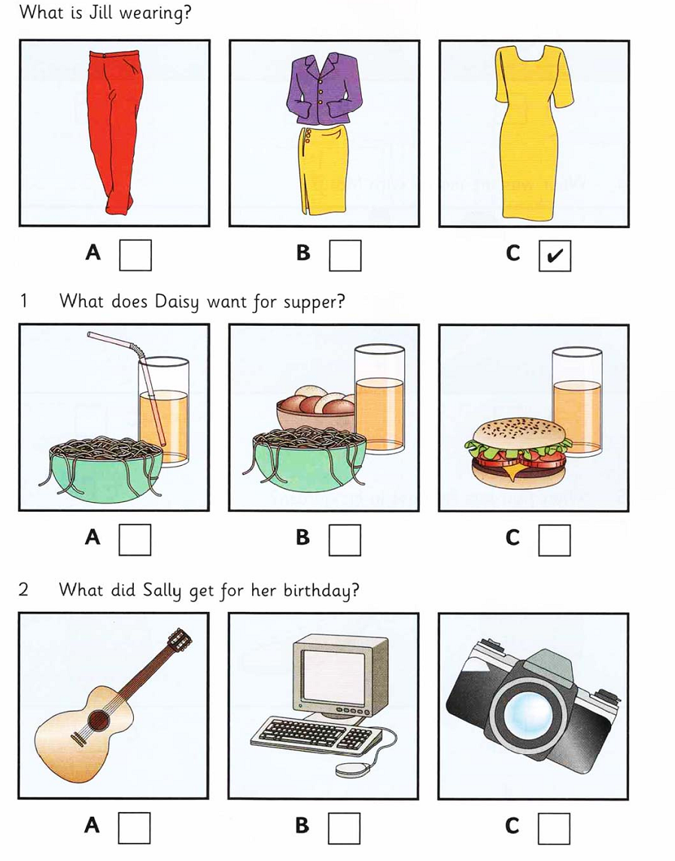

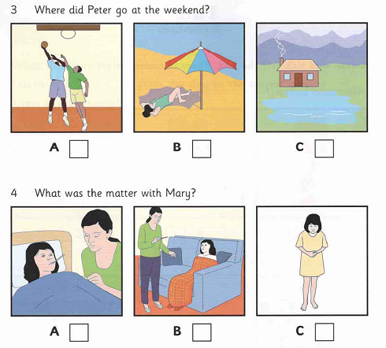
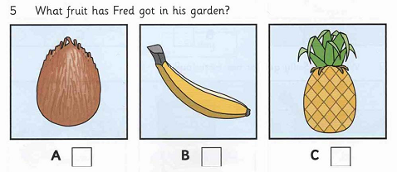

1. NB……, 2. NB……, 3. NB……., 4. NB ……., 5. NB……..

II. Listen and write. (1.0 pt)
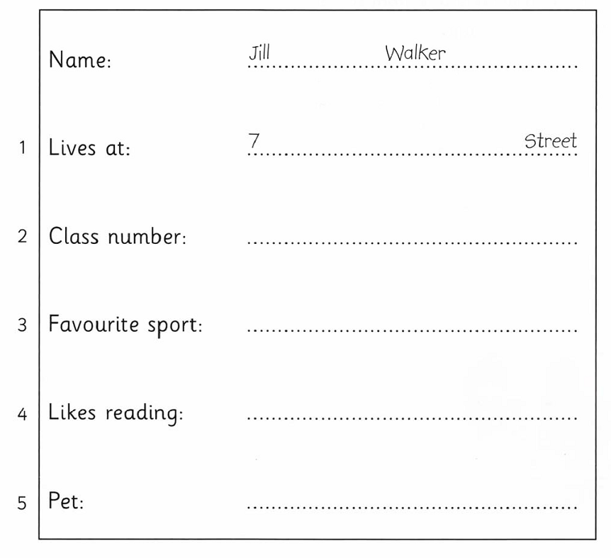 | NB  TH  TH  VD  VD
B. READING
I. Choose the word or phrase that best fits the blank space in each sentence (2 pts)
1. Odd one out : A. postcard B. town C. coast TH
2. That channel is popular. It attracts many ______________ NB
A. viewers B. characters C. games
3. ……….._days do you go to class? + I go to class five days a week. NB
A. How B. How often C. How many
4.What’s your favorite ___________? - I like swimming. NB
A. subject B. game C. sport
5. We use rackets to play_____________ TH
A. swimming B. cycling C. badminton
6. We ___________to Ho Chi Minh for our last summer vacation. NB
A. go B. went C. will go
7. …………….Liz buy a lot of souvenirs for her friends? NB
A. Did B. Do C. Were
8. This computer game belongs to me and my brother. This computer game is ________. TH
A. us B. ours C. we’re
9. …………._ is the symbol of Singapore. NB
A. Big Ben B. Merlion C. Eiffel Tower
10. Our team won the game yesterday. TH
A. That's a good idea. B. Congratulations! C. I know it.

II. Read the passage and choose the best option (1.0 pt)
Hoi An is one of the (1) ................. towns in Viet Nam. It (2) ................. on the lower section of the Thu Bon river. It is a very beautiful town with a lot of colour lanterns which are hung around the town. Hoi An is famous for one- day tailoring. Customers order clothes (3) ................. the morning and get them in the evening. The price is not really (4) ................. . If you want to find the place of the old time, Hoi An is a (5).............. choice.
1. A. newer B. newest C. oldest TH
2. A. are B. is C. are being NB
3. A. at B. in C. on NB
4. A. expensive B. cheap C. more expensive NB
5. A. good B. best C. bad TH
III. Read the passage and do the tasks below. (1.0 pt)
WHO WANTS TO BE A MILLIONAIRE?
One of the most popular quiz programmes on television in the world is called Who Wants To Be A Millionaire? In Britain, the quiz master is Chris Tarrant. He asks the contestants fifteen questions. The first questions are easy but later they are more difficult. If you can answer the fourteenth question, you can win £500,000. You can win a million pounds if you can answer the last question. Of course, the last question is very difficult.
All the questions on Who Wants To Be A Millionaire? are multiple-choice questions. After you hear the question, you see four answers. Only one answer is correct. You have to choose the correct answer. If you don’t know the answer to a question, there are three ways you can get help: you can ask the quizmaster to take away two wrong answers; you can ask the studio audience which answer is right; or you can telephone a friend and ask for help. You can only do these things once. Very few people win the million pounds. The first person won a million pounds one year after the programme started.
Today, Who Wants To Be A Millionaire? can be seen in more than 100 countries and is now the world’s most popular quiz programme.
1. Who is the quizmaster in Britain? TH
A. Chris Tarrant B. Chris Tarrante C. Peter Tarrant
2. How many questions do you have to answer? TH
A. 13 B. 14 C. 15
3. How much do you win for the fourteenth question? VD
A. 300.000 B. 400.000 C. 500.000
4. How many ways can you get help? NB
A. two B. three C. four
5. Who Wants To Be A Millionaire is famous............... VD
A. all over the world B. in Britain C. in Viet Nam
D. WRITING.
Choose the best answer (0,4 pt)
1. It started raining an hour ago. NB
A, It has rained for an/one/a hour.
B, It rained an/ one/ a hour ago.
C, It rained for an/ one/ a hour.
2. Nobody in our class is taller than Nga. NB
A, Nga is as tall as every one.
B, Nga is the tallest in our class.
C, Nga is taller than others.
Rewrite each sentence so that it means the same as the first. (0,6 pt)
3. My house is behind the post office.
→ The post office ............................................................................ VD
4. Let’s go swimming.
→ What about...................................................................................? VD
5. What is the price of a cake and an orange?
- How ..........................................................................................? VD
II. Imagine you are visiting a place in Vietnam. Write a postcard to your friend using suggestions. (1 pt) VDC
1- Where are you now? Where are you staying?
2- What's the weather like? What is the food like?
3- What have you seen or done?
4- What will you do next?
5- How do you feel?

V. SPEAKING
1. Introduction:
Introduce yourself with basic information (name, class, age, hobby, family, etc.) (0.5 point)
2. Each of you will now receive a card. On the card there is a picture and clues for five questions. You should use the words to make questions and ask your friend. Your friend will answer the questions based on the picture he/she has. (0.5 point)
Use the words given below to make questions. Ask your friend about his/her picture and listen to the answers.
- You / see/ people/ picture?
- Where/they?
- What/they/do?
- What /see / picture?
- You/like the picture? Why/Why not?

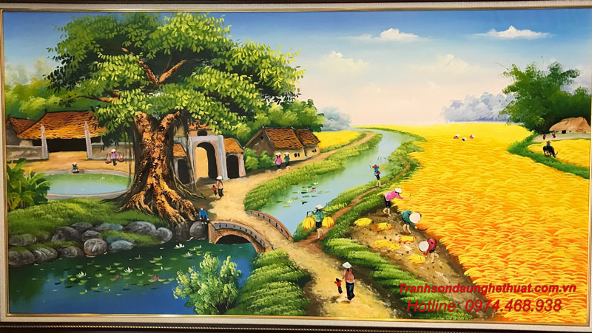
3. Answer further questions (1 point)
- Where is your neighborhood?
- What are there in the area?
- What are your favorite places in the area?
- What don’t you like about the area?
- What would you like to change about your neighborhood?

PHÒNG GD&ĐT NINH GIANG | HƯỚNG DẪN CHẤM KIỂM TRA HỌC KỲ II NĂM HỌC 2022 - 2023  MÔN: TIẾNG ANH 6

Câu | Đáp án | Điểm
A  ( 2 điểm) | I. ( 1 điểm)  - A 2. C 3. C 4. B 5. C | 0.2 điểm/ câu
A  ( 2 điểm) | II. ( 1 điểm)  1. Main 2. 4b 3. hockey 4. comics 5. snake | 0.2 điểm/ câu
B  (3 điểm) | I. ( 1 điểm)  1. F 2. A 3. G 4. C 5. B | 0.2 điểm/câu
B  (3 điểm) | II. ( 1 điểm)  1. C 2. B 3. B 4. A 5. A | 0.2 điểm/câu
B  (3 điểm) | III. ( 1 điểm)  1. A 2. C 3. C 4. B 5. A | 0.2  điểm/câu
C  (3 điểm) | Tổng 1.5 điểm. Mỗi câu đúng 0.3 đ  1. It has rained an hour ago  2. Nga is the tallest in her class  3. The post office is in front of my house.  4. What about going swimming?  5. How much is a cake and an orange? | 1.5 điểm  0.3x5
C  (3 điểm) | Tổng 1.5 điểm. Bài viết bao quát được các ý sau:  - Opening  - Weather/ food/ hotel  - An overall feeling about the place  - What you have seen/done  - What will you do next  - closing | 0.2  0.6  0.2  0.2  0.3

