School: …………………………………………………..  Class: ……………………………………………………..  Full name: ………………………………………………. | Mark:

SPEAKING TEST 1 (SEMESTER 1)
(UNITS 1 & 2)

TASK 1 |  |  | Let’s talk about your town or city.  The following questions may help you.
 | 1. | Where is your town/ city?
 | 2. | What is your town/ city like?
 | 3. | What are the places of interest in your town/ city?
 | 4. | Where in your town/ city do you often spend your free time?
 | 5. | What do you often do to keep your town/ city clean and green?

TASK 2 | Work in pairs. Each of you receives a card. Use the clues on your card to make questions about your friend’s picture. Use the picture on your card to answer your friend’s questions.

CARD A
Ask your friends about his/ her picture. Listen to his/ her answers. |  | 
1. | What/ you/ like/ do/ leisure time?
2. | How often/ do/ this activity?
3. | Who/ do this activity/ with?
4. | What / need/ do this activity?
5. | What/ are/ its benefits?
 |  | Answer your friend’s questions about this picture.

CARD B
Ask your friends about his/ her picture. Listen to his/ her answers.

1. | What/ you/ like/ do/ leisure time? | 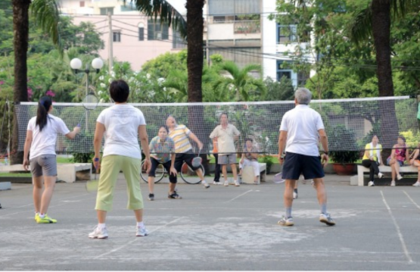
2. | How often/ do/ this activity?
3. | Who/ do this activity/ with?
4. | What / need/ do this activity?
5. | What/ are/ its benefits?
 |  | Answer your friend’s questions about this picture.

