School: ……………………………………….. | Date:……………………………………..
Class: ……………………………..................... | Period: …………………………….........

UNIT 3: PROTECTING THE ENVIRONMENT
Lesson 1.2 - Grammar (Page 25 & 26)

I. OBJECTIVES
By the end of the lesson, Ss will be able to:
1.1. Language knowledge and skills
- use First Conditional to talk about future situations.
- distinguish the differences between “if” and “unless”.
1.2. Competences
- improve communication, collaboration, critical thinking
1.3. Attributes
- be aware of the causes and effects of pollution.
II. TEACHING AIDS AND LEARNING MATERIALS
1. Teacher’s aids: Student book and Teacher’s book, class CDs, Digital Book (DCR phần mềm tương tác SB, DHA (từ vựng/ cấu trúc) phần mềm trò chơi tương tác), projector/interactive whiteboard / TV (if any), PowerPoint slides, handouts.
2. Students’ aids: Student’s book, Workbook, Notebook.
III. ASSESSMENT EVIDENCE
Performance Tasks | Performance Products | Assessment Tools
- Read and fill in the blanks.  - Listen and repeat.  - Read and fill in the blanks with correct form of the verbs.  - Look and write First Conditional sentences.  - Ask your partner about the activities in task c. | - Ss’ answers.  - Ss’ performance.  - Ss’ answers.  - Ss’ answers/ presentation.  - Ss’ presentation | - T’s feedback.  - T’s feedback/Peers’ feedback.  - T’s feedback/Peers’ feedback.  - T’s observation, T’s feedback/Peers’ feedback.  - T’s observation, T’s feedback/Peers’ feedback.
IV. PROCEDURES
A. Warm up: (5’)
a) Objective: To introduce the new lesson and set the scene for Ss to acquire new language; get students' attention at the beginning of the class by enjoyable and short activities as well as to engage them in the follow-up steps.
b) Content: review present simple and future simple tenses.
c) Expected outcomes: Ss can make their own sentences with the use of Present Simple and Future Simple tenses.
d) Organization of the activity:
TEACHER’S ACTIVITIES | STUDENTS’ ACTIVITIES
- Option 1: Unscramble letters  - Give a list of some nouns whose letters are unscramble, have Ss work in groups of 4 to write the correct words and then make sentences with those words in Present Simple tenses and Future simple tenses.  - Call Ss to give answers.  - Check Ss’ answers, give feedback.  *Noun list: pollution, environment, air, health, wildlife, disease.  → Lead to the new lesson  - Option 2: Unscramble words  - Give a list of some disorder words, have Ss divide them into groups of 4.  - Ask them to put sentences in correct order.  - Call Ss to give answers.  - Check Ss’ answers, give feedback.  * Unscramble sentences:  1. tourism/pollution/affects.  2. better and better/be/will/environment.  3. fresh air/usually/has/countryside.  4. your health/eating apples/for/is.  5. animals/home/for/wildlife/is.  → Lead to the new lesson. | - Work in groups.  - Write answers.  Possible answers from the students  1. Pollution affects tourism.  2. Environment will be better and better.  3. Countryside usually has fresh air.  4. Eating apples is good for your health.  5. Wildlife is home for animals.  - Work in groups.  - Read or write answers.  Possible answers from the Ss  1. Pollution affects tourism.  2. Environment will be better and better.  3. Countryside usually has fresh air.  4. Eating apples is good for your health.  5. Wildlife is home for animals.

B. New lesson (35’)
- Activity 1: Presentation (10’)
a) Objective: Introduce the First Conditional sentences, the differences between “if” and “unless”.
b) Content: Listen and repeat. Go through the grammar point.
c) Expected outcomes: Ss can make their own sentences with the use of First Conditional and use it in some following exercises.
d) Organization of the activity:
TEACHER’S ACTIVITIES | STUDENTS’ ACTIVITIES
Task a. Read about First Conditional with “if” or “unless”, then fill in the blanks  - Have Ss look at the picture (using DCR).  - Play audio (CD1 – Track 14) and have Ss listen and read the speech bubbles.  - Play the audio again and have Ss listen and repeat.  Grammar box  - Option 1:  - Have Ss look at the grammar explanation meaning and form (using DCR).  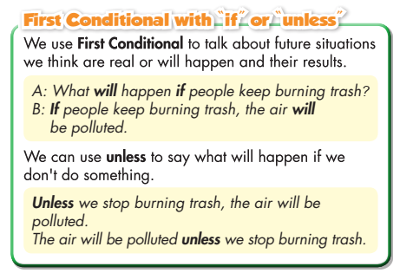  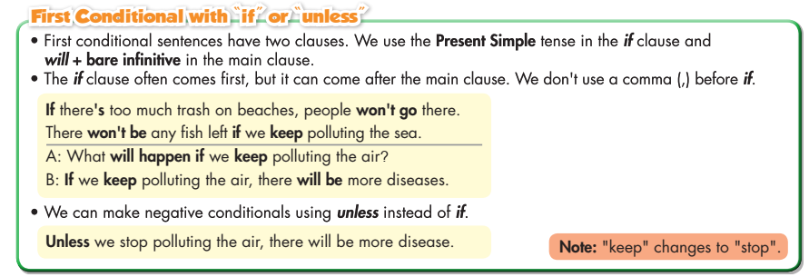  - T emphasizes the use of First Conditional sentence.  - Ask Ss to fill in the blanks.  - Option 2:  - Have Ss close books.  - Give some model sentences in if clause (the causes), ask Ss to make main clause (the effects).  Examples:  - If I turn off the fan, …  - If I don’t eat dinner, ……  - If I don’t do my homework, ….  - Then have Ss pay attention to if and main clause.  →Introduce: First Conditional sentences.  - Show grammar box, have Ss look and read, then fill in the blanks  - Give feedback and evaluation. | - Look.  - Listen, then read.  - Listen and repeat.  - Look and read.  - Listen.  - Work individually  Answers  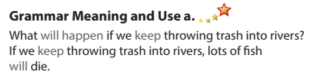  - Close all books.  - Look and give answers.  Possible answers from the Ss  - If I turn off the fan, it will be hot.  - If I don’t eat dinner, I will be hungry.  - If I don’t do my homework, I will be punished.  - Look and read, then fill in the blanks  Answers
- Activity 2: Practice (19’)
a) Objective: Students can use First Conditional with “if” or “unless” to do the given exercises.
b) Content:
- Fill in the blanks with the correct form of the verbs in brackets.
- Look at student’s notes and write First Conditional sentences.
c) Expected outcomes: Students can get used to the use of the First Conditional and use them correctly.
d) Organization of the activity:

TEACHER’S ACTIVITIES | STUDENTS’ ACTIVITIES
Task a. Read and fill in the blanks with the correct form of the verbs in brackets to make First Conditional sentences.  - Demonstrate the activity, using the example (using DCR).  - Have Ss read the sentences and write the correct form of verbs.  - Have Ss work in pairs to check each other’s work.  - Have some Ss share their answers with the whole class.  - Give feedback, correct Ss’ answers if necessary.  Task b. Look at student’s notes and write First Conditional sentences using “if” or “unless” clauses.  - Demonstrate the activity, using the example (using DCR).  - Have Ss look at the notes and write the questions.  - Have Ss check answers with their partners.  - Call Ss to write answers.  - Check Ss’ answers, give feedback and evaluation. | - Look and listen.  - Work individually.  - Work in pairs.  - Read answers.  Answer keys  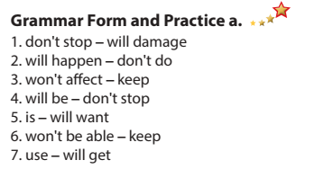  - Look and listen.  - Work individually.  - Work in pairs.  - Write answers.  Answer keys  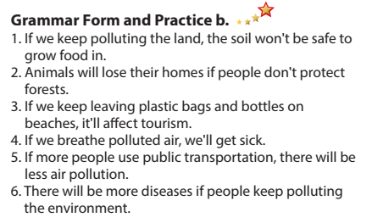

- Activity 3: Production (6’)
a) Objective: Students master the grammar point they study in the lesson.
b) Content: Speaking: Discuss with your partner about the activities in Task c.
c) Expected outcomes: Ss produce the new language successfully, and they can use First Conditional in everyday speaking and writing.
d) Organization of the activity:
TEACHER’S ACTIVITIES | STUDENTS’ ACTIVITIES
Task d. In pairs: Make First Conditional sentences using the prompts and “if” or “unless”  - Divide class into pairs.  - Have Ss discuss about conditional clause and main clause.  - Have some pairs tell the answers in front of the class.  - Give feedback and evaluation.  - For more practice, have Ss play a game, using DHA. | - Have discussion in pairs.  - Present.  - Listen.

C. Consolidation and homework assignments (5’)
* Consolidation:
- First Conditional with “if” or “unless”.

* Homework:
- Make 3 sentences, use First Conditional with “if” or “unless”.
- Do the exercises in WB: Grammar (page 15).
- Play the consolidation games in Tiếng Anh 8 i-Learn Smart World DHA App on www.eduhome.com.vn
- Prepare: Lesson 1 – Pronunciation and Speaking (pages 26 & 27 – SB).

V. REFLECTION
a. What I liked most about this lesson today:
…………………………………………………………………………………………
- What I learned from this lesson today:
…………………………………………………………………………………………
c. What I should improve for this lesson next time:
…………………………………………………………………………………………

