Tiếng Anh 7 – i-LEARN SMART WORLD

MIDTERM TEST – SEMESTER 2
Note: Each correct answer earns 0.2 points.

I. PRONUNCIATION (0.8 points)
A. Choose the word whose underlined part is pronounced differently.
1. A. annoyed B. balloon C. passport D. abroad
2. A. buses B. bicycles C. clothes D. rules
B. Choose the word that has a different stressed syllable from the rest.
3. A. suitcase B. although C. ticket D. subway
4. A. decorate B. educate C. uniform D. discover

II. VOCABULARY AND GRAMMAR (2.4 points)
Choose the best option (A, B, C or D) to complete each of the following questions.
5. I never take the bus because buses are __________ than any other transport in my town.
A. as slow B. slower C. more slow D. much slow
6. When I go hiking, I often take some food and water in my ________.
A. luggage B. wallet C. suitcase D. backpack
7. The teacher was __________ because some students were talking in class and weren’t paying attention to the lesson.
A. pleased B. excited C. annoyed D. delighted
8. I’m not going out tonight; I have a lot of math __________ to do.
A. homework B. tests C. reports D. essays
9. Student A: Where’s Andy? Can you see him?
Student B: Over there! He’s the boy with a _________ bag.
A. big light brown new B. big new light brown
C. new big light brown D. big light new brown
10. Peter _________ likes his school because he has a lot of friends there and the teachers don’t give him too much homework.
A. so B. much C. really D. a lot
11. Person A: Excuse me, is this suitcase _______?
Person B: No, it’s not _________.
A. yours / mine B. your / mine C. your / my D. you / me
12. I think people should cycle more. It’s more __________ because it doesn’t cause air pollution.
A. frequent B. convenient C. useful D. eco-friendly
13. He lost his __________, so he had to contact the embassy. He needs it to fly back to his home country.
A. ticket B. passport C. baggage D. boarding
14. Student A: Let’s go bowling tonight. There’s a new bowling alley near my house.
Student B: _________. I have to finish my book report.
A. I’d love to B. It will be fun C. Sure, thank you D. I’m sorry I can’t

15. What does that sign mean?
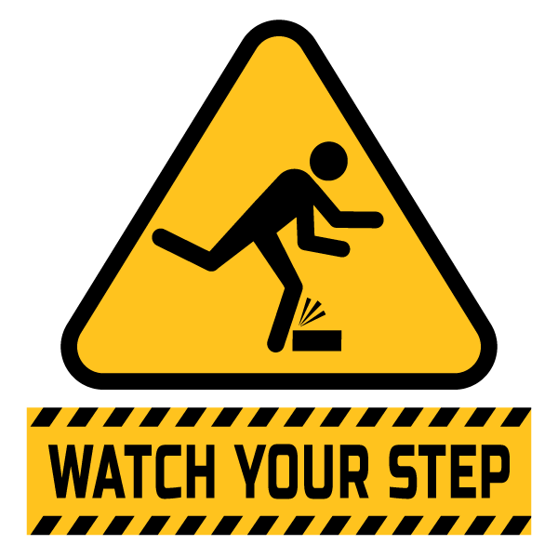 | A. Be careful! People are watching your step.  B. You have to look at the way you step.  C. You should be careful when you are walking.  D. You have to look at your feet when you are walking.

16. What does this sign mean?
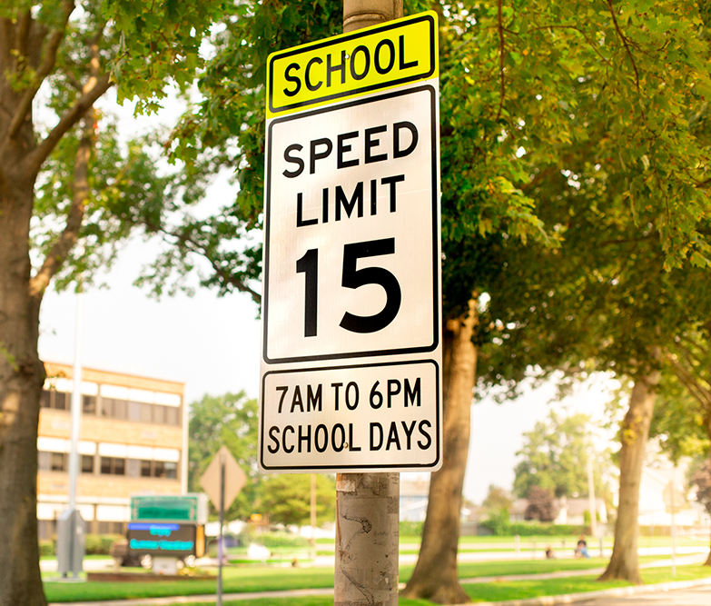 | - You must drive faster than 15km/h in the school zone.  - Students should be at school from 7 a.m. to 6 p.m.  - The speed limit is not for weekends.  - Students shouldn’t drive on school days.

III. WORD FORMATION (1.2 points)
Write the correct form of the words in brackets.
17. Timothy was __________ at the result of his geography test. (DISAPPOINT)
18. Ben came top of the class in all subjects and his parents were so ___________. (SURPRISE)
19. Traveling around the UK by train is a fast and __________ way to explore the country. (COMFORT)
20. Although I prepared carefully, I got nervous when giving my __________. (PRESENT)
21. Studying abroad makes you more __________ and open to new experiences. (DEPEND)
22. During the Lazarim Carnival in Portugal, there are singing __________. (COMPETE)

IV. LISTENING (2 points)
A. You will listen to a conversation. For each question, complete the notes with NO MORE THAN TWO WORDS.
The teacher, Ms. Johnson, enjoyed Jimmy’s (23)____________ on a story about a young girl named Bria who travels to South America. The story reminded the teacher about when she got to (24)____________ in Brazil.
The teacher told Jimmy he would need to (25)____________ a test to get accepted to the school. Jimmy thought his parents would be so (26)____________ to hear about this news. The teacher also told Jimmy to study (27)____________ and finish all his homework to get good grades.
B. You will listen to a conversation. For each question, circle the correct option A, B, C, or D.
28. What is this vlog about?
A. transportation that protects the environment B. transportation that is comfortable
C. David’s trip to Japan D. Japan’s public transportation

29. What type of transportation is the maglev?
A. bus B. car C. plane D. train

30. Why is the maglev comfortable to ride?
A. It is always on time. B. It feels like riding on air.
C. It is near the city. D. It goes fast.

31. How fast can the maglev train go?
A. 400 kilometers per hour B. 100 kilometers per hour
C. 500 kilometers per hour D. 300 kilometers per hour

32. What makes the maglev reliable?
A. It is always on time. B. It is near the city.
C. It goes fast. D. It feels like riding on air.

V. READING (2 points)
A. Read the following passage. For each question, circle the correct option A, B, C, or D that best suits each blank.
This story is about how my (33)______ got lost on vacation. Last summer, I took an airplane to the Bahamas. I heard that airports are not always reliable and sometimes lose luggage. So, I put all my clothes in a (34)______ suitcase that would stand out from the others, and I put my phone and camera in a small backpack to take on the plane. I checked in my suitcase using my boarding pass and got on the plane. When the plane landed, I went to the (35)______ area to pick it up. I waited and waited, but it never came. I went to customs and showed them my (36)______ and asked them about my suitcase, but they had not seen it. I looked everywhere. Luckily, I still had my (37)______ with my phone in it. I was able to use it to call the airline and find my missing suitcase.

33. A. boarding pass B. luggage C. backpack D. phone
34. A. old pink large B. large pink old C. pink large old D. large old pink
35. A. baggage claim B. customs C. ticket counter D. airport
36. A. phone B. passport C. camera E. ticket
37. A. luggage B. suitcase C. backpack D. wallet
B. Read the following passage. For each question, write T if the statement is TRUE, F if the statement is FALSE, and NI if there is NO INFORMATION.
Journal Entry 15/07/2020
by Jennifer

I just returned home from a year of studying abroad in America. It's only been a few days, and I am already missing my new friends. I will have to keep in touch and follow them on social media because they were fun to play with and helped me in school. Sometimes, they would see that I would get really annoyed when I failed my tests, so they started helping me with my homework. I was lucky to have such great friends. Studying abroad was good because it showed me how hard work pays off, although it wasn't always easy. One time, I remember how disappointed my mom was when I told her I did not pass my science test. But, after lots of practice, my English improved, and I started to do better on my tests, which pleased her.

38. Jennifer started missing her new friends a year after returning home. ____
39. Jennifer was lucky to have great friends who helped her in school. ____
40. One way Jennifer improved her English was by watching movies. ____
41. Jennifer’s mom was disappointed when she failed her science test. ____
42. Studying abroad was easy for Jennifer, and she did not need help from her friends. ____

VI. WRITING (1.6 points)
A. Rewrite the following sentences without changing their meaning. Use the given word(s) if any.
43. The English exam wasn’t as easy as I thought. (DIFFICULT)
→ The English exam was .
44. Ivy studied a lot for her biology test. However, she didn’t pass it.
→ Although .
45. It’s the rules to remove your shoes and belts when you go through the airport security checkpoint.
→ You .
46. It’s not necessary for Laura to take part in the sports day if she doesn’t want to.
→ Laura .
B. Use the given words or phrases to make complete sentences.
47. Jack / pleased / because / he / get / A / biology test.
→
48. Trains / be / most popular form / public transport / the United Kingdom.
→
49. Riding / bike / fast / go / bus / in rush hours.
→
50. Tommy / not have / as much / homework / his sister.
→

***End – Of – Test***

