TRƯỜNG THCS VÕ THÀNH TRANG  Họ và tên: ________________________  Lớp : ___________ | KỲ THI THỬ TUYỂN SINH LỚP 10 NĂM HỌC 2025- 2026  MÔN: TIẾNG ANH 9  Ngày:……………..  Thời gian làm bài: 90 phút  (Không kể thời gian phát đề)
------------------------------------------------------------------------------------------------------------------------------
ĐIỂM : | Chữ ký giám khảo | Chữ ký giám thị
Điểm phần I | Điểm phần II | Điểm phần III | Điểm phần IV | Điểm phần V | Điểm phần VI | Điểm phần VII | Điểm tổng

- Choose the word or phrase (A, B, C or D) that best fits the space or best answers the question given in each
sentence. (3.5 pts.)
(Từ câu 1 đến câu 14, thí sinh viết mẫu tự (A, B, C hoặc D) đại diện cho câu trả lời đúng vào Phần
ANSWERS).

1. _
2. _
14.
13.
12.
11.
10.
9.
8.
7.
6.
5.
4.
3.
ANSWERS
- Which word has the underlined part pronounced differently from that of the others?
A. coughed B. wicked C. knocked D. helped
2. Which word has the underlined part pronounced differently from that of the others?
A. kindergarten B. industry C. windy D. kindness
- Which word has a different stress pattern from that of the others?
A. mechanic B. media C. vitual D. specialist
- Which word has a different stress pattern from that of the others?
A. decide B. postpone C. delay D. bother
- Mary: “Are you writing to your family?”
Tyler: “Yes, I’m sending my mom a postcard _______ I bought at the aquarium.”
A. where B. whom C. who D. which
- Doctors suggest Nga 8-10 hours of sleep a night.
A. getting B. to get C. get D. gets
- Following a zero-waste lifestyle, she not only reuses plastic bottles and bags, but also buys products_________packaging.
A. up B. of C. about D. without
- She is tired ________ she stayed up late doing her homework.
A. as B. but C. so D. and
- A: “Would you like to come to my birthday party next weekend? I’m sure you will make a lot of
friends there.” – B: “Thanks for your invitation. ________, and I’ll call you later.”
A. It’s nice of you to say so B. Have you thought of the party
C. Never mind D. Let me give it some thought
- I don’t think it’s worth ____________ money on rip-offs.
A. spend B. to spend C. spending D. Spent
FB: Thầy Đình (Dạy Tiếng Anh)
- Nowadays, most people live in ________ family with only parents and chidren.
A. extended B. nuclear C. single D. traditional
- Mike: Can you _______ what it would be like to live in a remote area without Wi-Fi?
Jess: Oh, that would be awful! I couldn't survive without it!
A. speak B. advise C. imagine D. understand
- I in the same company since I lived in Ha Noi.
A. work B. worked C. have worked D. working
- We use a huge amount of _________________ in the office every day.
A. paper B. pens C. office supplies D. materials

 ----------------------------------------------------------------------------------------------------------------------------
- Look at the signs. Choose the best answer (A, B, C or D) for questions 15 and 16. (0.5pt.)
(Từ câu 15 đến câu 16, thí sinh chỉ viết mẫu tự (A, B, C hoặc D) đại diện cho câu trả lời đúng vào Phần
ANSWERS)
- What does the sign mean?    - What does the notice mean?  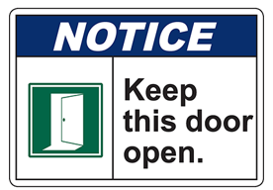 | A. No sleepwalkers allowed.  B. No chewing-gum allowed.  C. No spitting allowed.  D. No singing allowed.  A. Leave the door open.  B. Don’t leave the door unclosed  C. Don’t let the door hit you.  D. This door mustn’t be used. |  | ANSWERS  15.  16.
- Choose the word (A, B, C or D) that best fits the space in the following passage. (1.5 pts.)
(Từ câu 17 đến câu 22, thí sinh chỉ viết mẫu tự (A, B, C hoặc D) đại diện cho câu trả lời đúng vào Phần
ANSWERS)
Fifty-nine couples in Thailand got married while riding elephants on Sunday, in an annual Valentine’s Day mass wedding (17) _________ at a botanical garden in a province east of Bangkok.
22.
21.
20.
19.
18.
17.
ANSWERS
Dancers and a band led the procession of elephants and couples and a (18) ________ official, also on an elephant, oversaw the signing of the marriage license.
“For me, I’ve been planning for a long time that if I were to sign a marriage license one day, it must be an extraordinary event,” said groom Fatiphat Panthanon, sitting beside his (19) _________ bride.
The elephant-back wedding is an annual event at the Nong Nooch Tropical Garden in Chonburi province which usually attracts up to a hundred couples. But this year (20) _________ the coronavirus pandemic, the numbers were down.
Kampon Tansacha, president of the Nong Nooch Tropical Garden, said that due to strict screening protocols for visitors, people were feeling (21) _________ and have started to come back to visit the botanical park, (22) _______ showcases recreations of landscaped gardens from around the world.
FB: Thầy Đình (Dạy Tiếng Anh)

17. A. celebration B. anniversary C. ceremony D. party
18. A. local B. locally C. locals D. locality
19. A. 23-years-old B. 23-year-olds C. 23-year-old D. 23 years of age
20. A. due to B. in spite of C. although D. thanks to
21.A. safety B. safely C. unsafe D. safer
22. A. where B. which C. what D. that

 ----------------------------------------------------------------------------------------------------------------------------
- Read the following passage. Decide if the statements from 23 to 26 are True or False and choose the correct answer (A, B, C or D) for the questions 27 and 28. (1.5 pts.)(Từ câu 23 đến câu 26, thí sinh viết đúng từ True hoặc False và viết đáp án đúng (A, B, C hoặc D) cho câu 27 và 28 vào Phần ANSWERS)
Thanksgiving is one of the major holidays of Catholics celebrated annually mainly in the US and Canada to thank that God has given them in the past year. In fact, the original meaning of Thanksgiving day was to celebrate the harvest and thank God for a full and peaceful life, but gradually, the meaning of this holiday has become more human. On this national holiday, American people give gifts, cards or best wishes to those who have helped them over the past year.
In the US, Thanksgiving is celebrated on the fourth Thursday in November while Canadians celebrate it on the second Monday of the month.
Like Christmas, Thanksgiving is a time Americans spend with their families. On this day, families hold a big party at home. Roasted turkey or turkey served with gravy sauce, baked cowpeas, pumpkin pie is a must-have.
In addition to traditional dishes, a number of special activities like parades or football matches are also held. Right after Thanksgiving ends, Friday becomes a shopping day. This day is very famous around the world as Black Friday. On this day, stores launch biggest discounts of the year, attracting millions of shopaholics who have lined up since the night before to buy their favorite items at a price that could not be cheaper.
23. US residents celebrate Thanksgiving every year
24. American people always give gifts, money and best wishes to those who have helped them over the past year.
25. In the US, Thanksgiving is celebrated on the second Monday of November.
26. People hold family parties and many other activities on Thanksgiving.
27. Which of the following may be the best title for the reading passage?
A. National Holidays B. National Holiday Activities
C. Black Friday D. Holiday Foods
28. In the reading passage, all of the following are mentioned EXCEPT _____.
A. What people give B. What people eat C. What people sing D. What people do

28.
27.
26.
25.
24.
23.
ANSWERS
- Use the correct form of the word given in each sentence. (1.5 pts.)
(Từ câu 29 đến câu 34, thí sinh phải viết từ cần điền vào Phần ANSWERS bên dưới câu hỏi)

29. These beautiful girls speak English _______________. (nature)
30. People take enjoyment and __________________from their work, their families and leisure activities. (satisfy)
31. We asked for his support in the election, but he wasn't _________________to our request. (sympathy)
32. The vicinity of Dighton Rock has been ______________and furnished with parking and picnic facilities. (beauty)
33. People believe that the Internet is much more ______________than television or the press. (inform)
34. They will ________________go to school on time. (certain)
FB: Thầy Đình (Dạy Tiếng Anh)
ANSWER
29. _______________ 30. ________________ 31. ___________________
32. _______________ 33. ________________ 34. ___________________

 ----------------------------------------------------------------------------------------------------------------------------
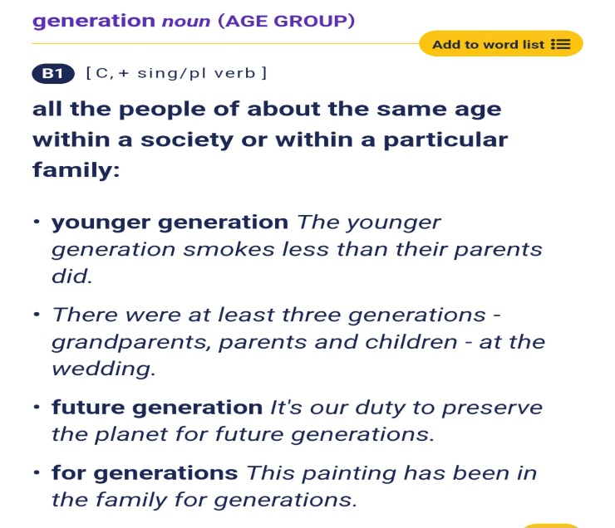
- Look at the entry of the word ‘generation’ in a dictionary. Use what you can get from the entry to complete the sentences with two or three words. (0.5p t)
- We must protect the environment to ensure better world for _________________ .
- The ____________________is more tech - savvy and adaptable to new technologies.
- Rewrite each of the following sentences in another way so that it means almost the same as the sentence printed before it. (1.0pt.)(Từ câu 37 đến câu 40, thí sinh hoàn thành phần trả lời bên dưới mỗi câu)
- Tom has never used such an interesting chat box before.
→ This is the first time .
- “Don’t go out without my permission,” Mrs Chau told the students.
→ Mrs Chau told .
- She studies hard so that she can pass the entrance exam.
→ She studies hard so as .
- Lan took care of her little sister when her mother went shopping yesterday.
→ Lan looked .
ANSWERS
- This is the first time

- Mrs Chau told

- She studies hard so as

- Lan looked

THE END OF THE TEST

