**TIẾNG ANH 9 FRIENDS PLUS**

**BÀI KIỂM TRA ĐỊNH KÌ**

**UNIT 4 – TEST 2**

**I. Pronunciation (1-4)**

**Câu 1.** Which word has the underlined part pronounced differently from that of the others?

**A.** nei**th**er  **B.** wea**th**er  **C.** sympa**th**y  **D.** fa**th**er

**Câu 2.** Which word has the underlined part pronounced differently from that of the others?

**A.** analys**ed**  **B.** surpris**ed**  **C.** stress**ed**  **D.** clos**ed**

**Câu 3.** Which word has a different stress pattern from that of the others?

**A.** restless  **B.** fearful  **C.** anger  **D.** impress

**Câu 4.** Which word has a different stress pattern from that of the others?

**A.** surprising  **B.** boredom  **C.** trouble  **D.** worry

**II. Choose the answer (A, B, C or D) that best fits the space in each question. (5-14)**

**Câu 5.** The long lecture caused a feeling of ____________ among the students. Some fell asleep.

**A.** embarrassment  **B.** concentration  **C.** excitement  **D.** boredom

**Câu 6.** The loud music can ____________ me from my homework. I prefer a quiet place to study.

**A.** concentrate  **B.** improve  **C.** distract  **D.** boost

**Câu 7.** It was ____________ when I forgot my lines in the play.

**A.** embarrassing  **B.** relaxing  **C.** exciting  **D.** calming

**Câu 8.** She was ____________ to see her friends at the party.

**A.** exciting  **B.** disgusted  **C.** annoying  **D.** surprised

**Câu 9.** You ____________ use your phone during the exam or you’ll be in trouble.

**A.** must  **B.** don’t have to  **C.** may not  **D.** mustn’t

**Câu 10.** You ____________ talk to the teacher if you don’t understand the lesson.

**A.** will  **B.** could  **C.** need  **D.** should

**Câu 11.** He ____________ finish his project by Friday. It’s his deadline.

**A.** shouldn’t  **B.** has to  **C.** have to  **D.** is able to

**Câu 12.** After practicing, she will ____________ play the piano well.

**A.** may  **B.** be  **C.** be able to  **D.** can

**Câu 13.** Everyone likes to sing ____________ to their favorite songs.

**A.** down  **B.** up  **C.** along  **D.** for

**Câu 14.** Whose suitcase is that?

**A.** I need a new shoelace.  **B.** I saw it at the store yesterday.

**C.** It’s not my hat.  **D.** It could be Peter’s.

**III. Look at the signs. Choose the best answer (A, B, C or D). (15-16)**

**Câu 15.** What does this sign mean?

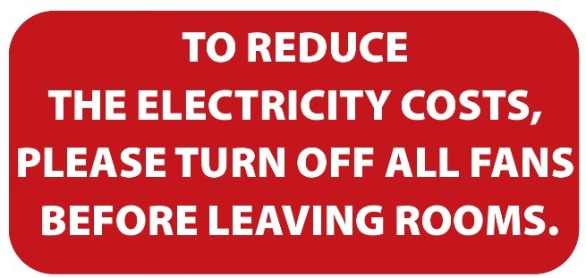

**A.** When you leave, please reduce the number of fans in your room.

**B.** Please leave the fans in the room after you go out.

**C.** Please reduce the costs of electricity by leaving the room.

**D.** Please switch off fans when you finish using a room to save electricity.

**Câu 16.** What is the deadline for high school students to apply for the District Swimming Contest?

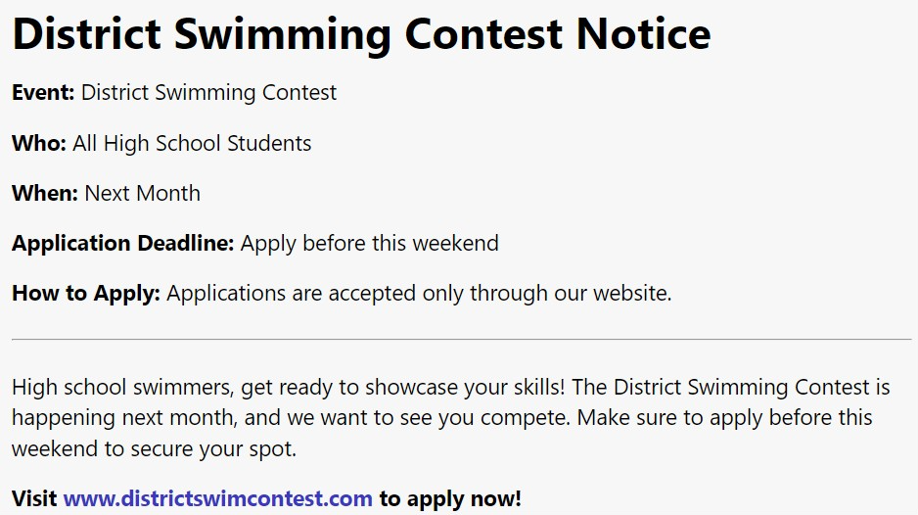

**A.** Next month  **B.** Two weeks from now

**C.** This weekend  **D.** Next weekend

**IV. Read the following passage and do as direct. (17-22)**

**Dear Elsa,**

**I’m glad to hear that you want to improve your public speaking skills. Here are a few tips that might help you.**

**First, practice is key. Try to speak in front of a mirror or record yourself to see how you look and sound. This will help you become more comfortable with your gestures and voice.**

**Second, focus on your breathing. Take deep breaths to stay calm and control your nerves. This will help you speak more clearly and confidently.**

**Third, know your material well. If you are confident about your topic, you will speak more naturally. Practice your speech several times until you feel comfortable with it.**

**Lastly, engage with your audience. Make eye contact and try to read their reactions. This will help you connect with them and adjust your speech as needed.**

**Remember, everyone gets nervous. With practice, you will get better and more confident. Good luck!**

**Best,**

**John**

**Câu 17.** Practicing in front of a mirror can help you become more comfortable with your gestures and voice.

**A.** False  **B.** True

**Câu 18.** Controlling your breathing has no impact on your public speaking nerves.

**A.** True  **B.** False

**Câu 19.** Knowing your material well can make you speak more naturally.

**A.** False  **B.** True

**Câu 20.** John suggests avoiding eye contact with the audience to reduce nervousness.

**A.** False  **B.** True

**Câu 21.** According to John, what is one way to practice public speaking?

**A.** Speaking in front of a mirror.  **B.** Avoiding public speaking altogether.

**C.** Reading books about public speaking.  **D.** Writing down your speech and memorizing it.

**Câu 22.** What does John suggest helping Elsa connect with her audience?

**A.** Speaking quickly to get the speech over with.  **B.** Making eye contact and reading their reactions.

**C.** Using complex vocabulary.  **D.** Avoiding looking at the audience.

**V. Choose the word (A, B, C or D) that best fits the blank space in the following passage. (23-28)**

**Body language is a way we ________(23) without using words. It includes our facial expressions, gestures, posture, and eye contact. For example, when someone ________(24), it usually means they are happy or friendly. A frown can show that a person is sad or upset.**

**________(25) like waving can mean hello or goodbye. Nodding your head up and down typically means yes, while shaking your head from side to side means no. Our posture also tells a lot about how we feel. Standing or sitting up straight can show confidence, while slouching might indicate tiredness or lack ________(26) interest.**

**Eye contact is another important part of body language. Looking someone in the eyes can show that you are paying ________(27) and are interested in what they are saying. Avoiding eye contact might make you seem shy or untrustworthy.**

**________(28) body language helps us communicate better and understand how others feel, even when they don’t say anything.**

**Câu 23.** Choose the correct answer.

**A.** communicate  **B.** think  **C.** understand  **D.** react

**Câu 24.** Choose the correct answer.

**A.** nods  **B.** frowns  **C.** smiles  **D.** cries

**Câu 25.** Choose the correct answer.

**A.** Waves  **B.** Signals  **C.** Gestures  **D.** Motions

**Câu 26.** Choose the correct answer.

**A.** at  **B.** of  **C.** with  **D.** in

**Câu 27.** Choose the correct answer.

**A.** kindness  **B.** ignorance  **C.** attention  **D.** neglect

**Câu 28.** Choose the correct answer.

**A.** Talking  **B.** Seeing  **C.** Understanding  **D.** Thinking

**VI. Supply the correct form of the word given in each sentence. (29-34)**

**Câu 29.** She turned red with _________ when she realized she had been speaking with food on her face. (embarrass)

**Câu 30.** _________, the quietest student in the class gave the best presentation. (surprise)

**Câu 31.** She found it difficult to maintain her _________ with all the noise in the background. (concentrate)

**Câu 32.** I would _________ trying a different route to avoid the traffic. (suggestion)

**Câu 33.** He was _________ by the constant interruptions during his work. (annoy)

**Câu 34.** The teacher had to call the parents after the student continued to _________ in class. (behaviour)

**VII. Rearrange the groups of words in a correct order to make complete sentences. (35-36)**

**Câu 35.** conduct at / all times. / **Employees are** / the company's code of / obligated to follow

______________________________________________________________

**Câu 36.** to cancel the outdoor / tomorrow, we will have / **If it rains** / event and / move it indoors.

______________________________________________________________

**VIII. Rewrite each of the following sentences in another way so that it means almost the same as the sentence printed before it. (37-40)**

**Câu 37.** Young children mustn’t travel alone at night. (allowed)

Young children …

**Câu 38.** Tom passed the final exam without any trouble. (difficulty)

Tom had no …

**Câu 39.** Lan told Paul, “I’m studying hard for the important test next week.”

Lan said to Paul …

**Câu 40.** I think staying at home is better than going out in this cold weather.

I’d rather …

**IX. Listening: listen and fill in each blank with one word. (41-50)**

**Câu 41.** Practicing public speaking can greatly improve your _______.

**Câu 42.** When you speak in front of others, you learn to _______ your nerves.

**Câu 43.** The more you practice, the _______ it becomes.

**Câu 44.** You start to feel more comfortable and less _______.

**Câu 45.** Public speaking helps you to _______ your thoughts clearly.

**Câu 46.** You learn to express your ideas in a _______ and direct way.

**Câu 47.** This skill is useful in many areas of life, such as school, work, and _______ situations.

**Câu 48.** Practicing also helps you to learn from your _______.

**Câu 49.** Your voice becomes stronger, and you make better _______ contact with your audience.

**Câu 50.** Public speaking practice helps you to connect with _______.

**----HẾT---**