Unit 2 | Vietnam and ASEAN

C. EXERCISE (BÀI TẬP)
❶ PHONETICS
I. Choose the words whose underlined part is pronounced differently from that of the others in each group.
1. A. waterfall B. cave C. bay D. flavour
2. A. modern B. chopsticks C. social D. historical
3. A. citadel B. architecture C. etiquette D. find
4. A. pagoda B. tomb C. social D. global
5. A. tower B. pocket C. bow D. mountain
6. A. body B. hot C. pond D. worship
7. A. stopped B. turned C. stayed D. moved
8. A. school B. church C. architecture D. chemistry
9. A. played B. lived C. cooked D. happened
10. A. watched B. washed C. walked D. waited
II. Choose the word whose main stressed syllable is placed differently from that of the other in each group.
11. A. attitude B. powerless C. pagoda D. difficult
12. A. mountain B. etiquette C. modern D. accept
13. A. behaviour B. architecture C. traditional D. historical
14. A. temple B. annoyed C. narrow D. valley
15. A. confused B. palace C. tower D. crowded
❷ WORD FORMATION
Complete the sentences with the correct form of the words.
- The library has an important collection of historical documents. (history)
- In Vietnam, it is traditional for a bride to wear Ao dai on wedding day. (tradition)
- I tend not to socialize with my colleagues. (society)
- I will confirm acceptance of your order by email. (accept)
- She was so annoyed with her daughter for turning up late. (annoy)
- To avoid confusion, the twins never wore the same clothes. (confuse)
- I tried my best for the exam but I were deeply disappointed about the result. (disappoint)
- The countryside in this region is very picturesque. (picture)
- This city has undergone a major modernization program in recent years. (modern)
- The main beach can get really crowded in summer. (crowd)
- They are looking for an IT data architect to work for a new project. (architecture)
- The road traverses a wild and mountainous region. (mountain)
- My mother is a regular worshipper at a church. (history)
- I lost my wallet, so I was anxious to return home. (anxiety)
- He bought this laptop on John's recommendation. (recommend)
❸ FURTHER PRACTICE

UNIT OPENER
I. Write the suitable word for each picture.

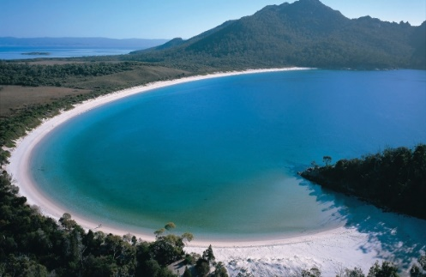 | 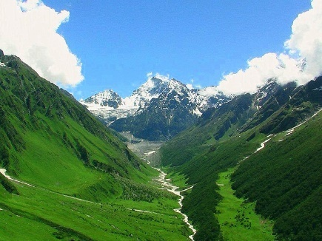 | 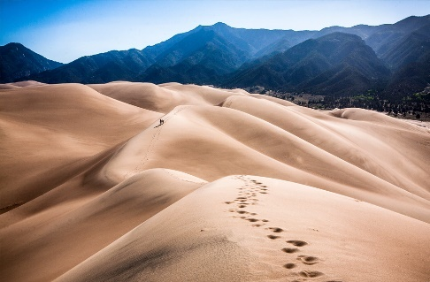
1. bay | 2. valley | 3. dunes
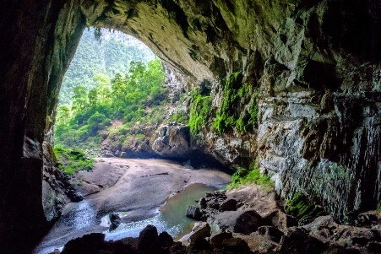 | 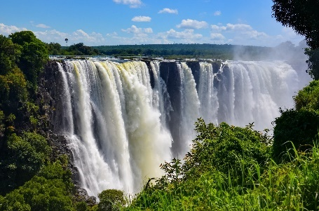 | 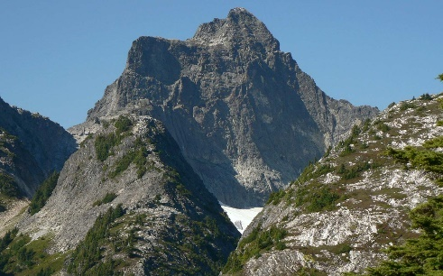
4. cave | 5. waterfall | 6. mountain

II. Complete the sentences with the words in exercise I.
- They were trapped in the cave for 19 hours.
- The boat struck a rock outside the bay and sank.
- The magnificent scene of the waterfall is pleasant.
- The Andes is the longest mountain range in the world.
- People have lived in this valley since ancient times.
- There is only a low sand dune formation along the beach
III. The following words end in ed. How do you pronounce this ending correctly?

1 | climbed → | 11 | smiled →
2 | answered → | 12 | stopped→
3 | decided → | 13 | washed →
4 | helped → | 14 | loved →
5 | asked → | 15 | lived →
6 | cleaned → | 16 | agreed →
7 | escaped → | 17 | believed →
8 | watched → | 18 | invited →
9 | acted → | 19 | liked →
10 | counted → | 20 | moved →

KEYS
1 | climbed → [d] | 11 | smiled → [d]
2 | answered → [d] | 12 | stopped→ [t]
3 | decided → [ɪd] | 13 | washed → [t]
4 | helped → [t] | 14 | loved → [d]
5 | asked → [t] | 15 | lived → [d]
6 | cleaned → [d] | 16 | agreed → [d]
7 | escaped → [t] | 17 | believed → [d]
8 | watched → [t] | 18 | invited → [ɪd]
9 | acted → [ɪd] | 19 | liked → [t]
10 | counted → [ɪd] | 20 | moved → [d]

IV. Choose a word that has the final sound(-ed) different from the others.

1. A. worked | B. wanted | C. stopped | D. asked
2. A. opened | B. knocked | C. played | D. occurred
3. A. talked | B. watched | C. lived | D. stopped
4. A. covered | B. installed | C. described | D. decorated
5. A. claimed | B. warned | C. occurred | D. existed
6. A. carried | B. looked | C. managed | D. opened
7. A. pleased | B. smoked | C. stopped | D. missed
8. A. waited | B. mended | C. objected | D. faced
9. A. pleased | B. erased | C. increased | D. amused
10. A. arrived | B. believed | C. received | D. hoped
11. A. opened | B. knocked | C. played | D. occurred
12. A. rubbed | B. tugged | C. stopped | D. filled
13. A. dimmed | B. travelled | C. passed | D. stirred
14. A. tipped | B. begged | C. quarrelled | D. carried
15. A. killed | B. hurried | C. regretted | D. planned
16. A. visited | B. showed | C. wondered | D. studied
17. A. sacrificed | B. finished | C. fixed | D. seized
18. A. needed | B. booked | C. stopped | D. washed
19. A. loved | B. teased | C. washed | D. rained
20. A. packed | B. punched | C. pleased | D. pushed
21. A. painted | B. provided | C. protected | D. equipped
22. A. tested | B. marked | C. presented | D. founded
23. A. used | B. finished | C. married | D. rained
24. A. allowed | B. dressed | C. flashed | D. mixed
25. A. switched | B. stayed | C. believed | D. cleared
26. A. decided | B. waited | C. handed | D. designed
27. A. annoyed | B. phoned | C. watched | D. remembered
28. A. hurried | B. decided | C. planned | D. wondered
29. A. posted | B. added | C. managed | D. arrested
30. A. dreamed | B. neglected | C. denied | D. admired

KEYS
1. B | 2. B | 3. C | 4. D | 5. D | 6. B
7. A | 8. D | 9. C | 10. D | 11. B | 12. C
13. C | 14. A | 15. C | 16. B | 17. D | 18. A
19. C | 20. C | 21. D | 22. B | 23. B | 24. A
25. A | 26. D | 27. C | 28. B | 29. C | 30. B

LESSON 2A. READING
I. Fill in the blanks using the words in the box.
tourist attractions | temple | architecture | symbol | worship | flavour | stall
travellers | site | traditional | culture | crowded | pagoda | handmade

- The company hasn't yet chosen the site for the new hospital.
- Don't forget to save room for one of their handmade desserts prepared daily.
- Huong pagoda is one of the largest and most unique religious sites in Hanoi.
- We don’t like watching movie on the weekend because the theater is often too crowded.
- American culture has been exported all over the world.
- The school uses a combination of modern and traditional methods for teaching reading.
- This hotel is for serious travellers, rather than tourists on two-week holidays.
- He runs a fruit and vegetable stall in the market.
- My fish was delicious but her beef had almost no flavour.
- The church was opened for public worship.
- The symbol for oxygen is O.
- The architecture of the building is modern.
- The temple was built about 206 B.C.
- Ha Long Bay is one of the most popular tourist attractions in Vietnam.

II. Read the article and correct the sentences.
0 We can save energy by turning on electrical items in our homes.
We can save energy by turning them off.
1 Food grown abroad is polluted.
_________________________________________________________________________________________________________
2 Transporting food a long way can cause traffic jams.
_________________________________________________________________________________________________________
3 Only a small part of the materials we waste can be recycled.
_________________________________________________________________________________________________________
4 Rainforests are home to around 80% of the planet’s plants and animals.
_________________________________________________________________________________________________________
5 Small areas of rainforests get destroyed each year.
_________________________________________________________________________________________________________
ANSWER KEYS
1It can cause pollution because it involves lots of transport.
2 It can cause more pollution.
3 It can all be recycled.
4 They’re home to around 50% of them.
5 Large areas of rainforests get destroyed each year.

Eco-friendlyTeens.com
The big question is: ‘How can we be more environmentally friendly?’ Well, here are some useful tips.
A Electricity
One of the biggest problems on the planet today is the growing need for energy. One of the most common forms of energy is electricity. The more we produce, the more pollution we create. My suggestion is to turn everything off in your house when you’re not using it. This includes light bulbs, TVs and computers. Simple, but effective!
B Food
Have you ever thought, ‘Where does my food come from?’ Well, the answer is… everywhere!
Green beans from Egypt, coffee from South America, and maybe even apples from New Zealand. This food travels with lots of different transport, which means lots of petrol and lots of pollution. So, why not eat food that is produced locally? It’s fresh, it doesn’t have to travel so far and it cuts down on your meal’s carbon footprint.
C Rubbish
‘Reduce, Reuse and Recycle’. Every year we throw away millions of tons of waste – glass, plastic, cans, paper and cardboard. But this can all be recycled.
Don’t just throw rubbish away; see if you can use it again, or if not, recycle it so it can be used
elsewhere.
D Rainforests
Rainforests are some of the most valuable habitats on Earth, and about half of the world’s species of animals and plants live in them. But every year a rainforest the size of Britain is destroyed. Everyone can help reduce this problem by planting more trees, buying eco-friendly paper, recycling anything that’s made of paper and shopping smart. Buy food that doesn’t have lots of packaging!
III. Read the article again and complete the sentences.
0 The growing need for energy, especially electricity, is a big problem nowadays.
1 We can buy food that is ___________________________so it doesn’t need to ______________________________________long distances and cause ___________________.
2 We shouldn’t our waste ___________________but see whether we can it _______________.
3 We should recycle like ______________________glass, plastic, ______________________ , paper and _________________.
4 We can__________________________more trees to help stop rainforests getting ____________________.
5 We should shop and buy food ________________________that doesn’t have a lot of___________________ .
ANSWER KEYS
1produced locally, travel, pollution
2 throw away, reuse or recycle
3 waste, cans, cardboard
4 plant, destroyed
5 smart, packaging

LESSON 2B. GRAMMAR
I. PAST SIMPLE AND PAST CONTINUOUS
Exercise 1: Put the correct form of the verbs in the blanks using the past simple.
1. My sister (get) __________ married last month.
2. Daisy (come) __________ to her grandparents’ house 3 days ago.
3. My computer (be ) __________ broken yesterday.
4. He (buy) __________ me a big teddy bear on my birthday last week.
5. My friend (give) __________ me a bar of chocolate when I (be) __________ at school yesterday.
6. My children (not do) __________ their homework last night.
7. You (live) __________ here five years ago?
8. They (watch) __________ TV late at night yesterday.
9. Your friend (be) __________ at your house last weekend?
10. They (not be) __________ excited about the film last night.
KEYS
1. got
2. came
3. was
4. bought
5. gave – was
6. didn't do
7. Did you live
8. watched
9. Was
10. weren't

Exercise 2: Put the verbs in brackets into the Past continuous
1. I ___________________down the street when it began to rain. (go)
2. At this time last year, I ___________________an English course. (attend)
3. Jim ________________ under the tree when he heard an explosion. (stand)
4. The boy fell and hurt himself while he _________________ a bicycle. (ride)
5. When we met them last year, they______________ in Santiago. (live)
6. The tourist lost his camera while he________________ around the city. (walk)
7. The lorry _______________ very fast when it hit our car. (go)
8. While I ____________________in my room, my roommate ___________________ a party in the other room. (study/ have)
9. Mary and I___________________in the kitchen when the telephone rang (cook)
10. We __________________ in the café when they saw us. (sit)
Keys
1. was going 6. was walking
2. was attending 7. was going
3. was standing 8. was studying/ was having
4. was riding 9. were cooking
5. was living 10. were sitting

Exercise 3: Choose the correct answer for each sentence.

1. I saw/ was seeing the accident when I was waiting for the taxi.
2. What were you doing/ did you do when I phoned?
3. They didn't visit/ weren't visiting their friends last summer holiday.
4. It rained/ was raining heavily last July.
5. While people were talking to each other, he read/ was reading his book.
6. Chris was eating/ ate pizza every weekend last month.
7. While we were running/ run in the park, Mary fell over.
8. Did you find/ Were you finding your keys yesterday?
9. Who was she dancing/ did she dance with at the party last night?
10. They were watching/ watched football on TV all day.
KEYS
1. saw
2. were you doing
3. did'nt visit
4. rained
5. was reading
6. ate
7. were running
8. Did you find
9. did she dance
10. were watching

Exercise 4: Correct the mistake in each sentence.
1. I was play football when she called me.
2. Was you study Math at 5 p.m. yesterday?
3. What was she do while her mother was making lunch?
4. Where did you went last Sunday?
5. They weren’t sleep during the meeting last Monday.
6. He got up early and have breakfast with his family yesterday morning.
7. She didn’t broke the flower vase. Tom did.
8. Last week my friend and I go to the beach on the bus.
9. While I am listening to music, I heard the doorbell.
10. Peter turn on the TV, but there was nothing interesting.

KEYS
1. I was playing football when she called me.
2. Was you studying Math at 5 p.m. yesterday?
3. What was she doing while her mother was making lunch?
4. Where did you go last Sunday?
5. They weren’t sleeping during the meeting last Monday.
6. He got up early and had breakfast with his family yesterday morning.
7. She didn’t break the flower vase. Tom did.
8. Last week my friend and I went to the beach on the bus.
9. While I was listening to music, I heard the doorbell.
10. Peter turned on the TV, but there was nothing interesting.
Exercise 5: Choose the correct answer for each sentence.
1. They__________ the bus yesterday.
A. don’t catch B. weren’t catch C. didn’t catch D. not catch
2. My sister__________home late last night.
A. comes B. come C. came D. was come
3. My father ______ tired when I__________ home.
A. was – got B. is – get C. was – getted D. were – got
4. What__________you__________two days ago?
A. do – do B. did – did C. do – did D. did – do
5. Where__________your family__________on the summer holiday last year?
A. do – go B. does –go C. did – go D. did – went
6. At this time last year, they _________this house
A. built B. is building C. was building D. were building
7. What _________you _________ (do) at 8 pm yesterday?
A. were you doing B. was you doing
8. They (not go) _________ to school when I met them yesterday.
A. didn’t go B. wasn’t going C. didn’t went D. weren’t going
9. At this time last year, they _________ (build) this house.
A. built B. was built C. was building D. were building
10. Friday will be a bad day for me – I have an extra session and maybe a press conference. I wish your mother _________on Saturday or Sunday. But I know it’s not your fault.
A. didn’t come B. were coming C. came D. had come
11. I (drive) _________ my car very fast when you called me.
A. drove B. was driving C. was drive D. were driving
12. I _________ (chat) with my friends while my teacher _________ (teach) the lesson yesterday.
A. was chatting – teaching B. was teaching – was teaching
C. was teaching – taught D. chatted – taught
13. My father _________ (watch) TV when I got home.
A. was watching B. watched C. were watched D. was watched
14. At this time yesterday, I _________ (prepare) for my son’s birthday party.
A. prepared B. was prepared C. was preparing D. were preparing
15. Where _________ (go) when I saw you last weekend?
A. was you going B. were you going C. did you go D. you went
16. They _________ (not go) to school when I met them yesterday.
A. weren’t going B. not going C. didn’t go D. weren’t go
17. My mother _________ (not go) the housework when my father came home.
A. didn’t go B. didn’t doing C. wasn’t doing D. weren’t doing
18. My sister _________ (read) books while my brother _________ (play) football yesterday afternoon.
A. was reading – playing B. was reading – was playing
C. was reading – played D. read – was playing
19. While Henry (play)_________ the piano, his mother (do)________ the washing-up.
A. was playing/ was doing B. were playing/ were doing
C. played/ did D. played/ was doing
20. I (have) _________ dinner when I suddenly__________a loud bang.
A. were having/ hear B. was having/ heard
C. had/heard D. was having/ was hearing

KEYS
- C
- C
- A
- D
- C
- D
- A
- D
- D
- B
- B
- B
- A
- C
- B
- A
- C
- B
- A
- B

II. CLEFT SENTENCES

Exercise 1: Choose the correct answer.
- ….…. we all look for.
- It is happiness that C. that happiness
- Happiness it is that D. happiness it is
- ….…. my neighbors who rescued me from the fire.
- It is B. It was C. that is D. this is
- ….…… me how to play the drum.
- It was my uncle who taught C. it was my uncle taught
- My uncle who taught D. it is my uncle teaching
- ….…….. I bought the golden fish.
- It was from this shop that C. it was this shop which
- It was from this shop which D. it was this shop that
- ….……. gave me that picture book.
- Mary B. It was Mary C. It was Mary whom D. It was Mary whose
- My new book, …………, is very interesting.
- It is on wild animals C. which is on wild animals
- Is on wild animals D. to be on wild animals
- Two players of our delegation, ……….., are in competition for the gold medal.
- It was Jim and John C. it is Jim and John
- They were Jim and John D. Jim and John
- It was Tom ………..to help us.
- Comes B. that comes C. to come D. who came
- ….……. the police had rescued from the fire.
- The baby B. the baby that C. It was the baby whom D. the baby whom
- ….……. my parents gave me the fish tank.
- It was on my birthday when C. It was my birthday that
- It was my birthday on that D. It was on my birthday that
- ….……. I first met my girlfriend.
- It was in London that C. it was London that
- It was in London where D. it was London which
- It was ……….. the wet and windy day that I drove over the hill to Milland.
- In B. on C. at D. for
- It was my friend, Shona, ………..
- I was at school with whom C. with who I was at school
- I was at school with D. with that I was at school
- ….…… on the phone.
- It is his mother whom is C. It was his mother who is
- It was his mother whom is D. It is his mother who is
- ….…….. those books on the desk?
- Were it you who put C. Was it you that put
- It was you who put D. It is you that put
- ….……. we have to wait.
- It is a long time that C. It is for a long time that
- It is a long time for that D. It is for a long time when
- It is ………. they are going to, not Russia.
- Spain B. Spain that C. Spain where D. in Spain that
- ….…….. he heard the news.
- It was three-week later that C. It was three-week later when
- It was three weeks later when D. It was three weeks later that
- ….……… a high level of blood cholesterol.
- It is eggs that contain C. It is eggs that contains
- Those are eggs it contains D. It is eggs contain
- ….…….. I first met him in that resort.
- It was last winter when C. It was in last winter when
- It was last winter D. It was the last winter which
- ….…….. disappeared when I arrived at the airport.
- My passport C. It is my passport that
- It was my passport D. It is my passport.
- It was the great efforts ……… to complete his study.
- That made B. that he made C. that he made it D. he made it
- It is ……… we will leave for Paris.
- April B. in April that C. April in that D. in April when
- ….…….. on my part that I could not manage to deliver the goods on time.
- An error B. that’s an error C. It was an error D. an error it was
- ….…… in sorrow than in anger that his parents criticized him on his failure.
- It is B. It was C. It was much D. It was more
- ….……. took my document?
- It is Peter that C. Was it Peter that
- It was Peter that D. Was that Peter
- It is ………. I get emotional satisfaction.
- Collecting stamps that C. collecting stamps from that
- From collecting stamps that D. collecting stamps that from
- It is the library ………….
- That I often borrow books C. where I often borrow books from
- That I often borrow books from D. from that I often borrow books
- ….…….. England won the World Cup.
- It was in 1966 that C. It was on 1966 that
- It was in 1966 when D. It was 1966 in that
- ….……… took my car.
- It was you B. It were you C. It was you that D. It was you whom
- It was the stamp collection …………
- About I have ever told you C. about that I have ever told you
- I have ever told you about D. that I have ever told you
- ….……. taught me how to collect butterflies.
- It was my father C. It was my father whom
- It is my father D. My father
- It is ………. that you can leave the exam room.
- Only when have you finished your papers.
- You have finished your papers
- Only have you finished your papers
- Only when you have finished your papers.
- It is ……….. we usually sit in the afternoon reading books.
- on the tree where C. by the tree
- under the tree that D. under the tree which
- It is Tom ……….. the test.
- Who have finished C. that has finished
- That are finishing D. finishing
- It was in 1990 ………… I met my husband.
- When B. which C. that D. Ø
- ….………. invented the telephone.
- He was Marconi that C. He is Marconi who
- It is Marconi that D. It was Marconi that
- ….…….. she was born.
- It is in Paris where C. it was in Paris that
- It is in Paris, that D. it was in Paris where
- ….…….. the nearest the sun.
- It is Mercury who is C. It was Mercury that are
- It is Mercury, which is D. It is Mercury that is
Exercise 2: Rewrite the sentences to focus attention on the underlined information. Using structure” it is / was ... that”
- He is interested in learning English most.
→It is English that he is interested in learning most.
- I heard that news in this morning.
→ It was that news that I heard in this morning.
- My aunt lives in Britain for ten years.
→It is my aunt that lives in Britain for ten years
- Mary and Peter are my close friends.
→ It is Mary and Peter that are my close friends
- The boat race was held in this river.
→ It was in this river that the boat race was held.
- I studied abroad when I was 22.
→ It was when I was 22 that I studied aboard.
- They play card during the night.
→ It is card that they play during the night
- He bought a new car yesterday.
→It was a new car that he bought yesterday.
- They go camping in the forest.
→ It is in the forest that they go camping
- My family usually go shopping at weekend.
→ It is at weekend that my family usually go shopping.
Exercise 3: Rewrite the sentences to focus attention on the underlined information. Using structure” it is / was ... that + passive voice”
- People talked about the fire last night.
→ It was the fire that was talked about last night.
- My mother gave me a nice dress on my birthday.
→ It was a nice dress that was given to me by my mother on my birthday.
- We watched TV show yesterday.
→ It was T.V show that was watched yesterday.
- She kept her memento carefully.
→ It was memento that was kept by her carefully.
- My family bought a new fridge.
→ It was a new fridge that was bought by my family.
- They served a lot of dishes at the party.
→ It was a lot of dishes that were served at the party.
- A cat broke the flower vase when it caught a mouse.
→ It was the flower vase that was broken by a cat when it caught a mouse.
- The teacher asked the student to do homework.
→ It was the student that was asked to do homework by the teacher.
- My mother bought foods in the supermarket.
→ It was foods that were bought in the supermarket by my mother.
- She held a farewell party yesterday.
→ It was a farewell party that was held by her yesterday.
Exercise 4. Rewrite the sentences to focus attention on the underlined information. Using structure” it is / was ... that”
1. She bought the car from Tom.
→ It was the car that she bought from Tom.
2.The computer gives me a headache.
→ It is the computer that gives me a headche.
3. We are coming to stay with Jane this weekend.
→ It is this weekend that we are coming to stay with Jane.
4. The president makes the important decisions.
→ It is the important decisions that the president makes
5. I’m looking forward to physics exam.
→ It is physics exam that I’m looking forward to.
6. I lost my wallet somewhere in there.
→ It was my wallet that I lost somewhere in there
7. I was born and grew up in a small village.
→ It was in a small village that I was born and grew up.
8. My teacher helped me a lot of with my study last semester.
→ It was last semester that my teacher helped me a lot of with my study
9. The headmaster gave Tam a bicycle as a scholarship.
→ It was a bicycle that the headmaster gave Tam as a scholarship.
10. Your carelessness caused the accident
→ It was your carelessness that caused the accident.
11. The neighbour told them about it.
→ It was the neighbour that told them about it.
12. My friend came to see me late last night.
→ It was last night that my friend came to see me late.
13. That boy scored the goal for his team.
→ It was the goal that that boy scored for his team
14. The dog grabbed at the piece of meat and ran away.
→ It was the piece of meat that the dog grabbed at and ran away.
15. The strong wind blew the roof off.
→ It was the strong wind that blew the roof off.
16. The woman answered the man rudely.
→ It was the man that the woman answered rudely.
17. The boy played ping pong the whole afternoon.
→ It was the whole afternoon that the boy played ping pong.
18. The girl gave the boy a special gift on his birthday.
→ It was a special gift that the girl gave the boy on his birthday.
19. The police arrested the man at the railway station.
→ It was at the railway station that the police arrested the man.
20. He borrowed the money from Linda.
→ It was Linda that He borrowed the money from
21. He bought the book from that corner shop.
→ It was from that corner shop that he bought the book
22. He got married when he was 26.
→ It was when he was 26 that he got married
23. They were having a barbecue in the park.
→ It was a barbecue that they were having in the park
24. I met him on the way to school.
→ It was on the way to school that I met him
LESSON 2C LISTENING
- Vocabulary
I. Read the description and write the words. The first letter of the word is given.
1. buildings used for religious worship, especially in religions other than Christianity. t_____________
2. feeling or showing surprise. s___________
3. building where objects of historical, scientific, or artistic interest are kept. m___________
4. extremely surprised. a___________
5. upset because something you hoped for has not happened or been as good, successful, etc. as you expected. d___________
6. tall religious buildings in Asia with many levels, each of which has a curved roof. p___________
7. a large house that is the official home of a king, queen, or other person of high social rank. p___________
8. to remove something. t___________ __________
9. to fly. t___________ __________
10. a person who lives in the particular small area that you are talking about. l___________

Answer keys
- Temples
- Surprised
- Museum
- Amazed
- Dissappointed
- Pagodas
- Palace
- Take away
- Take off
- Local
II. Complete the sentences with the words in exercise I.
1. When I travel, I usually ask a local about the best places to eat in town.
2. Hurry up! The plane is going to take off.
3. You need to take away the garbage every evening.
4. On the first day of Lunar New Year, Vietnamese people often visit pagodas and temples.
5. I was angry, disappointed and upset about his behaviour.
6. Buckingham Palace is open to the public.
7. I was amazed to hear that my sister had won first prize.
8. She looked at him with a surprised expression on her face.
9. The museum contains one of the best existing collections of Maori art.

B. Listening
I. Listen to the first part of the recording and write True or False.
Cambodia | 1. Travelling to Cambodia is very expensive. ____________  2. The people in Cambodia are very friendly and warm. ____________  3. Anchor Watt is an ancient complex that was hidden from civilization for thousand years. ____________
Singapore | 4. Singapore is perfect for those looking for cheap travelling. ____________  5. Travellers can explore temples, markets, shopping malls, casinos and marina bay sands when they visit Singapore. ____________  6. Southeast Asia is a pretty affordable place to explore. ____________
Philippines | 7. The Philippines offer a mixture of crowded city centres and picturesque beaches. ____________  8. This is a very affordable place to explore. ____________  9. Transport between the cities and different island is faster than the rest of Asia. ____________
- F
- T
- T
- F
- T
- F
- T
- T
- F
II. Listen to the rest of the recording and fill in the gaps.
VIETNAM  Places to visit in Vietnam:  - The war (1)___________________  - Cu Chi (2)___________________  - Halong (3)___________________  Private rooms: around (4)___________________a night.  There are plenty of (5)__________________ and (6)__________________ options for all budgets  Vietnam is actually one of the (7)__________________ places to visit in Southeast Asia. | THAILAND  Climate: (8)____________________________  Places to visit:  - Glorious (9)__________________  - Breathtaking (10)__________________  - Bustling (11)__________________  - Incredible (12)__________________.  Bangkok: to see the (13)_______ _ and visit the (14)____________ journey up north to see the (15)__________________ city of Chiang Mai and make sure to spend some time island hopping in the south.  Food: pad Thai and curries to (16)__________________ and (17)__________________ sticky rice.

Keys
II. Listen to the rest of the recording and fill in the gaps.
VIETNAM  Places to visit in Vietnam:  - The war museums  - Cu Chi tunnels  - Halong bay  Private rooms: around eight dollars a night.  There are plenty of flights and transport options for all budgets  Vietnam is actually one of the cheapest places to visit in Southeast Asia. | THAILAND  Climate: __________  Places to visit:  - Glorious beaches  - Breathtaking nature  - Bustling cities  - Incredible temples.  Bangkok: to see the sights and visit the markets journey up north to see the historic city of Chiang Mai and make sure to spend some time island hopping in the south.  Food: pad Thai and curries to durian and mango sticky rice.

Audio Scripts
PART 1
Southeast Asia has a lot of incredible countries to offer and it can be hard to know which to visit.
This is Katie from creative travel guide and today we share the five best destinations to visit in southeast Asia.

So firstly we have Cambodia.
CAMBODIA
There are some pros for visiting Cambodia which include everything being cheap, so hotels, transport, food, drink and attractions are all relatively cheap, perfect for those traveling Asia on a budget. The people in Cambodia are warm and friendly who are always welcoming to tourists visit the capital city of Phnom Penh which holds some destructive history but is worth learning about and exploring. While you're in Cambodia, also make sure to head to Siem Reap home to the stunning and expansive Anchor Watt, an ancient complex that was hidden from civilization for thousands of years.
SINGAPORE
Next, we have Singapore, so at the height of sophistication the contemporary city of Singapore is a perfect choice for those looking for some luxury in their travels.
Visit the temples and hawker markets before exploring the shopping malls, casinos and marina bay sands.
Just be aware that although southeast Asia is a pretty affordable place to explore Singapore does have expensive accommodation options, so this is one of the priciest places to visit in the region.
PHILIPPINES
Next, we have the Philippines. So, the Philippines offers a mixture of busy city centres luxurious landscapes and picturesque beaches. There is so much to enjoy across the country of the Philippines that makes the place well worth a visit. Again, this is a very affordable place to explore and there are so many stunning sights to be found here.
Just bear in mind that you will need a little bit more time to really explore the Philippines properly. The country is a developing place with less tourists than the rest of Southeast Asia meaning that transport between the cities and different islands can be slightly trickier and longer than the rest of Asia

PART 2
VIETNAM
The next place you have to visit in Southeast Asia is Vietnam. There are so many different cities towns and attractions to explore in Vietnam from the War Museums and Cu Chi tunnels to one of the natural seven wonders of the world Halong Bay. You could spend months in Vietnam exploring and learning about this rich culture. Vietnam is actually one of the cheapest places to visit in Southeast Asia with private rooms still costing only around eight dollars a night plus everything is accessible there are plenty of flights and transport options for all budgets
THAILAND
And lastly, we have Thailand with warm weather all year round, glorious beaches, breathtaking nature, bustling cities and incredible temples. There is something for everyone in Thailand.
Head to Bangkok to see the sights and visit the markets journey up north to see the historic city of Chiang Mai and make sure to spend some time island hopping in the south. While you are in Thailand, you will also want to check out the amazing food from pad Thai and curries to durian and mango sticky rice.

LESSON 2D SPEAKING
I. Write the suitable word for each picture.

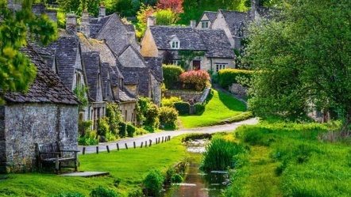 | 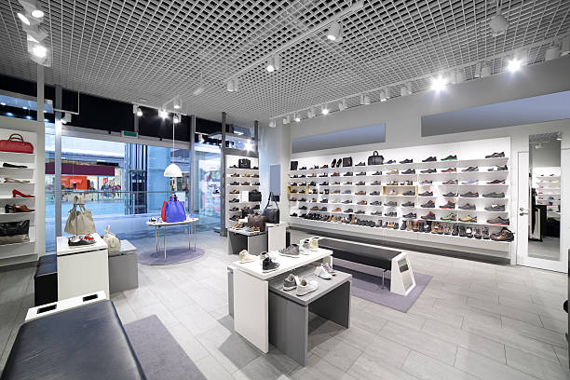 | 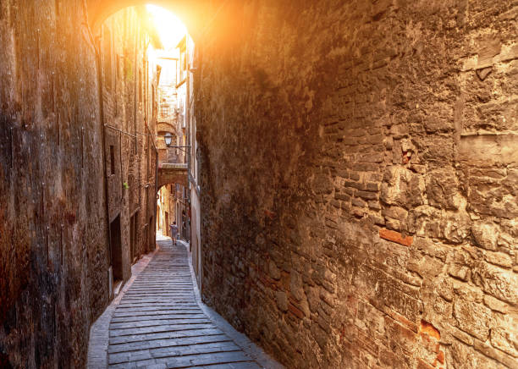
1. picturesque village | 2. modern shop | 3. narrow street
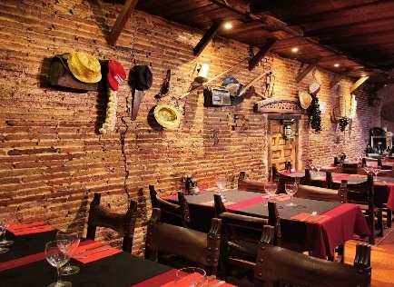  4. traditional restaurant | 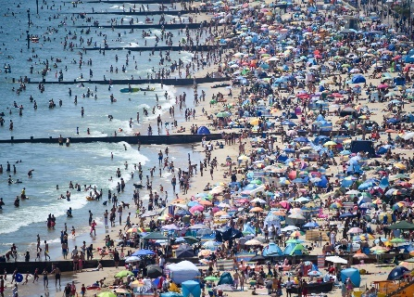  5. crowded beach | 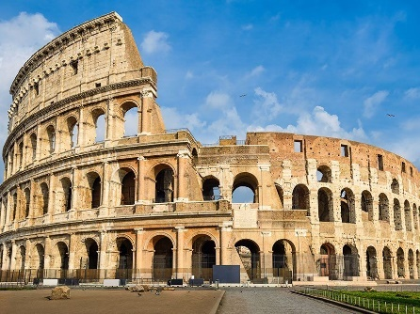  6. historical building
II. Match the sentences with the teenage problems in exercise I.
- Notre-Dame Cathedral is a very famous ______________for Catholics. historical building
- I like to go to the ___________________in this town because they serve great food and we can enjoy country music. Traditional restaurant.
- Last week, I went to a very ___________________. There were many people, so we cannot find any spaces to play volleyball on the sand. Crowded beach
- It is a ________________which used to be congested, and it is now proposed to widen it. narrow street
- Let’s go to see _______________ from today's leading brands. modern shops
- It is a___________________, with old cottages within its boundaries. picturesque village
LESSON 2D WRITING & CULTURE CORNER

I. Rewrite the sentences using the given words.
1. The/ Vietnamese/ bow/ people/ heads/ their/ to/ greet/.
…………………………………………………………………………………………………………
The Vietnamese bow their hands to greet people.
2. rude/ is/ It / refuse/ food/ drinks/and/ to /.
…………………………………………………………………………………………………………
It is rude to refuse food or drinks.
3. Vietnam, /In/ common/ is / it / oldest / wait/ person/ first/ eat/ to/ respect/ your/ show/ to/ for/ the/ to/.
…………………………………………………………………………………………………………
In Vietnam, it is common to wait for the oldest person to eat first to show your respect.
4. pagoda/ bell/ a/ this/ has/ tower/ 20/ metres/ height/ at/ a / of/.
…………………………………………………………………………………………………………
This pagoda has a bell tower at a height of 20 metres.
5. city/ ancient/ visit/ didn’t/ I/ the/ yesterday /.
…………………………………………………………………………………………………………
I didn’t visit the ancient city yesterday.
II. Rewrite the sentences so that it has the same meaning with the provided sentences.
1. We are coming to stay with Jane this weekend.
-> It is this weekend that we are coming to stay with Jane.
2. The president makes the important decisions.
-> It was the president who makes the important decisions.
3. I’m looking forward to physics exam.
-> It is physics exam that I'm looking forward to.
4. I lost my wallet somewhere in there.
-> It was my wallet that I lost somewhere in there.
5. I was born and grew up in a small village.
-> It was a small village that I was born and grew up.
6. I haven’t met Lucy since we left school.
-> The last time I met Lucy was when we left school.
7. I haven’t seen him since I was a student.
-> I last saw him when I was a student.
8. Shawn has been playing guitar since he was five.
-> Shawn started playing guitar since he was five.
II. Write an informal email

- This is part of a letter you receive from an English friend.

- Now write a letter to your friend.
- Write your letter in 100 words.
Write an email to Jane. In the email, you should:
- tell her about the problem you had.
- say what you worry about the problem?
- ask Jane for advice
Write your email in about 100 words.

I went to visit a historical building in Paris with my family last week.
Which do you prefer: visting a historical building or a crowded beach?
Tell me about your favourite place to visit.

………………………………………………………………………………………………………………………………
………………………………………………………………………………………………………………………………
………………………………………………………………………………………………………………………………
………………………………………………………………………………………………………………………………
………………………………………………………………………………………………………………………………
………………………………………………………………………………………………………………………………
………………………………………………………………………………………………………………………………
………………………………………………………………………………………………………………………………
………………………………………………………………………………………………………………………………
………………………………………………………………………………………………………………………………
………………………………………………………………………………………………………………………………
………………………………………………………………………………………………………………………………
………………………………………………………………………………………………………………………………

Tài liệu được chia sẻ bởi Website VnTeach.Com
https://www.vnteach.com

