**ENGLISH 6**

**Unit 10: OUR HOUSES IN THE FUTURE**

**Part 1: Listen to Mi talking about her favourite thing in her house. Choose the correct answer**

**Question 1**: The modern fridge in Mi’s house is ____________ metres high.

A. 1.6 B. 1.7 C. 1.8 D. 1.9

**Question 2**: Her parents bought it ____________ months ago.

A. 2 B. 3 C. 4 D.5

**Question 3**: It has two sections to make­­­­­­­­­­­­­­­___________________

A. ice B. cake C. rice D. water

**Question 4**: It can ask them ____________they need.

A. why B. how C. when D. what

KEY

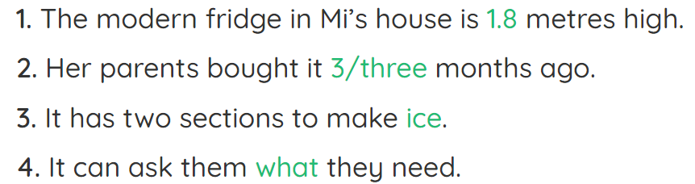

**Part 2: Listen to a boy talking about his future house. Decide if the statements are True (T) or False (F).**

**Question 1**: He loves climbing mountains.

A. True B. False

**Question 2**: There will be a garden in the back of his house.

A. True B. False

**Question 3**: There will be a smart electric fan in his living room.

A. True B. False

**Question 4**: He can control the TV with his voice.

A. True B. False

KEY

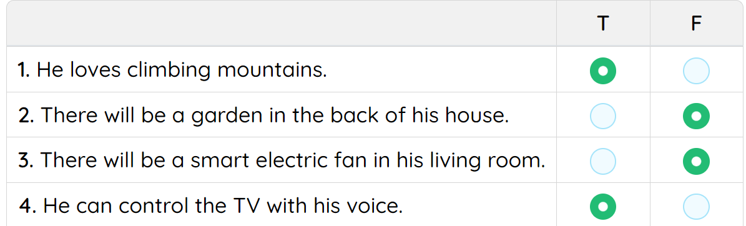

**Part 3 : Pronunciation**

**Question 1**. A. wireless **B. fridge** C hi-tech D. appliance

**Question 2.** A. UFO B. future **C. pollute** D. student

**Question** **3.** **A. space** B. draw C. automatic D. more

**Question** **4.** **A. machine** B. hi-tech C. school D. chemistry

**Question** **5.** A. watched B. dropped C. washed **D. traveled**

**Part 4 : Stress**

**Question 1**. A. factory B. company C. family **D. destruction**

**Question 2**. A. organise B. decorate **C. appearance** D. interview

**Question 3**. A. refreshment **B. horrible** C. exciting D. intention

**Question 4. A. outside** B. cooker C. palace D. ocean

**Question 5.** A. robot B. housework C. village **D. compete**

**Part 5 : Vocabulary**

**Question** **1.** Will robots look ________ the elderly and children?

A. for B. at C. into **D. after**

**Question** **2.** A smart ________ will keep track of your food stocks and suggest recipes based on food items you already have.

A. television **B.fridge** C. dishwasher D. clock

**Question 3.** Which kind of .................... do you like to live in?

**A. houses** B. factories C. kitchens D. gardens

**Question** **4.** .................... is standing for Unidentified Flying Object.

A. USA B. USB **C. UFO** D. UNIT

**Question** **5.** High buildings are also called ....................

A. tall houses **B. skyscrapers** C. tall office D. high house

**Part 6: Grammar**

**Question** **1.** In the future, machines all the work for us.

A. are doing **B. will do** C. were doing D. do

**Question** **2.** We ________ have flying cars in 2050, so there will probably be fewer cars on our roads.

A. can B.should C. must **D. might**

**Question** **3.** If he doesn't run, he catch the train.

A. will B. wouldn’t C. mustn’t **D. won’t**

**Question** **4.** People ________ on Mars someday, but it is too expensive to travel there now.

A. live B.are living **C. will live** D. have lived

**Question** **5.** .................... she come and clean the office this afternoon?

A. Is B. Did **C. Might** D. Could

**Part 7: Spoken language**

**Question 1:** : – "I’ve just received a scholarship." – "…………………".

A. Really **B. Congratulations** C. Thank you D. Well

**Question 2.** "The car of the future will probably run on water." - "........................."

**A. How fantastic!** B. Good job! C. Good idea! D. Well done!

**Question 3.** "Can you repeat that word, please ?" - "....................."

A. That's very kind of you **C. Sure**

B. Thank you D. Can I come in?

**Part 8 : Closest meaning**

**Question 1** : She looks after her chidren.

1. feeds B. sends **C. takes care of** D. contacts

**Question 2** : His kids are very good.

1. **children**  B. boys C. men D. women

**Question 3** : I study English and Maths.

1. do **B. learn**  C. speak D. go

**Part 9 : Opposite meaning**

**Question 1** : She always goes to school on time.

1. often **B. never** C. usually D. sometimes

**Question 2** : My house is very expensive

1. **cheap**  B. nice C. good D.famous

**Question 3** : He doesn't like this house

1. like **B. hate** C. want D. need

**Part 10 : Mistakes**

**Question 1** : We lives in SADEC city.

A B C D

1. lives **B. lives** C. to live D. living

**Question 2** : My uncle have a computer.

A B C D

1. uncle B. my **C. have** D. computer

**Question 3** : There are a beautiful picture on the wall .

A B C D

1. **are**  B. there C. picture D. wall

**Question 4 :** The robots will helps you water the flowers.

A B C D

1. **helps**  B. robots C. you D. flowers

**Question 5 :**There are a flower of the villa.

A B C D

1. **are**  B. there C. of D. villa

**Part 11: Choose the correct answers to complete the passage.**

Are you tired of the colour or pattern of your walls? In a smart home, you won’t have to (1)______ them. The walls will actually be digital screens, like computer or TV screens.

A computer network will link these walls with (2)________ else in your house. Called “ambient intelligence,” this computer “brain” will control your entire house. It will also adapt to your preferences. Your house will learn about your likes and dislikes. It will then use that knowledge to control the environment. For example, it will set the heat in the house to your (5)________ temperature. It will turn on the shower at the right temperature. It will also darken the windows at night and lighten them when it’s (6)________ to wake up.

**Question 1**: a. build b. cover c. pull d. repaint

**Question 2**: a. thing b. everything c. anything d. nothing

**Question 3**: a. favourite b. terrible c. high d. clearly

**Question 4**: a. occasion b. way c. time d. order

**Part 12: Read this passage carefully, then choose the correct answers.**

Technology will allow homes in the future to be “smart.” Appliances will communicate with each other - and with you. Your stove, for example, will tell you when your food is cooked and ready to eat. Refrigerators will suggest recipes based on food items you already have.

Futurologists predict that many homes will have robots in the future. Robots already do many things such as building cars and vacuuming floors. But scientists today are starting to build friendlier, more intelligent robots that will be able to show feelings with their faces, just like humans. These robots will do work around the house such as cooking and cleaning. They will even take care of children and the elderly.

How soon will this smart home be a reality? There’s a good chance it will be a part of your life in 25 or 30 years, perhaps sooner.

- recipe (n): *côngthứcnấuăn* - futurologist (n): *nhàtươnglaihọc*

**Question 1**: What will make future houses smart?

a. Technology b. Computers c. Humans d. Scientists

**Question 2**: According to the passage, the fridge of the future will be able to __________

a. keep food fresher and lasting longer.

b. tell you it’s time to buy more food.

c. give instructions on how to cook something.

d. look out for out-of-date food.

**Question 3**: Robots nowadays are widely used in __________

a. house building b. car manufacturing

c. public transportation d. communications technology

**Question 4**: Scientists are building robots that can __________

a. help take care of elderly people. b. do all household chores.

c. show feelings with their faces. d. all are correct.

**Part 13: Rewrite the sentences**

**Question 1**: It is my sister's eighteenth birthday next week

* My sister will ........................................................

**Question 2**: We will probably create a robot that can walk to school.

* We might ...........................................................................

**Part 14:** Write a paragraph (40-50 words) about your dream house. These questions will help you:

1. What type of house will it be?

2. Where will it be?

3. What will there be around your house?

4. How many rooms will be there?

5. What will you have in your house?

6.Will you have a robot in your house? If yes, what will your robot do?

**------TAPESCRIPT------**

**Listen 1**:

**Listen 2**:

**------SPEAKING------**

Talk about your dream house. You should mention

1. What type of house will it be?

2. Where will it be?

3. What will there be around your house?

4. How many rooms will be there?

5. What will you have in your house?

**Question 1**: Will you have a robot in your house? If yes, what will your robot do?

**Question 2**: Which part of your house will you like best?



*Giaoandethitienganh.info*  có rất nhiều tài liệu tiếng anh file word hay, chất lượng, mời bạn đăng ký tài khoản ( chỉ 100k/ năm) để chủ động tự tải tài liệu khi cần!