TEST 03

Listening
There are 25 questions
You will need coloured pens and pencils.

My name is…………………………….

PART 1
5 questions

This is an example. Now you listen and draw lines.
Jane | Paul |  | John |  | Hoa
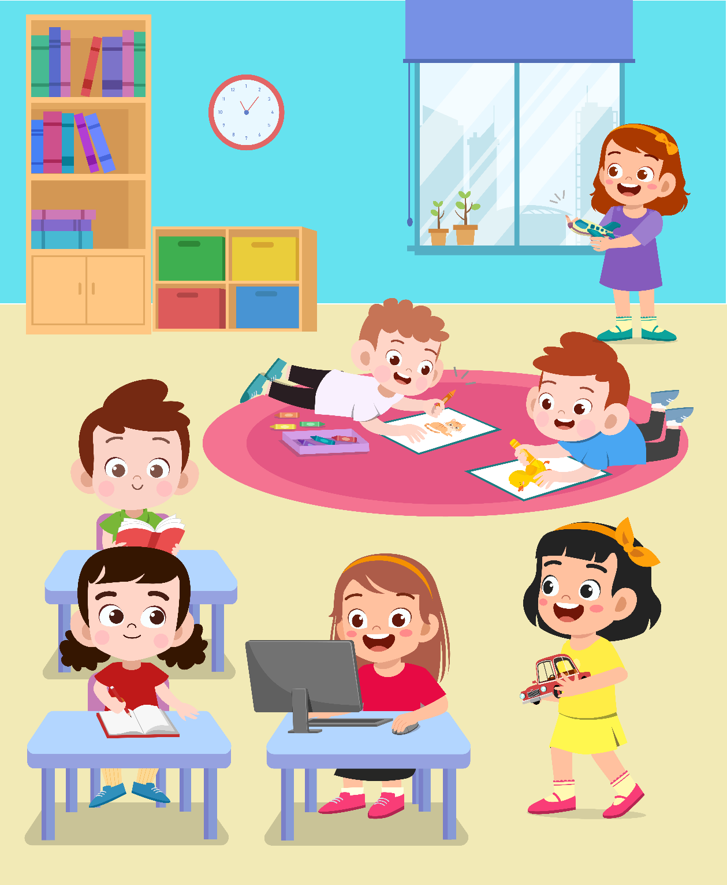
Trang |  | Daisy |  | Tim

PART 2
5 questions

Listen and write. There is one example.
 | 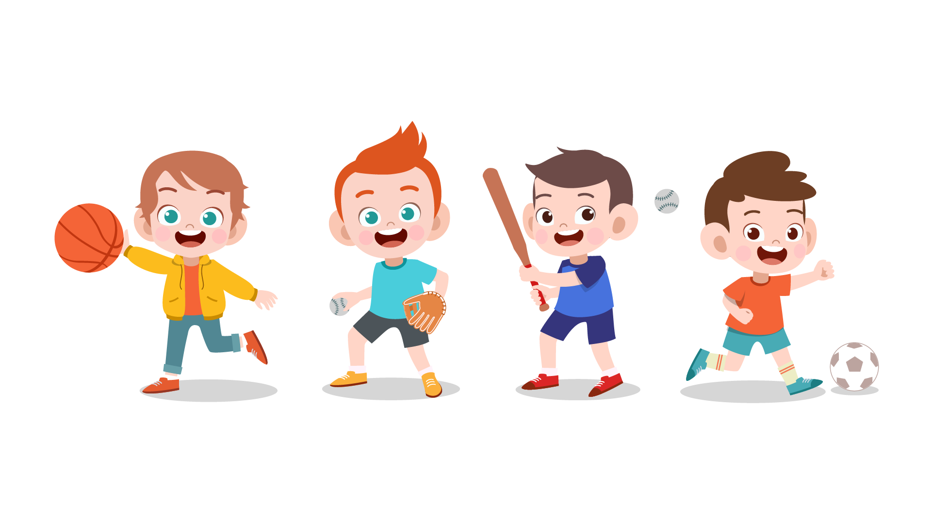
 | SPORTS LESSONS
0 | Name of sport: | …volleyball…
1 | Where: | in……
2 | When: | on…….
3 | Teacher’s name: | Mr……
4 | What to wear: | ……
5 | What to bring: | ……

PART 3
5 questions
What did Hoa do last week?
Listen and draw a line from the floor to the correct picture.
There is one example
 | Hà Nội  Hải Phòng  Đà Nẵng  Nha Trang  Đà Lạt  Phú Quốc  Hà Giang | 
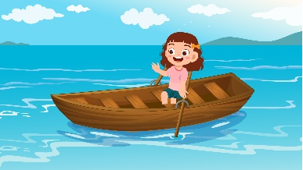 |  | 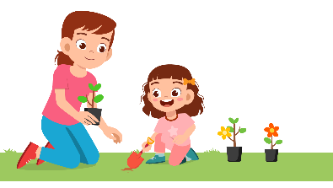
 |  | 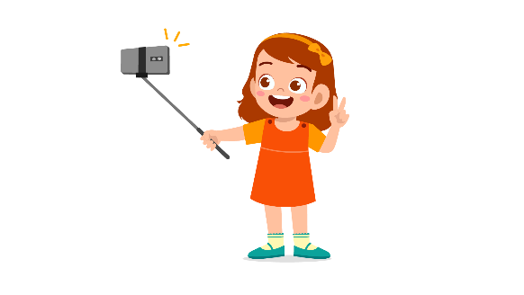

PART 4
5 questions

Listen and tick () the box. There is one example.
Example : What time did Laura go to school?
 |  | 
A ⬜ | B ⬜ | C ⬜
- Which person is Teacher Hoa?
 | 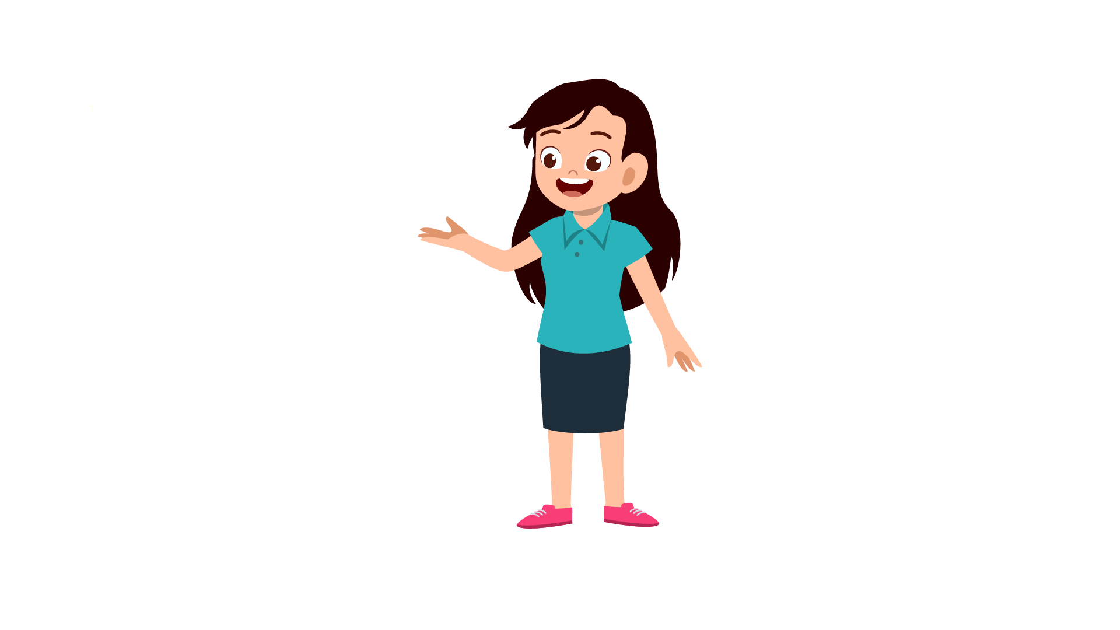 | 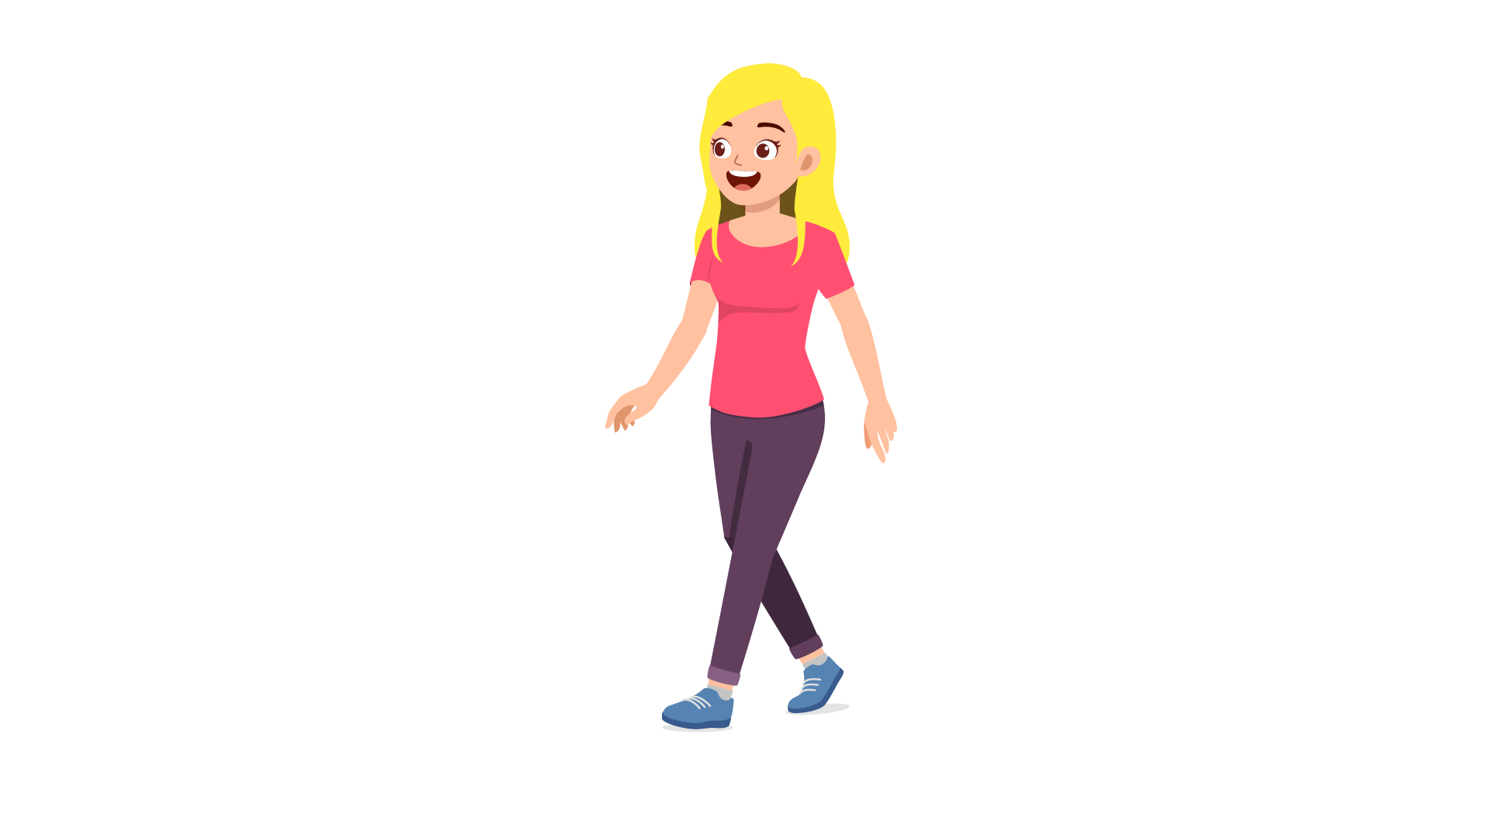
A ⬜ | B ⬜ | C ⬜
- What did Tom find in his car?
 |  | 
A ⬜ | B ⬜ | C ⬜
- What’s Jane doing?
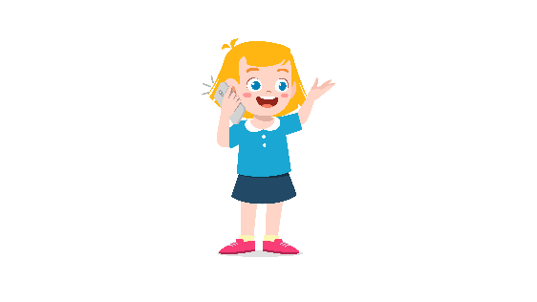 | 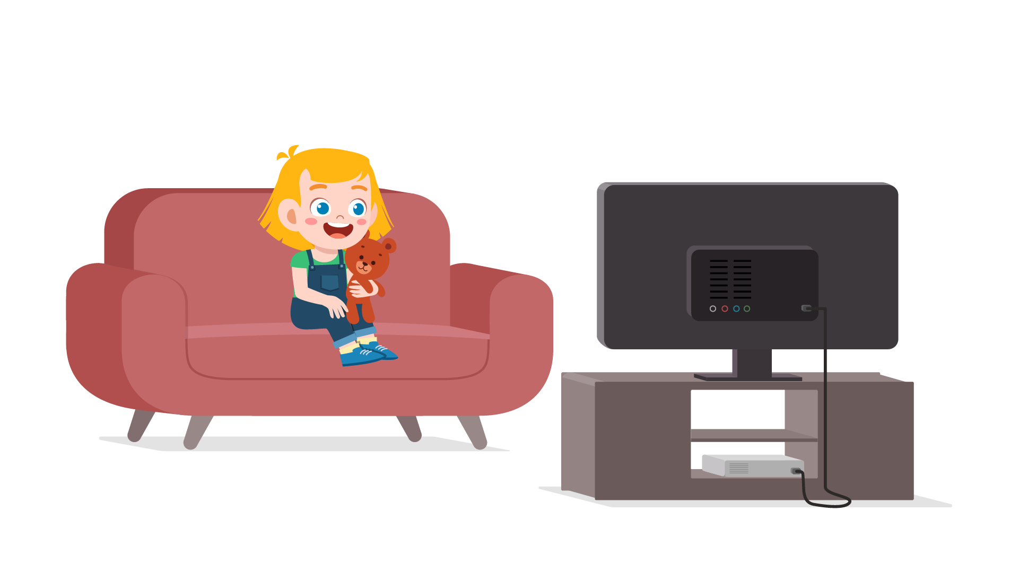 | 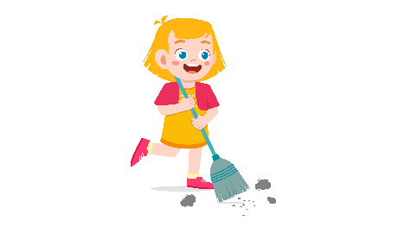
A ⬜ | B ⬜ | C ⬜
- What did Jim do at school today?
 | 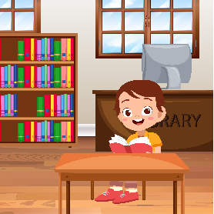 | 
A ⬜ | B ⬜ | C ⬜

- What’s the matter with Linh?
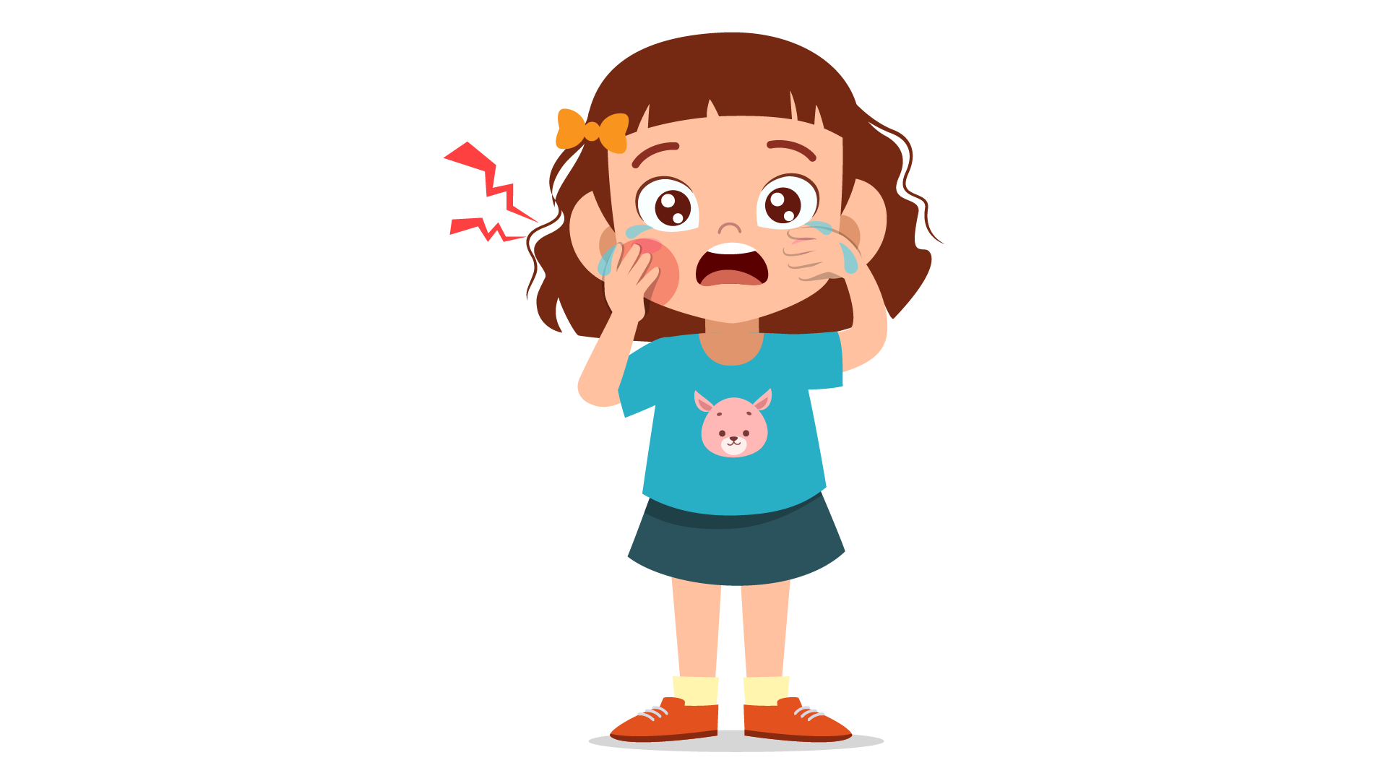 | 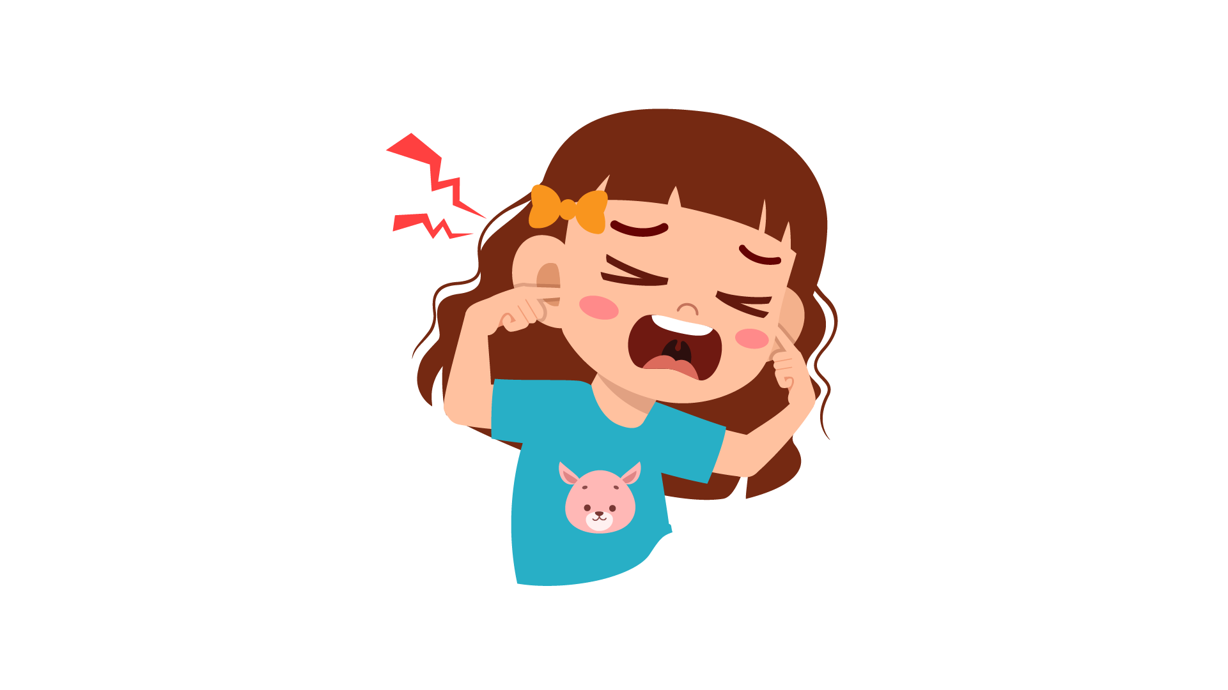 | 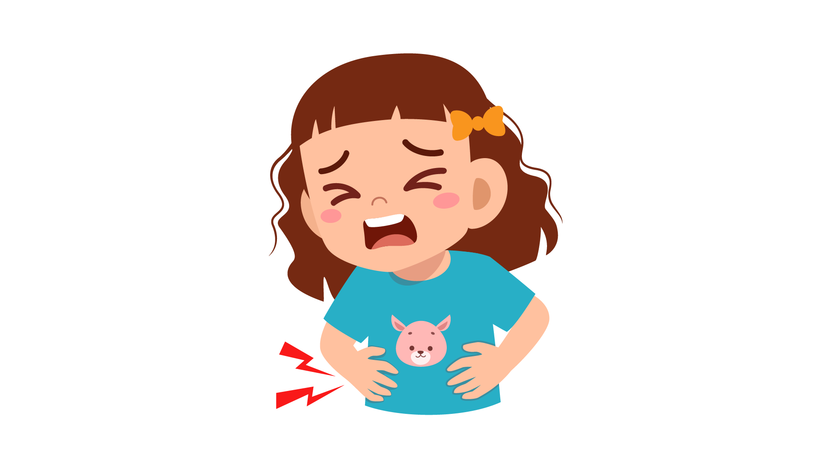
A ⬜ | B ⬜ | C ⬜

PART 5
5 questions

Listen and colour and draw.
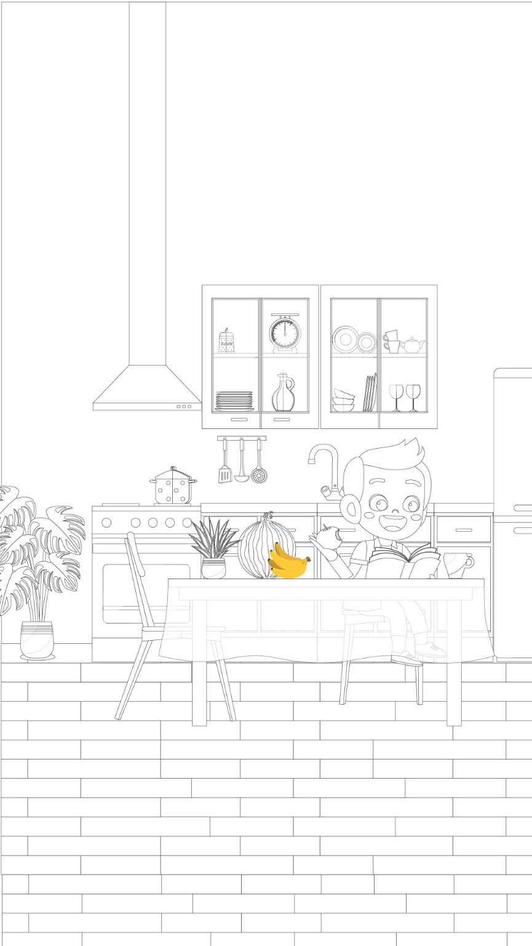

Reading and Writing
There are 35 questions
You have 30 minutes.
You will need a pen or pencil.
My name is…………………………….

PART 1
5 questions

Write the correct words on the lines.

 | 
A hospital | Wave
 | 
A balcony | A shape
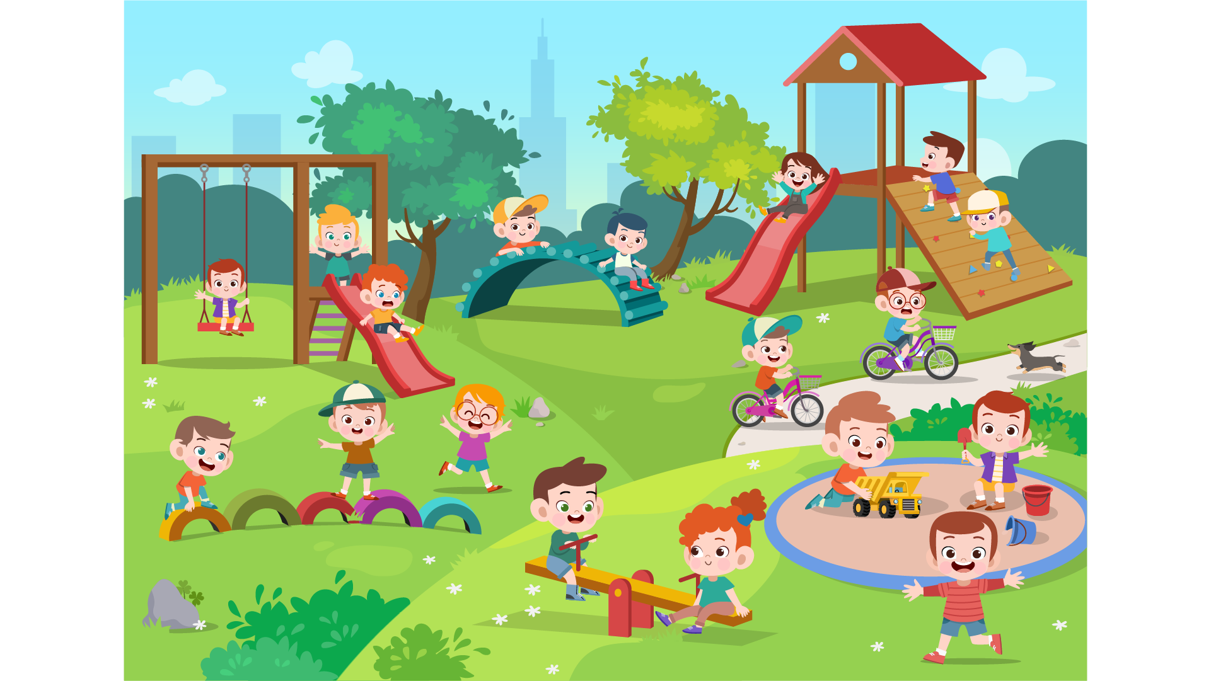 | 
A funfair | A puppy
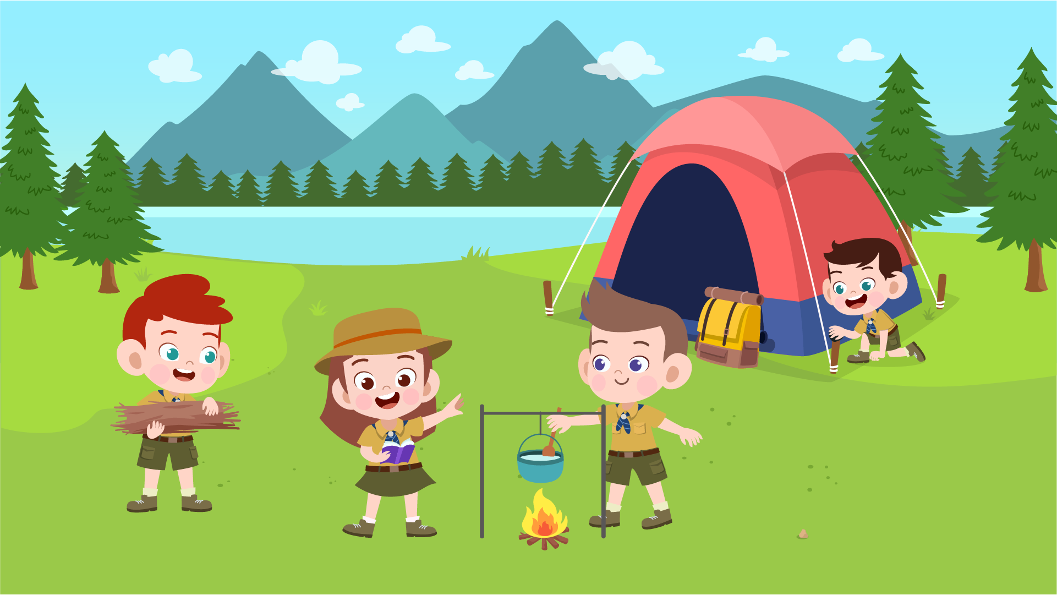 | 
A picnic | Bookcase

Example
(0) | It is a place. A doctor works there. | A hospital
Questions
1 | It’s a small dog. | ___________
2 | You put your book in it. | ___________
3 | It is a place in your house. It’s outside and upstairs. | ___________
4 | It’s a short trip. You eat outdoor in this trip. | ___________
5 | You see this when the sea moves.

PART 2
6 questions

Read the text and choose the best answer.
Jane is talking to her friend, Peter, on his first day at school.
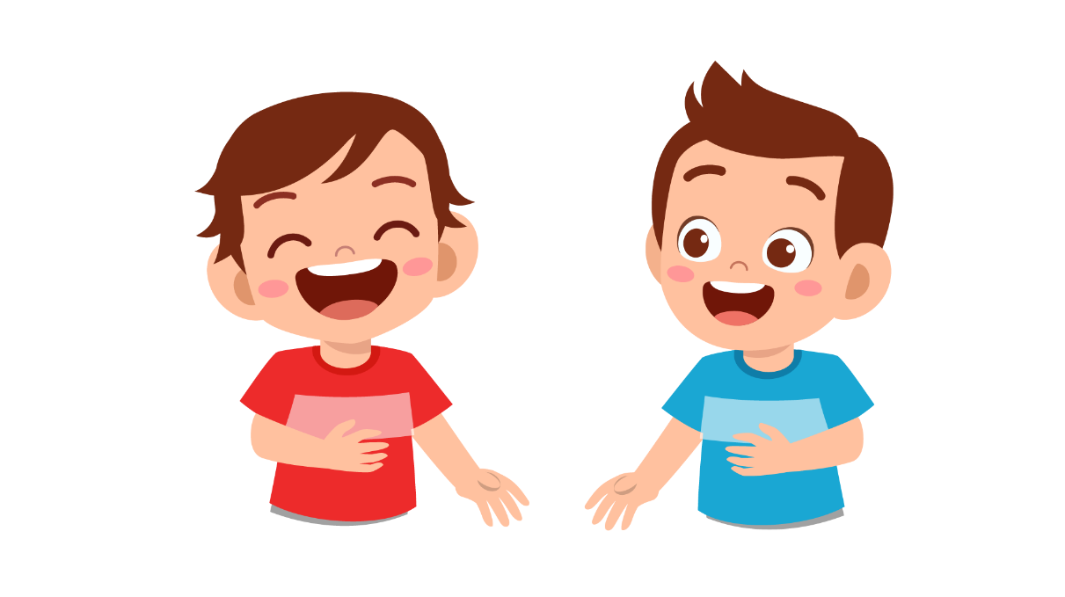

Example:
 | Jane: | How are you today, Peter?
 | Peter: | A. I’m five.
 |  | B. Thank you, and you?
 |  | C. I feel so good.
Questions:
1 | Jane: | What can you do, Peter?
 | Peter: | A. I don’t
 |  | B. No, I can’t.
 |  | C. I can play sports.

2 | Jane: | What’s your favourite sports?
 | Peter: | A. I like playing badminton with my friends.
 |  | B. I enjoy listening to music.
 |  | C. My favourite is pop music.

3 | Jane: | Are you in the school badminton team?
 | Peter: | A. Yes, I’m the captain of the team.
 |  | B. Yes, I’m the monitor of the class.
 |  | C. Yes, I’m the leader of my group.

4 | Jane: | Where do you often practice badminton?
 | Peter: | A. We study in the classroom.
 |  | B. We practice singing in music room.
 |  | C. We often play in the stadium at the weekend.

5 | Jane: | What time do you often practice badminton?
 | Peter: | A. From 6 p.m. to 8 p.m.
 |  | B. 2 hours every day
 |  | C. Twice a week.

6 | Jane: | Do you want to join us to practice badminton after school?
 | Peter: | A. No, absolutely not.
 |  | B. Why me?
 |  | C. Of course, yes!

PART 3
6 questions

Read the story. Choose a word from the box. Write the correct word next to the numbers 1-5. There is one example.
It was James’ birthday. He woke up and prepared to go to (0) …school… as usual. He had an English test on that day so he was quite worried. He had 1. … at home and rode to class. He wanted to come to class early, so he had more time to prepare for the test.
At 9 p.m., the teacher came in and gave each student a test paper. Everyone did the test silently. After the test, suddenly, someone turned off the 2. …. The room became so 3. … and James couldn’t see anything. Then the whole class sang the happy birthday song. The teacher brought a birthday cake with 4. … into class. Every one shouted “Happy birthday, James!”.
James was very 5. … and happy. It was his best birthday party ever!

Example
party | breakfast | lights
surprised | school | gifts
ice-creams | candles | dark

(6) Choose the best name for the story.
Tick one box.
A difficult test | ⬜
A surprising party | ⬜
The best class every | ⬜

PART 4
5 questions
Choose the right words and write them on the line.
 | Cheese
 | 
Example  1  2  3  4  5 | (0) How do people make cheese?  …, the farmer takes the milk from his cows. Then, he tests the milk.  … must be safe to drink! Then the farmer cooks the milk and sometimes adds different things to change its flavor. They can add fruits like strawberries or chocolate. You … ten big bowls of milk to make one big bowl of cheese! Some cheese you see in the shops is very new but some is … older. You can learn a lot bout making cheese … the internet.

Example: | live | living | lived
1. | Finally | When | First
2. | They | There | It
3. | need | needs | needing
4. | more | much | most
5. | in | on | at

PART 5
7 questions

Look at the picture and read the story. Write some words to complete the sentences about the story. You can use 1, 2 or 3 words.
A day at the zoo
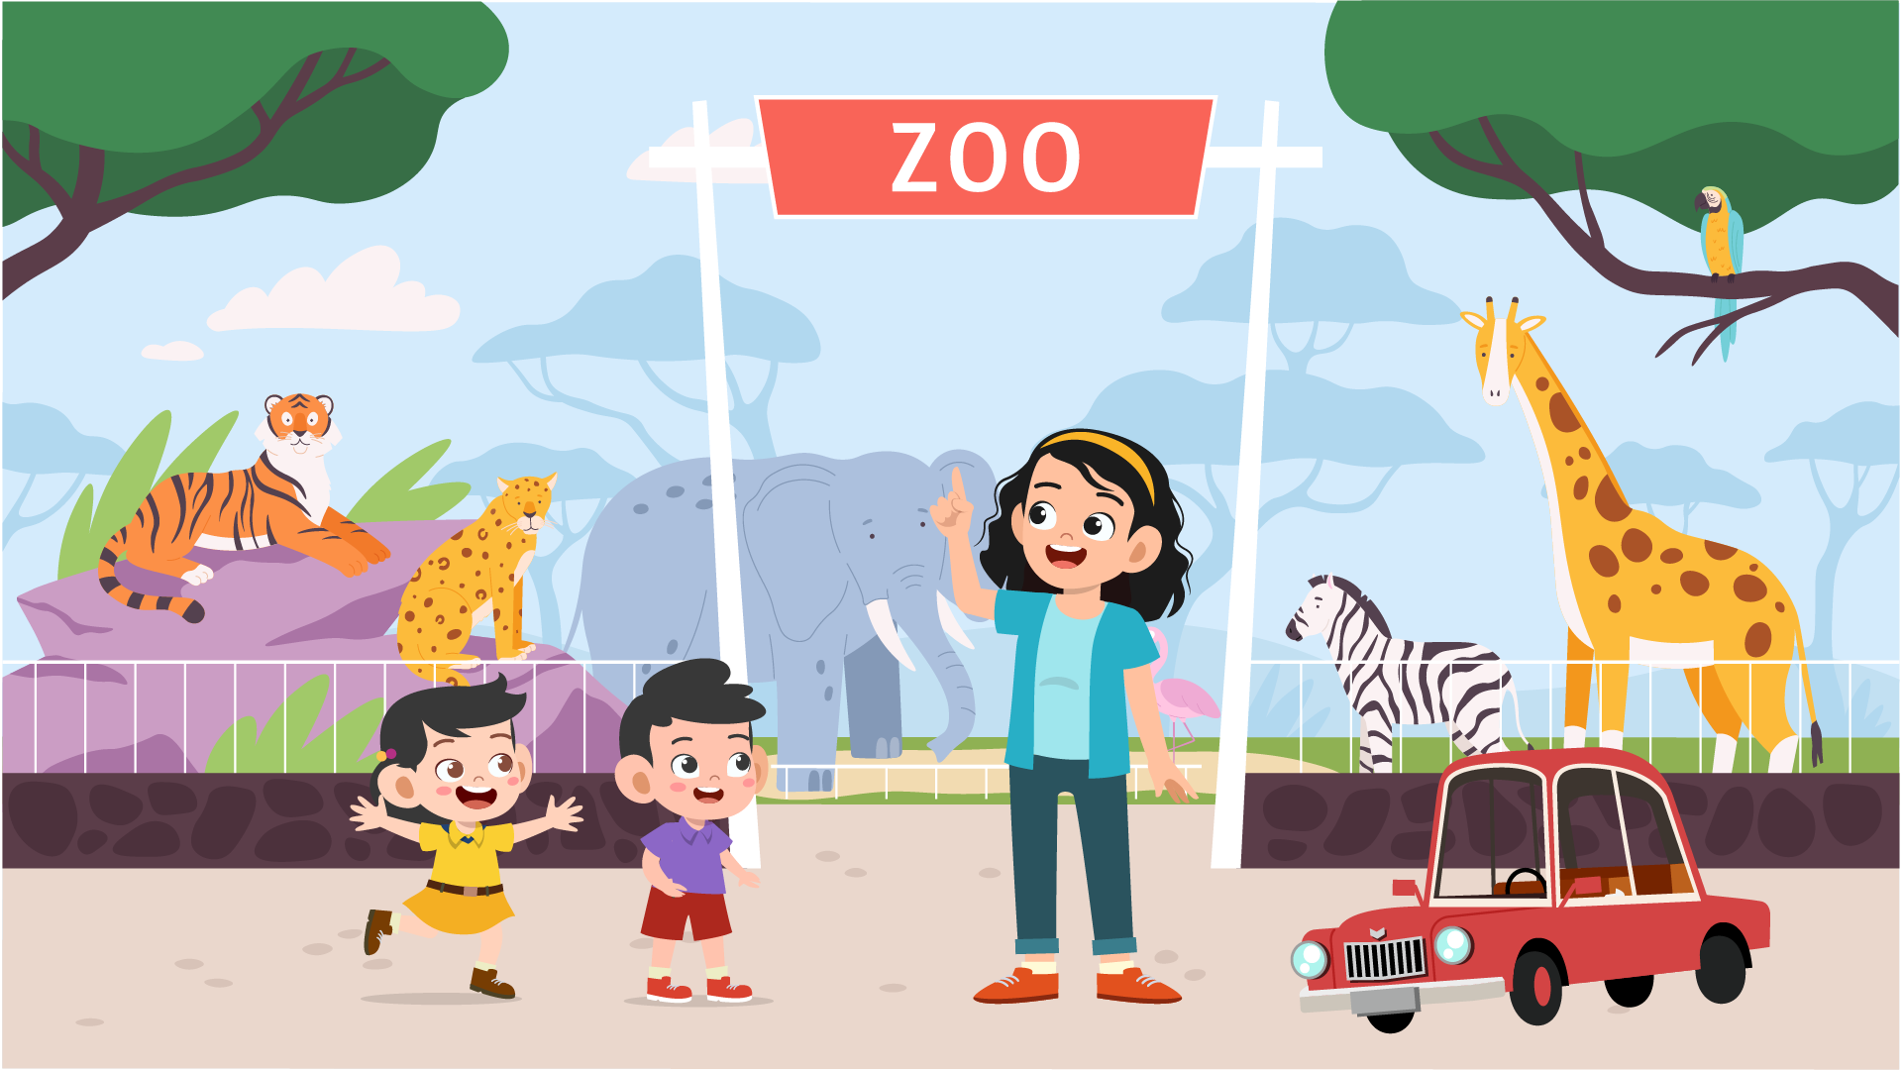
Last Sunday, Paul and Jane went to the zoo with their cousin, Sally. Sally was a nice girl. She was a university student and she really liked Paul and Jane. They often spent the weekends together. Sally came to Paul and Jane’s house. She took Paul and Jane to the zoo by her car.

Examples
Paul and Jane cousin is …Sally….
They came to the zoo by …car……

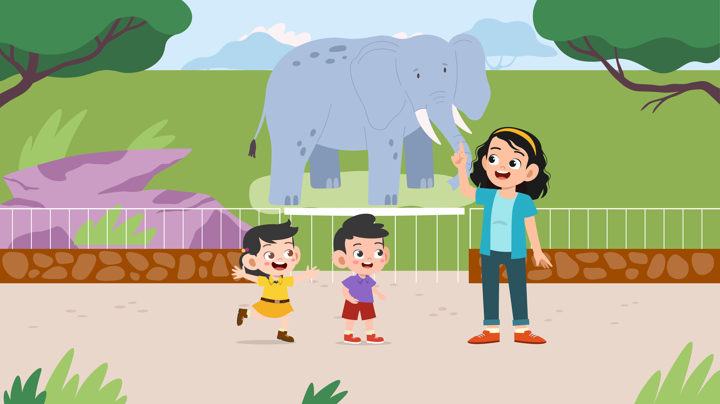
It was a hot and sunny day. So all three people needed to wear hats and sunglasses. When they were at the zoo, they looked at the elephants first. Then they visited the birds and the lions. The elephants were big. The birds were small but they were very fast. Paul was scared of the lions.

Question
1 | The weather was hot and ….
2 | … didn’t like the lions.
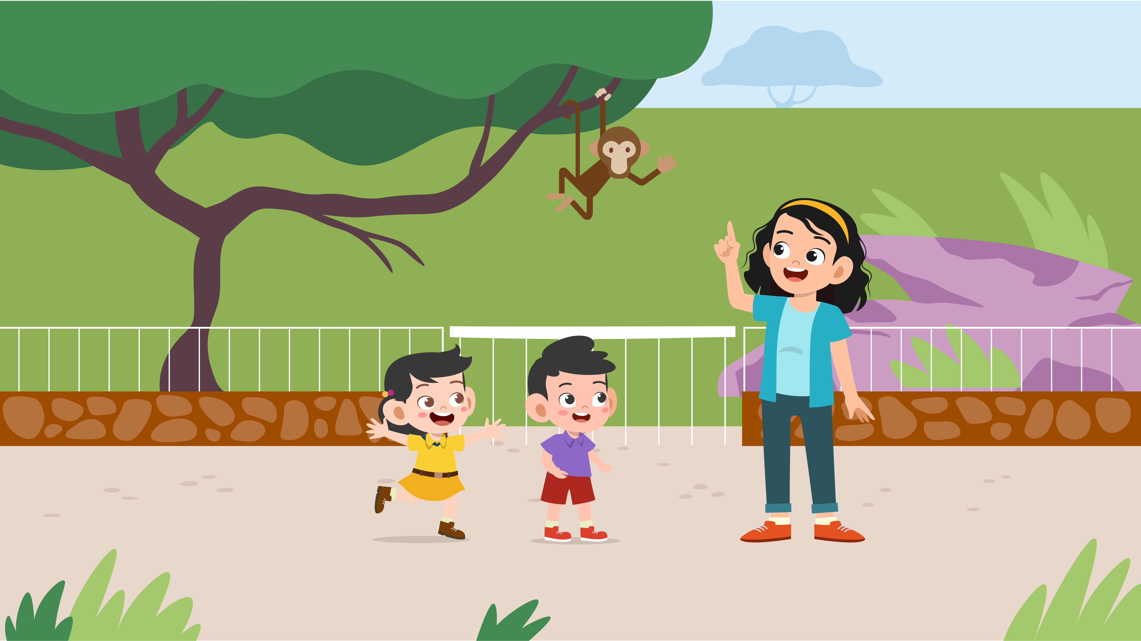
After lunch, Paul chose to see the monkeys. So they visited the monkeys together. Both Paul and Jane liked the peacocks. But there were not any at the zoo. So they visited the horses. Paul took a photo with horses. The photo looked nice. Jane wanted to take a photo with the monkeys. They looked very funny
Questions
3 | There were not any … at the zoo.
4 | They took photos of the … and monkeys.
5 | The … looked very funny.

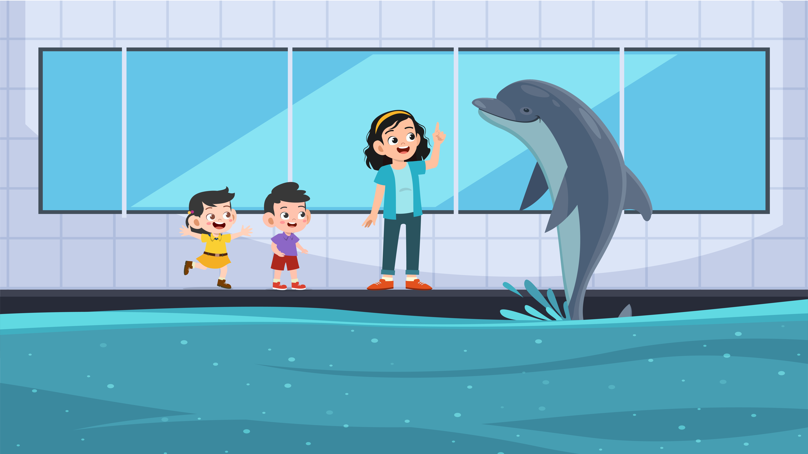
Before going home, they went to see the dolphin. They stood next to the pool. Sally took a photo of Jane and Paul with the dolphin. Then, the dolphin jumped. Jane and Paul got wet. Jane said “Oh, No! All my clothes are wet!”. Sally smiled and said “Don’t worry. Wear my coat and let’s go home.”

Questions
6 | The last animal they saw was the …
7 | Sally gave Jane her …

PART 6
6 questions

Look, read and write.
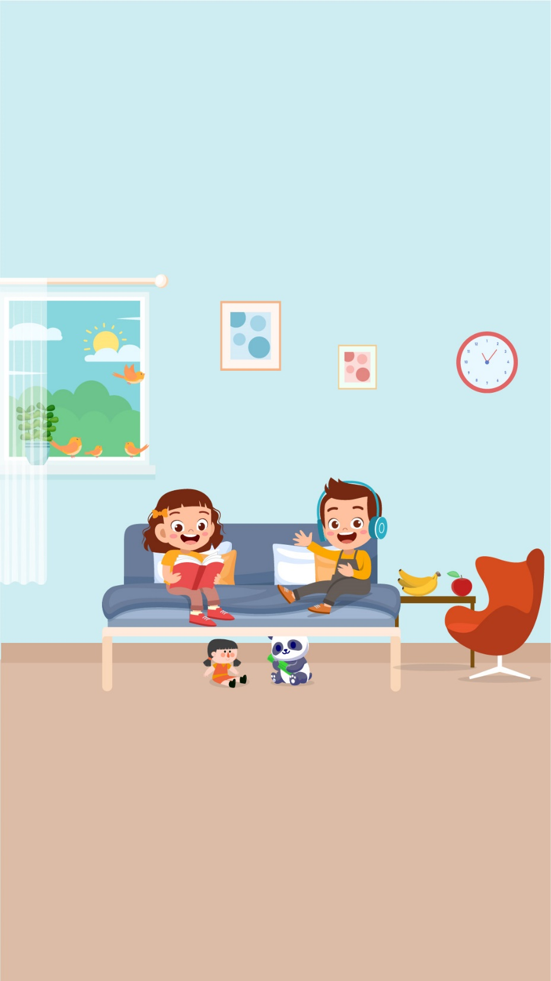
Examples:
There are two …children… lying on the bed.
Where is the bed? …next to…

Complete the sentences.
1. … birds are singing on the window.
2. A … is sitting next to the bed.

Answer the questions.
3. . What is the girl doing on the bed?
4. What are the fruits on the table?
Now write two sentences about the picture.
5. …………………………………….
6. …………………………………….
Speaking
My name is…………………………….

Summary of Procedures
The usher introduces the child to the examiner. The examiner asks how old the child is.

- The examiner asks the child to describe several differences between the two Find the Differences pictures, e.g. ‘In picture 1, there are four people but in picture 2, there are five’.
- The examiner tells the child the name of the story and describe the first picture, e.g. “It’s 11 o’clock. He’s watching TV.”. The examiner then asks the child to continue to tell the story.
- The examiner shows how to do the task with the first odd-one-out set of pictures. For example: ‘These are all places. But this is a room in a house’. Then the examiner asks the child to choose one picture in the other three sets and say which is different and why.
- The examiner asks questions about the child, e.g. ‘What do you often do in your free time?’

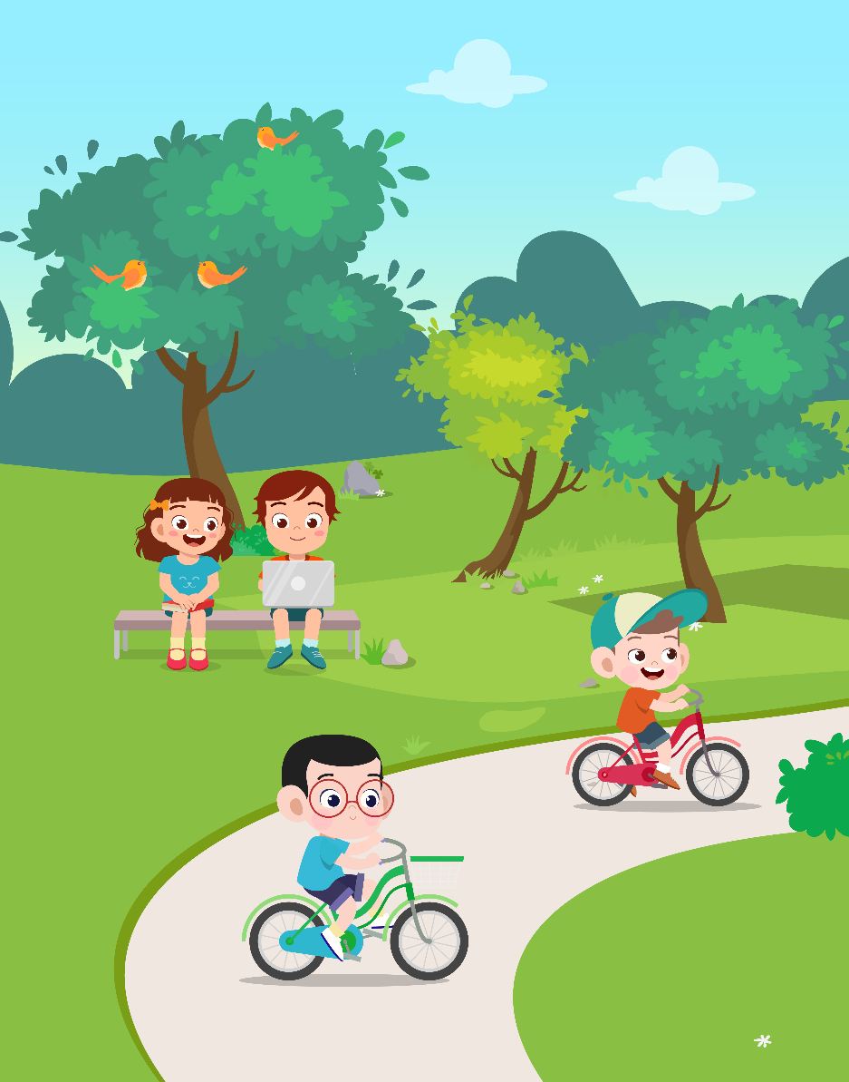 |  | 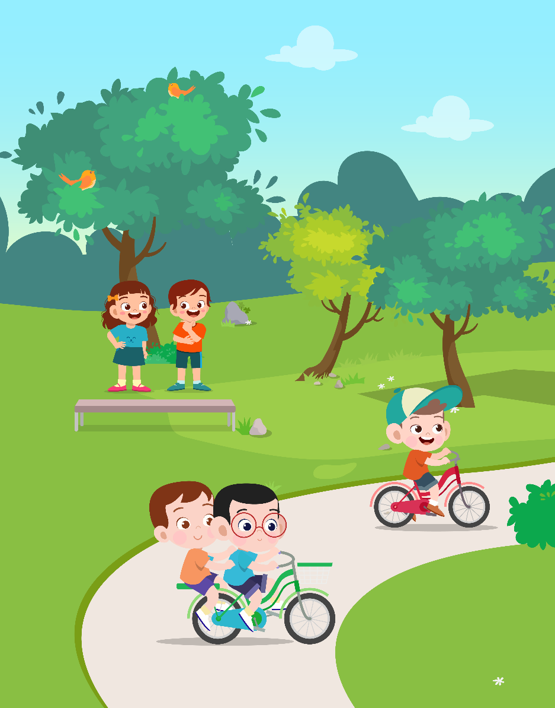

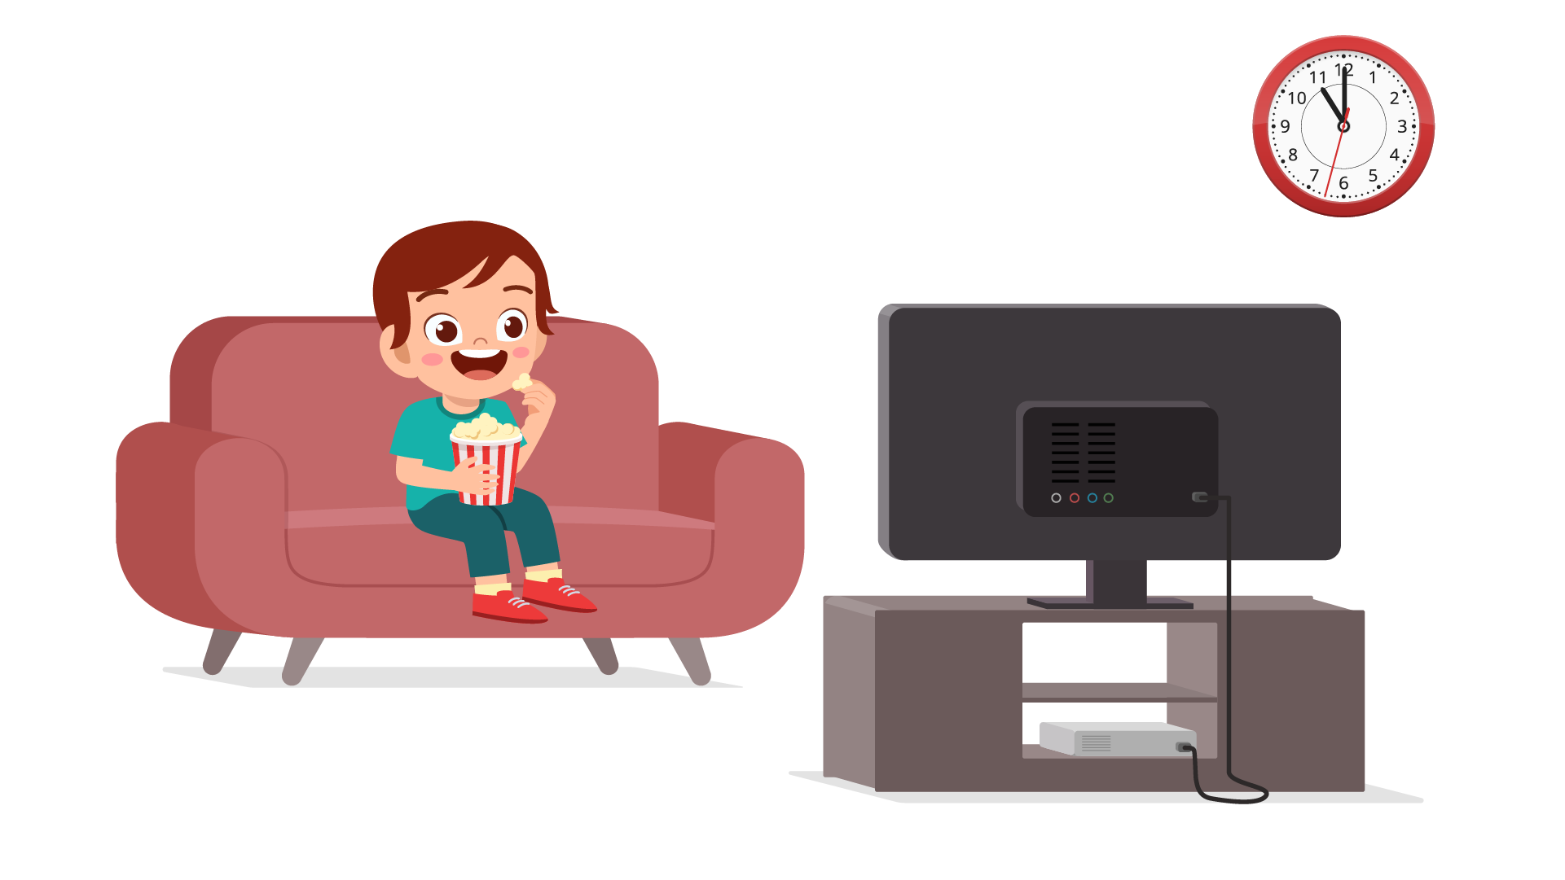
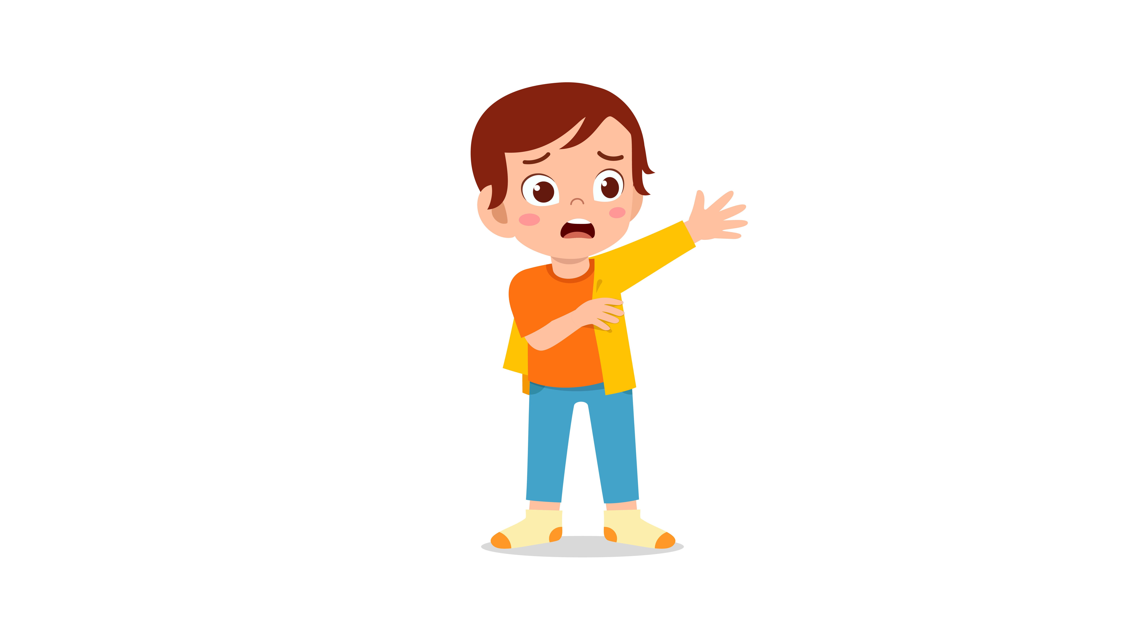 | 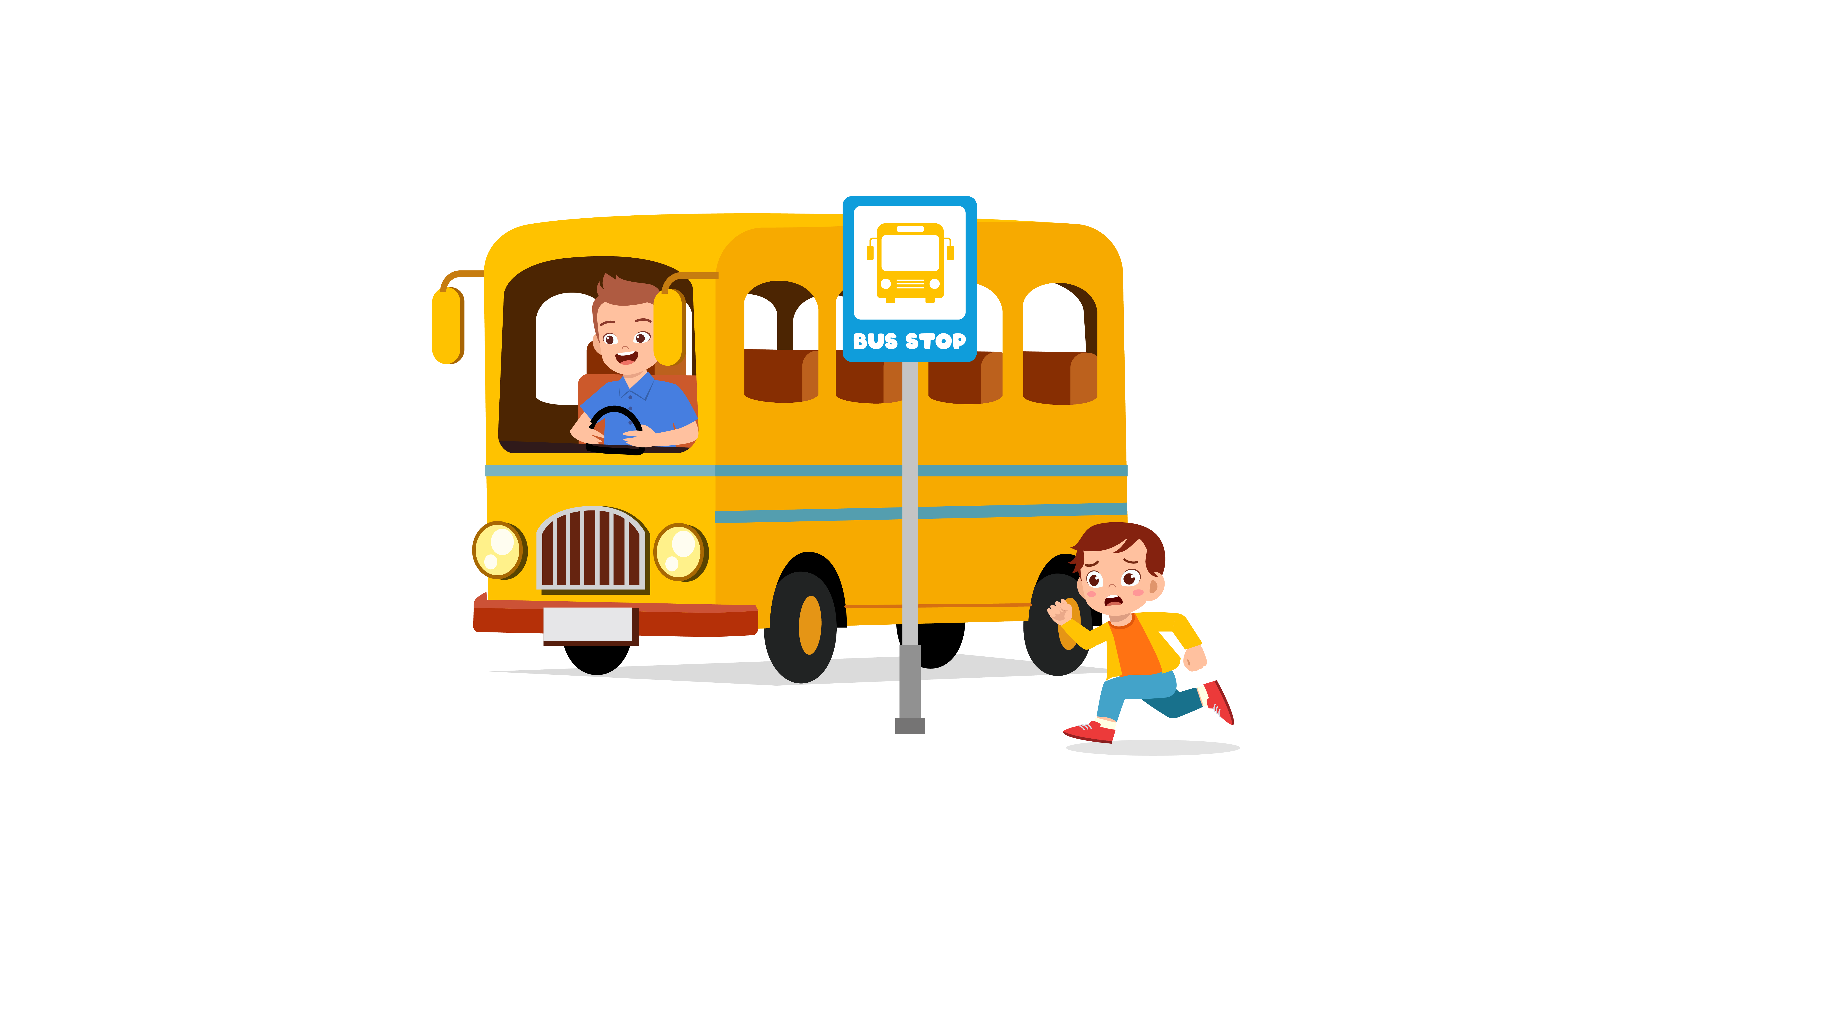 | 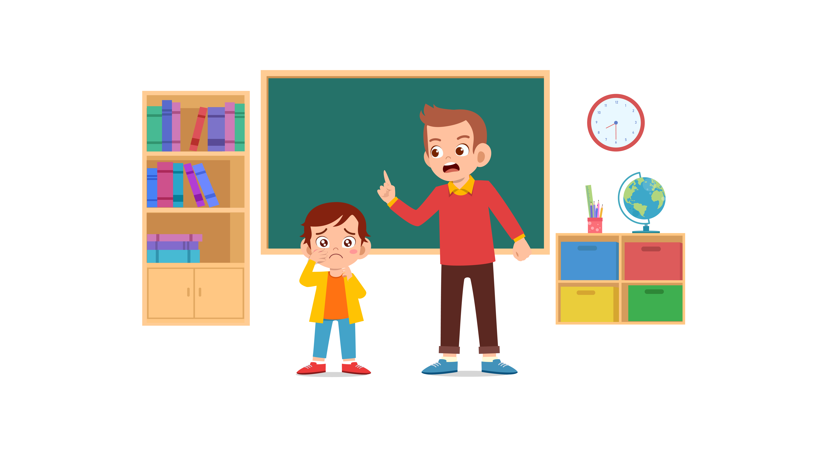

 |  | 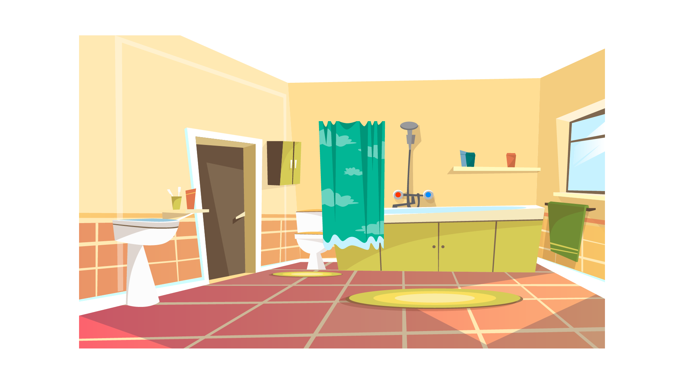 | 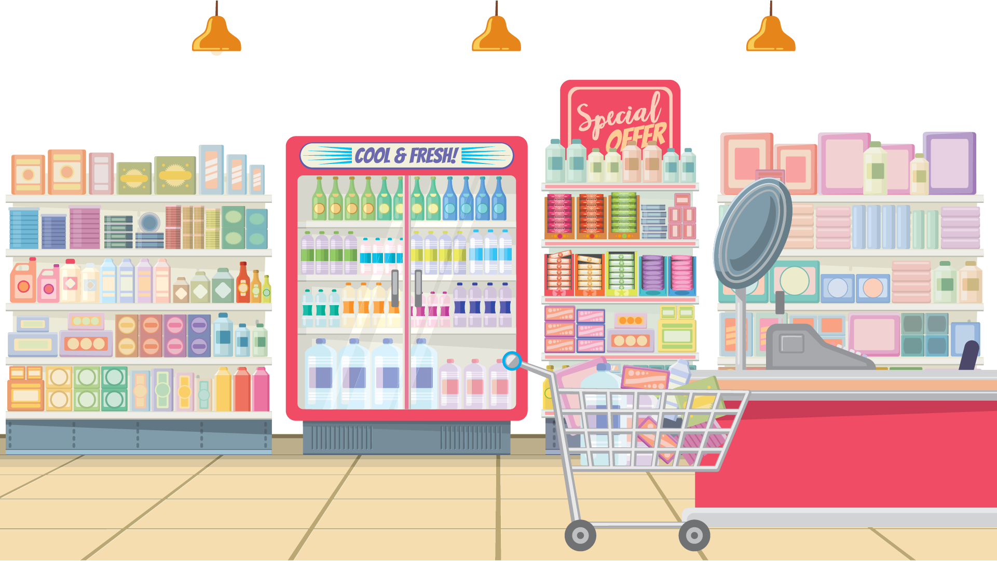
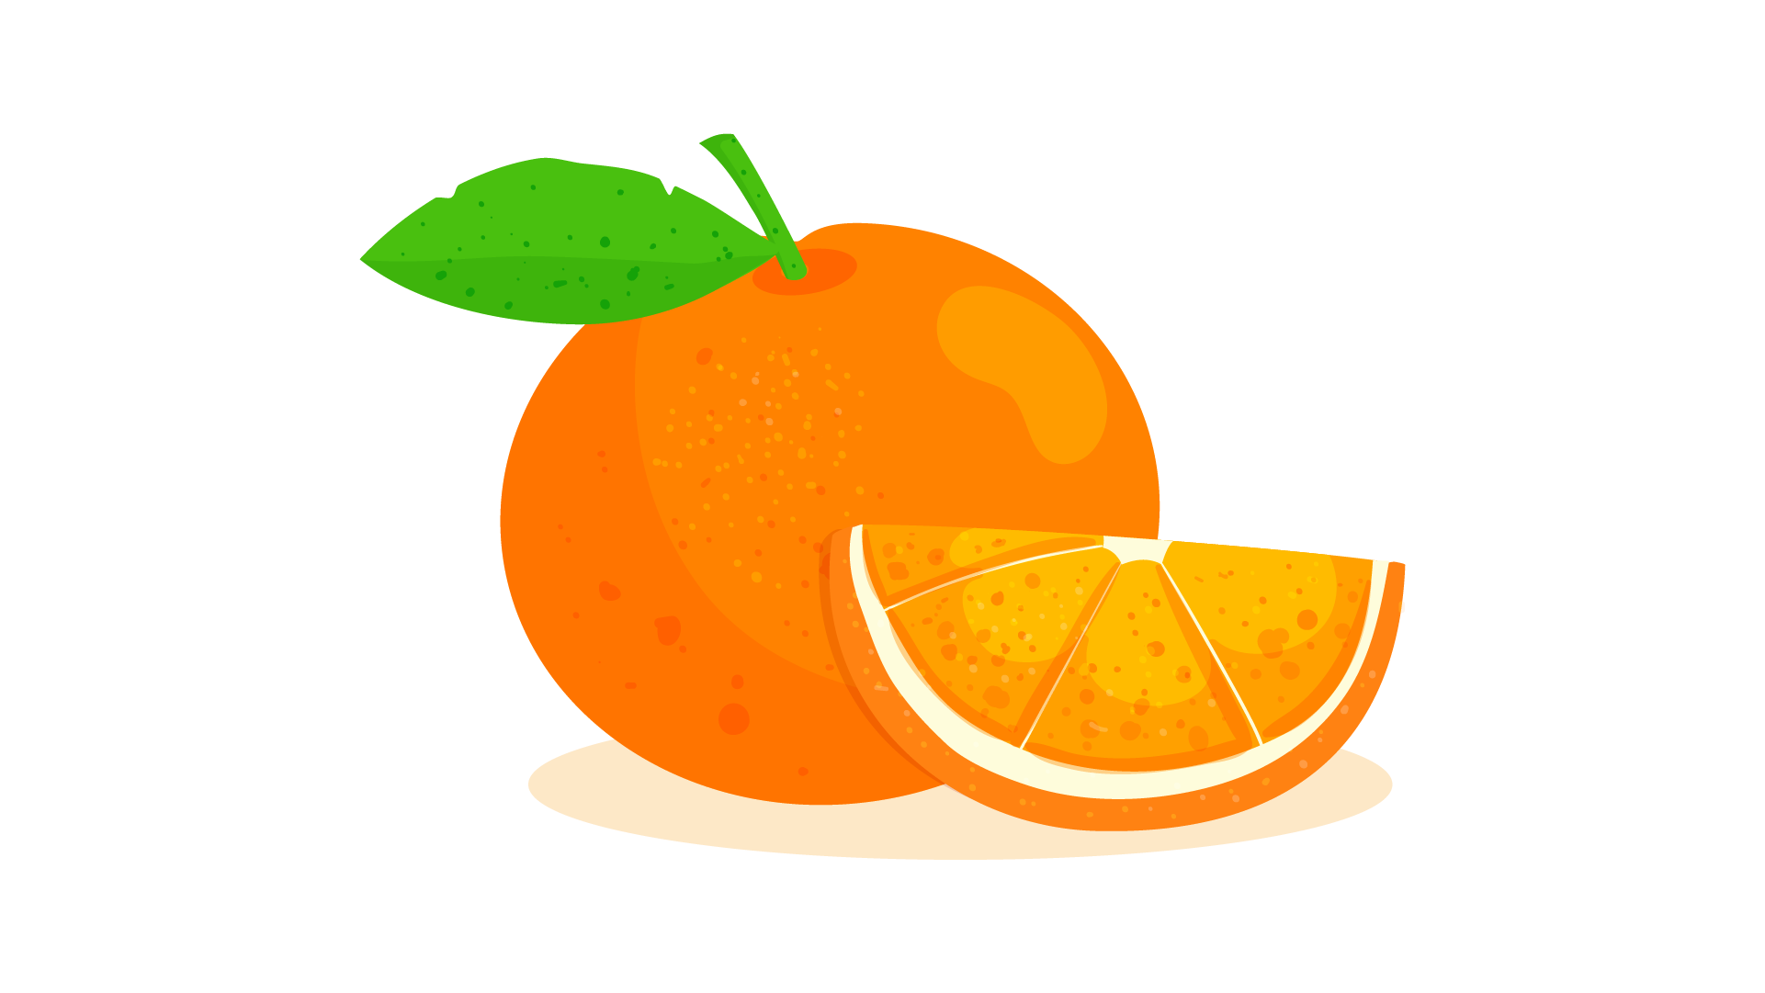 |  |  | 

 |  | 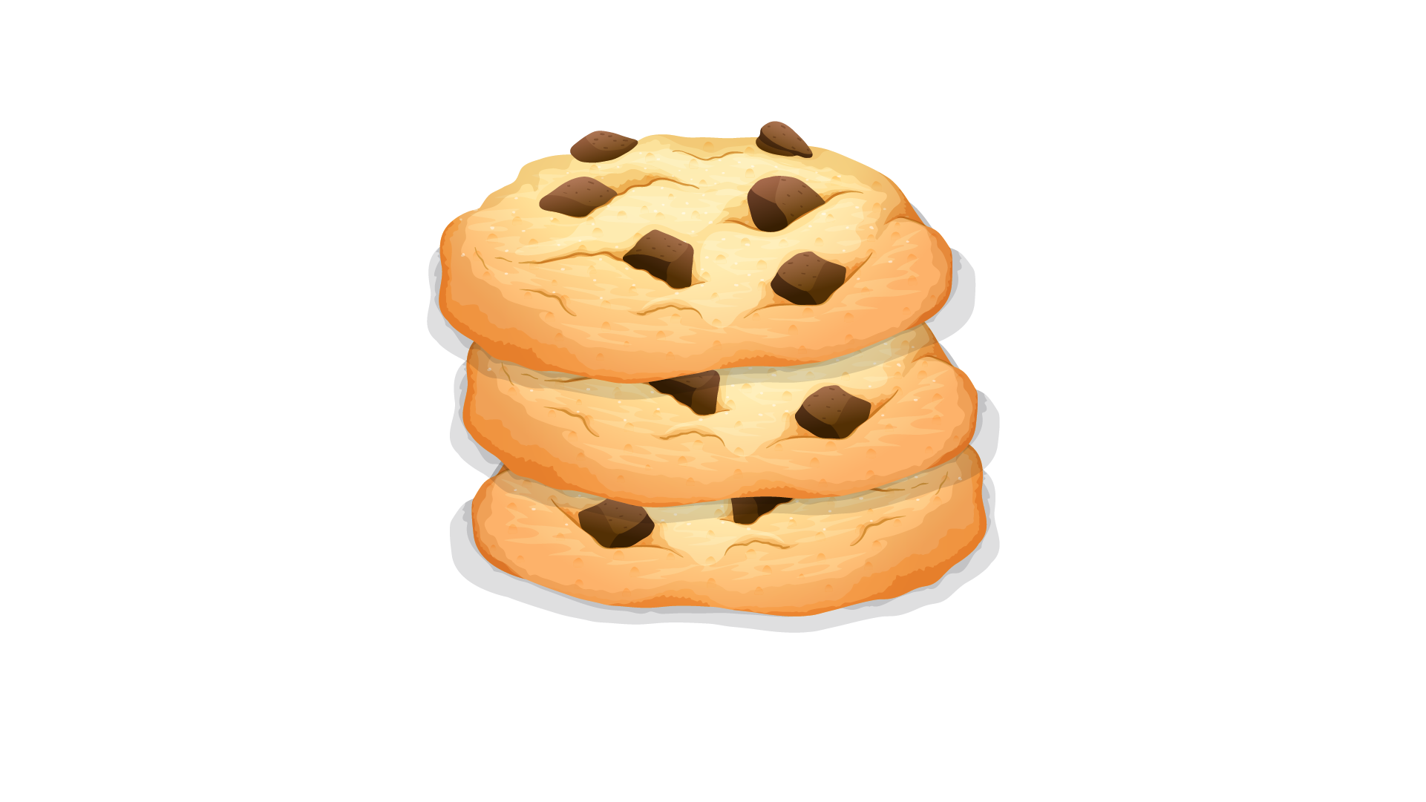 | 
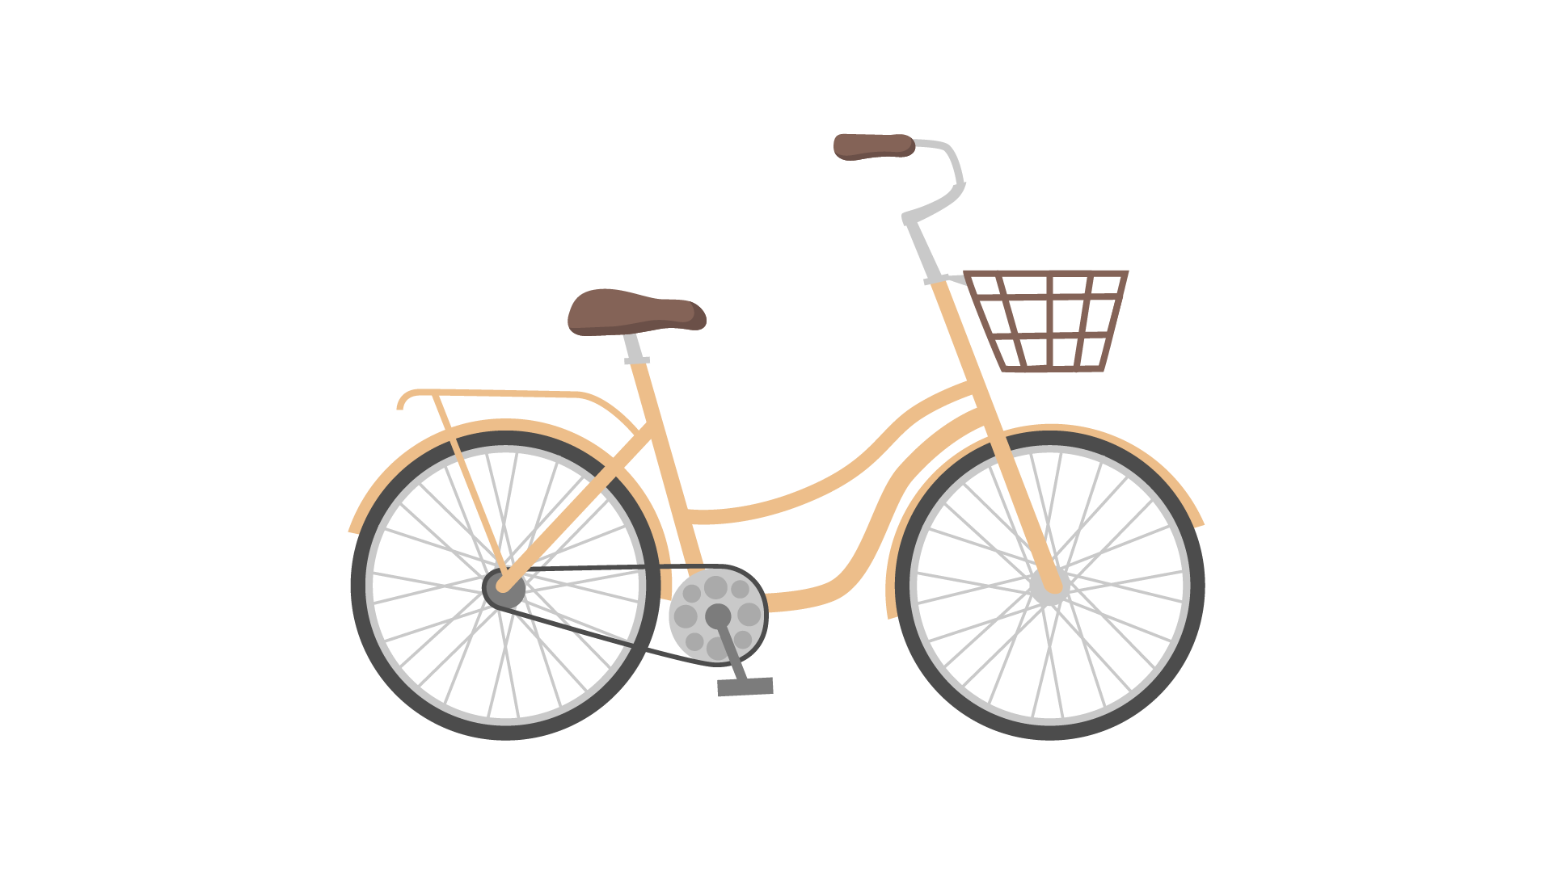 |  |  | 

