Thời gian làm bài: 40 phút (Không kể thời gian giao đề)
-------------------------
Họ tên thí sinh: .................................................................
Số báo danh: ......................................................................
Mã Đề: 011.
Câu 1. How many students is the snack shop looking for?
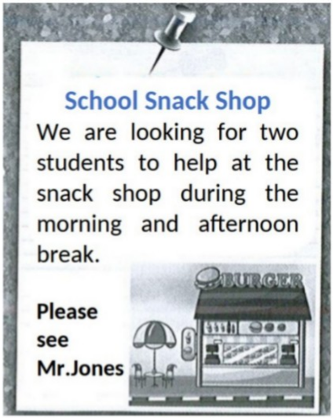
A. One B. Two C. Four D. Three
Câu 2. Look at the signs. Choose the best answer for the question.
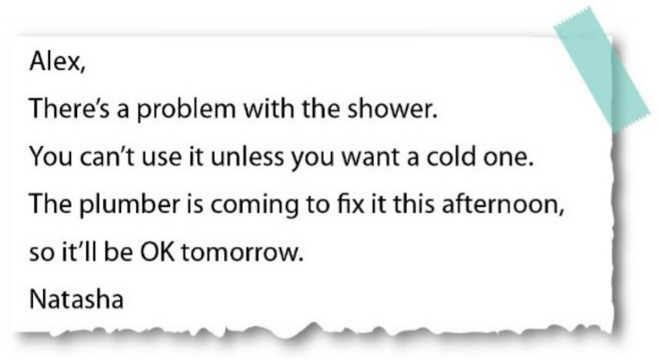
A. Alex can’t take a shower until tomorrow.
B. Alex prefers taking a cold shower today.
C. It is impossible to have a hot shower this morning.
D. The plumber will repair the shower tomorrow.
Câu 3. What is the main reason James cannot attend the concert?
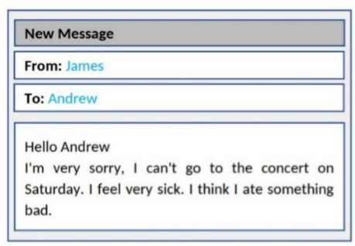
A. He is feeling unwell B. He doesn't like the music
C. He has another commitment D. He lost his ticket
Câu 4. What subject does John need help with?
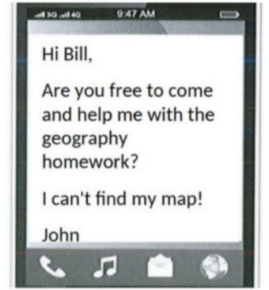
A. History B. Math C. Geography D. English
Câu 5. What does Rachel offer to do?
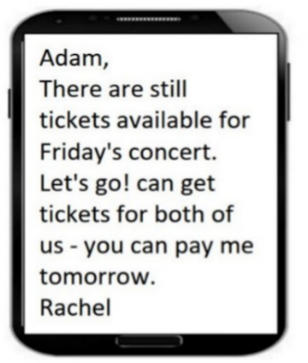
A. Reserve tickets for Adam B. Get tickets for both of them
C. Buy tickets for Adam D. Pay for both tickets
Câu 6. When can students receive a 20% discount at Sam's Café?
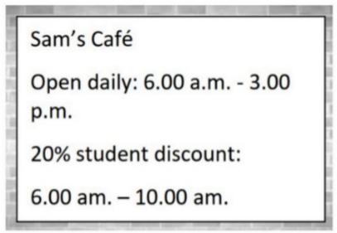
A. All day B. From 6:00 a.m. to 10:00 a.m.
C. After 10:00 a.m. D. From 6:00 a.m. to 3:00 p.m.
Câu 7. What activity is being proposed in the message?
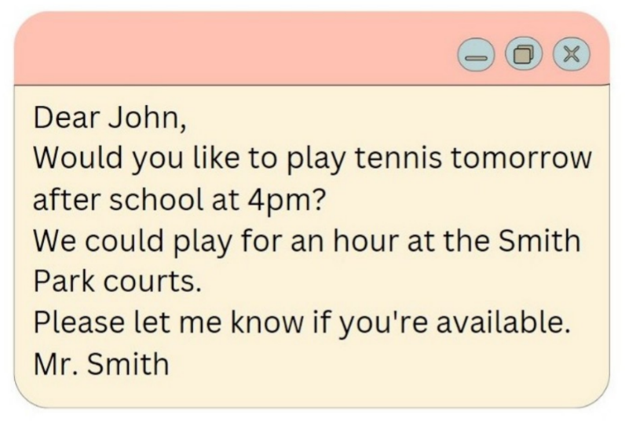
A. Playing tennis B. Playing basketball C. Going swimming D. Going for a run
Câu 8. Look at the signs. Choose the best answer for the question.
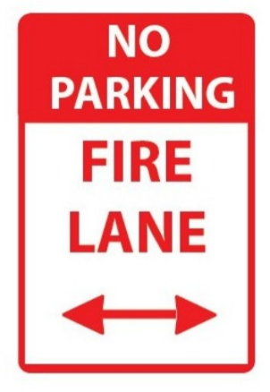
A. If there is a fire, park your vehicle in this area.
B. This area prevents your cars from fire.
C. You can’t park your car here when it is on fire.
D. You can’t park your car here because this area is for fire trucks.
Câu 9. Look at the signs. Choose the best answer for the question.
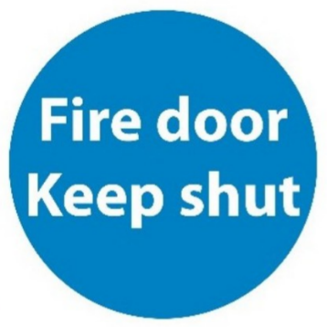
A. This door must remain closed to prevent the spread of fire.
B. You should only shut the door when it is on fire.
C. You mustn’t put the door on fire.
D. You should keep the door open unless there is a fire.
Câu 10. What are the things that Mom asked her kid to pick up?
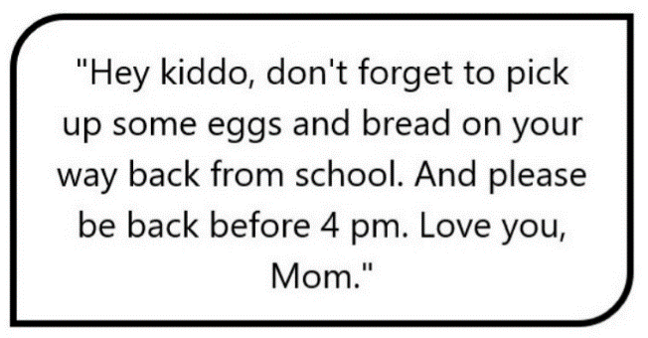
A. Eggs, bread, and milk B. Eggs and milk
C. Bread and milk D. Eggs and bread
----HẾT---

