Tiếng Anh 9 i-Learn Smart World – Đề tham khảo TS 10– THCS Lê lợi
Question 1: Choose the word whose underlined part pronounced differently from the others (0.5 pt.)
- A. breadwinner B. meanwhile C. weaker D. meal
- A subtitle B English C practice D dictionary
Question 2: Choose the word whose stress is not the same as that of the others (0.5 pt.)
- A. assistant B. generate C. furniture D. monitor
- A. criminal B. congested C. accident D. government
Question 3: Choose the correct answer to complete each sentence: (3 pts.)
- After her husband's sudden death, Melisa became the _____ and had to work hard to support her family.
A. housewife B. house husband C. breadwinner D. housekeeper
- The husband worked far away. Meanwhile, the wife raised the children alone.
A. Afterwards B. Whenever C. During that time D. Before
- Toby is my sister’s son, so he is my ______________.
A. nephew B. niece C. cousin D. daughter
- This neighborhood,________ many families have lived for decades, is very peaceful.
A. who B. where C. whom D. whose
- In the past, families________ often grow their own vegetables in the backyard.
A. will B. may C. have to D. would
- Instead of carrying paper maps, many people now use GPS navigation on their___________.
A. smartphone B. bicycle C. backpack D. compass
- A: "Let's meet at the library!" – B: "________”
A. That's easy! B. Alright. See you there!
C. I didn't know that. D. OK. Another time.
- It's sometimes confusing to ________ what is happening in a movie. You need the subtitles.
A figure out B come across C turn off D look up
- My dad is a police officer. He is ________ ensuring the safety of residents in my town.
A. interested in B. excited about C. in charge of D. fond of
- Sarah: “Was life hard when you looked for work for a long time, Gary?”
Gary: “Yes. ____________.”
A. It was homeless B. My job banned me
C. I struggled a lot D. I encouraged them
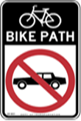
- What does this sign mean?
A. You can park here. B. This is path for cars only.
C. Only bikes are allowed here. D. You are allowed to drive cars here
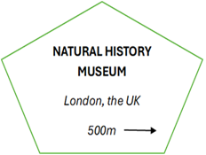
- What does this sign say?
A. Natural History Museum in London is 500 mins away on the right.
B. Natural History Museum in London is 500m away on the right.
C. Natural History Museum in London is 500 mins away on the left.
D. Natural History Museum in London is 500m away on the left.

Question 4: Give the correct form the words given in parentheses (1.5 pts)
- I feel _____________________________ for my mother's love and support. (thank)
- My parents have had a happy ______________________for 25 years. (marry)
- He lacks the ___________________skills for the job. (necessity)
- There was a sudden traffic jam because of a(n) _____________ car breakdown. (accident)
- They are building more affordable houses to solve the problem of _____________. (homeless)
- I damaged my car. I hope the _______________ can fix it. (machine)
FB: Thầy Đình (Dạy Tiếng Anh)

Question 5: Look at the entry of the word “useful” in the dictionary. Use what you can get from the entry to complete the sentences with two or three words (0.5pt.)
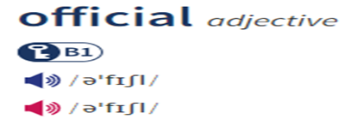
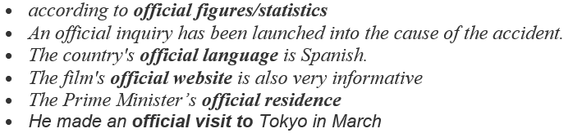

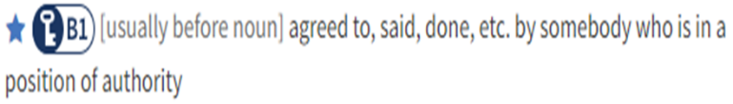

- The ambassador's _________________the country aimed to strengthen diplomatic relations..
- Mandarin is the _________________ of China and is spoken by millions of people worldwide.

Question 6: Read the passage carefully (1.5 pts.)
Next on our list is Sơn Đoòng Cave. It's one of the most impressive natural wonders in the world. You can find it in Quảng Bình Province, Vietnam. It is over 9 km long, up to 150 m wide, and up to 200 m deep. An underground river, which runs through the cave, created the cave's shape millions of years ago. Overall, it is 38.5 million m³ (cubic meters) in size. This makes it the largest known cave passage in the world by volume. Mr. Hồ Khanh, who is a local man, discovered the cave in 1991. He found it again in 2008, and that was when the world first heard about the cave. You can only visit Sơn Đoòng Cave from January to August. After August, heavy rains, which cause flooding, make it very difficult to get in and out of the cave. There is only one way to visit the cave. There is a special five-day tour, which has cave experts and tour guides. It's a challenging but unique experience, which you should try when you visit this cave. However, the number of visitors each year is limited to protect the cave from damage.

a. Decide TRUE OR FALSE
- Sơn Đoòng Cave, located in Vietnam, is the largest known cave passage in the world by volume. _____
- The cave was first discovered by Mr. Hồ Khanh 40 years ago. ____
- There are many ways to visit Son Đoòng Cave. _____
- You can only visit Sơn Đoòng Cave in January or August. ___

b. Choose the correct answer
- How deep is the deepest part of the cave?
A. 150 m B. 200 m C. 9 km D. 38.5 m
- Which of the following can you infer from the text?
A. You can visit the cave alone
B. You can't join a tour group
C. You must spend five days training before visiting the cave
D. You have to visit the cave with a tour group.

Question 7: Circle the letter of the correct answer to complete each sentence (1.5 pts.)
To stay healthy, it is important to take care of your body and mind. A __________ (31) is one of the most important things to focus on. A healthy diet includes eating __________ (32) such as fruits, vegetables, and proteins. Avoiding too much sugar and ______ (33) is also essential.
In addition _____ (34) a good diet, regular exercise is necessary. Exercise strengthens the heart, improves circulation, and helps to maintain a healthy weight. It is recommended to exercise for _______ (35) 30 minutes a day.
Getting enough sleep is another key factor for good health. Sleep helps the body recover and feel energized. Most teenagers need 8 to 10 hours of sleep each night.
Lastly, mental health is just as important. _____(36) stress, staying positive, and spending time with loved ones can all help to maintain a balanced life. A healthy mind and body are the foundation for a happy life.
FB: Thầy Đình (Dạy Tiếng Anh)

- A. balanced diet B. stressful lifestyle C. busy schedule D. random routine
- A. processed foods B. high-fat foods C. nutritious foods D. ugary snacks
- A. fat B. nutrients C. fruits D. foods
- A. on B. at C. for D. to
- A. less B. at least C. most D. more
- A. Manage B. Managed C. Managing D. To manage

Question 9: Rewrite the sentences, beginning as shown, so that the meaning stays the same (1pts.)
- When she was young, she did morning exercises every day.
→ She used_____________________________________________________________________
- The weather was so cold that we couldn’t go swimming.
→ It was such ___________________________________________________________________
- He passed the exam because of learning the lesson carefully.
→ Beause he ___________________________________________________________________
- People can control the lighting by speaking into their phones. They live in smart homes r.
→ People who __________________________________________________________________

--------------THE END-------------

