LỚP 6 HK1 FORM 2026 TEST 4

Mark the letter A, B, C or D on your answer sheet to indicate the word whose underlined part differs from the other three in pronunciation in each of the following questions.
Question 1. A. garage B. village C. message D. shortage
Question 2. A. hill B. ship C. kite D. chip

Mark the letter A, B, C or D on your answer sheet to indicate the word that differs from the other three in the position of primary stress in each of the following questions.
Question 3. A. historic B. direction C. museum D. gallery
Question 4. A. statue B. palace C. arrive D. peaceful

Mark the letter A, B, C or D on your answer sheet to indicate the correct answer to each of the following questions.
Question 5. “ Is there a square in your neighbour hood?” – “ ”

  - The square is beautifull C. No, there isn’t
  - My neighbourhood is big D. The square is in the neighborhood.
Question 6. My neighbourhood is much than his.
A. More exciting B. exciting C. most exciting D. excitingly
Question 7. Can you tell us the to White house?
A. Road B. street C. way D. instruction
Question 8. “What should we bring?” – “ ”
- I think you should stay at home C. We can bring some things
- We brought a torch D. Just some water and some food
Question 9. There aren’t natural wonders in that country.
A. Many B. some C. a few D. much
Question 10. A lion is regarded as a beast in African jungles.
A. Dangers B. dangerous C. dangerously D. dangerouness
Question 11. The American a midnight kiss with someone they love.
A. Share B. take C. bring D. celebrate
Question 12. , children will receive lucky money from adults during Tet holiday.
A. Tradition B. Traditions C. Traditional D. Traditionally
Read the following announcement and mark the letter A, B, C or D on your answer sheet to indicate the correct option that best fits each of the numbered blanks from 13 to 16.
HAPPY TET FROM EVERYONE AT SUNNY SCHOOL!
Tet is the most important festival in Vietnam. People usually visit their relatives and give each other lucky
(13) . Children wear new clothes and (14) red envelopes with money. Families eat special dishes and enjoy watching lion dances. Everyone (15) happy and excited. Tet is a great time to
(16) with family and friends.
Question 13: A. trees | B. pictures | C. money | D. wishes
Question 14: A. receive | B. receives | C. receiving | D. received
Question 15: A. be | B. is | C. are | D. was
Question 16: A. play | B. cook | C. travel | D. celebrate
Question 17: Put the sentences (a-c) in the correct order, then fill in the blank to make a logical text.
I went shopping for a new phone yesterday, but things didn’t go as planned. _________
a. When I arrived at the store, I found out that the phone model I wanted was out of stock.
b. I spent some time looking at other options, but I couldn’t find anything I liked.
c. After a long search, I decided to go to a different store to find the right phone.
A. a-b-c
B. b-a-c
C. c-a-b
D. b-c-a
Question 18: Choose the sentence that you can end the text (in Question 17) most appropriately.
A. I ended up buying a different model that was on sale.
B. The new store had a great selection, and I found the perfect phone.
C. I was disappointed but decided to return to the original store later.
D. I went home and decided to shop online for a better deal.

Read the following passage and mark the letter A, B, C or D on your answer sheet to indicate option that best fits each numbered blank from 19 to 24.
There are (19) Chinese festivals in Hong Kong. The Western New Year starts on the first day of January but the Chinese begin New Year on the first day of the first moon of the Chinese calendar. Before New Year's Day comes, people clean and decorate their houses, (20) a lot of traditional food and go shopping for presents and new clothes. New Year's Eve is the time (21) every family gathers its members together for dinner. People (22) the New Year with a music performance and a firework display to light up the sky. On New Year's Day, they visit their friends and relatives. The children get lucky money in red envelopes. Many people go to the (23) to wish for good health and good luck. Chinese people in Hong Kong celebrate the New Year with (24) and happiness.
Question 19. A. much B. many C. a few D. a little Question 20. A. take B. bring C. cook D. sell Question 21. A. when B. after C. before D. during Question 22. A. meet B. see C. end D. celebrate Question 23. A. houses B. pagodas C. family D. camps Question 24. A. hopeful B. hopeless C. hope D. hoping

Mark the letter A, B, C or D on your answer sheet to indicate the sentence that closest in meaning to the original sentence in each of the following questions.
Question 25. It's a good for you to take exercise every day.
- You should take exercise every day.
- You mustn't take exercise every day.
- You needn't take exercise every day.
- You shouldn't take exercise every day.
Question 26. It's a good idea to listen to the weather forecast before going camping.
- You must listen to the weather forecast before going camping.
- You should listen to the weather forecast before going camping.
- You couldn't listen to the weather forecast before going camping.
- You shouldn't listen to the weather forecast before going camping.

Mark the letter A, B, C or D on your answer sheet to indicate the sentence that is made from the given cues in each of the following questions.
Question 27. Viet Nam / people / should / break things / at Tet.
- In Viet Nam, people should break things at Tet.
- In Viet Nam, people didn't break things at Tet.
- In Viet Nam, people shouldn't break things at Tet.
- In Viet Nam, people will break things at Tet.
Question 28. the Scottish / go / grave yard / on New Year's Eve.
- The Scottish go to the graveyard on New Year's Eve.
- The Scottish don't go to the graveyard on New Year's Eve.
- The Scottish will go to the graveyard on New Year's Eve.
- The Scottish are going to the graveyard on New Year's Eve.
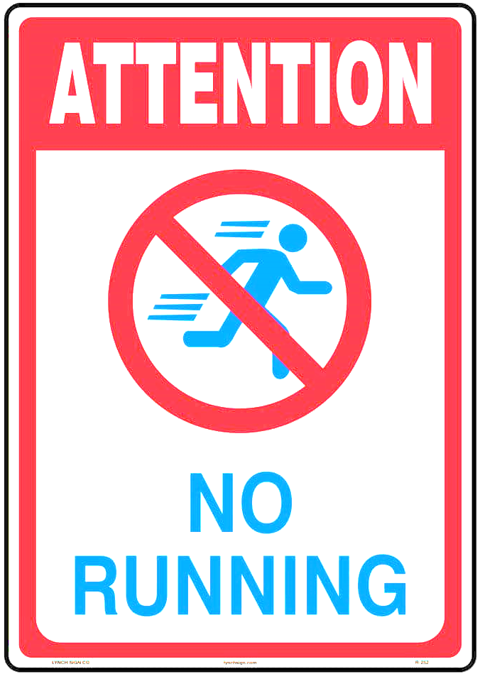
Question 29: What does the sign mean?

A. Running is not encouraged here, so you should run as much as you can.
B. Running is allowed in some specific places, but not here.
C. Only children are allowed to run here; adults should walk.
D. Running is not allowed in this area, so you need to walk instead of running.

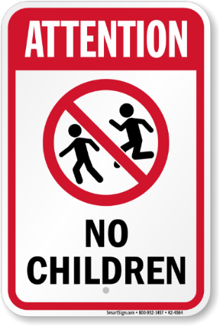
Question 30: What does the sign mean?

A. Children are welcome in this area.
B. The area is for people over 16 only.
C. Children are not allowed to run in this area.
D. Children can enter but must be accompanied by an adult.

Read the following passage and mark the letter A, B, C or D on your answer sheet to indicate the correct answer to each of the following questions from 31 to 36.
When people talk about Nha Trang, the biggest city in Khanh Hoa Province, they often think of a tropical paradise. Nha Trang is a famous seaside resort. It has a long coastline with beautiful white sandy beaches. In the morning and afternoon, tourists can take part in various fascinating outdoor activities such as mud bathing, swimming, snorkeling or scuba diving. Snorkeling and scuba diving are both interesting sports, as swimmers may swim underwater and admire the lives at the bottom of the sea. Besides, tourists can also take boat trips to the islands. One of the most enjoyable trips is the trip to Mieu Island, where Tri Nguyen Aquarium was built in 1999. This aquarium is now home to different kinds of colorful fish and even a few sharks.
In addition, tourists can spend an evening visiting a fishing village, where they could get a taste of the local seafood. There are crabs, shrimps, lobsters, clams, oysters, and several other kind of fish - all are fresh and delicious.
Question 31. Nha Trang is .
A. famous for its fresh and delicious seafood. B. located in Khanh Hoa Province.
C. a paradise for swimmers. D. not a resort.
Question 32. Tourists can take part in some outdoor activities such as .
A. visiting Nha Trang Pasteur Institute. B. eating the local seafood.
C. visiting Tri Nguyen Aquarium. D. scuba diving.
Question 33. At Tri Nguyen Aquarium, visitors can enjoy .
A. watching a few sharks only. B. a taste of the local seafood.
C. watching sharks and various kinds of colorful fish. D. feeding the fish.
Question 34. At a fishing village, tourist can .
A. get a taste of the local seafood B. catch the fish and cook them
C. choose crabs, shrimps D. enjoy fishing
Question 35. Which of the following sentences is NOT mentioned in the passage?
A. Nha Trang is a nice seaside resort.
B. Tri Nguyen Aquarium is on an island.
C. Most tourists are interested in snorkeling and scuba diving.
D. The local seafood is fresh and delicious.
Question 36. The word “famous” is CLOSEST in meaning to .
A. Well-known B. beautiful C. attractive D. romantic

Four phrases/ sentences have been removed from the text below. For each question, mark the letter A, B, C or D on your answer sheet to indicate the correct option that best fits each of the numbered blanks from 37 to 40.
Vietnamese food culture varies by regions from the north to the south. (37) . Northern Vietnam is seen to be the cradle of Vietnamese cuisine with (38) , etc. Then, food culture in Northern Vietnam became popular in Central and Southern Vietnam with suitable flavors in each regions.
The regional cuisine of Central Vietnam is famous for its spicy food. (39) . Food in the region is often used with chily peppers and shrimp sauces, namely, Bun Bo Hue, BanhKhoai, BanhBeo, etc.
In Southern Vietnam, the warm weather and fertile soil create an ideal condition for planting a variety of fruit, vegetables and livestock. Thus, food in the region is often added with garlic, shallots and fresh herbs. Particularly, (40) . Some signature dishes from Southern Vietnam include BanhKhot and Bun Mam.
- many notable dishes like Pho, Bun Rieu, Bun Thang, Bun Cha, BanhCuon
- Hue cuisine is typical Central Vietnam's food culture
- In Northern Vietnam, food is characterized by light and balanced
- Southerners are favored of sugar; they add sugar in almost dishes
Question 37 Question 38 Question 39 Question 40

