**TIẾNG ANH 9 FRIENDS PLUS**

**BÀI KIỂM TRA ĐỊNH KÌ**

**UNIT 8 – TEST 2 - KEY**

**I. Pronunciation (1-4)**

**Câu 1.** Which word has the underlined part pronounced differently from that of the others?

**A.** fr**u**strating  **B.** c**u**lture  **\*C.** s**u**bdue  **D.** l**u**nch

**Câu 2.** Which word has the underlined part pronounced differently from that of the others?

**A.** play**ed**  **\*B.** skat**ed**  **C.** cover**ed**  **D.** liv**ed**

**Câu 3.** Which word has a different stress pattern from that of the others?

**\*A.** exhibition  **B.** behaviour  **C.** environmental  **D.** destruction

**Câu 4.** Which word has a different stress pattern from that of the others?

**\*A.** adventurous  **B.** disappointed  **C.** preparation  **D.** beneficial

**II. Choose the answer (A, B, C or D) that best fits the space in each question. (5-14)**

**Câu 5.** Climbing a steep mountain can be very ________ if you are not prepared.

**\*A.** risky  **B.** overcrowded  **C.** thrilled  **D.** spread

**Câu 6.** It's important to _______ before making big decisions.

**A.** lead to  **B.** belong to  **\*C.** make up your mind  **D.** get involved with

**Câu 7.** We didn't have much choice, so we had to ________ what we had.

**A.** sprain  **\*B.** make do with  **C.** keep away from  **D.** ward off

**Câu 8.** She has a ________ of spiders and cannot even look at pictures of them.

**A.** thrill  **B.** ward  **C.** sprain  **\*D.** phobia

**Câu 9.** That idea is ________; it doesn't make any sense.

**\*A.** ridiculous  **B.** thrilling  **C.** fatal  **D.** extreme

**Câu 10.** You don’t want to get a new phone, do you?

**A.** I will phone you soon.  **\*B.** Well, this one’s a little old.

**C.** No, my home is very comfortable.  **D.** I didn’t think you would.

**Câu 11.** "Close the door," the teacher said to John.

The teacher told John...

**A.** to closing the door  **B.** close the door  **\*C.** to close the door  **D.** that close the door

**Câu 12.** Sarah asked, "Do you want to go to the park?"

Sarah asked me...

**\*A.** if I wanted to go to the park  **B.** do I want to go to the park

**C.** if you wanted to go to the park  **D.** did I want to go to the park

**Câu 13.** The train was so ________ that there was no place to sit.

**A.** fatal  **B.** thrilled  **C.** ridiculous  **\*D.** overcrowded

**Câu 14.** Parents often _______ family heirlooms to their children.

**\*A.** pass down  **B.** figure out  **C.** look forward to  **D.** get around

**III. Look at the signs. Choose the best answer (A, B, C or D). (15-16)**

**Câu 15.** What is the primary purpose of asking customers to arrive early?

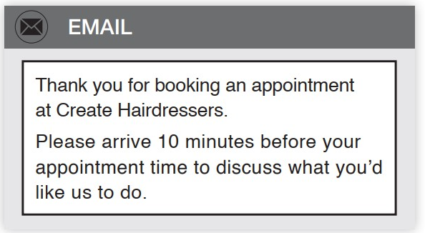

**A.** To ensure they don't miss their appointment  **\*B.** To discuss the desired hairstyle

**C.** To allow time for paperwork  **D.** To offer complementary services

**Câu 16.** What should customers do if they find a problem?

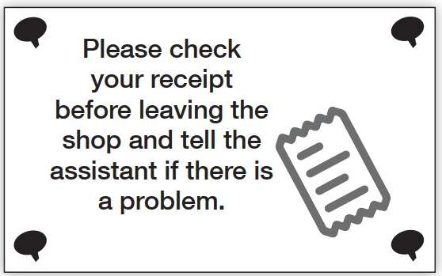

**A.** Write a complaint letter  **B.** Leave the shop immediately

**\*C.** Tell the assistant  **D.** Call the police

**IV. Read the following passage and do as direct. (17-22)**

**Soccer, also known as football in many countries, is one of the world's most popular sports. But how did it begin?**

**The exact origins of soccer are unclear, as many ancient cultures played games involving kicking a ball. In China, over 2,000 years ago, people played "cuju," which involved kicking a leather ball through a small net. Ancient Greeks and Romans also had ball-kicking games.**

**However, modern soccer began to take shape in England during the Middle Ages. At first, it was a rough game with few rules, often played between whole villages. The game could be violent and was sometimes banned.**

**In the 19th century, English schools started to play soccer, and the rules became more organized. In 1863, the Football Association was formed in England, creating the first official rules of the game.**

**From there, soccer spread around the world. As more countries began to play, international matches became popular. In 1904, FIFA was founded to oversee international competitions.**

**Today, soccer is played and loved by millions of people in almost every country on Earth.**

**Câu 17.** Soccer originated exclusively in England.

**\*A.** False  **B.** True

**Câu 18.** The ancient Chinese game "cuju" involved kicking a leather ball through a small net.

**\*A.** True  **B.** False

**Câu 19.** Modern soccer rules were first organized in the 19th century.

**\*A.** True  **B.** False

**Câu 20.** FIFA was founded in 1863.

**\*A.** False  **B.** True

**Câu 21.** What was the nature of soccer in England during the Middle Ages?

**A.** A non-contact sport  **\*B.** A rough game with few rules

**C.** A highly organized sport  **D.** A game played only by nobility

**Câu 22.** When was the Football Association formed in England?

**A.** Over 2,000 years ago  **B.** In 1904  **\*C.** In 1863  **D.** In the Middle Ages

**V. Choose the word (A, B, C or D) that best fits the blank space in the following passage. (23-28)**

**My trip to Hoi An, Vietnam was _____23______. This ancient town, with its colourful lanterns and charming streets, stole my heart. But what really made my visit ______24_____was the amazing food.**

**I ______25_____my culinary adventure with Cao Lau, a dish unique to Hoi An. The thick noodles, pork, and local greens in a savoury broth were delicious. For lunch, I tried Banh Mi, a Vietnamese sandwich. Hoi An's version was extra special, packed _____26______flavourful meats and fresh herbs.**

**In the afternoon, I joined a cooking class where I learned to make White Rose dumplings. These delicate shrimp dumplings are a Hoi An _____27______. We also made Com Ga, a fragrant chicken rice dish that's popular among locals.**

**For dinner, I couldn't resist trying Mi Quang, a turmeric-flavoured noodle dish with pork, shrimp, and quail eggs. I finished my day with a _____28______treat - Che, a colourful dessert made with beans, jellies, and coconut milk.**

**Hoi An's food was as vibrant and diverse as the town itself. It was a true feast for all my senses!**

**Câu 23.** Choose the correct answer.

**A.** normal  **B.** unimportant  **\*C.** unforgettable  **D.** unremarkable

**Câu 24.** Choose the correct answer.

**\*A.** special  **B.** speciality  **C.** especially  **D.** specially

**Câu 25.** Choose the correct answer.

**A.** completed  **B.** finished  **C.** ended  **\*D.** started

**Câu 26.** Choose the correct answer.

**A.** to  **\*B.** with  **C.** about  **D.** of

**Câu 27.** Choose the correct answer.

**A.** snack  **\*B.** speciality  **C.** spread  **D.** risk

**Câu 28.** Choose the correct answer.

**A.** bitter  **B.** sour  **\*C.** sweet  **D.** spicy

**VI. Supply the correct form of the word given in each sentence. (29-34)**

**Câu 29.** His [suggest] _________ to take a different route saved us time.

**Lời giải**

suggestion

**Câu 30.** She was [fascinate] _________ by the intricate patterns in the artwork.

**Lời giải**

fascinated

**Câu 31.** The [endanger] _________ Bengal tiger population is slowly recovering.

**Lời giải**

endangered

**Câu 32.** Stubbing your toe can really [painful] _________ you.

**Lời giải**

pain

**Câu 33.** The storm clouds gathered [fright] _________ on the horizon.

**Lời giải**

frighteningly

**Câu 34.** The wind howled [scary] _________ through the abandoned house.

**Lời giải**

scarily

**VII. Rearrange the groups of words in a correct order to make complete sentences. (35-36)**

**Câu 35.** the / hadn’t seen / police that I / **I told the** / burglars.

_______________________________________________________________

**Lời giải**

I told the police that I hadn’t seen the burglars.

**Câu 36.** around to search / **After walking** / for a spot, we finally found / grass under a tree. / a small patch of

_______________________________________________________________

**Lời giải**

After walking around to search for a spot, we finally found a small patch of grass under a tree.

**VIII. Rewrite each of the following sentences in another way so that it means almost the same as the sentence printed before it. (37-40)**

**Câu 37.** You must tell me the whole truth, or I won’t help you.

If ______________________________________

**Lời giải**

If you don't tell me the whole truth, I won't help you.

**Câu 38.** “Does your mother still cook her tasty curry, Peter?”

Sarah asked ______________________________________

**Lời giải**

Sarah asked Peter if his mother still cooked her tasty curry.

**Câu 39.** “Where are you going to spend your holiday this summer, Sue?”

Paul asked Sue ______________________________________

**Lời giải**

Paul asked Sue where she was going to spend her holiday that summer.

**Câu 40.** Minh doesn’t take part in playing tennis with us.

➔ I wish ______________________________________

**Lời giải**

I wish Minh would take part in playing tennis with us. (I wish Minh took part in playing tennis with us)

us)

**IX. Listening: listen to the opening of a new mall and do as direct. (41-50)**

**Câu 41.** Horizon Plaza is opening next Sunday.

**A.** True  **\*B.** False

**Câu 42.** The mall has exactly 150 stores.

**\*A.** False  **B.** True

**Câu 43.** Parking is free for the first month after opening.

**\*A.** True  **B.** False

**Câu 44.** The first 1000 visitors will receive $50 gift cards.

**A.** True  **\*B.** False

**Câu 45.** The ribbon-cutting ceremony is at 9 AM.

**A.** False  **\*B.** True

**Câu 46.** How many stores does Horizon Plaza feature?

**A.** Exactly 150  **\*B.** Over 150  **C.** 200  **D.** Over 100

**Câu 47.** What percentage discount is offered at all stores on opening day?

**A.** 25%  **B.** 15%  **C.** 10%  **\*D.** 20%

**Câu 48.** What entertainment option is mentioned in the announcement?

**A.** Ice skating rink  **B.** Bowling alley  **\*C.** Multiplex cinema  **D.** Water park

**Câu 49.** How often will prize draws be held on opening day?

**\*A.** Every hour  **B.** Every 30 minutes  **C.** Every two hours  **D.** Three times a day

**Câu 50.** Which of the following is NOT mentioned as part of the opening celebrations?

**A.** Special performances  **B.** Gift cards for early visitors

**\*C.** Free food samples  **D.** Celebrity appearances

**----HẾT---**