|  |  |  |
| --- | --- | --- |
| PHÒNG GIÁO DỤC VÀ ĐÀO TẠO……. ĐỀ CHÍNH THỨC | ĐỀ KIỂM TRA __________ Năm học: 20__ - 20__ Tiếng Anh - Lớp 7 Thời gian làm bài: 60 phút | |
| Trường: ________________________ Họ tên: _______________________ Lớp: _____________ | Điểm | Nhận xét của giáo viên |

|  |  |  |
| --- | --- | --- |
|  | **Tiếng Anh 7 i-Learn Smart World - Unit 4.1 Time allotted: 60** | Mã đề: a |

|  |  |
| --- | --- |
| **PART 1** | **Pronunciation (4 questions)** |

**Choose the word whose underlined part is pronounced differently.**

1. A. washed B. picked C. cleaned D. helped

2. A. reused B. recycled C. raised D. donated

**Choose the word that has a different stressed syllable from the rest.**

3. A. support B. talent C. event D. collect

4. A. volunteer B. charity C. organize D. decorate

|  |  |
| --- | --- |
| **PART 2** | **Vocabulary and Grammar (12 questions)** |

**Choose the best option (A, B, C or D) to complete each of the following questions.**

5. Every child has the ______________ to get an education.

A. talent B. activity C. right D. event

6. Last summer, my class collected bottles and cans for ______________.

A. recycling B. raising C. cleaning up D. reducing

7. We ______________ old textbooks, unused notebooks and spare stationery to help students in mountainous areas.

A. raised B. picked C. took D. donated

8. A(n) ______________ is someone who does work without getting any money for it.

A. charity B. volunteer C. organization D. community

9. We ______________ organize a charity car wash. It’s an easy and fun way to raise money.

A. shouldn’t B. need C. should D. would like

10. ______________ are a popular way to raise money for schools and clubs because lots of people love cakes, cookies, muffins, pies and biscuits.

A. Bake sales B. Craft fairs C. Talent shows D. Garage sales

11. We took part ______________ the charity walk for Children in Need yesterday, and it was great fun.

A. on B. in C. with D. for

12. Many schools hold ______________ every year because they are fun and give students a chance to show off their special skills, such as singing, dancing or doing magic tricks.

A. school fairs B. car washes C. art shows D. talent shows

13. Last month, we ______________ a lot of trees in the schoolyard. It was so much fun.

A. collected B. raised C. planted D. donated

14. Student A: “What did you do to help our community?”  
Student B: “______________”

A. I want to volunteer at a soup kitchen. B. I made cards to sell at the school fair.

C. I like planting trees in the park. D. I think I will donate books and clothes.

**Choose the best option (A, B, C or D) to complete each of the following questions.**

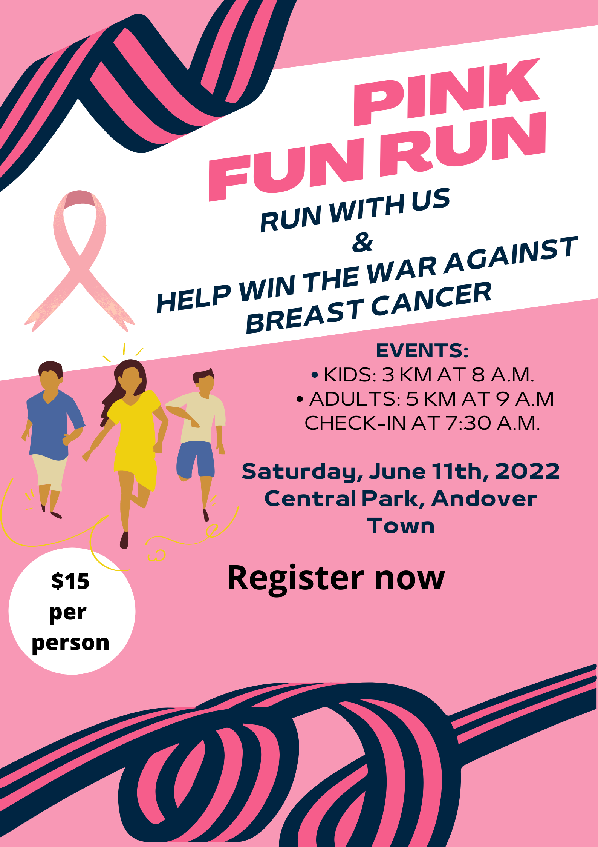

15. Read the poster and choose the correct statement.

A. You have to wear a pink uniform. B. There are events for both children and adults.

C. It’s free to take part in the fun run. D. You can check in at 8 a.m.

**Choose the best option (A, B, C or D) to complete each of the following questions.**

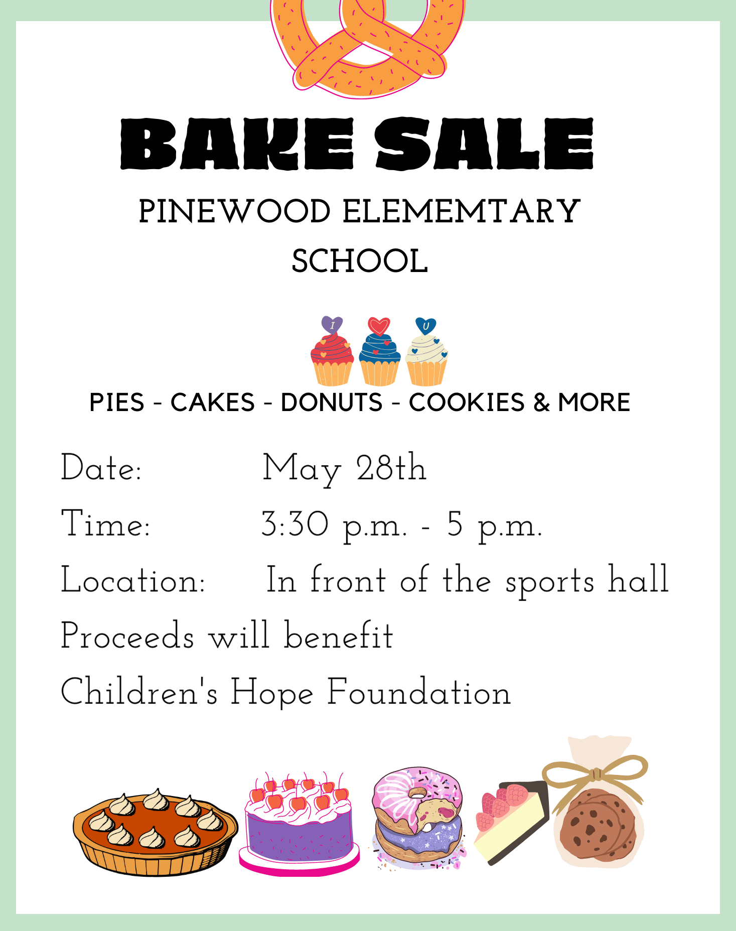

16. Read the poster and choose the correct statement.

A. The bake sale takes place all day. B. The bake sale takes place indoors.

C. The bake sale is for elementary students. D. The bake sale raises money for Children’s Hope Foundation.

|  |  |
| --- | --- |
| **PART 3** | **Word Formation (6 questions)** |

**Write the correct form or compound of the words in brackets.**

17. There are ___________ ways that you can do to help the community. ***(DIFFER)***

18. Work as a volunteer at an animal shelter. You can help taking care of ___________ animals by feeding or bathing them.

***(HOME)***

19. Make a ___________ to charity projects. ***(DONATE)***

20. Spend some time at an orphanage. You can bring ___________ to orphan kids by playing with them or teach them music and crafts. ***(HAPPY)***

21. Take part in community ___________. You can pick up rubbish on the streets, sidewalks, beaches and parks, or clean the graffiti off the walls. ***(CLEAN)***

22. Little things you do can have an___________ impact on the society. ***(AMAZE)***

17. different

18. homeless

19. donation

20. happiness

21. clean-ups

22. amazing

|  |  |
| --- | --- |
| **PART 4** | **Reading (10 questions)** |

**Read the following passage. For each of the questions, write T if the statement is TRUE, F if the statement is FALSE and NI if there is NO INFORMATION on it. (5 questions)**

Girl Scouts of the USA is the largest organization for girls in the world. Juliette "Daisy" Gordon Low organized the first group of Girl Scouts on March 12th, 1912. She wanted to give girls the opportunity to get out of the house and help their community. Girl Scouts of the USA started with 18 members. Today, there are about 2.5 million girl and adult members worldwide. The girls work on a variety of projects. Simple projects may involve sewing, or collecting toys for kids who live in shelters. Other community services for older girls includes volunteering at a soup kitchen, planting trees, doing car washes or cleaning up litter in their community. Girl Scouts is famous for raising money by selling delicious Girl Scout cookies. The girls bake cookies at home with their mums volunteering as an advisor. The organization believes that selling cookies helps Girl Scouts practice life skills like teamwork and money management. When they complete goals, they earn badges for their work which they wear on their sashes.

**Answers** **True** **False** **Not given**

23. There were 18 girls joining the first Girl Scouts group. **◯** **◯** **◯**

24. Girl Scouts members do different community services. **◯** **◯** **◯**

25. To raise money, the girls sell cookies that their mothers make. **◯** **◯** **◯**

26. Girl Scouts raised a lot of money by selling cookies. **◯** **◯** **◯**

27. After finishing one goal, the girls receive a sash. **◯** **◯** **◯**

**Read the passage. For questions, choose the correct option that best suits each blank. (5 questions)**

Hi Ethan,   
Last week, I (28)___________ in a color run in my city. It was a fundraising event for disabled children. More than two thousand people joined the event. It was a 5K run, and there were five stations around the track. Volunteers threw color powder a (29___________ when they made their way through each station. The powder was cornstarch, so it was natural and safe. The (3)___________ part was the colored gel – it was cold and wet and coming at the runners from huge water guns. Runners started out wearing white T-shirts, and by the end of the run, they were covered in colors of red, green, purple and orange. It looked quite crazy, dirty and messy, (31)___________ it was super fun. After the run, there was a big music party with DJs and rock bands. It was so amazing. A color run is definitely something to do with friends. I want to do another one soon. Would you like (32)___________ ?   
See you,   
Nathan

(28) A. had B. went C. took part D. organized

(29) A. *participants* B. participation C. participated D. participating

(30) A. most B. most interested C. more exciting D. best

(31) A. because B. but C. however D. so

(32) A. coming B. come C. to come D. to coming

|  |  |
| --- | --- |
| **PART 5** | **Writing (9 questions)** |

**Rewrite the following sentences without changing their meaning. Use the given word(s) if any.**

33. Let’s have a craft fair to raise money for children with special needs.

→ How___________

34. We shouldn’t have the concert outdoors because it might be cold in the evening.

→ Let’s___________

35. Why don’t we take part in the fun run next Sunday? (TAKE)

→ How___________

36. It’s a good idea to host a school-wide yard sale on the weekend.

→ We should___________

**Use the given words or phrases to make complete sentences.**

37. Last month, my school/ organize/ a fun run/ raise money/ the local soup kitchen.

→ ___________

38. My brother/ work/ a volunteer/ Kenya/ last year.

→ ___________

39. I/ go/ a clean-up/ the forest/ last week.

→ ___________

40. you/ donate/ money/ help/ flood victims/ yesterday?

→ ___________

33. How about having a craft fair to raise money for children with special needs?/How about we have a craft fair to raise money for children with special needs?

34. Let’s not have the concert outdoors because it might be cold in the evening.

35. How about we take part in the fun run next Sunday?

36. We should host a school-wide yard sale on the weekend.

37. Last month, my school organized a fun run to raise money for the local soup kitchen.

38. My brother worked as a volunteer in Kenya last year.

39. I went to a clean-up in the forest last week.

40. Did you donate money to help flood victims yesterday?

|  |  |
| --- | --- |
| **PART 6** | **Listening (10 questions)** |

**You will listen to Ms. White interviewing Annie Williams – a middle school student. Complete the notes with NO MORE THAN TWO WORDS for each blank. (5 questions)**

Last month, Annie donated (41)___________ and old toys to (42)___________ children.   
Last week, Annie cleaned up the (43)___________ and planted flowers and trees there.   
 (44)___________, Annie volunteered at a (45)___________ with her friends.

41. warm clothes

42. (the) poor

43. park

44. Yesterday

45. soup kitchen

**You will listen to a radio show. Choose the correct option for each of the following questions. (5 questions)**

46. Green Steps organized clean-ups in ______________ cities and towns.

A. 14 B. 30 C. 40 D. 56

47. Volunteers cleaned up parks and rivers in ______________.

A. Palmdale B. Crabtree C. Greendale D. Pearl

48. In Crabtree, Green Steps volunteers ______________.

A. picked up trash on the beach B. cleaned up the city

C. organized World Environment Day D. worked with local people

49. How many people took part in the clean-up at Pearl Beach?

A. 12 B. 20 C. 13 D. 800

50. Ms. Carrie Ford believes ______________ is a serious problem.

A. trash along the streets B. plastic pollution

C. dirty beaches and rivers D. the environment

**---THE END---**