Thời gian làm bài: 40 phút (Không kể thời gian giao đề)
-------------------------
Họ tên thí sinh: .................................................................
Số báo danh: ......................................................................
Mã Đề: 009.
Câu 1. Look at the signs. Choose the best answer for the question.

A. This area is supervised by camera. B. You must look after your cameras in this area.
C. Cameras can only be used for security purposes. D. Cameras can be used in this area.
Câu 2. What is the offer at the Tennis Club?
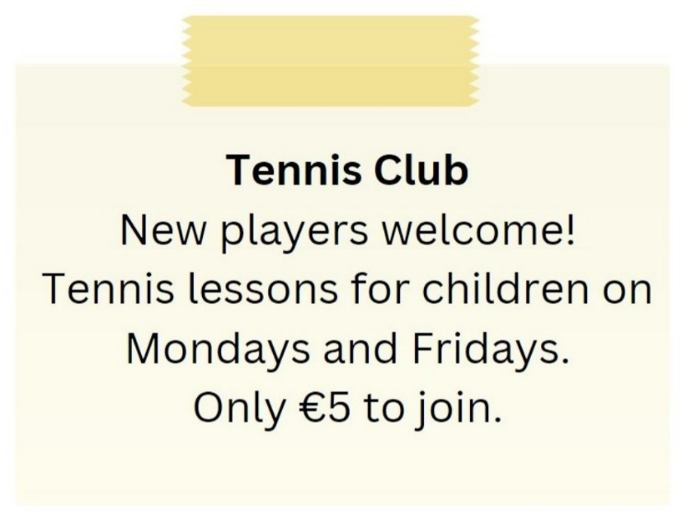
A. Tennis lessons for children on Tuesdays and Thursdays
B. Tennis lessons for adults on Mondays and Fridays
C. €10 to join the club
D. Tennis lessons for children on Mondays and Fridays for €5 to join
Câu 3. What can we infer about the current weather situation?
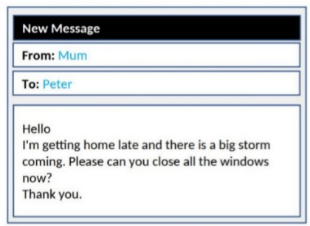
A. It's a sunny day B. It's already raining heavily
C. The storm has passed D. A storm is approaching
Câu 4. Which of the following statements is true?

A. The IT course starts on 1st October.
B. The IT course is for advanced learners.
C. The IT course does not provide a certificate.
D. The IT course covers hardware, software, networking, and security.
Câu 5. What discount does Adventure Park offer for groups?
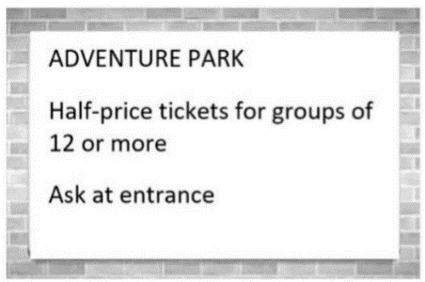
A. Free tickets for every 12th person B. 10% off for groups of 10 or more
C. 50% off tickets D. 25% off tickets
Câu 6. During what hours is the special offer available?

A. Only after 2 PM B. All day
C. From 12 PM to 2 PM D. From 2 PM to 12 AM
Câu 7. What alternative does Missie suggest if Tess can't lend her laptop?
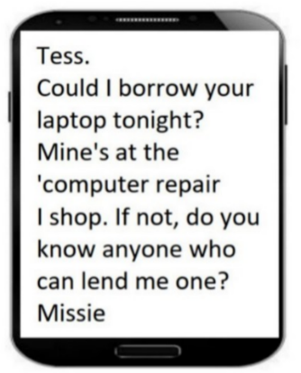
A. Going to an internet cafe B. Finding someone else who can lend a laptop
C. Using a desktop computer D. Asking Tess to help with her work
Câu 8. What does it say?
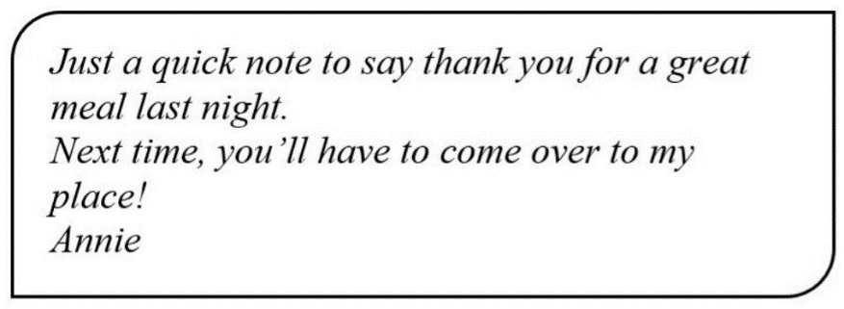
A. Annie invited her friend to her house last night. B. Annie went to her friend’s house last night.
C. Annie cooked a great meal last night. D. Annie went to a restaurant last night.
Câu 9. Look at the signs. Choose the best answer for the question.

A. You have to choose your seat when you buy tickets.
B. You may sit where you like.
C. The tickets don’t show bus numbers.
D. There aren’t any numbers on the seats.
Câu 10. How many students is the snack shop looking for?
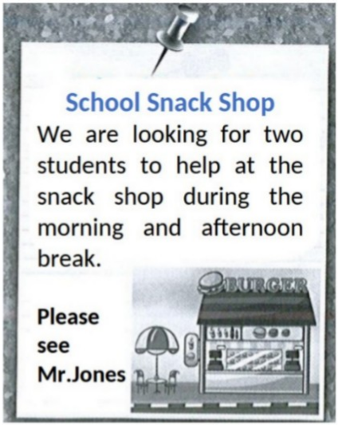
A. Three B. Four C. Two D. One
----HẾT---

