Date of preparing: ………………………………….
Date of teaching: ………………………………….

Period……
UNIT 9: HOUSES IN THE FUTURE
Lesson 1 - Part 2 (Page 71) - Grammar

I. OBJECTIVES
By the end of the lesson, Ss will be able to…
1. Knowledge
- use the simple future to think to give ideas about the future
2. Ability
- improve the use of language
- develop the ability to communicate and cooperate with their partners, to self-study and other skills
3. Quality
- have a positive attitude in English language learning so that they actively participate in all classroom activities
II. TEACHING EQUIPMENT AND LEARNING MATERIALS.
Lesson plan, PPT slides, student’s book, workbook, notebook, personal computer (if any), projector/TV, speakers, DCR & DHA on EDUHOME, handouts…
III. PROCEDURES
A. Warm up: (5’)
a) Objective: To set the scene for the new lesson
b) Content: Revision and introduction of new grammatical point.
c) Product: Ss can understand and have general ideas about the simple future
d) Competence: Collaboration, communication, presentation
e) Organization of the activity:
Teacher’s activities | Students’ activities
* Option 1:  - Ask students to look at the conversation and guess what they are talking about.  - Ask students to find out the structure they have learned in the last period.  * Option 2:  - Ask students to find out the differences between the structure in the conversation and what they have learned in the last period.  - Lead to the new lesson. | - Talking about the technology in the future.  - Revise the structure they know “I think…”  - Work in pairs.

B. New lesson (34’)
- Activities 1: Introduce and practice new language (25’)
a) Objectives:
- To identify, understand the situation and language materials (new grammatical point)
- To use the knowledge in practical situations with the new grammar point presented to express ideas
b) Content: (Section: Grammar page 71).
c) Products: Ss can use the knowledge they have learned to produce the language.
d) Competence: Collaboration, communication, analytical & synthesizing skills.
e) Organization of the activity:
Teacher’s activities | Students’ activities
* GRAMMAR  a. Listen and repeat. (Presentation)  * Option 1:  - Have Ss look at the picture.  - Play the audio  - Play the audio again.  * Option 2:  - Ask students to find out the differences between the structure in the conversation and what they have learned in the last period.  - Have Ss look at the grammar explanation and examples.  - Have Ss look at the table with the different forms.  - Have some Ss read the sentences aloud.  - Ask Ss to write the new language in their notebooks.  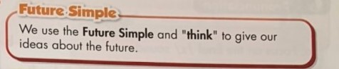  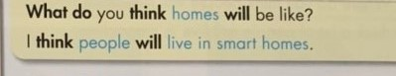  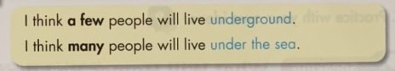 | - Look at the pictures  - Listen and read the speech bubbles.  - Listen and repeat.  - Do the task in pairs.  + Expected answers:  - I think you/he/she should (give advice) and  - I think people will … (give ideas in the future)  - Read the sentences aloud.  - Write in notebooks.
b. Write sentences in Future Simple using the prompts (Practice)  * Option 1:  + Help students know how to use Future Simple and indefinite quantifiers.  - Demonstrates the activity using the example.  1. Do you think lots of people will live in smart homes?  * Option 2:  + Help students use Future Simple and indefinite quantifiers correctly in forms.  - Have Ss write sentences using the prompts.  - Have Ss check their works in pairs.  - Have some Ss share their answers with the class.  - Corrects and give feedback  c. Write sentences using the survey notes.  * Option 1:  + Help students know how to use Future Simple and indefinite quantifiers in other contexts.  - Demonstrate the activity using the example.  1. I think some people will live in earthscrapers.  * Option 2:  + Help Ss improve their use of Future Simple and indefinite quantifiers correctly in difficult contexts.  - Have Ss write sentences using the survey notes.  - Have Ss check their works in pairs.  - Have some Ss share their answers with the class.  - T corrects and gives feedback | - Listen to T’s demonstration and write the sentence in notebooks.  - Write sentences using the prompts.  - Work individually.  - Works in pairs.  - Share the answers with the class.  + Expected answer:  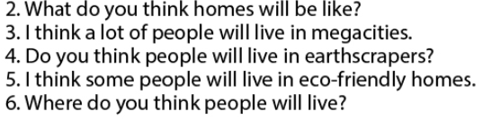  - Check the answer and correct.  - Listen to T’s demonstration and write the sentence in the notebook.  - Write sentences using the prompts.  - Work individually.  - Work in pairs.  - Share their answers with the class.  + Expected answers:  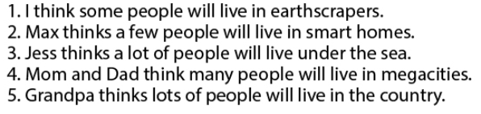  - Check the answers and correct.

- Activity 2: Speaking Skill (10’)
a) Objective: to use the knowledge they have learned to practise converastion and act out the dialogue in close and in open pairs.
b) Content: speaking/ asking and answering questions.
c) Products: Ss can use the knowledge they have learned in their speeches.
d) Competence: Collaboration, communication, presentation, analytical & synthesizing skills.
e) Organization of the activity:
Teacher’s activities | Students’ activities
d. Now, practice saying the sentences with your partner:  * Option 1:  - Help students deepen the new languages.  - Divide the class into pairs.  - Have Ss practice saying the sentences.  - Call on some pairs to demonstrate the activity in front of the class.  * Option 2:  - Help students improve their competence in using new languages in their speeches.  + Game: Lucky Numbers.  - Ask Ss to play the game in teams.  - Divide the class into two teams: Team A and B.  - Ask Ss to choose a number attached to a word/phrase and then say out loud a sentence with the structure they have learned.  Number 1: Some/ smart homes  Number 2: A Lucky Number  Number 3: lots/ megacity  Number 4: few/ megacity  Number 5: a lot/ eco-friendly homes  Number 6: A Lucky Number  Number 7: a few/ eco-friendly homes  Number 8: few/ earthscrapers  - Declare the winner of the games. | - Work in pairs (open pair)  - Work in pairs (closed pairs)  - Work in pairs (their own conversations)  Cues:  - Play the game in teams; Team A and B.  - Join in the game to find out the winner.

C. Consolidation (3’)
- Using the simple future and think to give ideas about the future.
  - What do you think home will be like?
  - I think people will live in smart home.
- Using indefinite quantifiers to give ideas about the future.
  - I think a few people will live underground.
Homework
- Practice asking and answering with the simple future and think and indefinite quantifiers to give ideas about the future correctly with a partner.
- Do exercise in the workbook: Lesson 1- Grammar and Writing (page 51)
- Prepare: Lesson 1 – Pronunciation and Speaking (page 72 – SB)

