UBND HUYỆN  Mã đề 6.1.12 | ĐỀ KIỂM TRA GIỮA KÌ I  NĂM HỌC 2022-2023  MÔN: TIẾNG ANH 6  Thời gian làm bài 60 phút  (Đề gồm: 05 trang)
Full name: ...............................................Class: 6....
Mark | Comment
A. LISTENING
I. Listen then choose the right answer A, B or C. (1 pt)
1. What can people see outside?
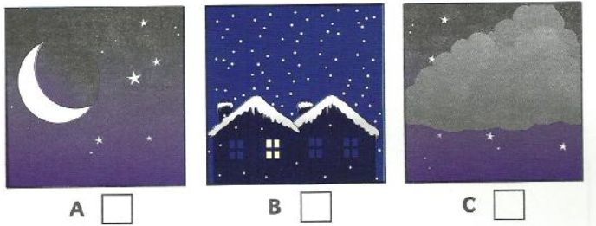
2. What’s the matter with Sally?
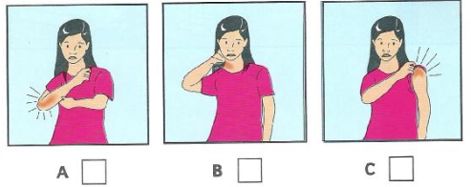
3. Which picture does the girl like?
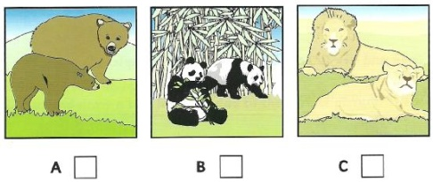
4. What has John’s mom got to buy?
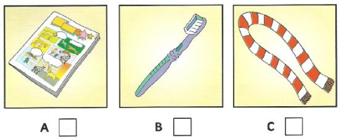
5. Where’s Sue’s towel now?
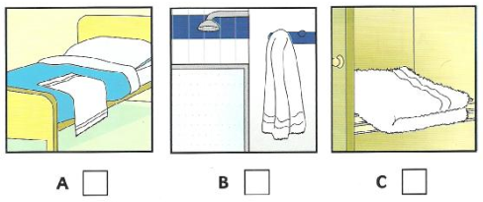
II. Listen to the conversation and fill in the missing information. (1pt)
HOMEWORK- Shopping in town
Favorite shop: | The supermarket
6. Always buys: | ……………………………..
7. How she goes: | By ………………………....
8. Go with: | Her………………………...
9. When she goes: | In the……………………...
10. Name: | Mrs ……………………..…
B. VOCABULARY + GRAMMAR + LANGUAGE FUNCTION
I. Circle the best answer. (3 pts)
- Listening to music is one of the most popular leisure ___.
A. kindergarten B. activities C. hobby D. equipment
- Turn on the __, please. It's so dark in here.
A. cupboard B. dishwasher C. air conditioner D. lamp
- I __ an __ with three friends.
A. share – apartment B. move – attic C. share – furniture D. move – country house
- I put my clothes in the __ at the corner of my bedroom.
A. wall B. hall C. kitchen D. chest of drawers
- My sister always has a lot of new ideas. She's a ___ person.
A. creative B. hard-working C. quiet D. healthy
- He __ have enough money for a long vacation this year.
A. Ø B. don't C. doesn't D. isn’t
- __ always washes the dishes after having dinner.
A. His father B. His parents C. They D. Both A & B are correct.
- When my mom __ the housework, I often help her __ the flowers.
A. does – waters B. does – water C. don't – water D. does – watering
- Do people there __ in a very friendly manner towards you?
A. behave B. behaves C. don't behave D. behaving
- This boy __ very young but he already __ two university degrees.
A. is – have B. are – does not C. is – has D. is having – is
- What about watching TV? - ………….
- That’s right. B. That’s a good idea. C. No, thanks. D. Yes, please.
- Let’s go to the movies. -…………………
- That’s right. B. I’m fine. C. No, thanks. D. Sorry, I’m busy.
- Would you like some pizza? - ……………
- That’s right. B. I’m fine. C. No, thanks. D. Sorry, I’m busy.
Find the word which has a different sound in the underlined part
14. A. apple B. cap C. lamp D. mark
15. A. action B. answer C. afternoon D. part
C. READING
I. Read the text and choose the best answer to fill in the gaps (1,5pts)
MY DREAM HOUSE
A tree house is my most favourite house. It is (1)……….. a tree, of course. But it is under the big branches of leaves. It’s made of wood. There is .a (2) ……..glass window on the roof. I can watch the birds inside the trees through that. There (3)………. a ladder from the ground to the floor of the (4)………. I can run up and down it. The house is small, so I put no table and chair there. I like to store my favourite toys in the house. It’s also a wonderful hideaway place. I can (5)……….. hide and seek with my friends after school.
1. A. in B.on C. at D. between
2. A. big B. kind C. long D. short
3. A. have B. are C. is D. be
4. A. apartment B.flat C. cottage D. house
5. A. do B. get C. play D. skip
II. Read. Then answer the questions by circle A, B, C or D. (1,5pts)
My name’s Quan. One of my best friends is Phong. He is my classmate and we always go to school together. Phong is twelve. He’s tall and rather thin. He has short black hair and brown eyes. Phong is funny and confident. I like being with him because he always makes me laugh. He is also very sporty and plays football and basketball very well. We often play basketball and football at the weekend. He loves music and he plays the guitar. I don’t play any instruments but I love music too. Phong doesn’t like computer games. He likes playing with his friends in the street.
Phong is a very good student. His favourite subject is Maths. He’s not good at Science but he studies hard to pass it.
1. How old is Phong? A. 9 B. 10 C. 11 D. 12
2. What does Phong look like?
A. He is tall and thin. B. He is tall and fat.
C. He is funny and outgoing. D. He likes to play the guitar.
3. Phong has ________.
A. curly brown hair and brown eyes B. short black hair and brown eyes
C. black eyes and short hair D. brown eyes and straight brown hair
4. What is he like?
A. He is tall and thin B. He likes sports.
C. He is funny and confident. D. His hair is short and curly.
5. What subject is Phong very good at?
A. Science B. Maths C. Maths and science D. Computer
D. WRITING
I. Write the sentences with the given words. (1.0 pt)
- My house has got five rooms.
→ There ………………………….…………………………….………………….
- There isn’t a telephone in the living room.
→ We don’t……….…………………..……………………………………………..
- The house is behind the trees.
→ There are trees ………………………………………………………………….
4. Phuong has a brother, Nam.
→ Phuong is ..
5. My father usually drives to work.
→ My father usually goes ..
II. Write a short paragraph to describe your best friend, using the following suggested questions. (1.0 pt)
Viết một đoạn văn tả người bạn tốt nhất của em, dùng các câu hỏi gợi ý sau
- her name/ Mary
- she/ eight/ old
- she/tall/thin
- she/kind
- I/ like/her/because she/kind/intelligent
………………………………………………………………………………………
………………………………………………………………………………………
………………………………………………………………………………………
………………………………………………………………………………………
………………………………………………………………………………………
………………………………………………………………………………………
………………………………………………………………………………………
………………………………………………………………………………………
===========The end ============

Mã đề 6.1.12 | HƯỚNG DẪN CHẤM  ĐỀ KIỂM TRA GIỮA KÌ I  NĂM HỌC 2022-2023  MÔN: TIẾNG ANH 6  (Hướng dẫn chấm gồm: 01trang)

CÂU | Ý | ĐÁP ÁN | ĐIỂM
A-I | 5 | - 1. C 2. C 3. A 4. B 5. B | 1,0 (0,2 for each)
A-II | 5 | 6. Vegetables 7. Bus  8. daughter 9. Afternoon  10. Rich | 1,0 (0,2 for each)
B | 15 | 1.B 2. D 3. A 4.D 5. A  6.C 7.A 8.B 9. A 10. C  11. B 12. D 13. C 14. A 15. C | 3  (0,2 for each)
C-I | 5 | - B 2. A 3. C 4. D 5. C | 1,5 (0,3 for each)
C-II | 5 | 1. D 2. A 3.B 4. C 5. A | 1, 5 (0,3 for each)
D-I | 5 | - There are five rooms in my house.  - We don’t have a telephone in the living room.  - There are trees behind the house.  - Phuong is Nam’s sister .  - My father usually goes to work by car. | 1,0 (0,2 for each)
D-II | 5 | - Her name is Mary.  - She is eight years old.  - She is tall and thin.  - She is kind.  - I like her because she is kind and intelligent. | 1,0  (0,2 for each)

