Unit 9: FESTIVALS AROUND THE WORLD
Lesson 6: Skills 2

I. OBJECTIVES
By the end of this lesson, Ss will be able to gain:
- Listen for special information about a festival
- Write an email to describe a festival
1. Knowledge:
a. Vocabulary: types of festivals, festival activities
b. Grammar: review
2. Core competence:
- Develop communication skills and creativity
- Be collaborative and supportive in pair work and teamwork
- Actively join in class activities
3. Personal qualities
- Develop self-study skills

II. PREPARATIONS
1. Teacher
- Grade 7 textbook, laptop, TV/Projector/ pictures and cards, speakers, lesson plan, sachmem.vn…
2. Students
- Grade 7 textbook, notebooks, school things….
III. TEACHING PROCEDURES
Notes
In each activity, each step will be represented as following
* Deliver the task
** Implement the task
*** Discuss
 Giving comments or feedback
ACTIVITY 1 – WARM – UP & INTRODUCTION (5’)
a) Aims:
- To warm up and get Ss’ interest.
- To lead in the new lesson.
b) Contents: Play the game “Our eating habits”
c) Products: Ss’ answers
d) Teaching steps:
Teacher’s and students’ activities | Content
* Teacher tells the rules of the game:  - Each student gets a piece of paper, draws a table with 3 rows and 3 columns, then fill in the table with names of some festivals randomly.  - Teacher calls out the names of some festivals. Each time the teacher calls out a word, the students search for the right square on their paper and mark.  - The student who has 3 words highlighted in a row yells “Bingo” and wins.  ** Students play the game in individuals  *** Teacher and students discuss the answers.   Teacher confirms the answers and gives feedback. | Bingo!

ACTIVITY 2 – PRESENTATION (7’)
a) Aims:
- To prepare Ss for the listening text.
- To help Ss check their answer in Task 1.
b) Contents:
- Look at the animal. Discuss the questions with a partner.
- Listen to Mark talking about how his family celebrates a festival. Check your answers.
c) Products:
- Ss’ answer
- Answer key
d) Teaching steps:
Teacher’s and students’ activities | Content
* Teacher asks students to work in pairs, read the questions and answer.  ** Students quickly discuss with a partner.  *** Teacher allows Ss to cross check.   Teacher calls some Ss to give their answer on the board and elicits their answers.  * Teacher tells Ss what they are going to listen to and plays the recording.  ** Students listen and check their answers.  *** Teacher allows students to peer check first.   Teacher confirms the answers and gives feedback. | LISTENING  Task 1: Look at the animal. Discuss the questions with a partner.  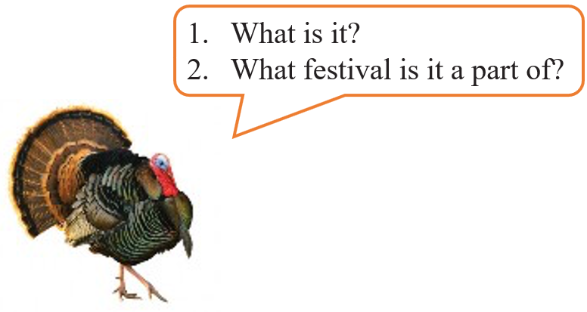  Task 2: Listen to Mark talking about how his family celebrates a festival. Check your answers.  Answer key:  1. A turkey  2. Thanksgiving
ACTIVITY 3 – PRACTICE (20’)
a) Aims:
- To help students develop listening skills for specific information.
- To brainstorm ideas and make an outline for Ss’ writing.
- To practise how to write a paragraph about a festival
b) Contents:
- Listening again and decide whether the following statements are true or false.
- Think about a festival that your family usually celebrates. Fill in the blanks with your answers.
- Write an email of about 70 words to tell Mark about the festival. Use the notes in 4.
c) Products:
- Answer key
d) Teaching steps:
Teacher’s and students’ activities | Content
* Teacher asks students to read through the statements, have a guess before they listen to the recording the second time and write their guesses on the board.  ** Teacher plays the recording again. Ask students to listen and choose the correct answer.  *** Teacher lets students peer-check with a partner.   Teacher calls some students to give the answers to the class and correct the mistakes where necessary, encourages students to correct the false statements.  Audio Script:  Hello everyone. I’m Mark. Today I’m going to talk about Thanksgiving, or Turkey Day. It’s a national holiday. People from Canada and the USA celebrate it every year to be thankful for successful harvests. In the USA, we celebrate it on the fourth Thursday of November. We usually prepare a feast for family and friends. Both adults and children take part in the food preparation. Some of the traditional foods are turkey, sweet potatoes, and cornbread. After the meal, we play board games together. My family usually takes this opportunity to help others. My parents volunteer to cook and serve food to homeless people. My sister and I read books to old people in a nursing home near our house.  * Teacher asks students to work individually to complete the mind map.  ** Students in individuals and decide on their festival.  *** Teacher goes around and helps if needed.   Teacher calls some Ss to give their answer (if time allows) and gives feedback.  * Teacher shows a model of a short paragraph about a festival (T may use the audio script or reading passage-page 97). Then recalls students’ knowledge on the structure of an email.  ** T has Ss write their email in individuals based on the information in 4.  *** Teacher allows students to cross check first.   Teacher gives feedback. | Task 3: Listening again and decide whether the following statements are true or false.  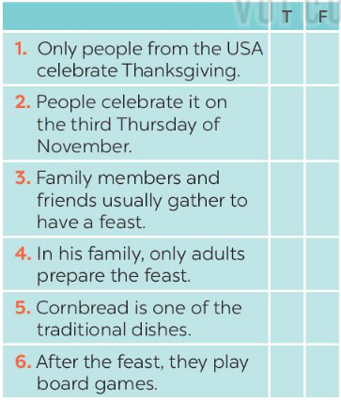  Answer key:  1. F  2. F  3. T  4. F  5. T  6. T  Task 4: Think about a festival that your family usually celebrates. Fill in the blanks with your answers.  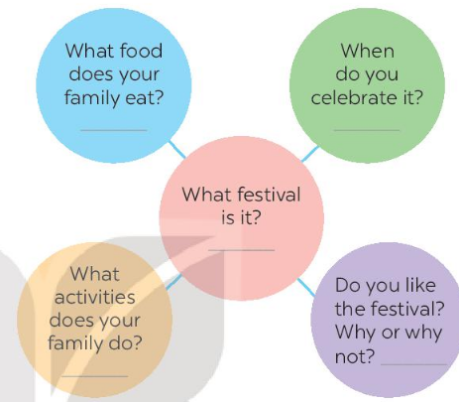  Task 5: Write an email of about 70 words to tell Mark about the festival. Use the notes in 4.  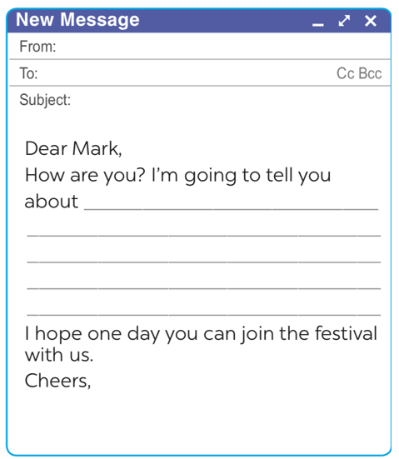
ACTIVITY 4 – PRODUCTION (10’)
a) Aims:
- To peer check, cross check and final check students’ writing.
b) Contents:
- Give peer-reflection & evaluation
c) Products:
- Ss’ writing
d) Teaching steps:
Teacher’s and students’ activities | Content
* Teacher asks students read their “production”.  ** Students listen to each other’s work.  *** Students then give comments to each other.   Teacher then gives feedback as a class discussion. |   Task 6:  Class gallery
IV. WRAP-UP & HOMEWORK (3’)
- Teacher has Ss summarise what they have learnt in the lesson with the two skills.
If there is time, have them draw a mind map to summarise the main points of the lesson.
- Teacher asks Ss to rewrite the emails on their notebook.
- Teacher asks Ss to prepare the next lesson “Unit 9 – Looking back & project”
V. FEEDBACK

……………………….…, ngày………….tháng…………..năm 2022
Duyệt của Tổ chuyên môn

